|  |  |
| --- | --- |
| Name: __Zain Akhtar__ | EE-272L Digital Systems Design |
| Reg. No.: ____2023-EE-63____ | Marks Obtained: ____________ |

**Lab Manual**

|  |  |  |  |  |  |
| --- | --- | --- | --- | --- | --- |
| **DSD Lab Manual Evaluation Rubrics** | | | | | |
|  |  |  |  |  |  |
| **Assessment** | **Total Marks** | **Marks Obtained** | **0-30%** | **30-60%** | **70-100%** |
| Code Organization (CLO1) | 3 |  | No Proper Indentation and descriptive naming, no code organization.  Zero to Some understanding but not working | Proper Indentation or descriptive naming or code organization.  Mild to Complete understanding but not working | Proper Indentation and descriptive naming, code organization.  Complete understanding, and proper working |
| Simulation (CLO2) | 5 |  | Simulation not done or incorrect, without any understanding of waveforms | Working simulation with errors, don't cares's(x) and high impedance(z), partial understanding of waveforms | Working simulation without any errors, etc and complete understanding of waveforms |
| FPGA (CLO2) | 2 |  | Not implemented on FPGA and questions related to synthesis and implementation not answered. | Correctly Implemented on FPGA or questions related to synthesis and implementation answered. | Correctly Implemented on FPGA and questions related to synthesis and implementation answered. |

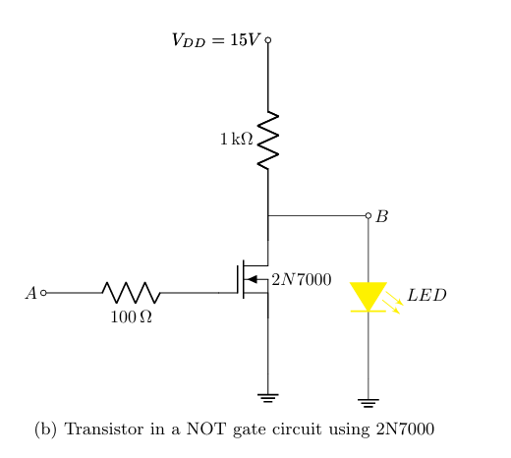

**TASKS:**

* When 5V is applied at terminal A, the voltage at terminal B is **0.05V** and the **LED does not glow.**
* When 0V is applied at terminal A, the voltage at terminal B is **1.99V** and the **LED glows**.

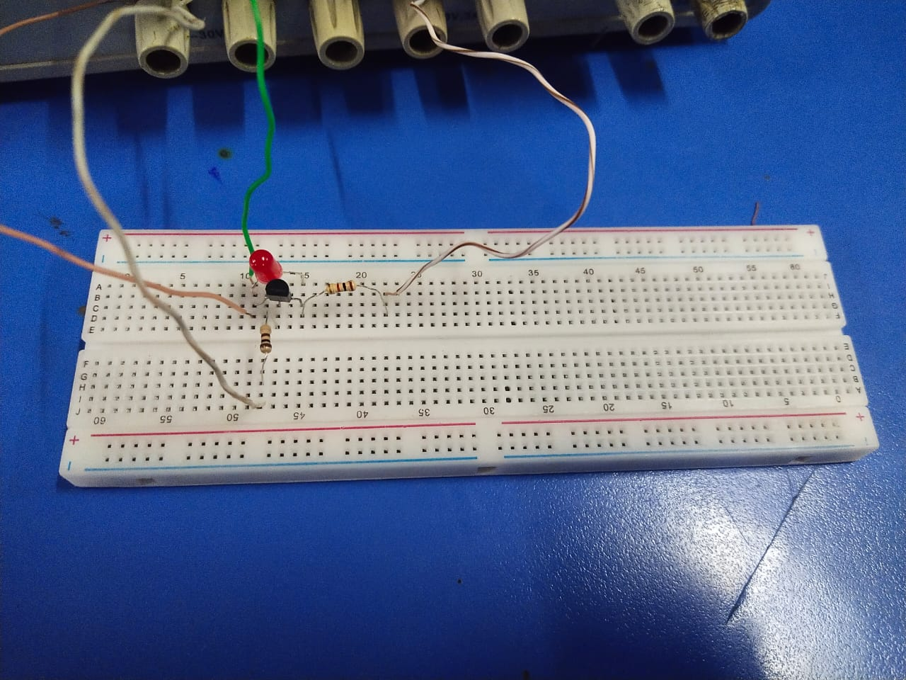

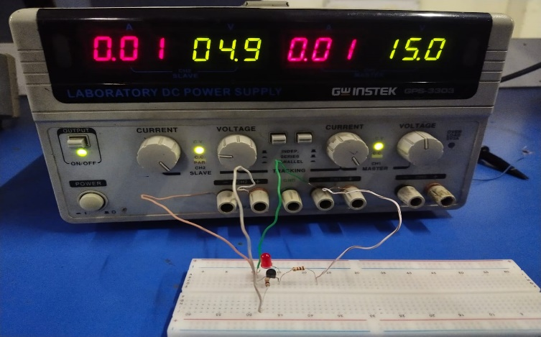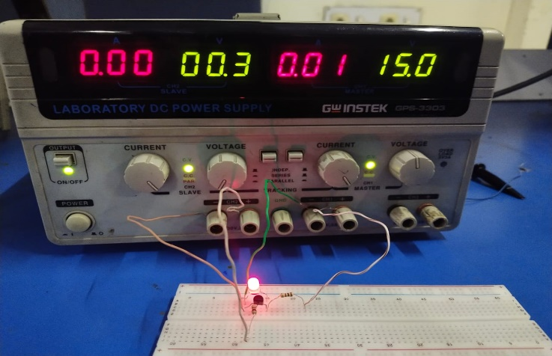

* 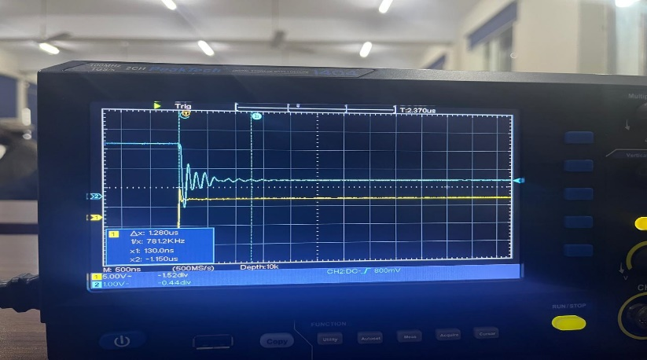We apply a 1 kHz, 10V (peak-to-peak) voltage square  
  wave at terminal A using the signal   
  generator. When the input goes from low   
  voltage to high voltage then the   
    
  **Propogation delay is 1.280μs.**
* 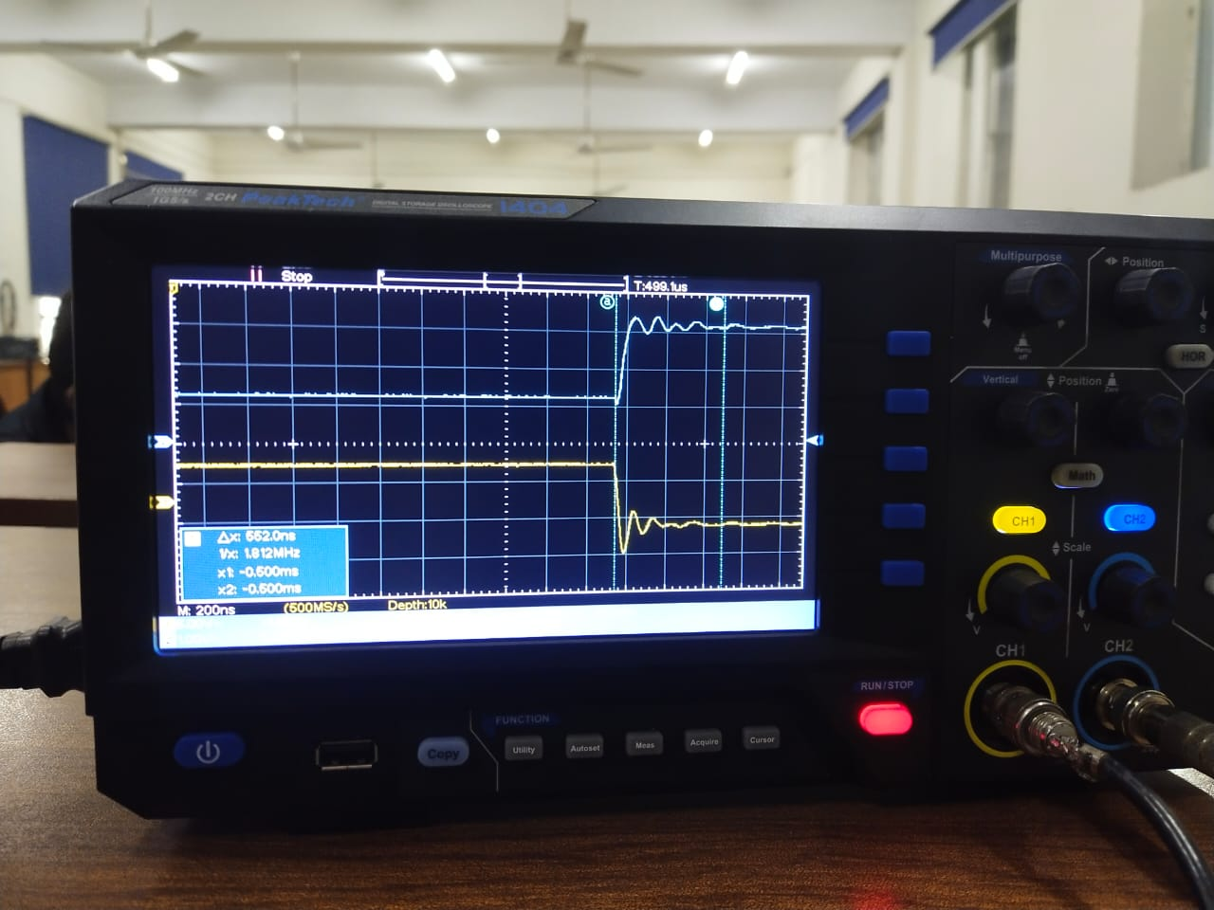 When the input goes from high  
  voltage to low voltage then the   
    
  **Propogation delay is 552ns.**
* 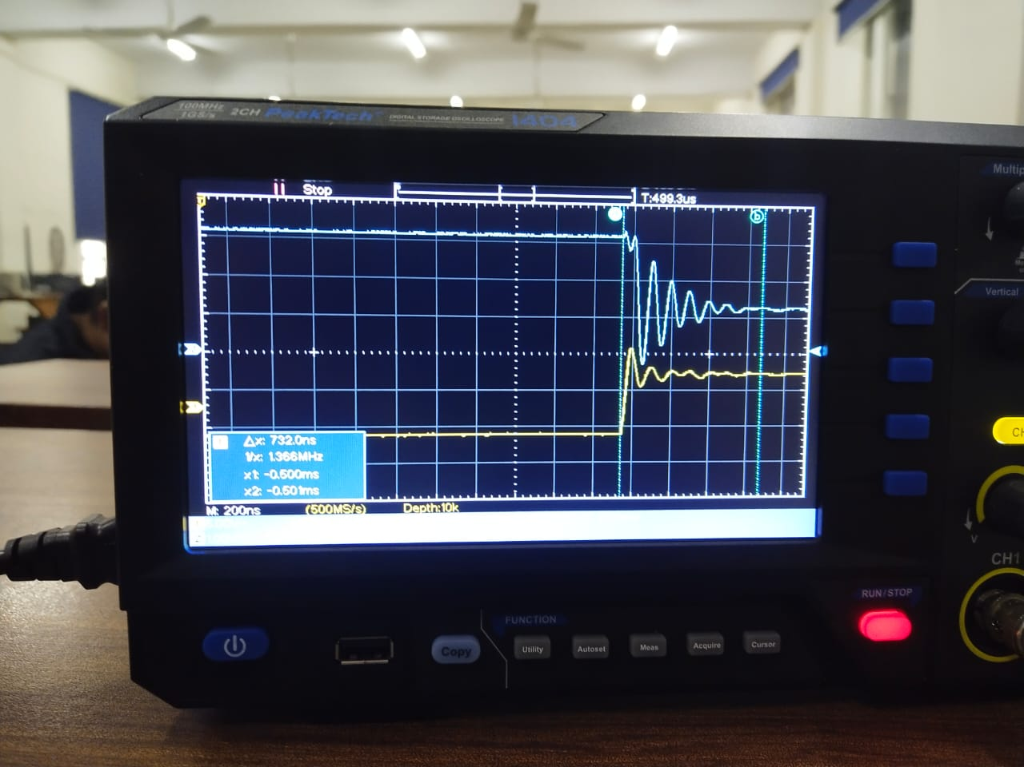We apply a 100kHz, 10V (peak-to-peak) voltage square  
  wave at terminal A using the signal   
  generator. When the input goes from low   
  voltage to high voltage then the   
    
  **Propogation delay is 732ns.**

* 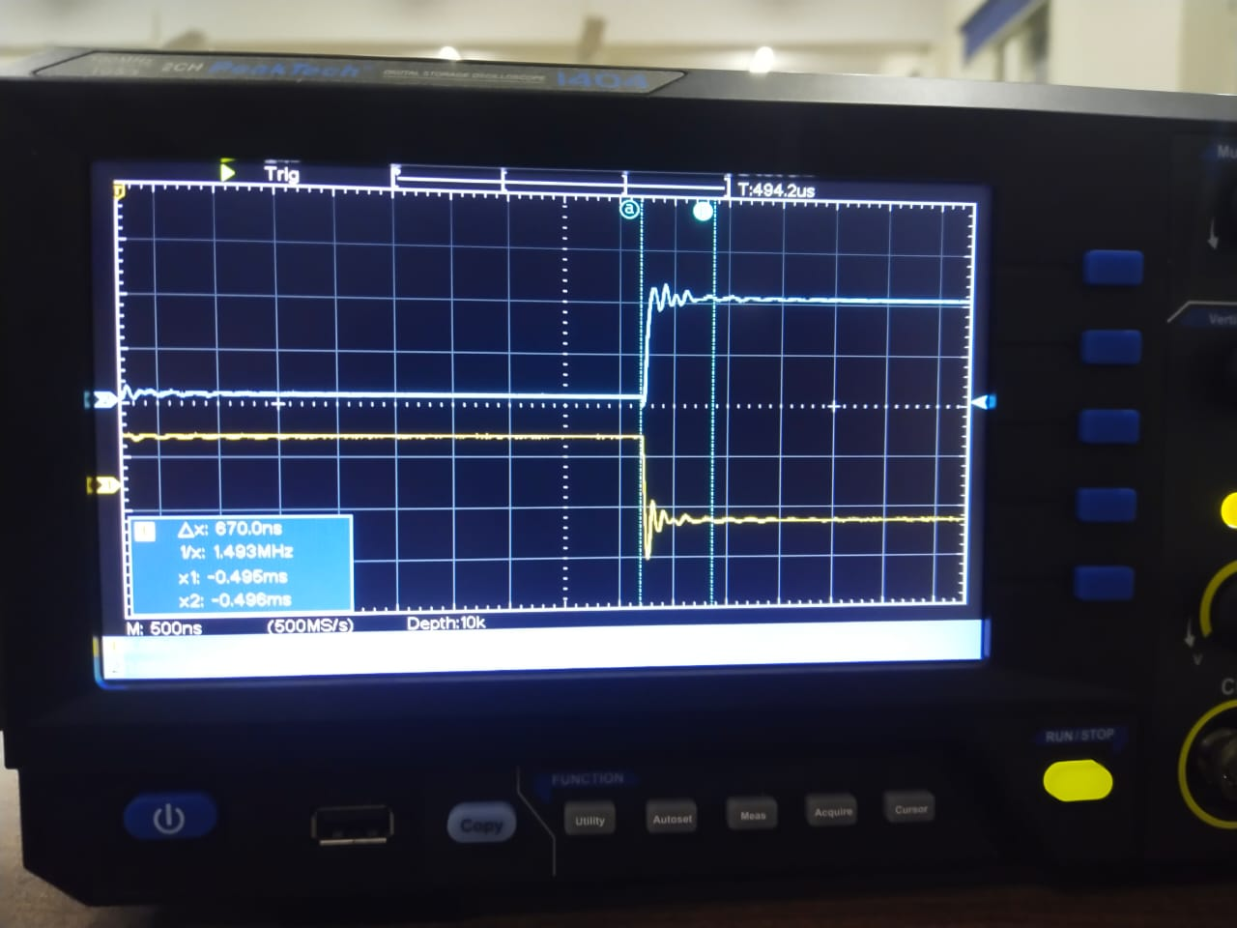 When the input goes from high  
  voltage to low voltage then the   
    
  **Propogation delay is 552ns.**
* As we increases the frequency our signal become distorted.