**Atlas based segmentation (integration to the EM algorithm)**

**Course Title:** Medical Image Segmentation and Applications (MISA)

**Group Member:** Md Imran Hossain, Muhammad Zain Amin

**Email:** hossainimran.maia@gmail.com, zainamin1@outlook.com

*Erasmus Mundus Joint Master in Medical Imaging Applications (MAIA), University of Girona, Spain*

**Objective(s):**

A) To understand the segmentation algorithm when integrating atlas information. To design, analyze and implement the algorithm in Python.

B) To test the algorithm with the provided images (training images for building the atlas and testing for providing results).

C) To evaluate the results using the ground truth provided and the Dice Similarity Coefficient values. The Dice Similarity Coefficient values will be provided per class.

**Introduction:**

The objective of Multi-Atlas based segmentation is to enhance the efficiency of segmentation algorithms by leveraging pre-existing knowledge regarding the task. This knowledge is typically extracted from a collection of training images that possess validated ground truths. Various approaches exist to incorporate this information into a segmentation framework. For example, one method involves utilizing the atlas labels as a starting point for an expectation-maximization-based technique. Another approach involves employing tissue models and probability maps to deduce the labels, or conditioning the posterior probabilities generated by the Expectation Maximization (EM) segmentation algorithm by multiplying them with the probability maps of atlas tissue.

**Methodology:**

Carrying out the process of atlas-based segmentation comprises two primary phases:

1. **Registration**

During the initial phase, the atlas images must undergo registration to align with the target images requiring segmentation. The obtained optimal registration parameters were subsequently utilized to propagate the atlas probability maps into the respective space of each individual case.

1. **Segmentation**

Once the atlas is acquired within the target image's framework, there are numerous ways available for executing segmentation. In the following sections, we will elaborate on the various approaches we explored in this assignment for utilizing an atlas to conduct segmentation.

* 1. **Non-Expectation Maximization methods**

A solitary atlas can offer two categories of information that have the potential to be utilized for obtaining segmentation in three distinct manners.

* + 1. **Intensity-based segmentation**

Atlases have the capability to construct tissue models, wherein these models allocate a probability to each potential intensity value indicating its likelihood to belong to various tissue classes. Subsequently, each voxel can be designated to the class with the highest probability corresponding to its intensity value, a process often referred to as the Maximum a Posteriori methods.

$Y (x,y,z)= \max_{k}{TM_{k}\left(I\left(x,y,z\right)\right)}$, $k=\{CSF, GM, WM\}$ (i)

Here, 'TM' represents the tissue maps, while 'Y' signifies the classification label assigned to the voxel located at position (x, y, z) with the intensity denoted as I(x, y, z).

* + 1. **Position-based segmentation**

The propagated atlas probability maps allocate probabilities to each voxel, indicating the likelihood of belonging to various tissues contingent on their respective positions. Once more, every voxel can be allocated to the class displaying the highest probability associated with its particular location.

$Y (x,y,z)= \max_{k}{T{PM}_{k}\left(x,y,z\right)}$, $k=\{CSF, GM, WM\}$ (ii)

Here, 'TPMk' represents the probability map for tissue 'k' derived from the multi-atlas, while 'Y' denotes the classification label assigned to the voxel positioned at (x, y, z).

* + 1. **Combined segmentation approach**

By multiplying the probability maps generated from the tissue model with the propagated atlas probability maps, a segmentation outcome can be achieved that considers both intensity and positional information.

(iii)

* 1. **Initializing the Expectation Maximization Algorithm with Atlases**

Atlases can enhance segmentation performance by integrating them into the EM process, offering various methods to achieve this. Within this study, our emphasis is on exploring the following two approaches:

* + 1. **Inside EM**

Given the iterative nature of EM, the atlases can play a role in each iteration by being multiplied with the probability maps generated by EM. This utilization ensures continual guidance of the segmentation within the EM process, incorporating location-specific conditioning in each iteration. This approach helps prevent the intensity-driven outcomes from deviating towards implausible results.

$w_{ik}= \frac{p_{k}\left(v_{i} | θ_{k}\right).α_{k}}{\sum_{m=1}^{k}{p_{m}}(p_{m}\left(v_{i} | θ_{m}\right).α_{m})}$ (iv)

$w_{ik}^{'}$ = $w_{ik}* {TPM}_{k}(v_{i})$ (v)

$Y\left(v_{i}\right)= \max_{k}{w_{ik}^{'}}$ (vi)

**Project Management and Implementation:**

The study comprised two primary phases. Initially, our emphasis was on achieving accurate registrations of the atlases concerning each of the test images. Subsequently, we adapted the segmentation method based on feedback obtained from prior lab sessions. Following this, we implemented various segmentation methods, conducting tests on a subset of cases before deploying them on the entire provided test set. Finally, we presented the results, assessing segmentation performance via dice scores and evaluating computational costs in terms of time and required iterations.

During this project, Python served as the chosen programming language. The EM+GMM segmentation framework, previously developed and updated based on the provided corrections, was utilized. Elastix, a tool utilized for registration purposes, facilitated the registration process in our project.

**Results:**

In this section, we will provide comprehensive insights into the outcomes derived from the various experiments conducted in this lab project.

1. *Segmentation without EM*

For every test image, we conducted segmentation solely relying on the information offered by the atlas, excluding the EM optimization, which includes tissue models, tissue probability maps, or a combination of both, as detailed in the preceding sections.

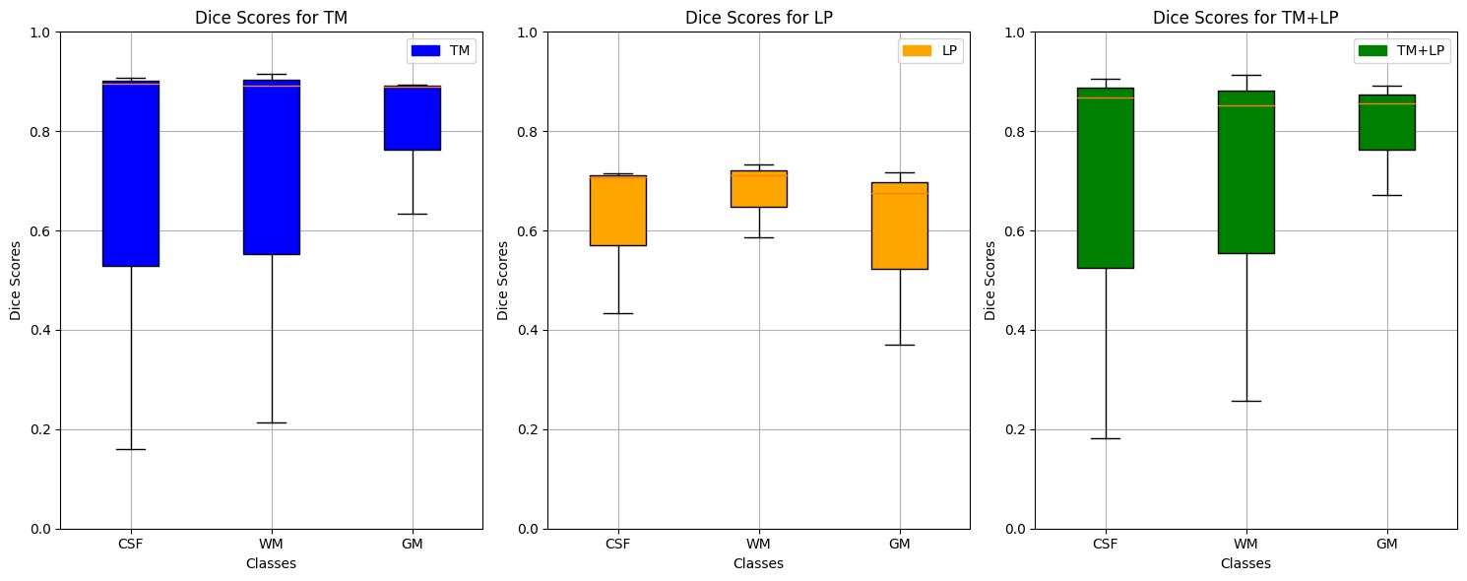

*Figure 1. Box Plot for Segmentation [TM, LP, TM + LP]*

*Table 1. Means and Standard Deviations of the dice scores of Segmentation without EM*

|  |  |  |  |
| --- | --- | --- | --- |
| *Statistics* | *Tissue* | *Mean* | *Standard Deviation* |
| *TM* | *CSF* | *0.6547* | *0.4277* |
| *WM* | *0.6728* | *0.3985* |
| *GM* | *0.8062* | *0.1491* |
| *LP* | *CSF* | *0.6190* | *0.1600* |
| *WM* | *0.6767* | *0.0794* |
| *GM* | *0.5880* | *0.1894* |
| *TM + LP* | *CSF* | *0.6521* | *0.4076* |
| *WM* | *0.6741* | *0.3617* |
| *GM* | *0.8060* | *0.1186* |

1. *EM initialization*

For comparing the diverse initialization methods available for the EM procedure such as K-means, tissue models, probability maps, three separate experiments were executed on the test set for each atlas. Figure 2 presents a summary of the results using boxplot, while Table 2 offers more comprehensive details for comparison.

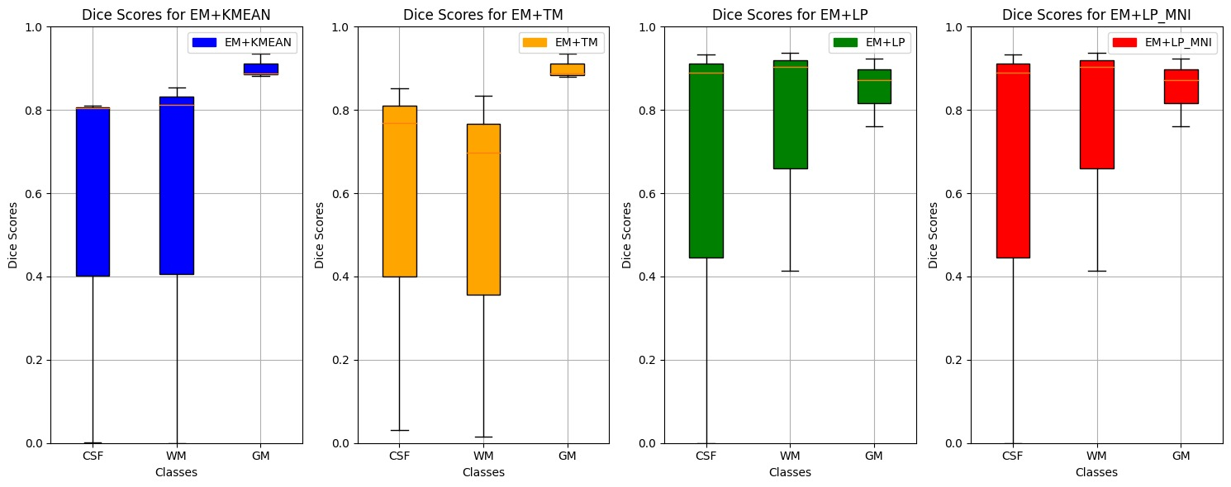

*Figure 2. Box Plot for Segmentation [EM+KM, EM+TM, EM+LP, EM+LP_MNI]*

*Table 2. Means and Standard Deviations of the dice scores of Segmentation with EM Initialization*

|  |  |  |  |
| --- | --- | --- | --- |
| *Statistics* | *Tissue* | *Mean* | *Standard Deviation* |
| *EM + K Means* | *CSF* | *0.5386* | *0.4653* |
| *WM* | *0.5551* | *0.4811* |
| *GM* | *0.9016* | *0.0294* |
| *EM + TM* | *CSF* | *0.5504* | *0.4519* |
| *WM* | *0.5159* | *0.4384* |
| *GM* | *0.9007* | *0.0302* |
| *EM + LP* | *CSF* | *0.6080* | *0.5270* |
| *WM* | *0.7516* | *0.2924* |
| *GM* | *0.8520* | *0.0837* |
| *EM + LP_MNI* | *CSF* | *0.6080* | *0.5270* |
| *WM* | *0.7516* | *0.2924* |
| *GM* | *0.8520* | *0.0837* |

1. *Atlas Into EM*

In this series of experiments, we assess the segmentation performance by integrating the atlas information into the EM process through multiplication at the conclusion of each iteration. Figure 3. provides a summary of the outcomes, while Table 3. offers additional detailed information.

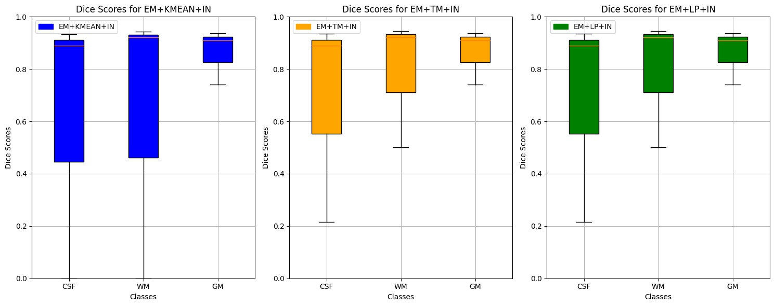

*Figure 3. Box Plot Box Plot for Segmentation [EM + KMeans + IN, EM+TM+IN, EM+LP+IN]*

*Table 3. Means and Standard Deviations of the dice scores of Atlas into EM*

|  |  |  |  |
| --- | --- | --- | --- |
| *Statistics* | *Tissue* | *Mean* | *Standard Deviation* |
| *EM + K Means + IN* | *CSF* | *0.6080* | *0.5270* |
| *WM* | *0.6215* | *0.5383* |
| *GM* | *0.8625* | *0.1057* |
| *EM + TM + IN* | *CSF* | *0.6799* | *0.4033* |
| *WM* | *0.7895* | *0.2500* |
| *GM* | *0.8625* | *0.1057* |
| *EM + LP + IN* | *CSF* | *0.6799* | *0.4033* |
| *WM* | *0.7895* | *0.2500* |
| *GM* | *0.8625* | *0.1057* |

1. *MNI Atlas Into EM*

Based on the findings obtained from the preceding experiments and the overview presented in figure 4, it is evident that, in most instances, the atlas we constructed delivers superior Dice scores across all tissue types compared to the MNI atlas. This supports the notion that employing atlases with distributions closer to the evaluated data during test time can positively impact segmentation performance. However, it's essential to note potential biases; upon further examination, the MNI atlas lacked segmentation details for the cerebellum region, unlike our atlas and the provided labels for the test set. As a result, the overall use of this atlas might have resulted in a comparatively lower performance specifically in that region.

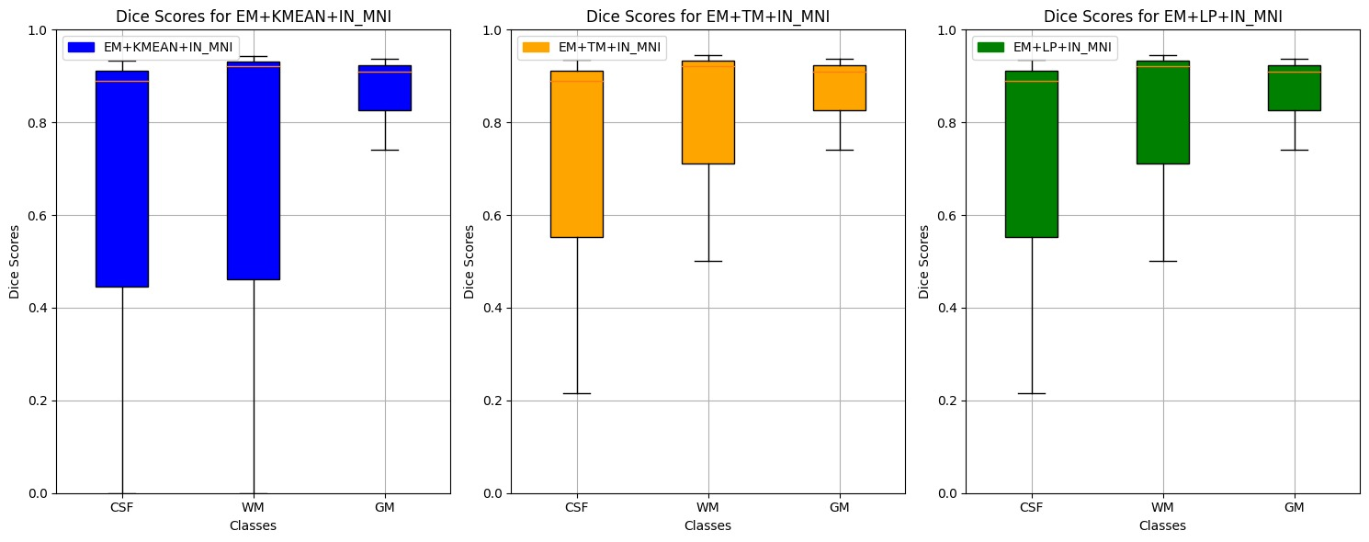

*Figure 4. Box Plot Box Plot for Segmentation [EM + KMeans + IN_MNI, EM+TM+IN_MNI, EM+LP+IN_MNI]*

*Table 4. Means and Standard Deviations of the dice scores of EM+ATLAS+IN with MNI*

|  |  |  |  |
| --- | --- | --- | --- |
| *Statistics* | *Tissue* | *Mean* | *Standard Deviation* |
| *EM + K Means + IN_MNI* | *CSF* | *0.6080* | *0.5270* |
| *WM* | *0.6215* | *0.5383* |
| *GM* | *0.8625* | *0.1057* |
| *EM + TM + IN_MNI* | *CSF* | *0.6799* | *0.4033* |
| *WM* | *0.7895* | *0.2500* |
| *GM* | *0.8625* | *0.1057* |
| *EM + LP + IN_MNI* | *CSF* | *0.6799* | *0.4033* |
| *WM* | *0.7895* | *0.2500* |
| *GM* | *0.8625* | *0.1057* |

The comparison among segmentation methods reveals distinct performance traits. Tissue Models (TM) exhibit moderate yet consistent scores across cerebrospinal fluid (CSF), white matter (WM), and gray matter (GM). In contrast, Label Propagation (LP) demonstrates stability in CSF and WM but slightly lower scores in GM. Expectation-Maximization (EM) methods, particularly EM+LP, stand out with promising results, especially in WM, showcasing its efficacy in segmentation. Additionally, when incorporating extra information (IN) with EM, there is a consistent improvement in CSF and WM segmentation quality compared to standalone EM approaches. Notably, LP remains robust even after data modifications (LP_MNI), reflecting its stability across various conditions. Overall, while TM and LP show decent performance, the incorporation of additional data consistently enhances segmentation quality, particularly in CSF and WM, across EM methodologies.

Comparing the results between LP and LP_MNI, the means and standard deviations for CSF, WM, and GM remain identical, suggesting that the Montreal Neurological Institute (MNI) adjustments did not significantly influence the outcomes of Label Propagation (LP) in this analysis.

**Conclusion:**

Overall, the findings suggest that while TM and LP demonstrate stable performance, incorporating supplementary data consistently enhances CSF and WM segmentation quality across EM methodologies. Interestingly, the integration of MNI adjustments in these methods doesn't substantially alter the segmentation outcomes.

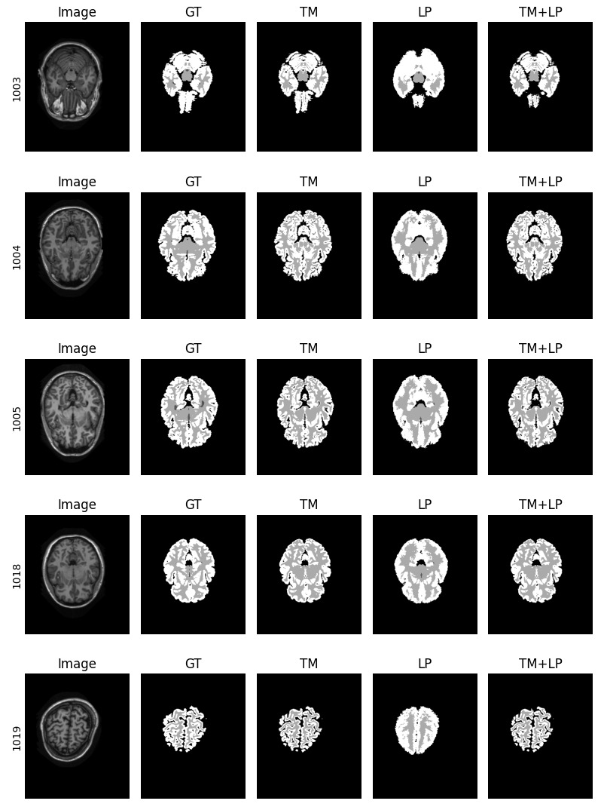

Figure 5. Segmented Image for [TM, LP, TM&LP] -- Without EM

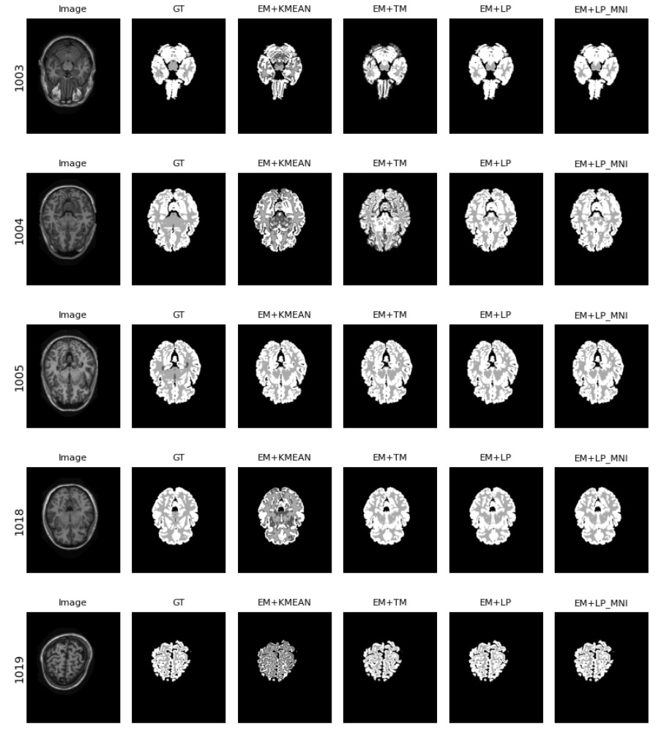

Figure 6. Segmented Image [EM+Kmean, EM+TM, EM+LP, EM+LP_MNI]

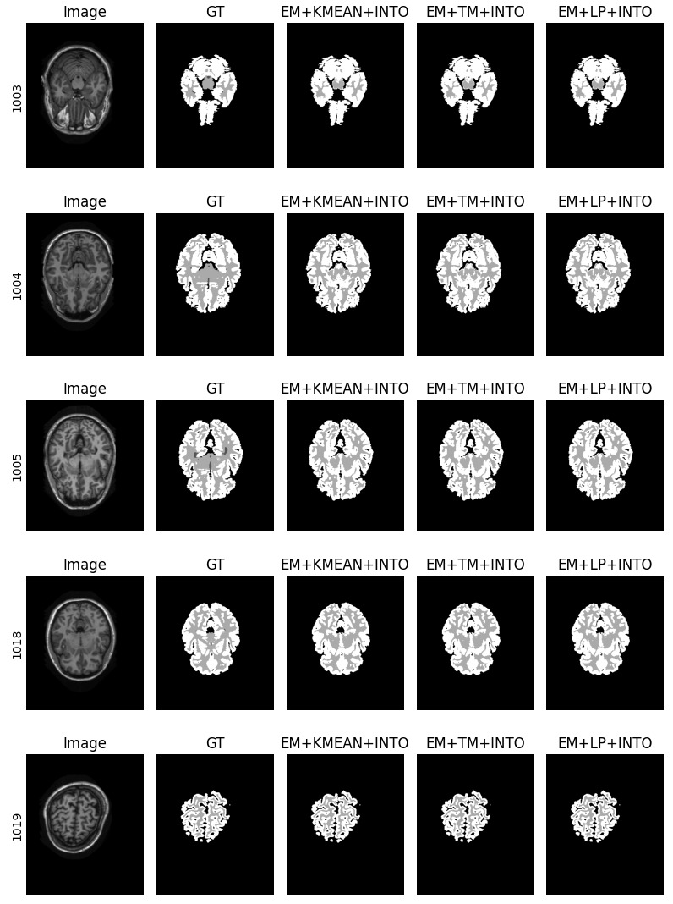

Figure 7. Segmented Image [KM+Kmean into, KM+ TM into, KM+LP into]

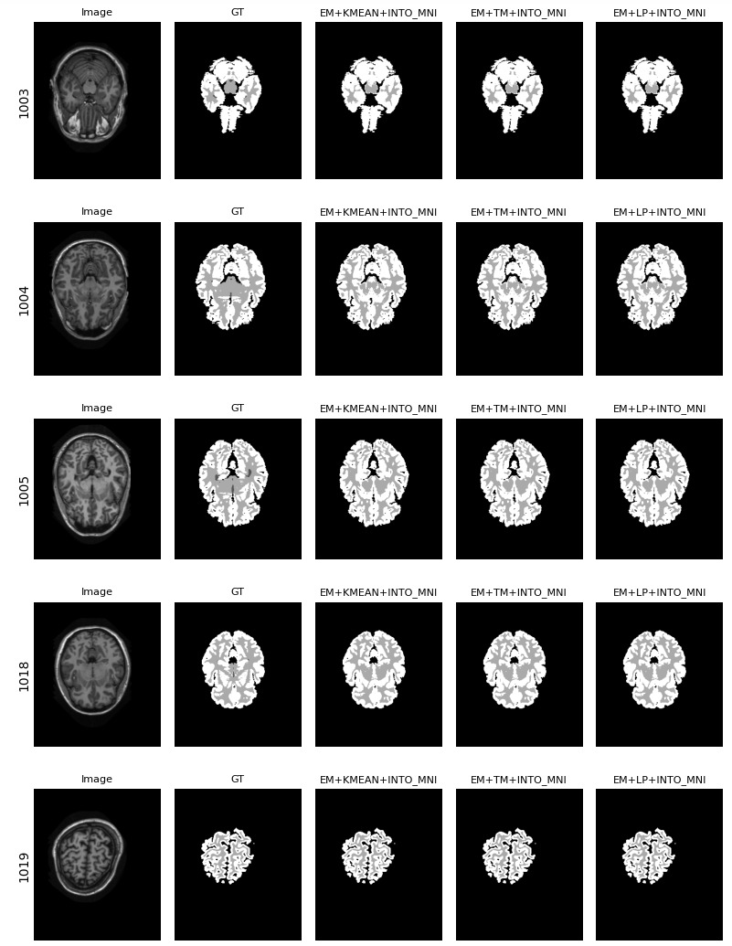

Figure 8. Segmented Image EM+ATLAS (INTO) Plot with MNI