**Q1) Display all the employees of a particular department (e.g. grocery)?**

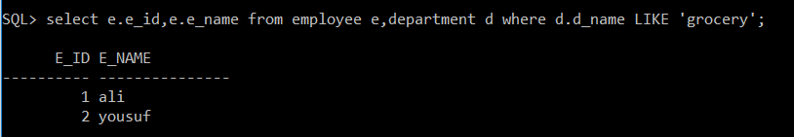

**Q2) Show the designation of a particular employee (e.g. yousuf)?**

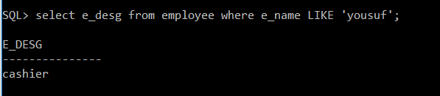

**Q3) Display which employee ordered particular product (e.g. beef)?**

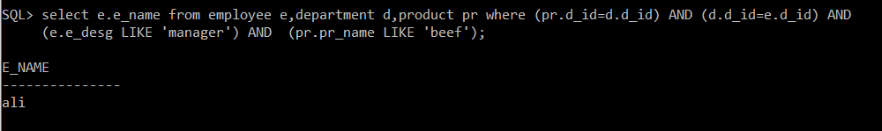

**Q4) Show the cost & sale of a particular product (e.g. rice)?**

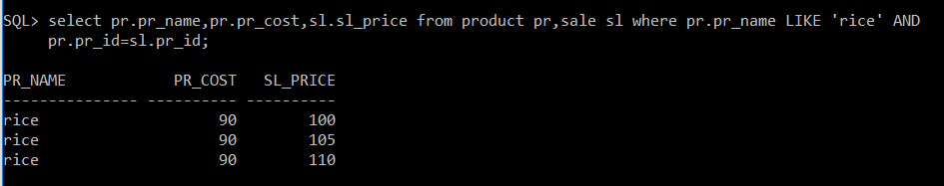

**Q5) Show all transactions of a particular product (e.g.rice)?**

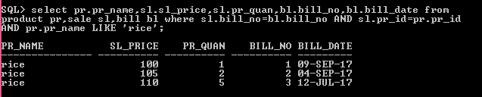

**Q6) Show the total amount of sale of a particular month (e.g. SEPTEMBER)?**

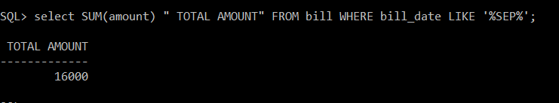

**Q7) Display all products supplied by a particular supplier (e.g. ahmed)?**

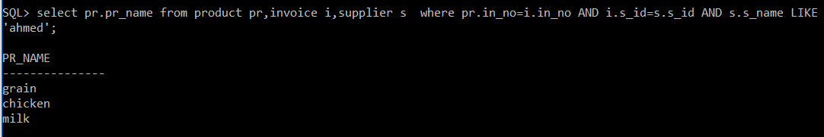

**Q8) Display the record of all bills where the total amount exceeds 5000?**

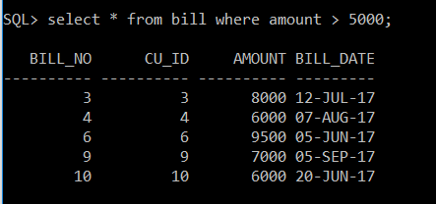

**Q9) Display list of all customers who spent less than 5000?**

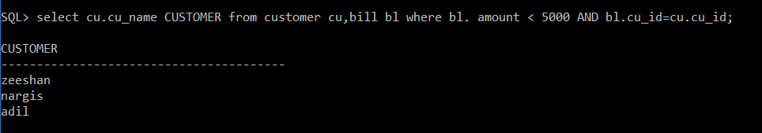

**Q10) Display all the products of a particular department (e.g. grocery)?**

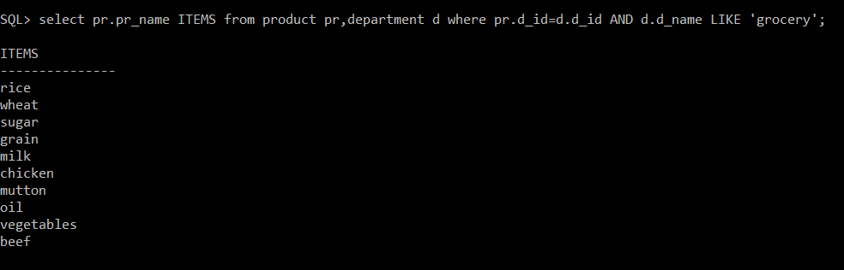

**Q11) Show which product is supplied by which supplier at which cost?**

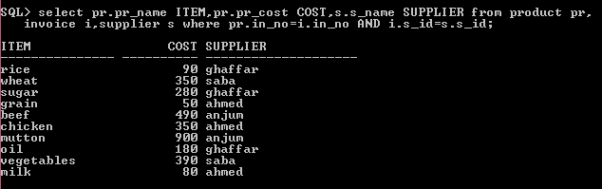

**Q12) Show total quantity of products sale in ascending order?**

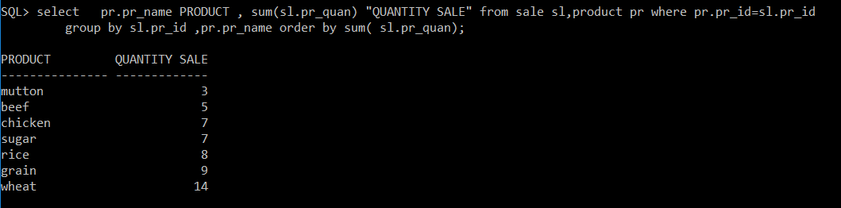

**Q13) Display the frequent visitors of the store?**

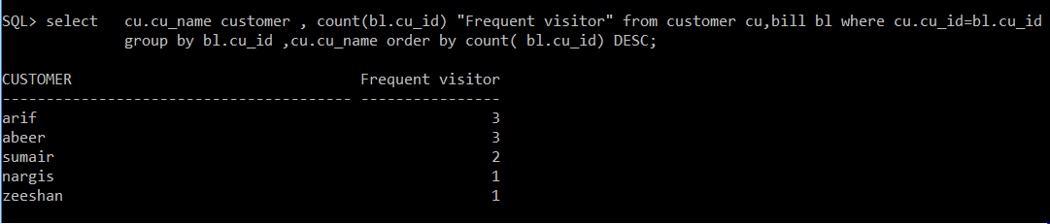

**Q14) Display the comparison of cost of particular product by the supplier (e.g. rice)?**

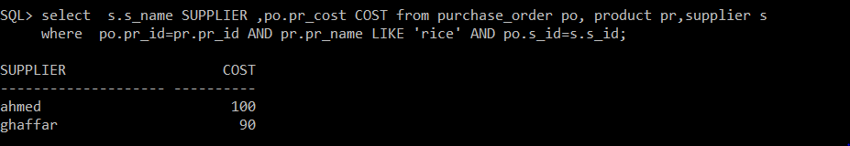

**Q15) How many customers visited in a particular month (e.g. SEPTEMBER) ?**

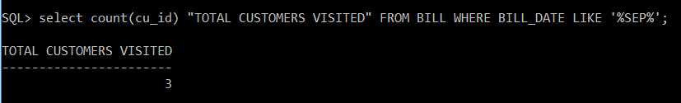

**Q16) Show all the cost of different types of meat?**

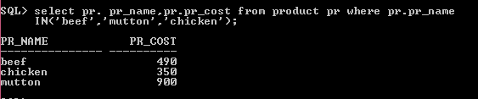

**Q17) Display all the products whose cost is less than 300 by suppliers?**

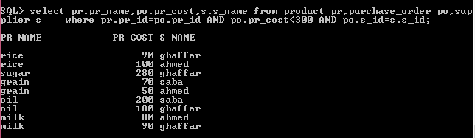

**Q18) Display all the cashiers of a store?**

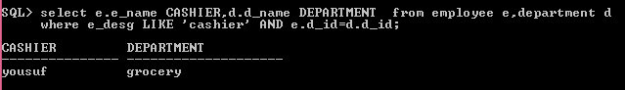

**Q19) Display all the managers of a store?**

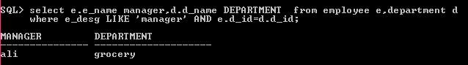

**Q20) Display all the products which have been purchased?**

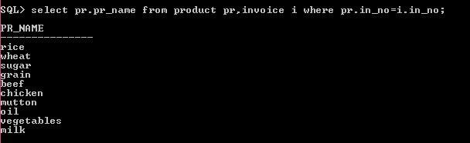

**Q21) Show all the invoice numbers of a particular supplier (e.g. ghaffar)?**

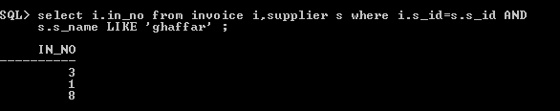

**Q22) Show all the purchases of a particular customer (e.g. zeeshan)?**

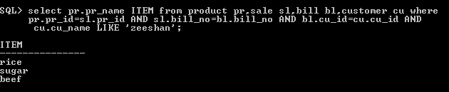

**Q23) Display details of all departments?**

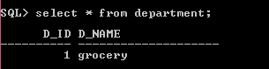

**Q24) Display details of all customers?**

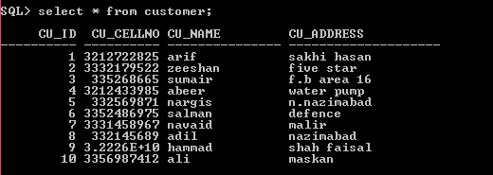

**Q25) Display details of all suppliers?**

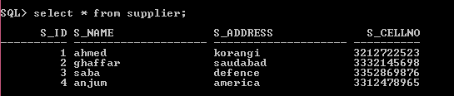

**Q26) which customer is the highest purchaser of a store?**

