

BRAND PROPOSAL
Pick a Pakora at The Centaurus Mall
Relaunch of Islamabad's original pakora brand, established 2016
Prepared for
Mr Kashif Butt, Senior Marketing Director
The Centaurus Mall, Islamabad
Prepared by
Pick a Pakora
August 2026

1. Introduction
Pick a Pakora is a quick-service food brand built around one idea: take the most loved street snack in Pakistan and give it the variety, hygiene and presentation of a modern food court brand. We were the first outlet in Islamabad to offer a full menu of pakora varieties under one name.
Our first outlet opened on 3 March 2016 on the 7th floor food court of Safa Gold Mall, Jinnah Super, Islamabad. From day one the concept drew strong response from customers, referrals and the mall management, both for the idea and for the quality offered at the price point.
The Safa Gold outlet was closed when the Capital Development Authority shut down the mall's food court, not because of the business itself. Since then the brand has been dormant but not forgotten, and we have used the time to rebuild it properly.

Why Centaurus, and why now
Islamabad's customers are brand conscious and expect the whole experience, not just the food. We are not returning with the same outlet. This relaunch brings:
- A redesigned identity: new logo, colours and packaging built for signage, social media and delivery apps.
- A new menu with more variety, new recipes and a rotating Today's Special that keeps regulars coming back.
- Improved taste and consistency, with recipes reworked and standardised so every order is the same.
- A digital-first marketing plan for a 2026 audience, alongside the in-mall activity that worked for us before.
The Centaurus food court is the right home for this. It has the footfall, the family and youth mix, and the standard of neighbouring brands that Pick a Pakora is now built to sit beside.

2. Company profile
Pick a Pakora is an Islamabad-based food brand, owned and managed locally. The founding team ran the Safa Gold outlet from 2016 and is leading the relaunch at Centaurus.
Key facts: brand founded 2016 · first outlet Safa Gold Mall, Islamabad · registered office 22E, First Floor, Service Road, F-11/1, Islamabad · directors and management: [add names and roles]

3. Core value
High quality food at the most economical price possible. Every decision, from ingredients to packaging, is tested against that line. We would rather earn a customer twice a week than once a month.

4. Objective
To be the leading pakora brand in Pakistan, and the brand people think of first when they think of pakora. We introduced the concept in Islamabad in 2016. Our objective at Centaurus is to re-establish that position with a stronger product, then use it as the flagship for further outlets.

5. Core team
Our people are the product. The kitchen is run by home chefs with 10 years of cooking experience who care about hygiene, freshness and doing things properly, and the outlet is supported by a team covering operations, finance and supply chain.
[Update: names of the kitchen and operations leads, and number of staff planned for the Centaurus outlet]

6. Raw material and equipment
- All ingredients are branded and sourced from approved suppliers to meet consistent quality and hygiene standards. We do not trade quality for price.
- Chutneys, batters and kachori fillings are prepared fresh daily from our own recipes.
- Flavoured soda syrups are sourced from specialist craft suppliers in Karachi (Thirsty, CO2 or One Degree).
- Frying is done in a commercial electric fryer with multiple independent slots so several orders cook at once, and veg and chicken items never share oil.
- Cold storage, prep and holding equipment sized for a mall food court operation.

7. Process
We run a simple, strict process from supplier to customer:
- Procurement: branded, traceable raw material only, delivered on a fixed schedule.
- Prep: daily fresh prep with labelled, dated storage. Nothing is carried over beyond its shelf life.
- Cooking: every item is fried to order in front of the customer. Nothing sits under a heat lamp.
- Hygiene: caps, gloves and aprons for all staff, sanitised counters, and daily cleaning logs.
- Service: target order-to-hand time of under five minutes, tracked at the counter.
- Feedback: an open feedback board at the outlet, as we ran at Safa Gold, plus digital reviews.

8. Advancements
Within a short time of opening in 2016, Lipton approached us and we added Lipton tea and a range of green tea to the menu. We also ran Today's Special, a different pakora recipe each day, which became one of the most popular reasons to visit.
For Centaurus we are building on that with:
- A larger core menu (see section 9).
- Today's Special, a rotating daily item, planned for the months following the opening once the core menu is running smoothly.
- Listing on food delivery platforms from launch.
- A loyalty and social media programme to convert first-time visitors into regulars.

9. Menu (tentative)
The menu below is the launch menu under development. Final items and prices will be confirmed before opening.
Category | Items
Pakoras (veg) | Aloo Pakora · Aloo Achari Pakora · Hari Mirchi Pakora · Mixed Veg Pakora · Palak Paneer Pakora
Pakoras (chicken) | Chicken Jalapeño Pakora · Chicken Achari Pakora · Chicken Sausage Pakora · Pizza Pakora
Wraps and sandwiches | Naan Pakora Wrap · Veg Sandwich Pakora · Chicken Sandwich Pakora
Kachori | Kachori (2 pcs) · Kachori (6 pcs) · Kachori (12 pcs) · Unfried Kachori (take-home pack)
More bites | Afghani Burger · Onion Rings · Chicken Nuggets / Hot Shots
Chutneys | Green Chutney · Imli Chutney · Homemade chutneys and masalas
Bakery | Banana Bread · Hazelnut Cookies · Walnut Cookies
Drinks | Flavoured Soda (craft syrups) · Doodh Soda · Tea · Green Tea

Today's Special is planned for the months after opening, with one rotating item each day, for example Egg Pakora, Baingan Pakora, Zucchini Pakora, Spaghetti Pakora, Banana Pakora and seasonal daal kachori combos.

10. Today's Special
Photos from the Safa Gold outlet showing how Today's Special worked in practice: a chalkboard at the counter, a new recipe every day, and a served tray with chutneys. We plan to bring it back in the months after the Centaurus opening.
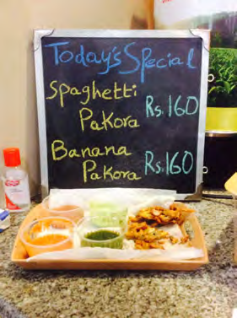 | 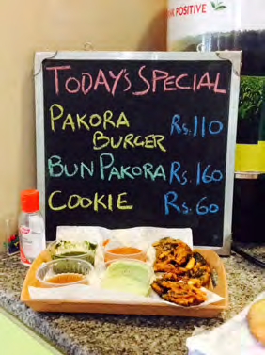 | 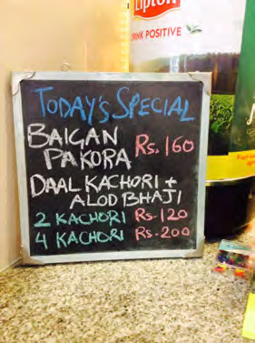 | 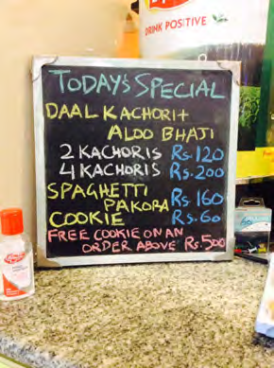

11. Product pictures
A selection from the Safa Gold outlet. New photography of the relaunch menu will be shared once the kitchen is set up.
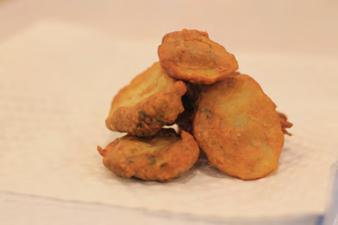  Aloo pakora | 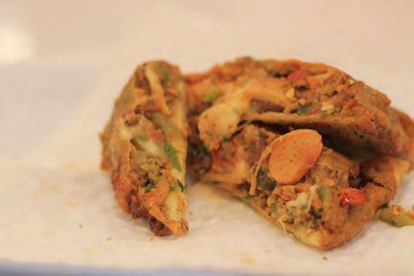  Palak paneer pakora | 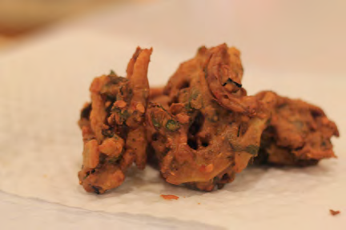  Mixed veg pakora
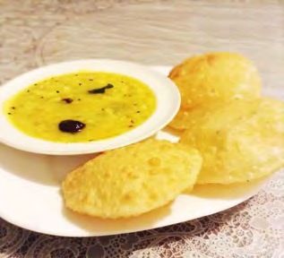  Kachori with chutney | 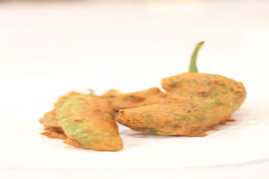  Hari mirch pakora | 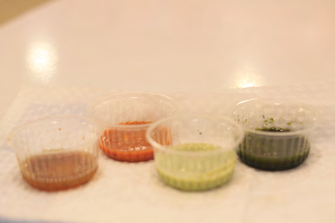  Chutney selection
[Add new product photos here once available]

12. Outlet and packaging
Our Safa Gold outlet in 2016, with the customer feedback board at the front, and our branded takeaway packaging. The Centaurus outlet will use the new identity throughout: signage, counter, uniforms, bags and boxes.
Pakora is carry-and-eat food, so packaging matters more than it does for a sit-down meal. We are introducing a friendly, unique disposable plate and holder that keeps the pakoras and chutneys together in one hand, looks good on social media, and is easy to carry around the mall.
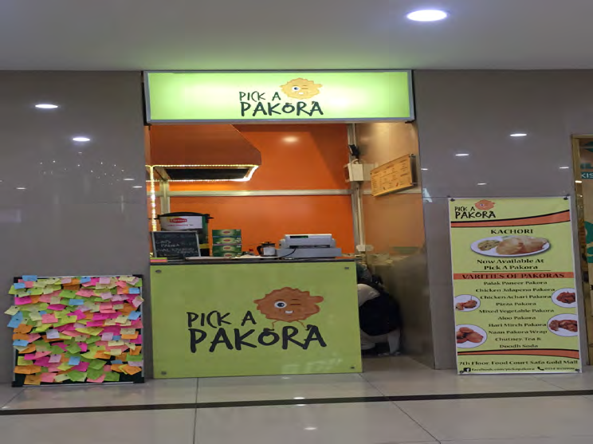  Safa Gold outlet, 2016 | 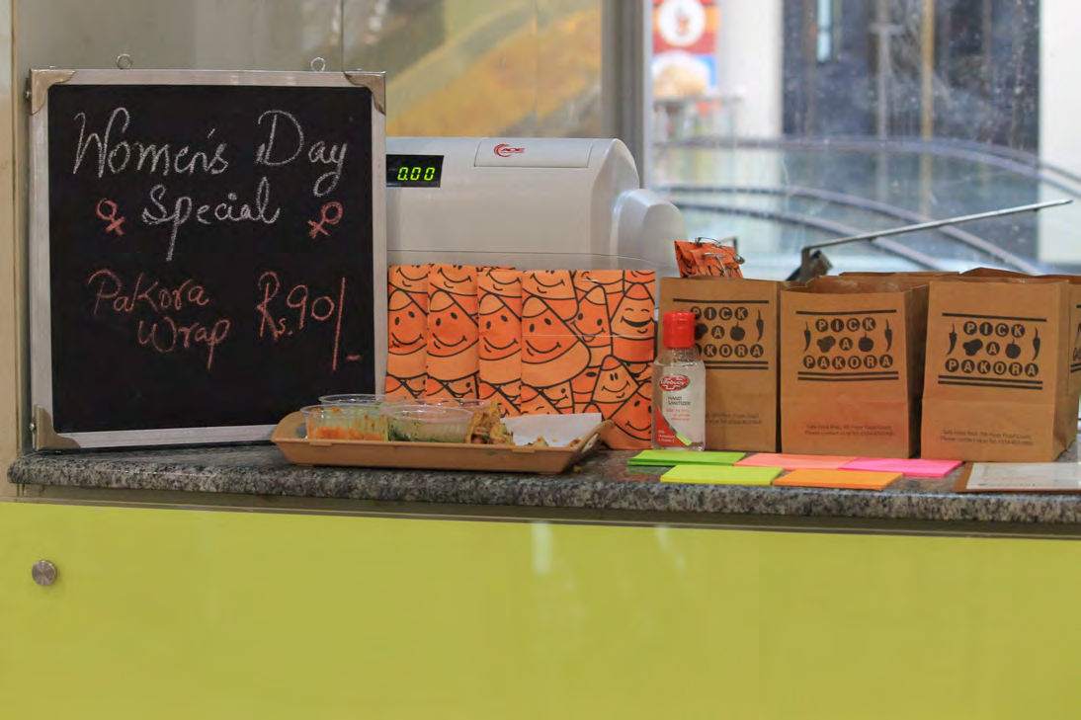  Branded packaging | 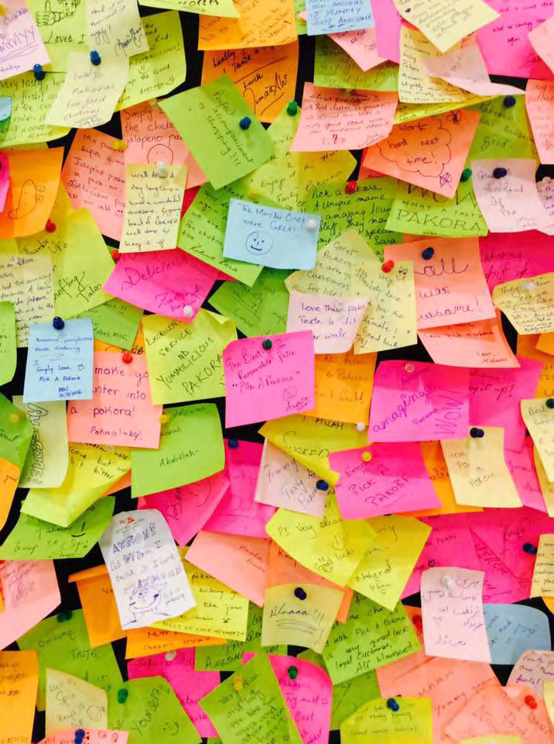  Customer feedback board
Space required: [e.g. 150 to 200 sq ft food court kiosk, or exact requirement]. Kiosk design concept for Centaurus: [attach or mark as to follow]

13. Launch plan

Pre-launch (4 weeks before opening)
- Teaser campaign on Instagram, TikTok and Facebook: "We're back", with the 2016 story and the new look.
- Flyer and standee placement across the mall.
- Listing set-up on food delivery platforms.
- Soft opening for mall management, influencers and press.

Launch week
- Standees and bunting in the mall, with in-mall announcements.
- Opening discount offers and a free Today's Special sampling counter.
- Media and influencer coverage, boosted social content.
- Loyalty card launch: every tenth order free.

14. Marketing plan (year one)

Events and promotions
- New Year, Valentine's Day, 23 March, Ramzan and Eid, Independence Day, and the mall anniversary.
- Participation in mall events and community events, as we did with Footy Mania in 2016.
- Winter and monsoon campaigns, when pakora demand peaks.

Menu
- Menu revised seasonally with weather-led items.
- Today's Special with a rotating item every day.

Media
- Daily Instagram, TikTok and Facebook content, with paid boosts around launches and offers.
- Food delivery platform promotions and featured placement.
- Flyer distribution and standee placement in and around the mall.
- Customer feedback board and online reviews.

15. Marketing and launch budget
Launch and marketing budgets will be finalised and shared once space availability is confirmed, so they can be allocated against the actual location, size and opening date. For reference, our 2016 launch was supported by a dedicated launch budget and a separate first-year marketing budget, and we will commit at least the same again for Centaurus.

16. Our request
We are requesting a food court space at The Centaurus Mall for the relaunch of Pick a Pakora. We understand no space is available at present and would like to be placed in the queue for the next suitable unit. We are ready to move quickly once a space is offered: the brand identity, menu and supplier arrangements are already in place.
One requirement on the space itself: as a frying outlet, we need a unit with a proper exhaust system so that oil heat and smoke are vented out of the food court. This keeps the outlet, the neighbouring units and the customers comfortable, and it is the one thing we cannot work around.

17. Contact details
Office address: 22E, First Floor, Service Road, F-11/1, Islamabad
Phone: [phone number]
Email: [email]
Web: www.pap.com.pk (under development)
Facebook: www.facebook.com/pickapakora
Instagram: [handle]

Thank you for your time. We look forward to bringing Pick a Pakora to The Centaurus Mall.

