***TITLE FOR THE TABLE***

DefaultTableModel model;

Table = new Jtable();

table.setBackgroung(new Color(176,189,222));

model=new DefaultTableModel();

Object[] column = {“ID”, “NAME”, “CONTACT”, “COURSE”} ;

final Object[] row = new Object[0];

model.setColumnIdentifiers(column);

table.setModel(model);

scrollPane.setViewportView(table);

Actionn performed for button add 🡪 model.addRow(row);

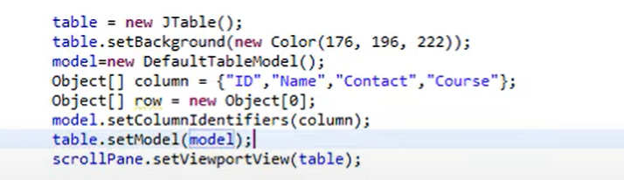

To prevent blank entries to the table

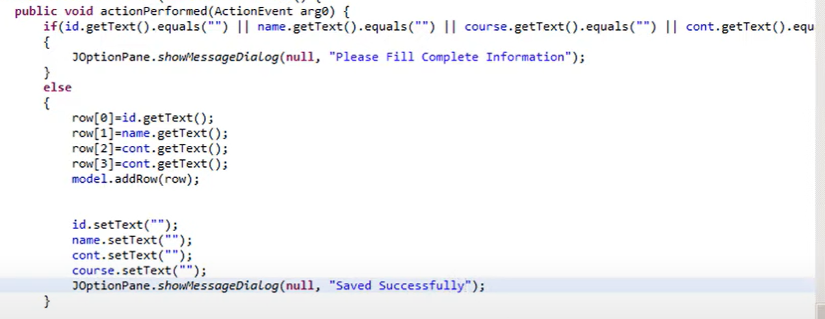

FORMS :

1. Student ::
   1. USN :: exactly 10 digits. Extract 2nd ,3rd character ,,give to branch
   2. Name
   3. Mobile :: exactly 10 numbers
   4. Email
   5. City
   6. DOB :: Jcalendar;condition date > 1 Jan 1999 and < 1 Jan 2005
2. Room ::
   1. ID (3 digit , 1st digit 🡪 Floor number)
   2. Room Type (1,2,3,4 sharing) 🡪 checkbox / TEXT