Part of Princeton University's engineering curriculum is a class centered on microprocessors and their applications. This class uses model train sets as the platform for students to create and test their own automated model train sets, utilizing the knowledge they have gathered from the class. Students are given several tools to create their models and aid in the automation. One of the most useful is a DCC railroad track switch thrower with a trickle-charged capacitor (DCC RR switch thrower). However, with the board's design being ~20 years old, and the limits becoming clear, it was decided that it was necessary to remake the board with updates to modernize it.

What was done first was analyze the schematic (Figure 1) of the old board. Before remaking it, I had to understand the schematic, and what each individual part does. This schematic used the power supplied by the track, as well as an optional 5V DC input, and charges a capacitor over the course of about 12 seconds. When the relay is triggered, it releases the charge of the capacitor, and throws the switch. 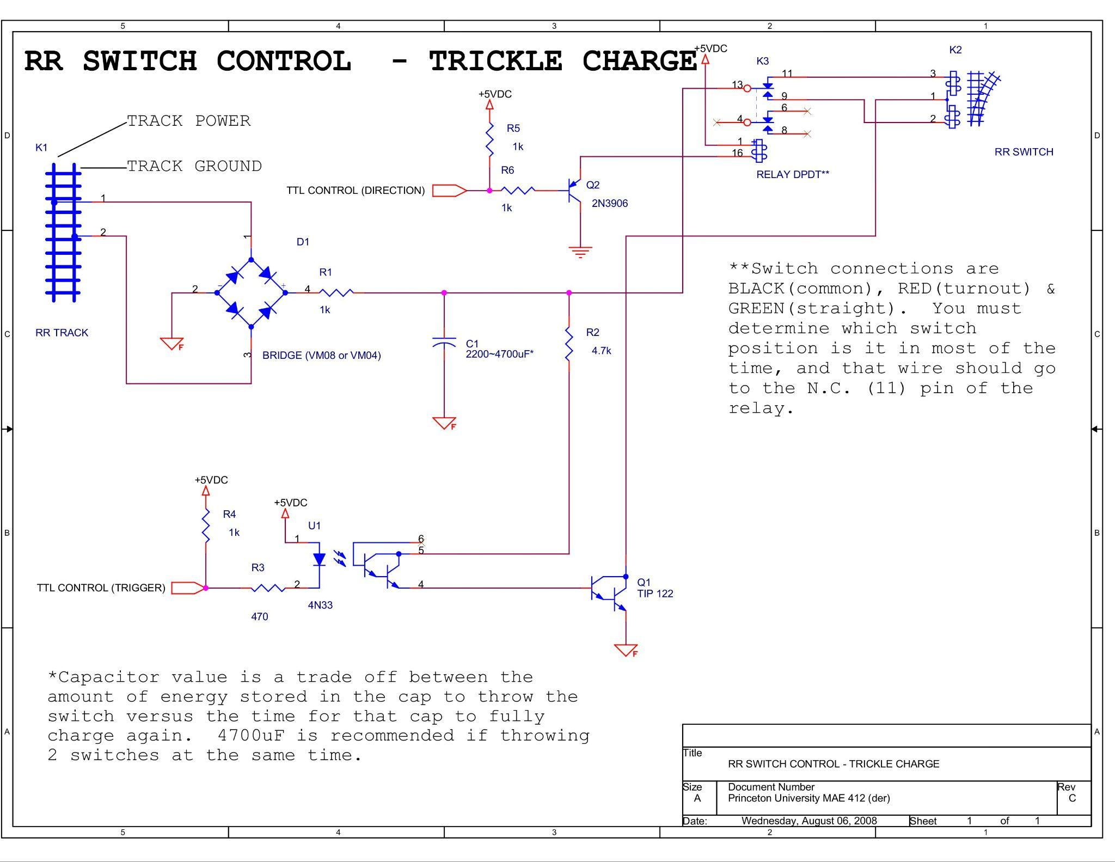
(Figure 1)

The new board was to serve the same purpose, but with two key new additions. The first, and most important, was putting an ATMEGA-328P chip on the board. By adding a microprocessor, it eliminated the need for external connections, and allowed the track to be more easily controlled and automated. The second addition was a second capacitor, so that more charge is stored, and two actions can be done in swift succession. The original DCC RR switch thrower was a double sided board. This board was to be single sided, which made the board more complex to design. It took about two weeks to finish the design of the new DCC RR switch thrower (New schematic Figure 2). It took about a week to gather all the parts, and solder the board together. After being reviewed by my superior, it was given two notes, which were immediately corrected, and is now being put to use. 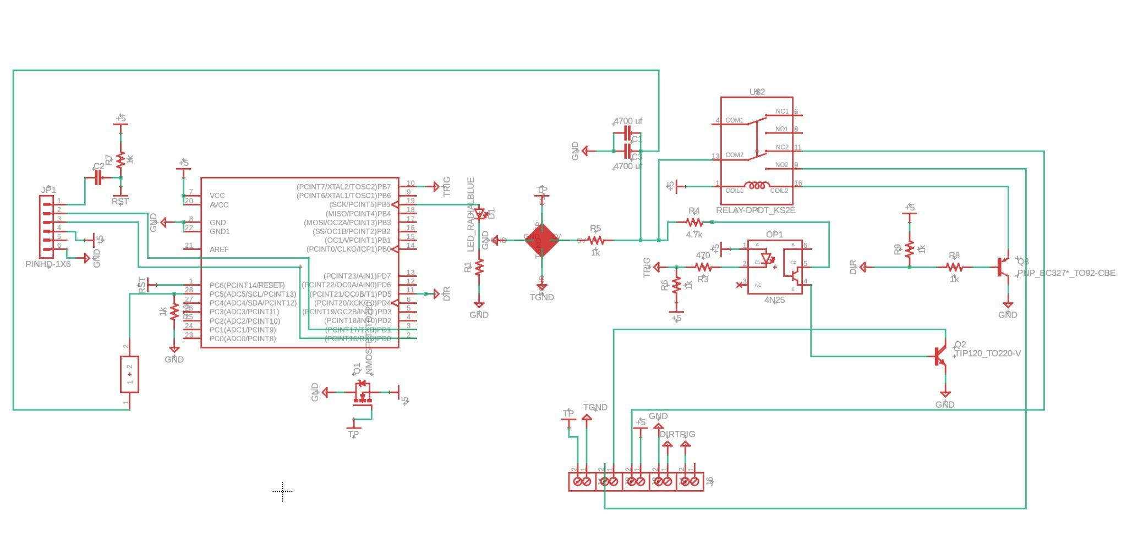
(New DCC Track Switch Thrower Figure 2)

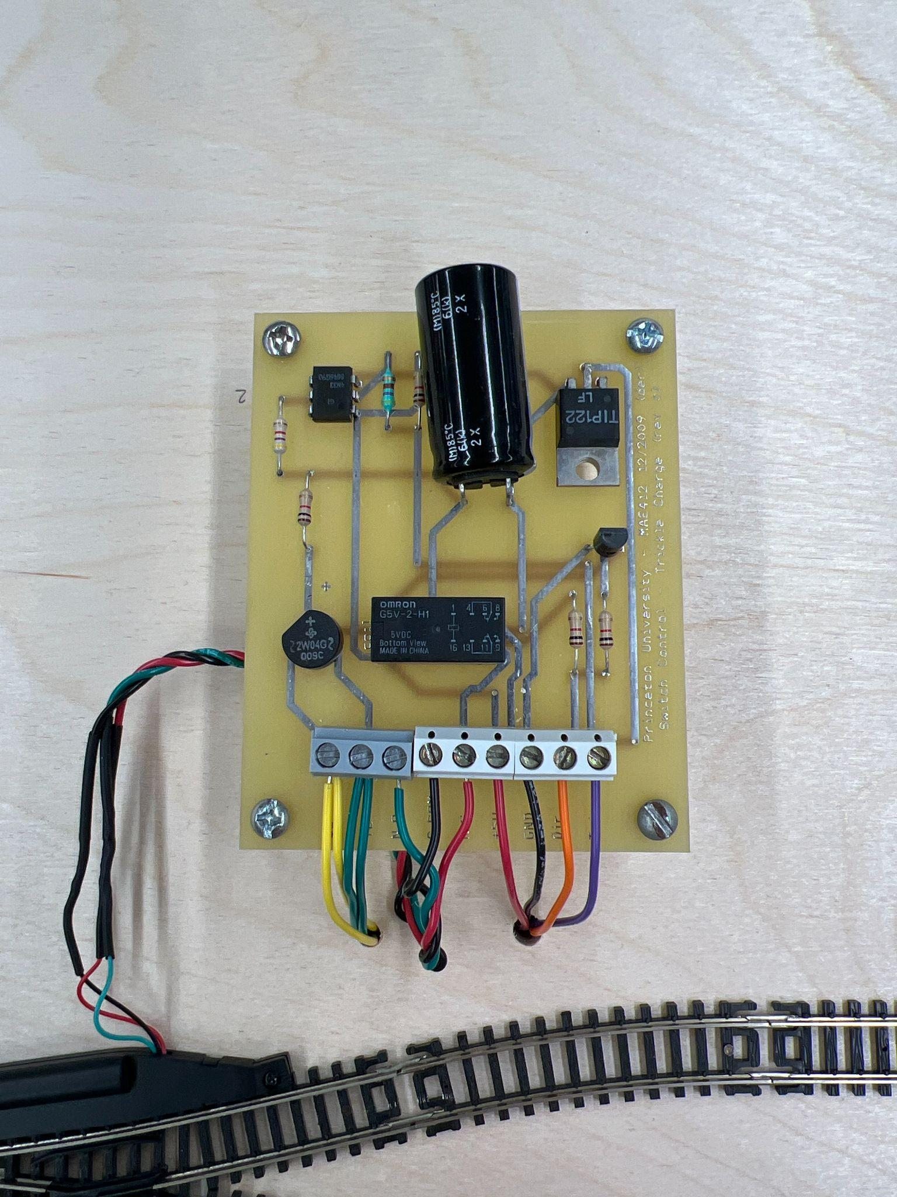
(Old DCC RR Track Switch Thrower Figure 3)

