**Barcodes**

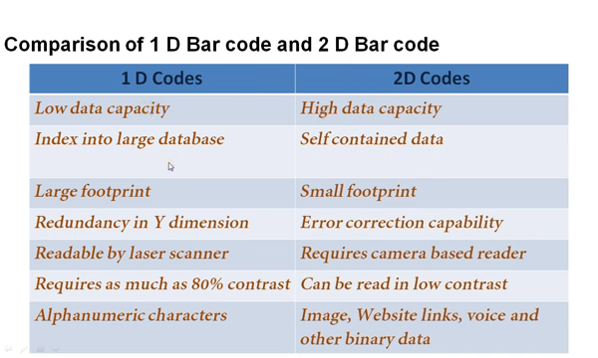

**Types of BarCodes**

There are many types of barcodes and each brings unique opportunities and limitations.

**Barcodes are available in two different types: Linear barcodes and two-dimensional matrix barcodes.**

One-Dimensional (1D) Barcode Types Two-Dimensional (2D) Barcode Types Codes

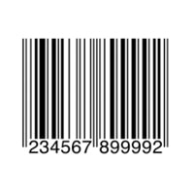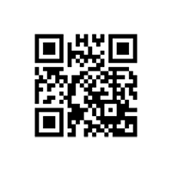

## One-Dimensional (1D) Barcode Types

Linear barcodes. These consist of lines and spaces of various widths that generate specific patterns. ..

### 1 :UPC CODE

UPC actually stands for universal product code :::::::::::: The purpose of this barcode is to make it easy for users to identify specific product features (like its size or color)

**Industry:** Retail

**Variations:** UPC-A, UPC-E



### 2: EAN CODE

They look very similar to UPC codes, and the main distinction is their geographical application.

EAN-13 (comprising 13 digits) is the default form factor,

EAN-8 (covering eight digits) barcodes on products where space is limited, like small candies.

The main advantage of EAN codes is their flexibility.

. EAN codes are also easy for 1D scanners to read, making the scanning process fast and seamless.

**Industry:** Retail

**Variations:** EAN-13, EAN-8, JAN-13, ISBN, ISSN

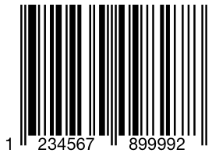

### 3: CODE 39

[Code39 barcodes](https://www.scandit.com/products/barcode-scanner/symbologies/code-39/) (or Code 3 of 9) are used to label goods across many industries and are often found in the automotive industry

One limitation of Code39 is its relatively low data density.

**Industry:**Automotive and Defense

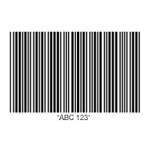

### 4:CODE 128

[Code 128](https://www.scandit.com/products/barcode-scanner/symbologies/code-128/) barcodes are compact, high-density codes used in logistics and transportation industries for ordering and distribution. They’re geared toward non-POS products, like when supply chain applications label units with serial shipping container codes (SSCC). Because they support any character of the ASCII 128 character set, Code 128 barcodes can store highly diversified information.

The greatest advantage of Code 128 is its high data density.

These strengths make Code 128 barcodes a natural choice for shipping and supply chain operations.

**Industry:** Supply Chain

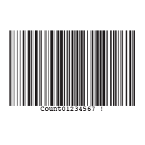

### 5:ITF (Interleaved 2 OF 5)

[ITF](https://www.scandit.com/products/barcode-scanner/symbologies/itf-2-of-5/) (or Interleaved 2 of 5) barcodes are used to label packaging materials across the globe.

ITF barcodes encode 14 numeric digits and use the full ASCII set.

One of the greatest strengths of Interleaved 2 of 5 is that its printed tolerances are suited for corrugated cardboard. As a result, this self-checking code is a powerful tool for encoding information on product packaging. While the Interleaved 2 of 5 barcode can only encode numbers (not letters), it does not require a check digit.

**Industry:** Packaging

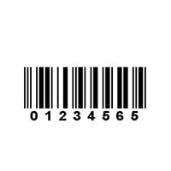

### 6:CODE 93

[Code 93](https://www.scandit.com/products/barcode-scanner/symbologies/code-93/) barcodes are used in logistics to identify packages in retail inventory, label electronic components, and even provide supplementary delivery information for the Canadian Post

 Its small size and data redundancy make it ideal for use across a wide range of industries, from automotive to retail and logistics.

**Industry:** Retail, Manufacturing and Logistics

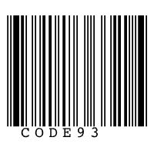

### 7:CODABAR

[Codabar](https://www.scandit.com/products/barcode-scanner/symbologies/codabar/) barcodes are used by logistics and healthcare professionals,

Advantages of Codabar barcodes include ease of scanning and self-checking, which reduces errors when entering the code. However, Codabar codes are being phased out in favor of newer code forms, which allow more data to be stored in a much smaller form. Regardless, Codabar is still commonly used across logistics, healthcare and even schools, where the code is applied to the spines of library books.

**Variations:** Codabar, Ames Code, NW-7, Monarch, Code 2 of 7, Rationalized Codabar, ANSI/AIM BC3-1995, USD-4

**Industry:** Logistics, Healthcare and Education

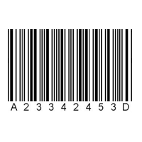

### 8:GS1 DATABAR

[GS1 DataBar](https://www.scandit.com/products/barcode-scanner/symbologies/gs1-databar/) barcodes (formerly known as Reduced Space Symbology)

GS1 DataBar codes offer many potential benefits. For example, leading retailers use these compact tools to reduce point-of-sale transaction times. GS1 codes also support faster and more enjoyable checkout experiences for customers at self-checkout stations. These codes also support faster and more efficient scanning workflows in patient care environments.

**Variations:** GS1 DataBar Omnidirectional, Truncated, Stacked, Stacked Omnidirectional, Expanded, Expanded Stacked

**Industry:** Retail and Healthcare

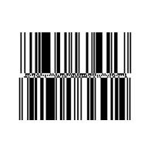

**2: Two-Dimensional Matrix Barcodes.**

, Matrix barcodes are a two-dimensional way of representing data.

Two-dimensional, (or 2D) barcodes systematically represent data using two-dimensional symbols and shapes. They are similar to a linear 1D barcode, but can represent more data per unit area.

### 1:QR CODE

[QR codes](https://www.scandit.com/products/barcode-scanner/symbologies/qr-code/) are most often used in tracking and marketing initiatives, such as advertisements, magazines and business cards. They are flexible in size,

**Industry:** Retail, Entertainment and Advertising



### 2:DATAMATRIX CODE

[Datamatrix](https://www.scandit.com/products/barcode-scanner/symbologies/datamatrix-code/) codes are usually used to label small items, goods and documents. Their tiny footprint makes them ideal for small products in logistics and operations.Datamatrix codes offer high data density, which means they take up less space on products and assets. Datamatrix codes offer strong fault tolerance as well.

**Variation:**Micro-Datamatrix

**Industry**: Electronics, Retail and Government

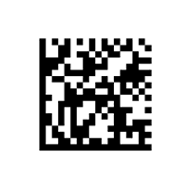

### 3:PDF417

[PDF417](https://www.scandit.com/products/barcode-scanner/symbologies/pdf417/) codes are used for applications that require the storage of huge amounts of data, such as photographs, fingerprints and signatures. They can hold over 1.1 kilobytes

PDF417 codes are suited to a wide variety of applications, including transport and inventory management. These barcodes are also well suited for creating paper boarding passes, as well as state-issued identification cards.

**Variation:**Truncated PDF417  
**Industry:** Logistics and Government

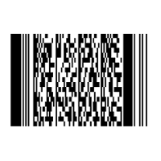

### 4:AZTEC

[Aztec](https://www.scandit.com/products/barcode-scanner/symbologies/aztec/) codes are commonly used by the transportation industry, particularly for tickets and airline boarding passes.

Aztec barcodes are extremely space-efficient. They can hold massive amounts of data while maintaining a relatively small size—and features excellent error correction to prevent scanning errors.

**Industry:** Transportation

