COMP 521  
Winter 2017  
Assignment 1  
Zain Virani - 260567997

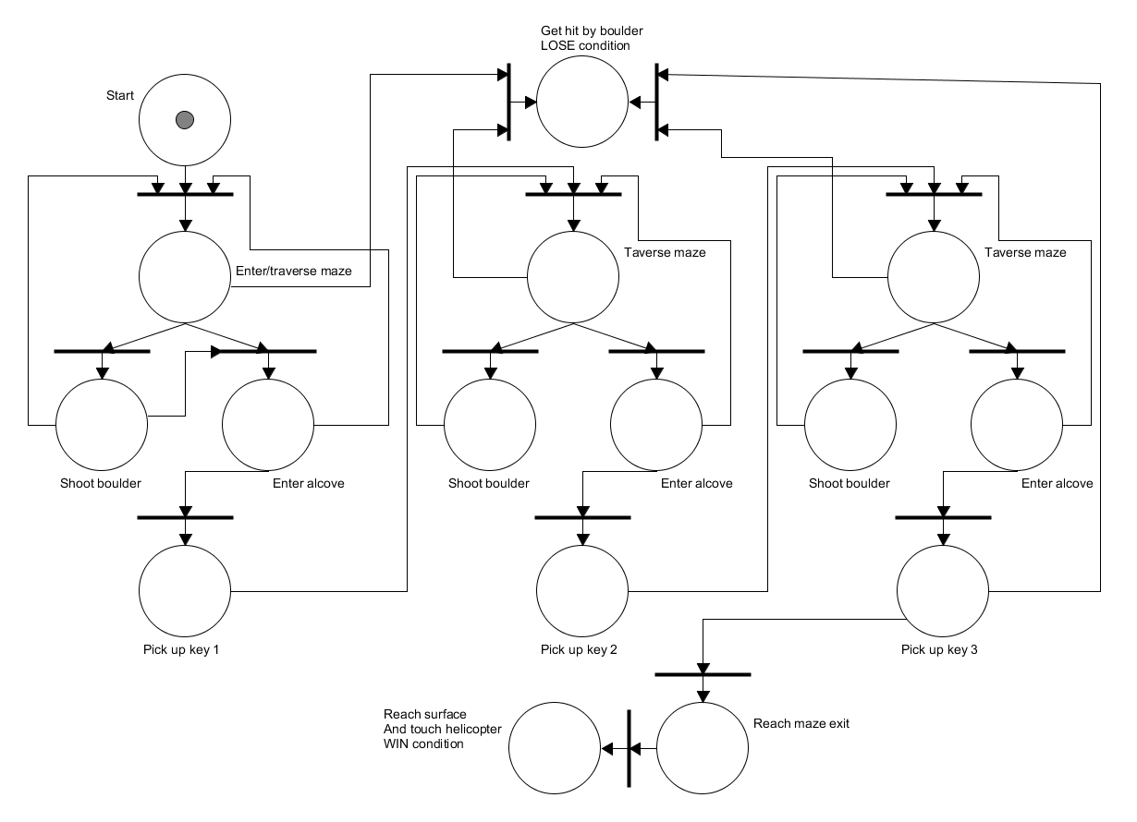

It is impossible for a player to win and lose at the same time, and at no point can a player be in limbo (neither win nor lose). To show this, consider that, at any point, the player either has all 3 keys or doesn’t.

Case 1: player does not have all 3 keys.  
In this case the player cannot win without getting the remaining keys, they can only lose, but, they are also still able to find each key, taking us to case 2.  
  
Case 2: player has all 3 keys.  
In this case the player has found the 3rd key. From the diagram, we can see that they either get hit by the boulder and face the LOSE condition, or reach the maze exit and face the WIN condition. As there is only one token (this is a 1-safe diagram), the player can only follow one option.