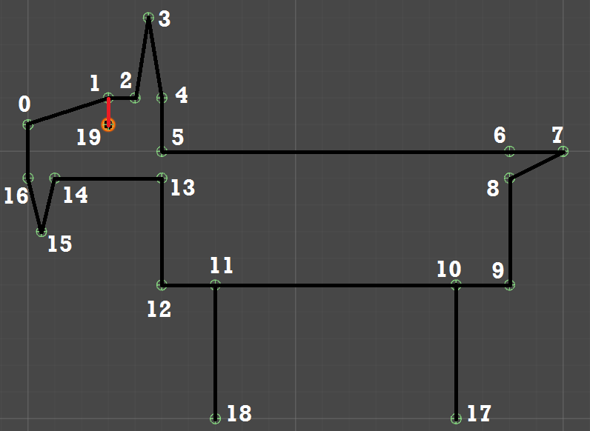

The goat consists of 20 verlets. Verlets 0-5, 13-6, and 19 make up the head, while verlets 6-12, 17, and 18 make up the body.

The black lines (as well as the black eye) in the diagram above are what shows up in the final product.

Each verlet has a corresponding element in the arrays lengthConstraints[] and angleConstraints[].   
The length constraint of verlet x is the length from verlet x to x + 1.  
The angle constraint of verlet x is the angle between the lines (x, x - 1) and (x, x + 1).  
  
Special cases:  
- For verlet 19 (the eye), the length is the length from verlet 19 to verlet 1 (represented by the red line in the diagram), and its angle is the 90 degree angle between (1, 2) and (1, 19).  
- For verlets 18 and 17, the length is the length from verlet x to x - 7, and the angle is the 90 degree angle between (x - 7, x) and (x - 7, x - 8).

These constraints, when combined, define the goat’s shape. Each verlet can look at the length constraint of the verlet before it to find its distance, as well as the angle constraint of the verlet behind it to figure out if any rotation (around the z-axis through the previous verlet) is needed.  
If we only had angles, points would only rotate around the z-axis through a moving point, and if we only had lengths, points would only follow moving vertices in a straight line opposite to its direction of motion.