**The python code:**

#This code is written by Zaina Sharawy  
  
  
#QUESTION 1  
import math  
radius = float(input("enter the radius: "))  
print("the area of circle is: " + str( radius**2 * math.pi) )  
print(" the perimeter of the circle: " + str( 2* math.pi * radius))  
  
  
  
#QUESTION 2  
number = int(input("enter a number between 1 to 100: "))  
while number < 1 or 100 < number:  
 print( number, " is not between the range:")  
 number = int(input("enter a number between 1-100: "))  
while number > 1 and number < 100 :  
 for i in range(1,11):  
 print(number, "x ", i, " = " , number*i)  
 break  
  
  
  
#QUESTION 3  
sen = str(input("enter a sentence: "))  
sen = sen.replace("," , " ")  
print(sen)

Outputs for Q1 (calculating area & perimeter of circle):

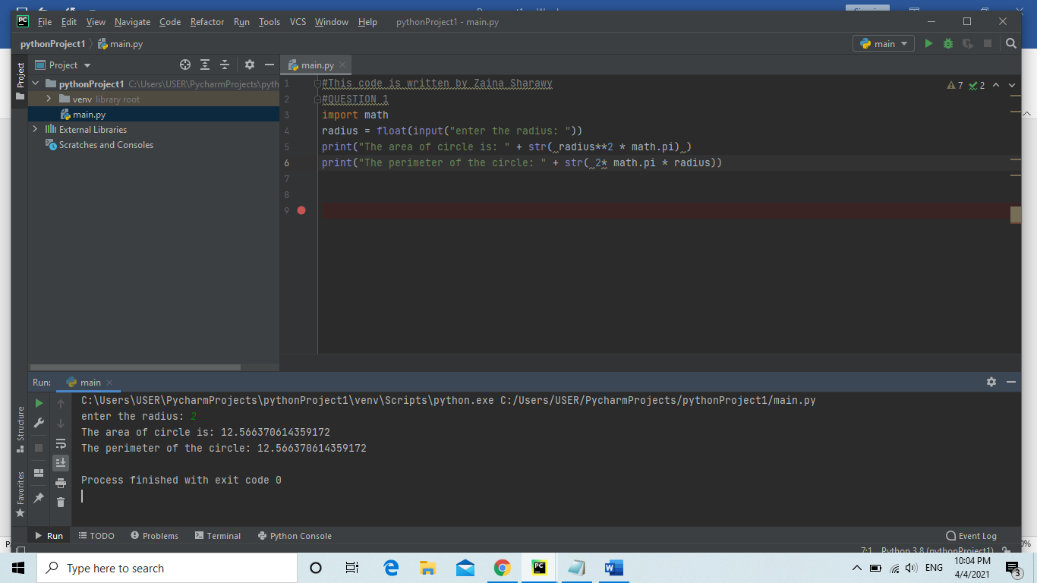

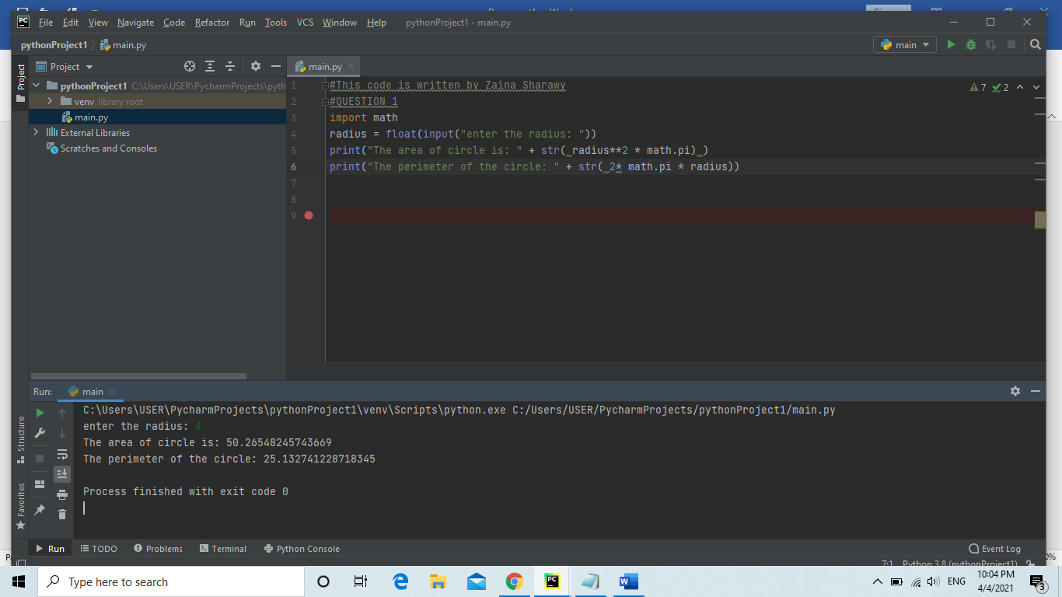

Outputs for Q2(printing multiplication table for any number between 1-100:

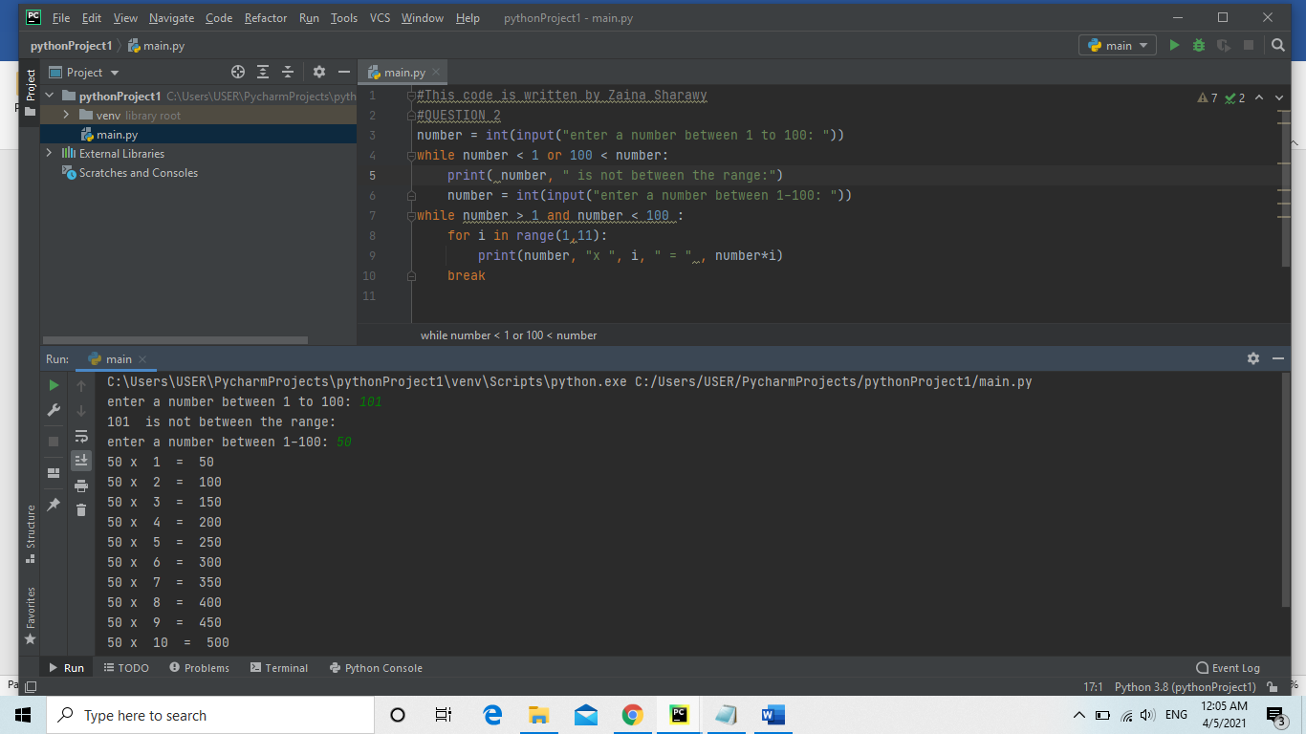

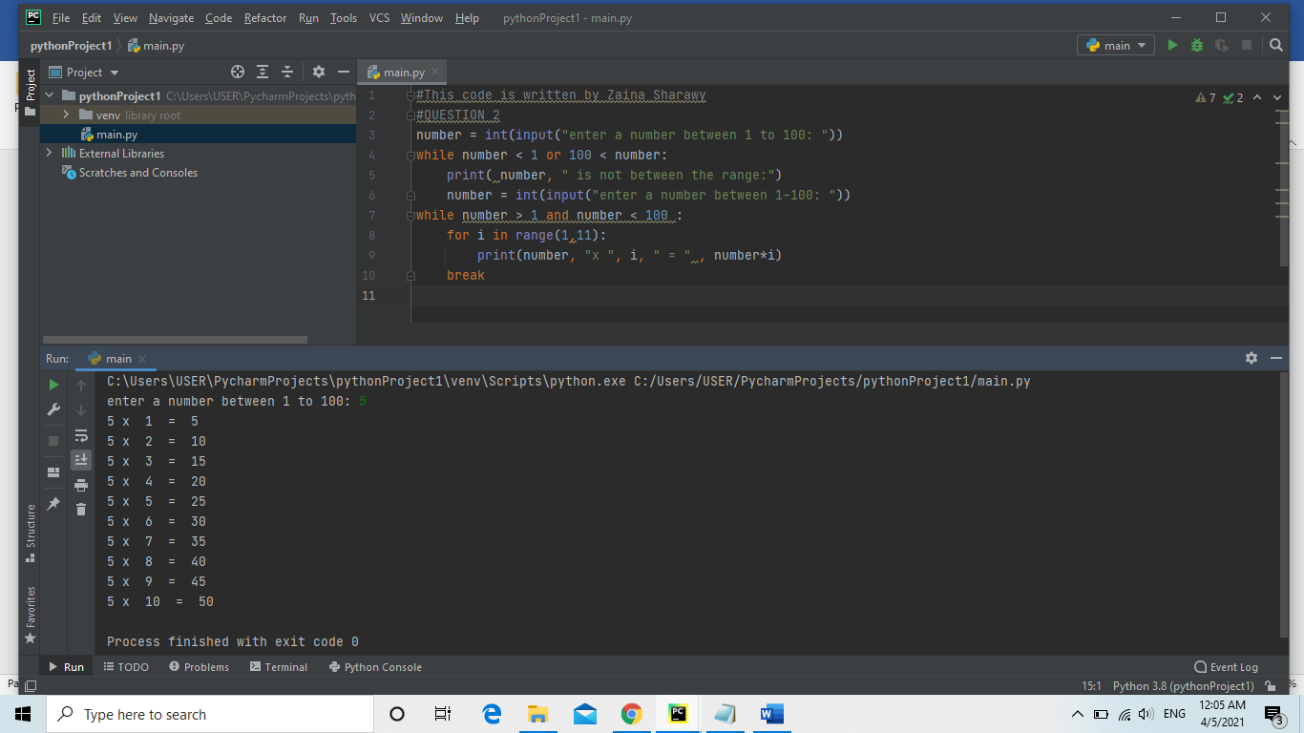

Outputs for Q3(removal of commas within a sentence):

