Assignment 3

Code:

#This code is written by Zaina Sharawy  
  
from PIL import Image  
ent = input("Enter if you're Type-A or Type-B: ")  
image =input("Enter the name of image: ")  
im= Image.open(image)  
pix = im.load()  
im.show()  
redPixel = (255,0,0)  
greenPixel = (0,255,0)  
bluePixel = (0,0,255)  
yellowPixel = (255,255,0)  
if ent == "Type-A":  
  
 for y in range(im.height):  
 for x in range(im.width):  
 (r,g,b) = pix[x,y]  
 if r>= 160 and g<= 55: #red becomes green  
 pix[x,y] = greenPixel  
 elif r<= 70 and g>= 160: #green becomes red  
 pix[x,y] = redPixel  
 else:  
 pix[x, y] = (r, g, b)  
  
elif ent == "Type-B":  
  
 for y in range(im.height):  
 for x in range(im.width):  
 (r, g, b) = pix[x, y]  
 if g <= 90 and b>=180: #blue becomes green  
 pix[x, y] = greenPixel  
  
 elif r <=70 and g>= 150: #green becomes blue  
 pix[x, y] = bluePixel  
   
 elif r>= 160 and g<= 55: #red becomes yellow  
 pix[x,y] = yellowPixel  
   
 elif r >=210 and g>= 210 and b<=45: #yellow becomes red  
 pix[x, y] = redPixel  
   
 else:  
 pix[x, y] = (r, g, b)  
  
newImage = im.save("newImage.jpg")  
im.show()

Output for Type-A (Red-Green color):

Inputs:

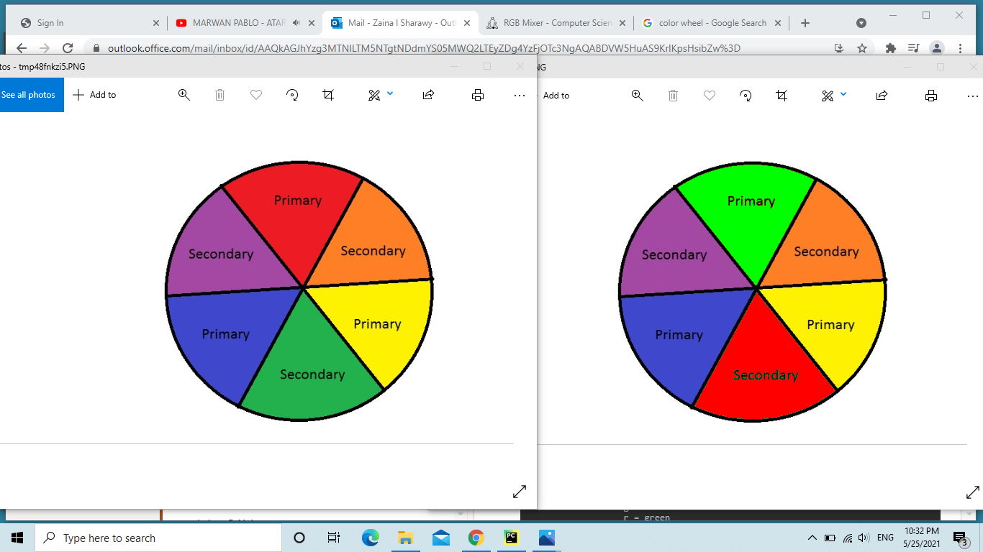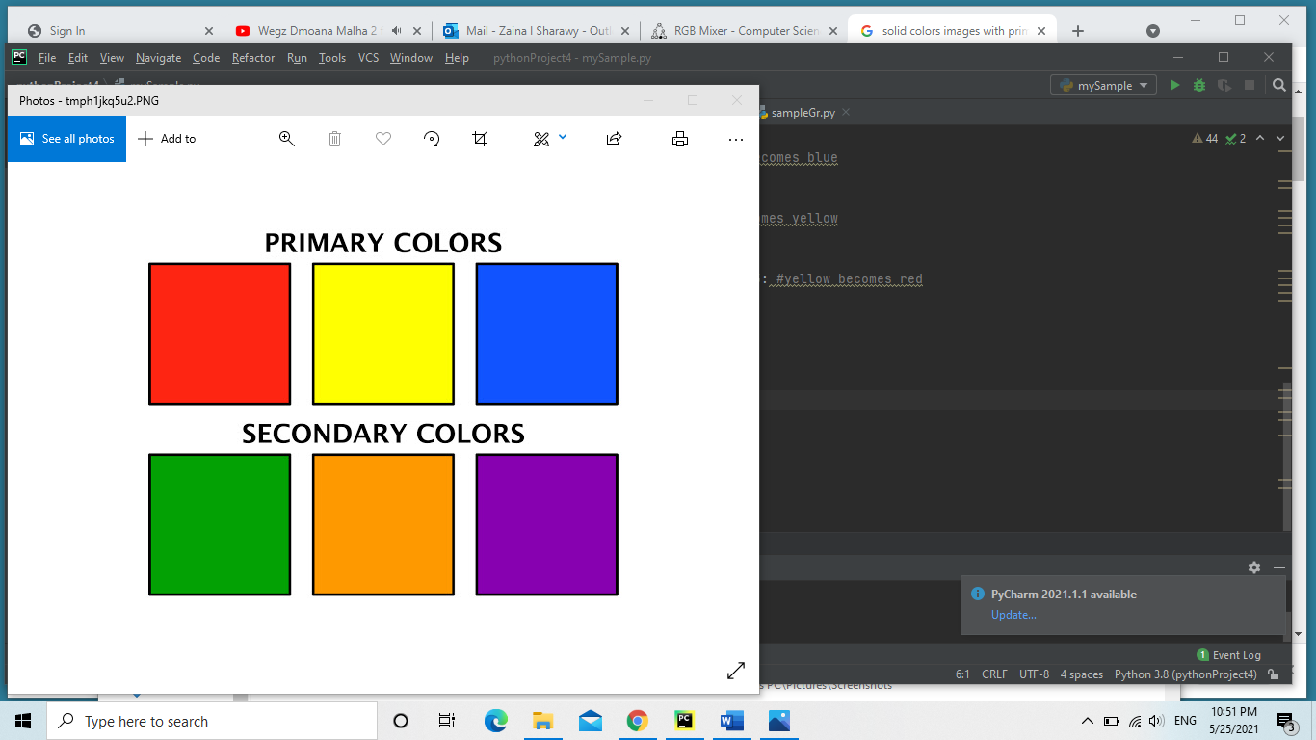

Outputs:

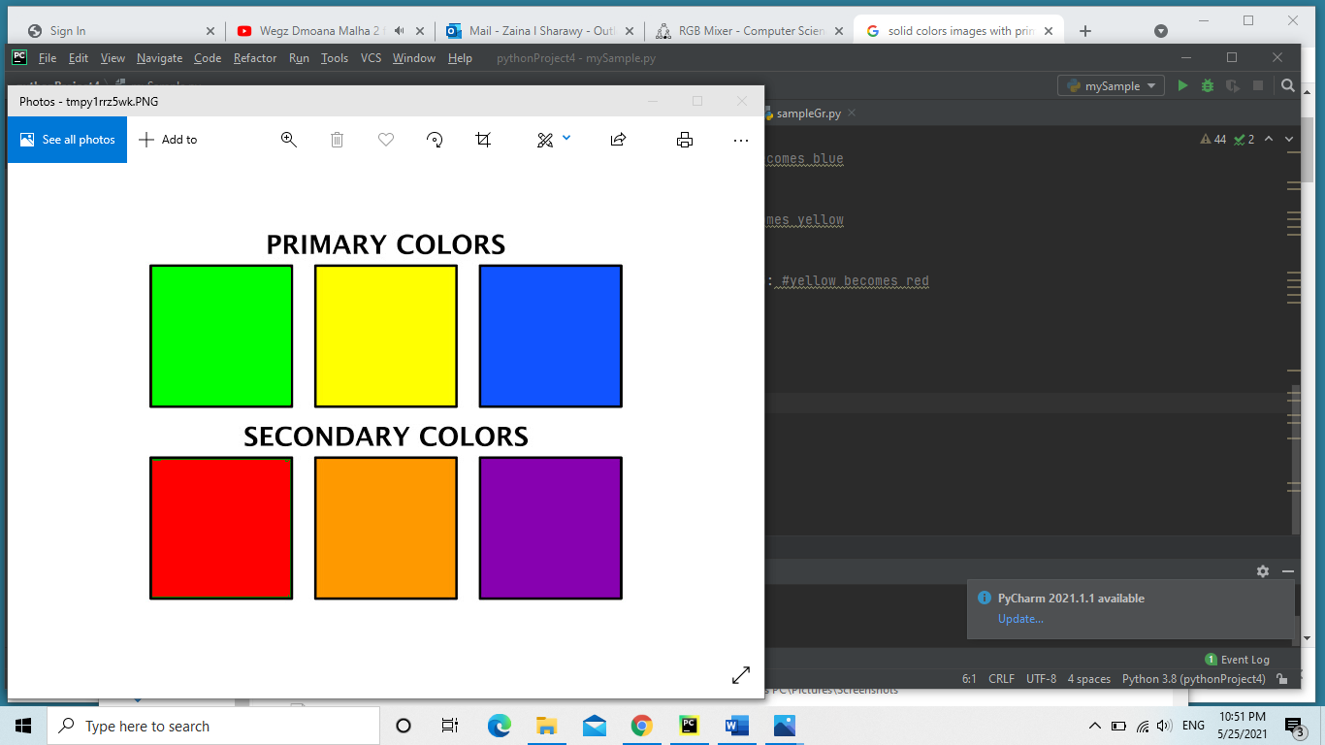

Output for Type-B ( Blue-Yellow color):

Inputs:



Outputs:

