Assignment 2:

Question 1 code:

#This code is written by Zaina Sharawy

alphaToNum = {'0':'-',  
 '10': 1,  
 'ABC': 2,  
 'DEF': 3,  
 'GHI': 4,  
 'JKL': 5,  
 'MNO': 6,  
 'PQRS': 7,  
 'TUV': 8,  
 'WXYZ': 9}  
  
s = input("enter a sentence to convert:")  
  
def digitOfLetter(n):  
 for i in alphaToNum:  
 if n in i:  
 return alphaToNum[i]  
  
def correspondingNum(s):  
 number = " "  
 for i in s:  
 if i>= "1":  
 number = number +str(digitOfLetter(i))  
 else:  
 number= number + i  
 return number  
print(correspondingNum(s))

Question 2 code:

#This code is written by Zaina Sharawy

sentence= input("enter a sentence: ")

def brokenKeyboard(sentence):

emptyList=[]  
 index =0  
 for i in sentence:  
 if i == '[':  
 index=0  
 elif i== ']':  
 index = len(emptyList)  
 else:  
 emptyList.insert(index,i)  
 index+=1  
 return ("".join(emptyList))  
print(brokenKeyboard(sentence))

Outputs for question 1:

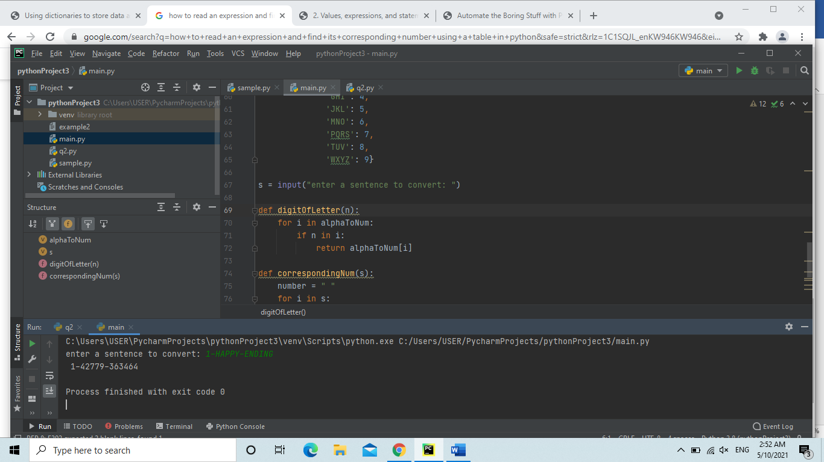

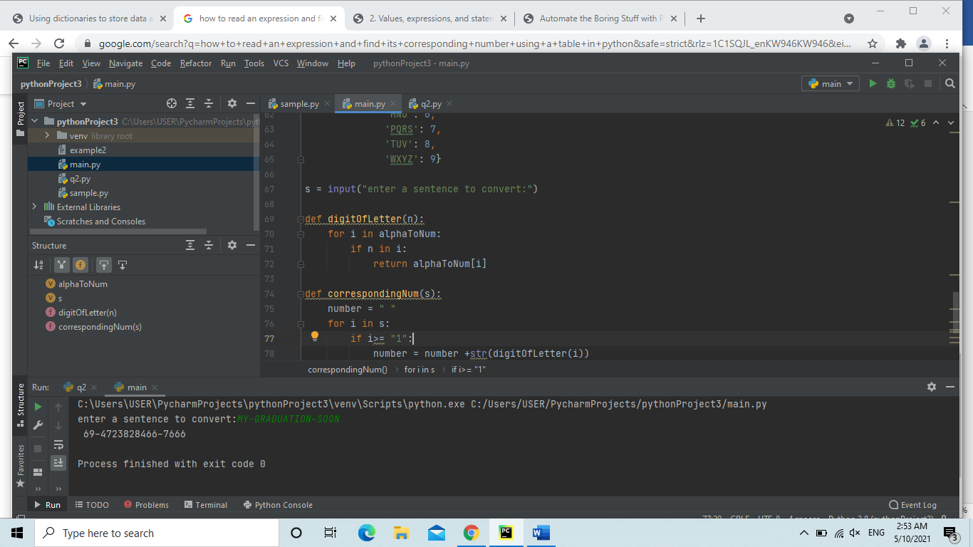

Outputs for question 2:

