|  |
| --- |
| Assignment # 03 |
| Formal Methods |
| Zainab Obaid | 111802 | BESE-5B |

**My Model**

I have constructed a model for two students who are taking three courses in a semester. The helping material is available to them in the form of slides and a book. Depending on the subject, they use either of them. There is a single copy of both the slides and the book.

Technical and Business Writing (TBW) is an easy subject which will not require any helping material to pass. Formal Methods (FM) will either require slides or book. Software Construction (SC) is to be prepared with the book.

**Screenshots:**

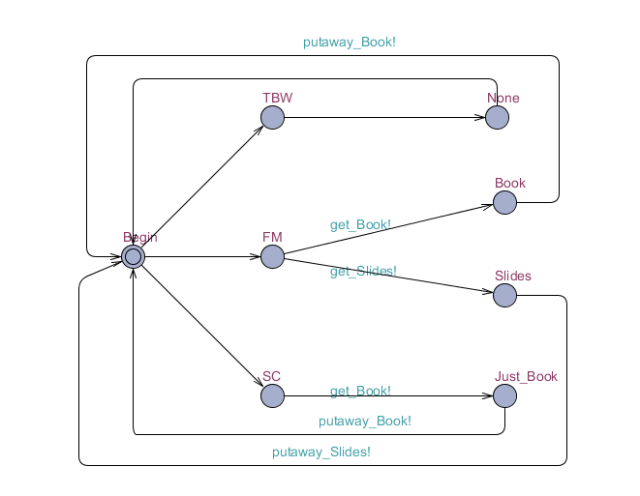

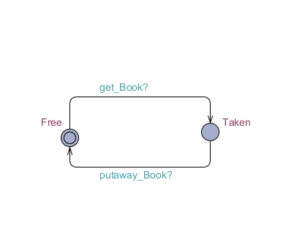

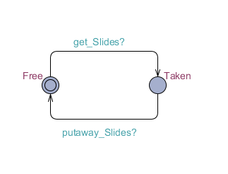

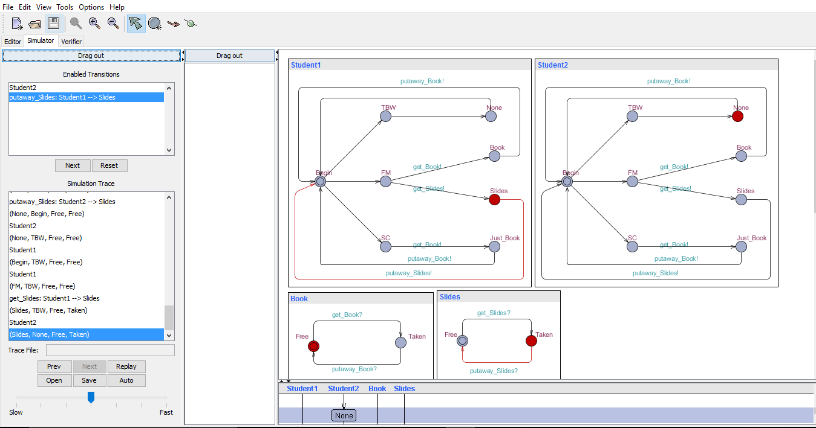

**Mutual Exclusion Principle**

**Screenshots:**

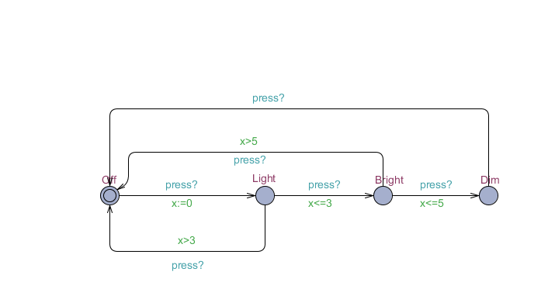

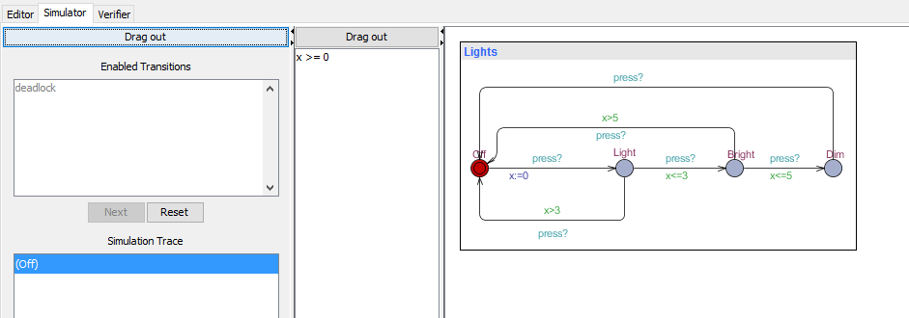

**Github Link:** <https://github.com/Zainab-95/Formal-Methods-Assignment-3>