

FRONT MATTER

Document control
Table 1 Document information
Field | Value
Document | SonicSentinel AI – Developer Guide
Version | 2.0 (this edition)
Status | Released for evaluation
Classification | Team and evaluators – competition prototype
System version | Python model py-xgb-20260924-0800 · GTM export gtm-TMv2-2026-09-24T20:51:32 · 70 automated tests
Source of truth | project repository SonicSentinel AI/ and the generated reports/
Owner | Testing & documentation lead (see Module ownership)
Reviewed by | ______________________ Date: ____________
Approved by | ______________________ Date: ____________

Table 2 Revision history
Version | Date | Author | Changes
1.0 | 24 Sep 2026 | SonicSentinel AI team | first developer guide: architecture, code, models, API, tests, deployment
2.0 | 24 Sep 2026 | SonicSentinel AI team | new cover and chapter design; at-a-glance page; module ownership; quick start; sequence, decision-flow and state diagrams; real-data charts; annotated event page; colour-coded callouts; highlighted code; clickable cross-references; lists of figures and tables; glossary and index

TEAM

Module ownership
Each module has one owner who can explain it in the viva (SRS 1.8) and reviews changes to it. Replace the placeholders with the team members' names and GitHub usernames – the same assignment is recorded in documentation/TEAM_CONTRIBUTIONS.md.
Table 3 Module owners
Owner | Role | Modules | Functions to be able to explain
Member 1  _name / GitHub_ | Team lead · integration | src/services/analysis.py, decision.py, rules.py, run.py, src/__init__.py | analyze_upload, finalize, decide, evaluate_rule, combine, look-alike check
Member 2  _name / GitHub_ | Dataset & training | scripts/, augmentation/, python_models/ | build_dataset.py, random_augment, train_models.main, aggregate_scores
Member 3  _name / GitHub_ | GTM & front end | gtm_model/, static/js/gtm.js, live.js, templates/ | GTM spectrogram, classify, live window loop, prepare_gtm_samples --zip
Member 4  _name / GitHub_ | Audio pipeline | audio_preprocessing/, feature_extraction/ | validate_file, analyze_quality, preprocess_signal, segment, extract_features, similarity
Member 5  _name / GitHub_ | Testing & documentation | tests/, documentation/, README, report, blog, video | conftest.py isolation, benchmark and hidden-test scripts, this guide

 | NOTE Fill in before submission  Names in this table, in AI_USAGE.md ("Student modifications", "Verified by") and in TEAM_CONTRIBUTIONS.md must match the GitHub accounts that made the commits.

SUMMARY

At a glance
Key numbers of the current release, all taken from reports/ and the test suite.
86.8 %  Combined accuracy  Python 0.7 + GTM 0.3 · 695 unseen clips | 86.5 %  Python accuracy  macro-F1 0.863 · XGBoost | 60.6 %  GTM accuracy  Teachable Machine run 3 | 1.00  Help-request recall  critical recall ≥ 0.83 for all 5
1.47 s  30-s clip analysed  target ≤ 8 s · max 1.74 s | 0.11 s  Live window  target ≤ 3 s | 20,020  Events benchmarked  5 concurrent users · 0 errors | 0  Crashes  2,926 hidden-test runs
10  Sound classes  + Unknown outcome | 299  Acoustic features  per 2-s segment | 70  Automated tests  5 files · all passing | 11  Database tables  SQLite via SQLAlchemy

Table 4 The system in five sentences
Area | In one sentence
Input | uploads (WAV, MP3, FLAC, OGG, M4A), batch uploads and 2-second live microphone windows
Models | server-side XGBoost on 299 features and a browser-side Teachable Machine network, trained on the same TRAIN split and never sharing results
Decision | weighted combination, Unknown / overlap / look-alike checks, per-class alert rules with repeat confirmation, human review for doubtful cases
Explainability | full decision trace plus TreeSHAP feature-group contributions and the time span that triggered the class
Operations | role-based UI, audit trail, anomaly notifications, retention, /healthz, Docker and Render deployment

GET STARTED

Quick start – running in five minutes
- Install Python 3.10 – 3.12, FFmpeg and Chrome / Edge.
- Create the environment and install the libraries.
- Initialise the database and default accounts.
- Start the server and log in as admin / Admin@12345.
- Check /healthz and run the tests.
● ● ● Quick start – PowerShell POWERSHELL / SHELL
1 cd "SonicSentinel AI"
2 python -m venv .venv
3 .venv\Scripts\activate
4 pip install -r requirements.txt
5 python -m database.init_db
6 python run.py # open http://127.0.0.1:5000
7 # second terminal:
8 python -m pytest -q # expect: 70 passed

Table 5 Smoke test after installation
Check | Expected result
http://127.0.0.1:5000/healthz | {"status": "ok", "checks": {"database": "ok", "python_model": "py-xgb-…", "gtm_model": "gtm-TMv2-…"}}
Dashboard pills | Python version and "GTM · 10 classes" shown in green
Upload a clip from audio_dataset/processed/test/Gunshot/ | event page shows both models, a decision trace and a Critical alert
Live → Start monitoring | microphone status "Active" and the red privacy banner

 | TIP Recommended settings for the demo  Admin → Settings: python_weight 0.7, unknown_threshold 0.35, min_confidence 0.60 – the combination that gave 86.8 % on the unseen test split.

Contents
Document control i
Module ownership ii
At a glance iii
Quick start – running in five minutes iv
List of figures vii
List of tables viii
1. Introduction 1
1.1 Purpose of this guide 1
1.2 System summary 1
1.3 Technology stack 1
1.4 Conventions in this guide 2
2. Architecture 3
2.1 Component overview 3
2.2 Processing pipeline 4
2.3 Upload sequence 4
2.4 Live sequence 5
3. Repository structure 6
4. Development environment 7
4.1 Prerequisites 7
4.2 First-time setup 7
4.3 Environment variables 7
4.4 Useful development commands 8
4.5 Resetting local data 8
5. Configuration 9
5.1 Static configuration (config/settings.py) 9
5.2 Runtime settings (database, Admin → Settings) 9
5.3 Alert-rule schema (alert_rules/alert_rules.json) 10
6. Audio processing library 11
6.1 Loading (loader.py) 11
6.2 Validation (validation.py) 11
6.3 Quality analysis (quality.py) 11
6.4 Pre-processing and segmentation (preprocess.py) 12
6.5 Augmentation (augmentation/augment.py) 12
7. Feature extraction 14
7.1 The 299-dimensional feature vector 14
7.2 Audio fingerprint (fingerprint.py) 14
7.3 Visuals (visuals.py) 15
8. Python model 16
8.1 Training (python_models/train_models.py) 16
8.2 Results of the current model (py-xgb-20260924-0800) 17
8.3 Model bundle and inference (python_models/inference.py) 19
8.4 Clip-level aggregation 19
9. Google Teachable Machine integration 20
9.1 Model format 20
9.2 Spectrogram computation (static/js/gtm.js) 20
9.3 Training data for GTM (gtm_model/prepare_gtm_samples.py) 20
9.4 GTM results 21
10. Decision engine 22
10.1 Inputs 22
10.2 Algorithm 22
10.3 Output 23
10.4 Example trace 24
11. Data model 25
11.1 Entity relationships 25
11.2 Event life cycle 26
12. Web application 27
12.1 Application factory (src/__init__.py) 27
12.2 Security (src/security.py) 27
12.3 Page routes 28
12.4 Front end 28
12.5 Anatomy of the event page 29
13. JSON API reference 32
14. Supporting services 34
15. Testing 8
15.1 Test suite 35
15.2 Writing a new test 36
15.3 Evaluation and benchmark scripts 36
16. Dataset and data scripts 38
16.1 Build pipeline 38
16.2 Current state of the data 38
17. Deployment 40
17.1 Windows (demo laptop) 40
17.2 Docker 40
17.3 Render 40
17.4 Production checklist 40
18. Extending the system 41
18.1 Add a new sound class 41
18.2 Common changes 41
19. Known limitations 42
20. Developer troubleshooting 43
21. Glossary 44
Appendix A. Command reference 45
Appendix B. Related documents 46
Appendix C. Index 47

List of figures
Figure 1. Component architecture 3
Figure 2. Processing pipeline for one recording 4
Figure 3. Upload sequence – from the uploaded file to the final decision 5
Figure 4. Python model – precision, recall and F1 per class (TEST split) 17
Figure 5. Confusion matrix of the Python model on 695 unseen TEST clips 18
Figure 6. Accuracy and macro-F1 as white noise gets stronger 18
Figure 7. Python, GTM and combined decision against the 85 % SRS target 21
Figure 8. Decision flow inside decide() 23
Figure 9. Entity-relationship overview 25
Figure 10. Event status life cycle (EVENT_STATUSES) 26
Figure 11. Event page (blocks 1–3) – a correctly detected Gunshot: Acceptable Match, Critical alert, TreeSHAP explanation 29
Figure 12. Event page (blocks 4–6) – waveform, spectrogram, audio quality and metadata 30
Figure 13. Event page (blocks 7–10) – model comparison, segments, alerts and reviews 30
Figure 14. Hidden-test readiness per degradation (reports/hidden_test_robustness.csv) 37
Figure 15. Similar-event pairs – event recall vs. look-alike false alarms 37
Figure 16. Clips per class in the current dataset build 39

List of tables
Table 1. Document information i
Table 2. Revision history i
Table 3. Module owners ii
Table 4. The system in five sentences iii
Table 5. Smoke test after installation iv
Table 6. System summary 1
Table 7. Technology stack 1
Table 8. Component overview 3
Table 9. Repository structure 6
Table 10. Environment variables 7
Table 11. Static configuration (config/settings.py) 9
Table 12. Runtime settings (database, Admin → Settings) 10
Table 13. Validation (validation.py) 11
Table 14. Quality analysis (quality.py) 12
Table 15. Augmentation (augmentation/augment.py) 12
Table 16. The 299-dimensional feature vector 14
Table 17. Training (python_models/train_models.py) 16
Table 18. Results of the current model (py-xgb-20260924-0800) 17
Table 19. Results of the current model (py-xgb-20260924-0800) – Class 17
Table 20. Results of the current model (py-xgb-20260924-0800) – Noise condition (reports/noise_robustness.csv) 18
Table 21. GTM results 21
Table 22. Entity relationships 25
Table 23. Security (src/security.py) 27
Table 24. Page routes 28
Table 25. Event page blocks and the code behind them 30
Table 26. JSON API reference 32
Table 27. Supporting services 34
Table 28. Test suite 35
Table 29. Evaluation and benchmark scripts 36
Table 30. Current state of the data 38
Table 31. Current state of the data – Class (current build) 39
Table 32. Common changes 41
Table 33. Known limitations 42
Table 34. Developer troubleshooting 43
Table 35. Glossary 44
Table 36. Appendix B. Related documents 46

 CHAPTER 01

Introduction
What this guide covers, the system in one page and the technology stack.
SRS SRS 1.1 · 1.9 Interface requirements

1.1 Purpose of this guide
This guide is for developers who build, maintain, test, deploy or extend SonicSentinel AI. It describes the real code in the repository: module layout, data flow, algorithms, database schema, API, configuration, tests and deployment. Every number in this document comes from the code or from the generated reports in reports/ (model py-xgb-20260924-0800, GTM export of 2026-09-24 20:51 UTC).
For how to use the application, see the separate SonicSentinel AI User Guide.

1.2 System summary
SonicSentinel AI is a Flask web application that classifies audio into ten sound classes with two independently trained models – a Python XGBoost model on the server and a Google Teachable Machine (GTM) TensorFlow.js model in the browser – then compares them, applies configurable alert rules and routes doubtful results to a human reviewer.
Table 6 System summary
Property | Value
Classes (config/settings.py → CLASSES) | Machinery Fault, Glass Breaking, Alarm or Siren, Vehicle Horn, Animal Sound, Gunshot, Panic Scream, Aggression, Person Asking for Help, Background Noise (+ Unknown as a decision outcome)
Input | upload (WAV, MP3, FLAC, OGG, M4A, ≤ 25 MB, 0.5 s – 300 s), batch upload, live microphone (2-s windows)
Python model | XGBoost in a scikit-learn Pipeline (StandardScaler → XGBClassifier), 299 features per 2-s segment
GTM model | Teachable Machine audio project, TMv2 / speech-commands 0.4.0 BROWSER_FFT, 43 × 232 spectrogram input
Storage | SQLite via Flask-SQLAlchemy (11 tables); files under data/
Code size | ≈ 6,500 lines of Python in 60 files, plus Jinja templates and 6 JavaScript files (app, gtm, live, batch, lab, wav)
Tests | 70 pytest tests in 5 files

1.3 Technology stack
Table 7 Technology stack
Layer | Technology (from requirements.txt)
Web framework | Flask ≥ 3.0, Flask-SQLAlchemy ≥ 3.1, Flask-Login ≥ 0.6.3
WSGI server | waitress ≥ 3.0 (Windows), gunicorn ≥ 21.2 (Linux / Docker)
Audio | librosa ≥ 0.10.2, soundfile ≥ 0.12, soxr ≥ 0.3, noisereduce ≥ 3.0, SciPy ≥ 1.11, FFmpeg (MP3 / M4A decoding)
Machine learning | NumPy ≥ 1.26, pandas ≥ 2.1, scikit-learn ≥ 1.4, XGBoost ≥ 2.0, joblib ≥ 1.3
Reports | Matplotlib ≥ 3.8, openpyxl ≥ 3.1
Front end | Jinja2 templates, Tailwind CSS (CDN, custom palette), Chart.js, TensorFlow.js 1.3.1 + @tensorflow-models/speech-commands 0.4.0 (the versions Teachable Machine exports for)
Testing | pytest ≥ 8.0
Optional | sounddevice (record_samples.py), pyttsx3 (generate_help_phrases_tts.py)

1.4 Conventions in this guide
- monospace = file, function, setting or command. Paths are relative to the project root SonicSentinel AI/.
- "Segment" = a fixed-length piece of audio classified by the models (2 s by default). "Window" = one live-microphone segment.
- Commands are shown for Windows PowerShell; on Linux / macOS replace .venv\Scripts\activate with source .venv/bin/activate.
TIP Reading on screen
Every chapter reference, every entry in the contents and every entry in the lists of figures and tables is a clickable link. In Word use Ctrl + click; in the PDF use the bookmarks panel.

 CHAPTER 02

Architecture
How the browser, the Flask server, the two models and the database work together.
SRS SRS 1.2 Steps 2, 10–12 · 1.8 model independence

2.1 Component overview
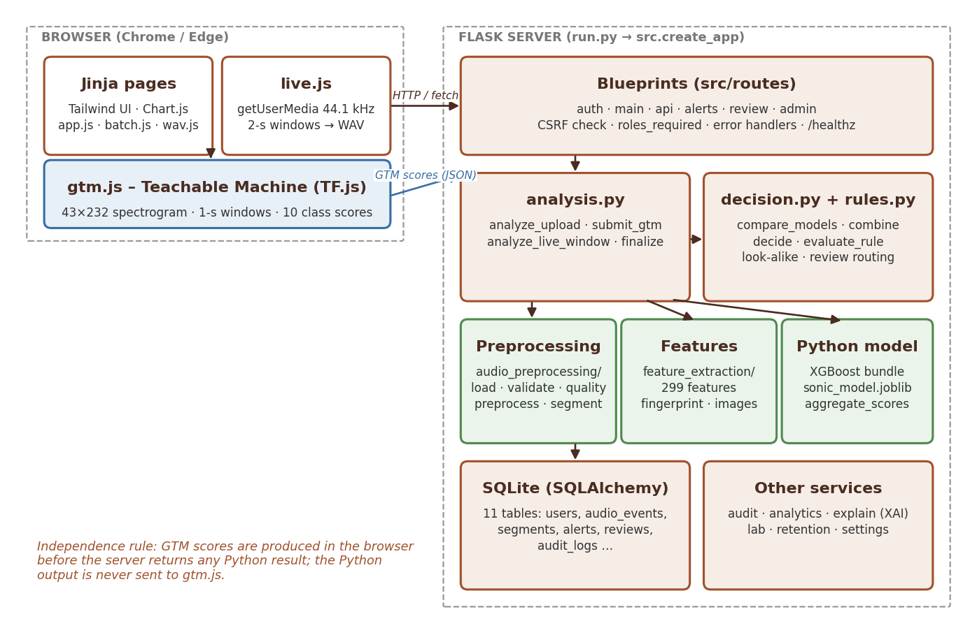
Figure 1 Component architecture
Table 8 Component overview
Component | Responsibility | Main files
Browser UI | pages, uploads, charts, toasts, live capture | templates/, static/js/app.js, batch.js, live.js, lab.js, wav.js (WAV encoder)
GTM client | computes the Teachable Machine spectrogram and runs the TF.js model on every segment | static/js/gtm.js, templates/partials/gtm_scripts.html
Routes | HTTP endpoints, access control, rendering | src/routes/*.py
Analysis service | orchestrates validation → quality → pre-processing → Python model → GTM hand-off → decision → storage | src/services/analysis.py
Decision engine | pure functions: model comparison, combined score, rule evaluation, look-alike check, review routing | src/services/decision.py, src/services/rules.py
Audio / features / model | reusable libraries shared by the app, training and scripts | audio_preprocessing/, feature_extraction/, python_models/, augmentation/
Persistence | ORM models and seeding | src/models.py, database/init_db.py
Support services | audit and notifications, analytics, explainable AI, Robustness Lab, retention, runtime settings | src/services/

2.2 Processing pipeline
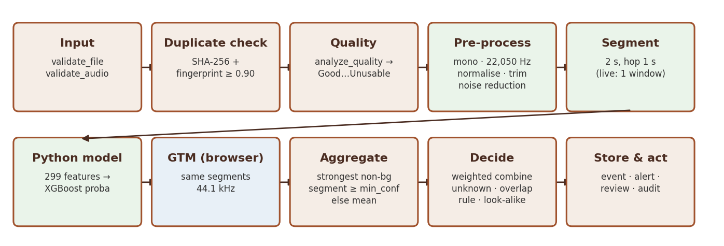
Figure 2 Processing pipeline for one recording

2.3 Upload sequence
- POST /upload (form) or POST /api/upload (fetch) saves the file under data/uploads/ and calls analysis.analyze_upload().
- analyze_upload validates, checks SHA-256 and fingerprint duplicates, analyses quality, pre-processes, segments, writes one 44.1 kHz WAV per segment to data/segments/<audio_id>/seg_NNN.wav, runs the Python model, draws the waveform and spectrogram, and commits the event with gtm_status = "pending".
- The event page loads gtm.js. For each segment it fetches the WAV (/media/segment/<id>), decodes it at 44.1 kHz, classifies it and posts {"segments": [{class: score}, …]} to POST /api/events/<audio_id>/gtm.
- submit_gtm() stores the per-segment GTM scores and calls finalize(), which aggregates both models, runs decision.decide() and creates an Alert if needed.
- If no GTM model is installed, finalize() runs immediately after step 2 with Python only (status "Uncertain Result").
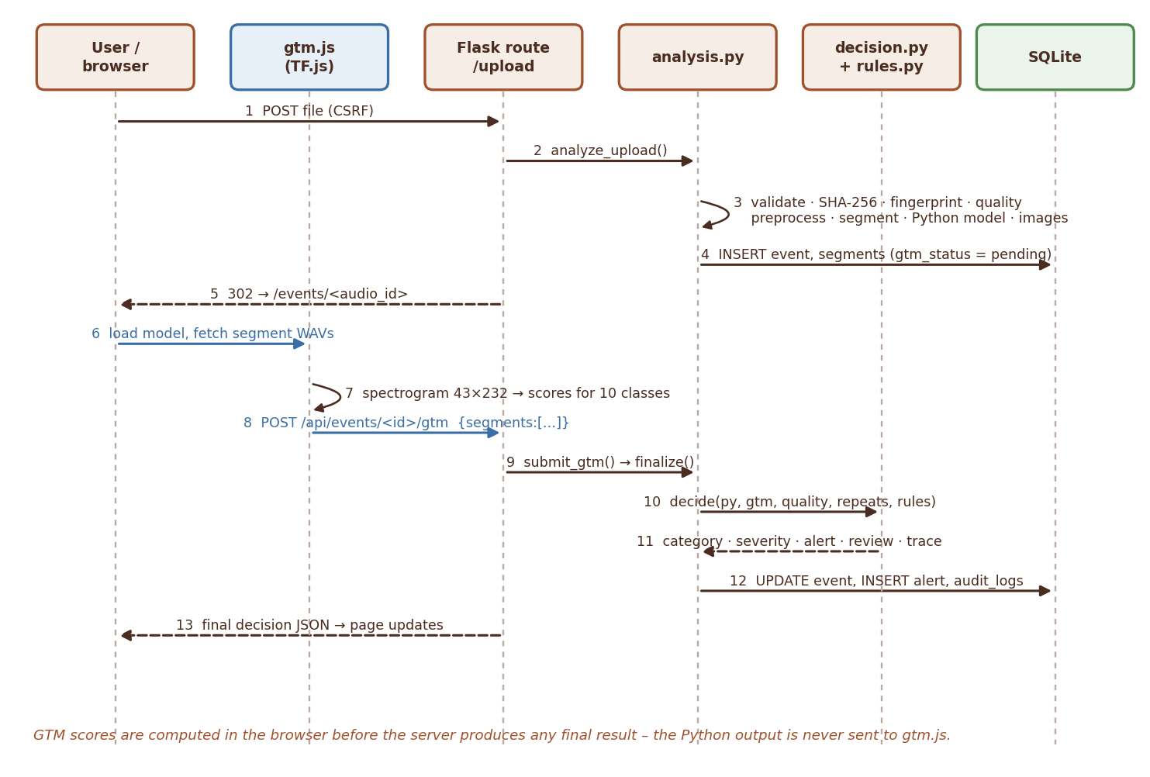
Figure 3 Upload sequence – from the uploaded file to the final decision

2.4 Live sequence
- live.js calls POST /api/live/start → a LiveSession with code LS-<timestamp>-<user>-<hex> is created and audited (mic_start).
- A ScriptProcessorNode on a 44.1 kHz AudioContext fills a buffer; every live_window_seconds (2 s) the window is cut. If the previous window is still being analysed the new one is dropped so the monitor never falls behind real time.
- GTM classifies the window in the browser first, then the WAV and the GTM scores are posted to POST /api/live/window.
- analyze_live_window() skips silent windows, stores a LIV-… event, runs the Python model and finalize(). Repeated detection counts consecutive windows of the same session inside repeat_window_seconds.
- The JSON response (and any alert) is rendered in the live table; POST /api/live/stop closes the session (mic_stop).
 | SRS Model independence (SRS 1.8)  GTM always runs on the client and receives only audio. The Python result is produced on the server and is never passed to gtm.js. For uploads, the event page does not show a final decision until GTM has posted its own scores. For live windows the GTM scores are attached to the request before the server sees the audio.

 CHAPTER 03

Repository structure
Where every part of the code lives.
SRS SRS 1.10 Deliverable 2 (source code)
Table 9 Repository structure
Path | Contents
run.py | entry point: app = create_app(); python run.py [--host] [--port] [--debug]
config/settings.py | paths, class list, audio constants, roles, statuses, default runtime settings, look-alike pairs, secret key
audio_preprocessing/ | loader.py (soundfile + FFmpeg fallback), validation.py, quality.py, preprocess.py
feature_extraction/ | features.py (299 features), fingerprint.py (near-duplicates), visuals.py (waveform / spectrogram PNG)
augmentation/augment.py | noise, shift, pitch, stretch, volume, reverb, distance, device; CLI for the training split
python_models/ | train_models.py (tuning, comparison, reports), inference.py (model wrapper, aggregation), saved/sonic_model.joblib
gtm_model/ | prepare_gtm_samples.py (WAV / playlist / TM zip export), tm_upload_fix.js, model/ (model.json, weights.bin, metadata.json)
alert_rules/alert_rules.json | one rule per class + _help block
database/init_db.py | creates tables, seeds default accounts and model versions
src/ | Flask app: __init__.py (factory, error handlers, /healthz), models.py, security.py, extensions.py, routes/, services/
templates/ | Jinja pages; partials/ (macros, icons, GTM scripts, auth art), admin/, auth/, events/, errors/
static/ | css/app.css (theme on top of Tailwind), js/ (app, gtm, live, batch, lab, wav), img/ (original SVG illustrations)
scripts/ | dataset import / build / TTS / recording, benchmark, hidden-test robustness, look-alike report
tests/ | pytest suite with isolated fixtures
data/ | runtime data: database, uploads, segments, images, lab files, dataset metadata (git-ignored except metadata)
reports/ | generated model, performance and robustness reports
documentation/ | architecture, dataset guide, data dictionary, testing, deployment, GTM log, project report, blog, user and developer guides

 CHAPTER 04

Development environment
Set up, run, debug and reset a local development environment.
SRS SRS 1.10 Deliverables 9–10

4.1 Prerequisites
- Python 3.10 – 3.12 (the code uses X | None type hints, so 3.10 is the minimum).
- FFmpeg on PATH for MP3 / M4A (winget install Gyan.FFmpeg). WAV, FLAC and OGG work without it.
- Chrome or Edge for live monitoring and GTM (Web Audio + TF.js).

4.2 First-time setup
● ● ● PowerShell – project root POWERSHELL / SHELL
1 cd "SonicSentinel AI"
2 python -m venv .venv
3 .venv\Scripts\activate
4 pip install -r requirements.txt
5 python -m database.init_db # tables + default accounts
6 python run.py --debug # http://127.0.0.1:5000

setup_windows.bat performs the same steps; run_windows.bat starts the app; run_server.bat runs waitress with automatic restart and logs to logs/server.log.

4.3 Environment variables
Table 10 Environment variables
Variable | Default | Purpose
SONIC_SECRET_KEY | "change-this-secret-key-in-production" | Flask session signing – always set in production
SONIC_DATA_DIR | data/ | root for uploads, segments, images, database
SONIC_DB_PATH | data/sonicsentinel.db | SQLite file
SONIC_MODEL_PATH | python_models/saved/sonic_model.joblib | Python model bundle
SONIC_GTM_DIR | gtm_model/model/ | folder with model.json, metadata.json, weights.bin
SONIC_RULES_PATH | alert_rules/alert_rules.json | alert-rule file
HOST, PORT | 127.0.0.1, 5000 | bind address for run.py

 | SECURITY Secrets  Never commit a real SONIC_SECRET_KEY. Anyone who knows it can forge session cookies and log in as any user. Set it as an environment variable on the server (Render generates one automatically).

The test suite uses these variables to run against a temporary folder, database, model and rule file (see chapter 15).

4.4 Useful development commands
● ● ● Developer commands POWERSHELL / SHELL
1 python -m pytest -q # full test suite (70 tests)
2 python -m pytest tests/test_decision_rules.py -q # one file
3 python -m python_models.train_models --fast # quick training check
4 python scripts/benchmark_performance.py # NFR performance / scalability
5 python scripts/hidden_test_robustness.py # noise, echo, MP3 … on TEST clips
6 python scripts/lookalike_report.py # similar-event pairs
7 python -m gtm_model.prepare_gtm_samples --max-per-class 400 --zip

4.5 Resetting local data
Stop the server, delete data/sonicsentinel.db (and optionally data/uploads, data/segments, data/images), then run python -m database.init_db. create_app() also calls db.create_all() and seed_defaults() on every start, so missing tables and accounts are recreated automatically.
 | WARNING Deleting the database  Removing sonicsentinel.db deletes every event, alert, review and audit record. Copy the file first if the data is needed as evidence (model-comparison report, screenshots).

 CHAPTER 05

Configuration
Static constants, runtime settings and the alert-rule schema.
SRS FR xxxv–xxxvi · FR liii · FR lxxx

5.1 Static configuration (config/settings.py)
Table 11 Static configuration (config/settings.py)
Constant | Value | Used for
CLASSES | 10 class names (order matters for the model) | labels of both models; must match GTM metadata.json spelling
BACKGROUND_CLASS, UNKNOWN_CLASS | "Background Noise", "Unknown" | aggregation and decision special cases
CRITICAL_RECALL_CLASSES | Gunshot, Glass Breaking, Panic Scream, Aggression, Person Asking for Help | model selection tie-break, reports
SUPPORTED_FORMATS | wav, mp3, flac, ogg, m4a | upload validation
TARGET_SR / GTM_SR | 22,050 Hz / 44,100 Hz | Python pipeline / GTM input
MAX_UPLOAD_MB | 25 | per-file limit (request limit is 20 × this for batch)
MIN_DURATION_S / MAX_DURATION_S | 0.5 / 300 | duration validation
N_MFCC / N_MELS | 40 / 64 | feature extraction
SEVERITY_LEVELS | Informational, Low, Medium, High, Critical | rules, UI
QUALITY_LEVELS | Good, Acceptable, Poor, Unusable | quality analysis
EVENT_STATUSES | Uploaded, Classified, Uncertain, Alert Generated, Manual Review, Reviewed, Closed | event life cycle
ROLES | user, reviewer, security, maintenance, admin | access control
LOOKALIKE_PAIRS | class → [(look-alike label, real-world description)] | look-alike check (SRS Step 14)

5.2 Runtime settings (database, Admin → Settings)
DEFAULT_RUNTIME_SETTINGS holds defaults; administrators override them and the values are stored in the settings table. Always read them with settings_service.get_settings(), which merges stored values over the defaults. update_settings() casts form values to the default's type and ignores unknown keys and missing fields.
Table 12 Runtime settings (database, Admin → Settings)
Key | Default | Effect
segment_seconds / segment_hop_seconds | 2.0 / 1.0 | upload segmentation (model trained with 2 s – retrain if changed)
live_window_seconds | 2.0 | live window length
min_confidence | 0.60 | Medium confidence threshold, aggregation threshold, review trigger
top2_margin | 0.15 | uncertainty / review trigger
acceptable_match_diff | 0.20 | max |Δconf| for "Acceptable Match"
unknown_threshold | 0.35 | combined confidence below → Unknown
overlap_threshold | 0.25 | ≥ 2 non-background classes above → overlap
python_weight | 0.5 (0.7 recommended) | weight of the Python model in combine()
lookalike_margin | 0.20 | minimum gap between an event and its look-alike
repeat_window_seconds | 10 | live repeated-detection window
noise_reduction | True | spectral gating before the Python model
background_noise_limit_db | −20.0 | noise-floor alert for Background Noise
audio_retention_days / record_retention_days | 90 / 365 | retention.apply_retention()

5.3 Alert-rule schema (alert_rules/alert_rules.json)
● ● ● alert_rules/alert_rules.json JSON
1 "Gunshot": {
2 "severity": "Critical", "generate_alert": true, "min_confidence": 0.70, "top2_margin": 0.15,
3 "required_consecutive": 2, "strong_confidence": 0.85, "require_model_agreement": false,
4 "min_quality": "Poor", "manual_review_if_unconfirmed": true,
5 "escalate_after_repeats": 0, "escalate_to": "",
6 "recommended_action": "CRITICAL: possible gunshot. Alert security immediately, ...",
7 "audience": ["security"]
8 }

rules.load_rules() reads the file, save_rules() writes it (Admin → Alert rules), validate_rule() rejects invalid severities, qualities, probabilities outside 0 – 1 and required_consecutive < 1. A class without a rule gets default_rule() (Low, no alert, manual review if unconfirmed). Background Noise additionally supports noise_alert_severity and noise_alert_action.
 CHAPTER 06

Audio processing library
Loading, validation, quality analysis, pre-processing and augmentation.
SRS Steps 3–4, 13 · FR viii, x–xv, xix, xxxvii
audio_preprocessing/ is used identically by the web application, the training script, the evaluation scripts and the Robustness Lab, so the model always sees audio prepared the same way it was trained on.

6.1 Loading (loader.py)
- load_audio(path) first tries soundfile (WAV, FLAC, OGG); if that fails it pipes the file through FFmpeg (ffmpeg -i … -f wav -acodec pcm_f32le pipe:1) for MP3 / M4A. Native sample rate and channel count are kept.
- Returns AudioData(samples, sample_rate, channels, bit_depth, format, file_size); .duration and .metadata(filename) feed the event record.
- Raises AudioDecodeError for empty files, non-finite samples or undecodable data (missing FFmpeg is reported explicitly).
- load_bytes(raw, suffix) decodes in-memory audio (live windows) via a temporary file.

6.2 Validation (validation.py)
Table 13 Validation (validation.py)
Check | Rule | Result
Extension | in SUPPORTED_FORMATS | error
Size | > 0 bytes and ≤ 25 MB | error
Integrity | decodes without exception | error "File integrity check failed …"
Sample rate | ≥ 8,000 Hz (warning below 16 kHz) | error / warning
Channels | 1 – 8 | error
Duration | 0.5 s – 300 s (skipped for live windows) | error
Signal | peak ≥ 1e-4 | error "recording is silent"

validate_file() returns a ValidationResult(ok, errors, warnings, audio); the decoded audio is reused so the file is only read once.

6.3 Quality analysis (quality.py)
analyze_quality(samples, sr) works on the raw, un-normalised signal and returns the label, a list of human-readable issues and the measurements (RMS, peak, silence ratio, clipping ratio, noise floor, SNR, dropouts, spectral flatness). The label starts at Good and can only get worse:
Table 14 Quality analysis (quality.py)
Condition | Measurement | Label
Encoding problem | non-finite samples | Unusable
Silent | peak < 1e-4 or > 97 % of frames below −60 dB | Unusable
Too short / too long | < 0.5 s / > 300 s | Unusable / Poor
Clipping | > 1 % samples at |x| ≥ 0.999 / > 0.1 % | Poor / Acceptable
Low level | RMS < −50 dBFS / < −38 dBFS | Poor / Acceptable
Background noise | SNR (95th − 10th percentile frame dB) < 6 dB and flatness > 0.30 / SNR < 12 dB | Poor or Acceptable / Acceptable
Missing frames | runs of exact zeros ≥ 20 ms inside the clip (1 – 2 / > 2) | Acceptable / Poor

Low SNR alone is not penalised because continuous sounds (sirens, machinery hum) naturally have a small dynamic range; the spectral-flatness test separates them from real broadband noise. noise_floor_dbfs is stored as noise_level_db and drives the Background-Noise alert.

6.4 Pre-processing and segmentation (preprocess.py)
● ● ● audio_preprocessing/preprocess.py – API PYTHON
1 preprocess_signal(samples, sr, trim=True, denoise=True) -> (clean @ 22,050 Hz, trim_offset_s)
2 to_mono -> resample (soxr_hq) -> peak_normalize(0.95)
3 -> trim_silence(top_db=40) -> reduce_noise (noisereduce, stationary, prop_decrease=0.75)
4 -> peak_normalize
5
6 segment(y, sr, seg_seconds=2.0, hop_seconds=1.0) -> [(start_s, end_s, samples)]
7 clip shorter than one segment -> one zero-padded segment
8 trailing remainder < 50 % of a segment is dropped
9
10 prepare_for_gtm(samples, sr, 44100) # mono, 44.1 kHz, peak-normalised, NO noise reduction

Segment timestamps are shifted by the trim offset so they refer to the original recording. Live windows are not trimmed and are padded / truncated to exactly live_window_seconds.

6.5 Augmentation (augmentation/augment.py)
Table 15 Augmentation (augmentation/augment.py)
Function | Parameters (random ranges)
add_noise | SNR 5 – 25 dB; white noise or a real Background Noise clip
time_shift | roll by ± 30 %
pitch_shift | ± 2 semitones
time_stretch | rate 0.85 – 1.15
volume | −12 to +6 dB
reverb | RT60 0.15 – 0.6 s, exponentially decaying noise impulse response, 60 / 40 dry / wet
distance | 5 – 30 m: 4th-order low-pass (9 kHz − 200 Hz·m, ≥ 1.5 kHz) and attenuation
device | cheap microphone: 300 Hz – 4 kHz band-pass + tanh saturation

random_augment() chains 1 – 3 random operations and renormalises to 0.9 peak. The CLI (python -m augmentation.augment --per-clip 2) augments only the training split; augmented files keep parent_audio_id so they stay in their parent's split and cross-validation group.
 CHAPTER 07

Feature extraction
The 299-dimensional feature vector, audio fingerprints and visuals.
SRS Step 6 · FR xx–xxii, lxxiii–lxxiv

7.1 The 299-dimensional feature vector
feature_extraction/features.py → extract_features(y, sr=22050) turns one pre-processed segment into a fixed-length float32 vector (STFT: n_fft 2048, hop 512). feature_names() returns the names in the same order.
Table 16 The 299-dimensional feature vector
Block | Statistics | Dimensions
MFCC (40 coefficients from a 64-band log-Mel) | mean, std | 80
Δ-MFCC | mean | 40
Log-Mel spectrogram (64 bands) | mean, std | 128
Chroma (12) | mean, std | 24
Spectral contrast (7) | mean | 7
ZCR, RMS, centroid, bandwidth, roll-off, onset strength | mean, std, max (centroid, bandwidth, roll-off in kHz) | 18
Spectral flatness, tempo (/100) | mean / value | 2
Total |  | 299

NaN / ±inf are replaced by 0; digital silence gets a 1e-6 offset. FEATURE_VERSION = "v1" is part of the training cache key – bump it whenever the feature code changes so cached .npz files under data/features/<tag>/ are not reused.
WARNING Changing a feature
Any change to extract_features() changes the meaning of the vector. Bump FEATURE_VERSION, update feature_names() and retrain – an old model bundle with new features gives silently wrong predictions.

7.2 Audio fingerprint (fingerprint.py)
- compute_fingerprint(y, sr) at 11,025 Hz: a 32-band mean log-Mel profile (mean-removed, so volume-independent) and a 10 Hz log-RMS envelope (≤ 3,000 values).
- similarity(a, b): cosine of the profiles; if ≥ 0.85 and the durations are within a factor of 3.3, the best normalised cross-correlation of the envelopes is added: 0.3 · spectral + 0.7 · envelope.
- analyze_upload compares a new upload with the last 2,000 non-live events; ≥ 0.90 marks a near-duplicate (re-encoded, trimmed or volume-changed copy) and notifies the administrator. Identical files are caught earlier by SHA-256.

7.3 Visuals (visuals.py)
save_waveform() draws the waveform with segment boundaries and the deciding segment highlighted; save_spectrogram() draws a 128-band Mel spectrogram. PNGs are written to data/images/ and served through /media/event/<audio_id>/<kind>.
CHAPTER 08

Python model
Training, tuning, selection, results and inference of the Python model.
SRS Steps 7–8 · FR xxiii–xxvi · NFR 4

8.1 Training (python_models/train_models.py)
● ● ● python_models/train_models.py – CLI POWERSHELL / SHELL
1 python -m python_models.train_models # svm, rf, xgb, mlp – full grids
2 python -m python_models.train_models --models xgb,mlp,rf # what was used for the current model
3 python -m python_models.train_models --fast # small grids

- Read data/dataset_metadata.csv: training rows (including augmented copies), validation and test rows (originals only).
- Extract segment features with an on-disk cache keyed by FEATURE_VERSION, segment length, hop, noise reduction and sample rate.
- Drop quiet segments of event clips from training (energy < 25 % of the clip maximum) – a silent segment of a gunshot clip is not a gunshot.
- For every candidate: Pipeline([StandardScaler, classifier]), GridSearchCV(scoring="f1_macro") with GroupKFold(3) grouped by the original Audio ID, so segments and augmented copies of one recording never appear in two folds.
- Evaluate each tuned model at clip level on the validation split using the same aggregate_scores() as the app; select by validation macro-F1, then minimum critical-class recall.
- Evaluate the selected model once on the test split; add white noise at 20 / 10 / 5 dB SNR for the robustness report.
- Save the bundle and reports.
Table 17 Training (python_models/train_models.py)
Candidate | Base estimator | Grid
svm | SVC(probability=True, class_weight="balanced") | C ∈ {1, 10, 30}, gamma ∈ {scale, 0.005}
rf | RandomForest(300 trees, class_weight="balanced_subsample") | max_depth ∈ {None, 25}, min_samples_leaf ∈ {1, 2}
xgb | XGBClassifier(300 trees, tree_method="hist") | max_depth ∈ {4, 6}, learning_rate ∈ {0.1, 0.05}
mlp | MLPClassifier((256, 128), early_stopping) | alpha ∈ {1e-4, 1e-3}

8.2 Results of the current model (py-xgb-20260924-0800)
From reports/python_model_comparison.csv (validation split, clip level). SVM was not run for this model because fitting it on ≈ 38,000 segments takes hours.
Table 18 Results of the current model (py-xgb-20260924-0800)
Model | Best parameters | CV macro-F1 | Val. accuracy | Val. macro-F1 | Train time
XGBoost (selected) | learning_rate 0.1, max_depth 6 | 0.790 | 0.844 | 0.847 | 1,462 s
MLP | alpha 0.001 | 0.779 | 0.805 | 0.818 | 292 s
Random Forest | max_depth None, min_samples_leaf 1 | 0.742 | 0.769 | 0.802 | 953 s

Test split (reports/python_test_metrics.json, 695 unseen clips): accuracy 0.865, macro-F1 0.863, macro precision 0.847, macro recall 0.895.
Table 19 Results of the current model (py-xgb-20260924-0800) – Class
Class | Precision | Recall | F1
Machinery Fault | 0.769 | 1.000 | 0.870
Glass Breaking | 0.556 | 0.833 | 0.667
Alarm or Siren | 0.929 | 0.915 | 0.922
Vehicle Horn | 1.000 | 0.873 | 0.932
Animal Sound | 0.885 | 0.793 | 0.836
Gunshot | 0.962 | 0.927 | 0.944
Panic Scream | 0.636 | 0.933 | 0.757
Aggression | 0.889 | 0.889 | 0.889
Person Asking for Help | 1.000 | 1.000 | 1.000
Background Noise | 0.843 | 0.782 | 0.812

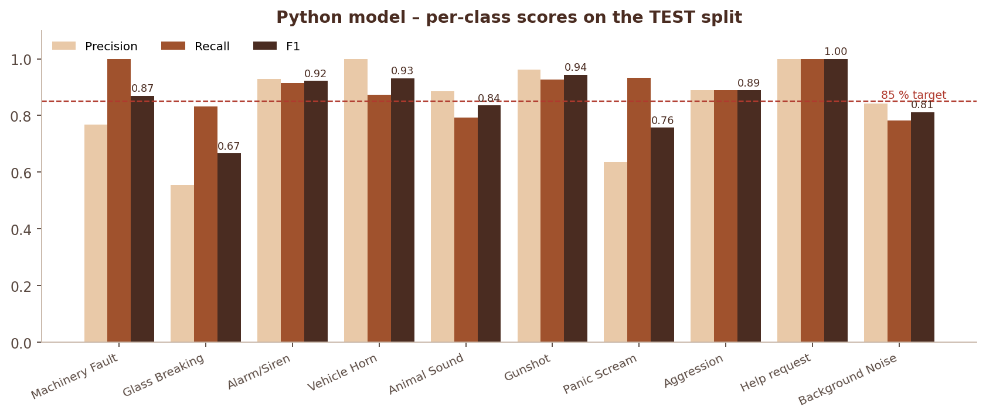
Figure 4 Python model – precision, recall and F1 per class (TEST split)
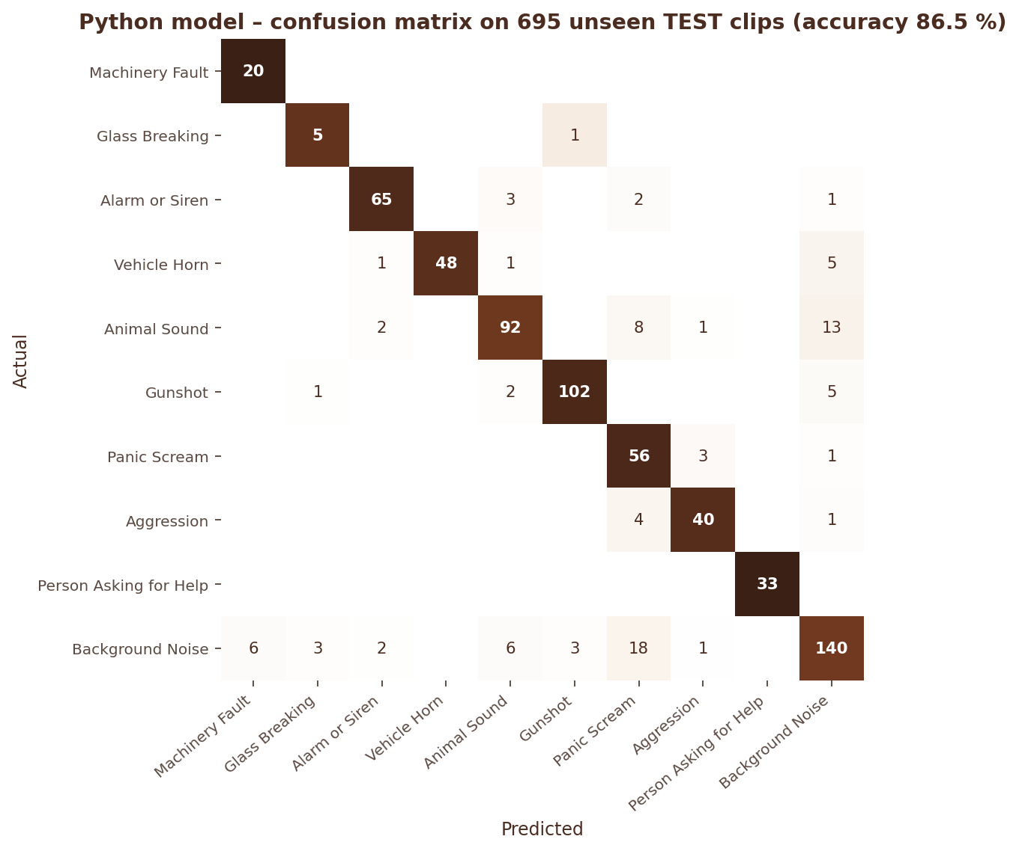
Figure 5 Confusion matrix of the Python model on 695 unseen TEST clips
Table 20 Results of the current model (py-xgb-20260924-0800) – Noise condition (reports/noise_robustness.csv)
Noise condition (reports/noise_robustness.csv) | Accuracy | Macro-F1
clean | 0.865 | 0.863
white noise 20 dB SNR | 0.809 | 0.780
white noise 10 dB SNR | 0.711 | 0.602
white noise 5 dB SNR | 0.663 | 0.529

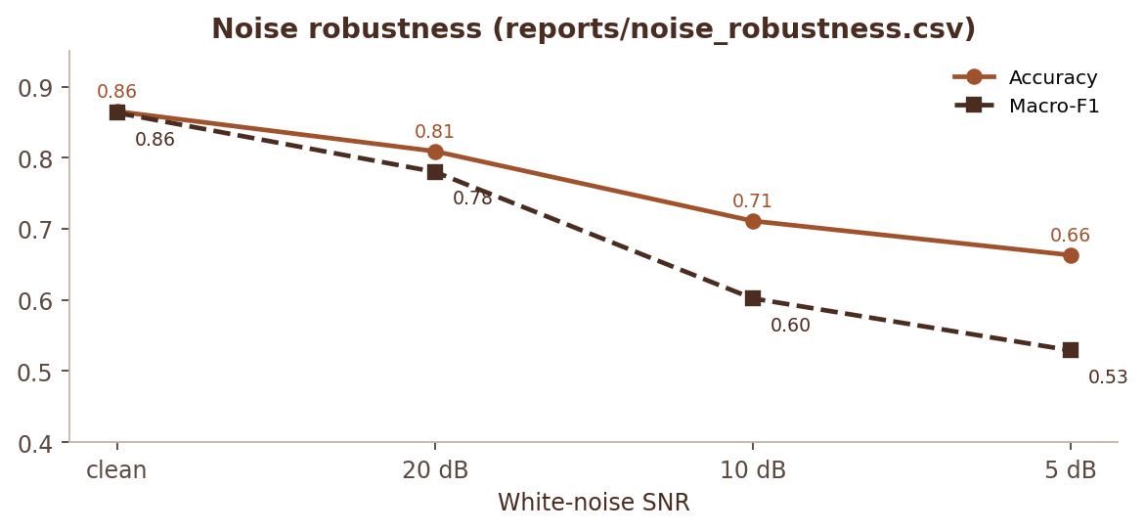
Figure 6 Accuracy and macro-F1 as white noise gets stronger

8.3 Model bundle and inference (python_models/inference.py)
● ● ● python_models/saved/sonic_model.joblib PYTHON
1 bundle = {
2 "pipeline": Pipeline([StandardScaler, XGBClassifier]), "classes": CLASSES,
3 "algorithm": "xgb", "version": "py-xgb-YYYYMMDD-HHMM", "feature_names": [...299],
4 "trained_at": iso-time,
5 "settings": {"segment_seconds", "segment_hop_seconds", "noise_reduction", "sample_rate"},
6 "metrics": {"validation": {...}, "test": {...}, "noise_robustness": [...]}
7 } # joblib.dump -> python_models/saved/sonic_model.joblib

- PythonSoundModel(path) loads the bundle (raises ModelNotAvailable if missing); predict_proba(X) returns one {class: probability} dict per segment covering all CLASSES.
- analysis.python_model() caches one instance per process; warm_up() runs the pipeline once on synthetic audio at start-up so the first real request does not pay librosa / numba JIT compilation.
- top_k(scores, k) and top_margin(scores) are shared helpers.

8.4 Clip-level aggregation
aggregate_scores(segment_scores, min_conf) is used for both models, in training evaluation and in the app:
- If any segment has a non-background top class with confidence ≥ min_conf, the clip takes the scores of the strongest such segment (a 0.3-s gunshot in a 20-s recording must not be averaged away). Its index is stored as python_segment_index.
- Otherwise the clip takes the mean over all segments (index −1).
 CHAPTER 09

Google Teachable Machine integration
How the Teachable Machine model is trained, exported and run in the browser.
SRS Steps 9–10 · FR xxvii–xxx

9.1 Model format
Teachable Machine audio projects export a TensorFlow.js speech-commands BROWSER_FFT model. gtm_model/model/metadata.json of the installed export:
● ● ● gtm_model/model/metadata.json JSON
1 {"tfjsSpeechCommandsVersion":"0.4.0","modelName":"TMv2","timeStamp":"2026-09-24T20:51:32.771Z",
2 "wordLabels":["Aggression","Alarm or Siren","Animal Sound","Background Noise","Glass Breaking",
3 "Gunshot","Machinery Fault","Panic Scream","Person Asking for Help","Vehicle Horn"]}

Labels are mapped by name, so their order does not matter, but the spelling must match CLASSES. analysis.gtm_info() reads the metadata, reports missing and extra labels (shown on the dashboard and Admin → Models) and builds the version string gtm-<modelName>-<timeStamp> stored with every prediction. The files are served by GET /gtm/<filename>.

9.2 Spectrogram computation (static/js/gtm.js)
The TM recorder feeds the model spectrograms from a Web Audio AnalyserNode. To classify uploaded files and live windows (not only TM's own microphone stream), gtm.js reproduces that front end exactly:
- 44.1 kHz mono audio, FFT size 2048, Blackman window, magnitude in dB (20·log10(|X|/2048)), first 232 bins.
- 43 frames with a hop of 1,024 samples (≈ 1 s per example), then z-normalisation over the whole 43 × 232 tensor (as speech-commands normalize()).
- classify(samples) slides 1-s examples with a 0.5-s hop over the segment and averages the scores; decodeUrl(url) decodes a WAV into 44.1 kHz mono with an OfflineAudioContext.
- Libraries: @tensorflow/tfjs@1.3.1 and @tensorflow-models/speech-commands@0.4.0 (the versions TM exports for), loaded in templates/partials/gtm_scripts.html.

9.3 Training data for GTM (gtm_model/prepare_gtm_samples.py)
GTM is trained only on the TRAIN split of the same dataset. The --zip mode writes one archive per class in Teachable Machine's own sample format, so samples can be uploaded digitally instead of being replayed through speakers:
● ● ● prepare_gtm_samples.py – output POWERSHELL / SHELL
1 python -m gtm_model.prepare_gtm_samples --max-per-class 400 --zip
2 -> gtm_model/training_samples/_tm_upload/<Class>.zip
3 samples.json [{ "frequencyFrames": [43 x 232], "blob": null, "blobFilePath": "sample-1.webm",
4 "startTime", "endTime", "recordingDuration" }, ...]
5 sample-1.webm all samples one after another (Opus via FFmpeg; playback only)
6 -> gtm_sample_counts.csv, gtm_samples_metadata.csv (Audio ID of every source recording)

The spectrogram frames are computed with the same FFT 2048 / Blackman / hop-1024 parameters as gtm.js. gtm_model/tm_upload_fix.js is a console snippet that works around two Teachable Machine web-app bugs on Windows: .zip files reported as application/x-zip-compressed are rejected by the upload box, and String.fromCharCode.apply overflows the call stack when thousands of examples are loaded.

9.4 GTM results
Table 21 GTM results
Run | Export | Test accuracy | Macro-F1 | Notes
2 | 2026-09-24 15:50 | 0.158 | 0.174 | under-trained export (≈ 20 % on its own training data)
3 (installed) | 2026-09-24 20:51 | 0.606 | 0.607 | best: Alarm or Siren F1 0.82, Help 0.73, Horn 0.72; weakest: Panic Scream 0.41
Combined with Python | python_weight 0.7 | 0.868 | 0.866 | better than either model alone

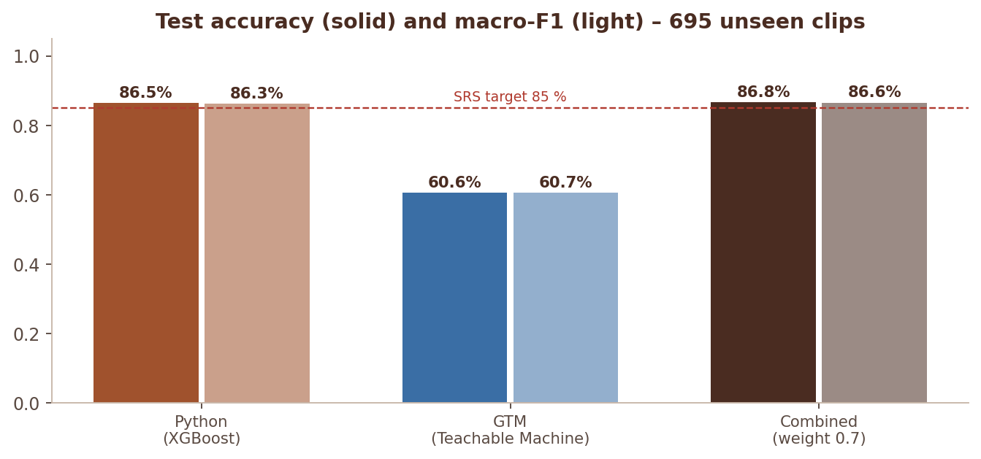
Figure 7 Python, GTM and combined decision against the 85 % SRS target
A classification head trained with SGD on the same TM base model reaches ≈ 0.64, so ≈ 0.6 – 0.65 is the practical ceiling of the 1-second speech-commands transfer model on these environmental sounds. This is documented as a known limitation (chapter 19).
 CHAPTER 10

Decision engine
The pure-function decision engine: comparison, combination, rules, look-alikes and review routing.
SRS Steps 11, 14–17, 19 · FR xxxi–lii, lvii
src/services/decision.py contains only pure functions (no database, no Flask). This makes the decision logic easy to unit-test (tests/test_decision_rules.py) and easy to explain in a viva. analysis.finalize() prepares the inputs and stores the outputs.

10.1 Inputs
● ● ● src/services/decision.py PYTHON
1 decide(py, gtm, *, quality, noise_db, repeated_for, rules, settings) -> dict
2 py, gtm clip-level {class: score} from aggregate_scores() (gtm may be None)
3 quality "Good" | "Acceptable" | "Poor" | "Unusable"
4 noise_db estimated noise floor (dBFS)
5 repeated_for function(category) -> consecutive detections
6 uploads: longest run of consecutive segments whose (Python+GTM)/2 top class = category
7 live: consecutive windows of the same session inside repeat_window_seconds
8 rules load_rules(); settings = get_settings()

10.2 Algorithm
- compare_models() – top class, confidence, top-2 margin and top-3 of each model; class_match, confidence_diff = |py_conf − gtm_conf|; consistency status: Uncertain Result if both < min_confidence or GTM missing, Acceptable Match if same class, both ≥ min_confidence and diff ≤ acceptable_match_diff, Weak Match if same class otherwise, else Model Disagreement.
- combine() – w · py + (1 − w) · gtm per class with w = python_weight (Python only if GTM is missing). Best class, confidence and margin are taken from the combined vector.
- Unknown – combined confidence < unknown_threshold → category "Unknown".
- Overlap – ≥ 2 non-background classes with combined score ≥ overlap_threshold.
- Uncertain reasons – below min_confidence, margin < top2_margin, Poor / Unusable quality, models disagree, GTM unavailable, overlap.
- Rule evaluation – rules.evaluate_rule() checks confidence, top-2 margin, quality (quality_ok), model agreement (if required) and repeated detection (repeated ≥ required_consecutive, or a single detection when both models agree at ≥ strong_confidence). All checks true = confirmed. Severity is raised to escalate_to when repeated ≥ escalate_after_repeats.
- Alert status – Background Noise with noise_db > background_noise_limit_db → noise alert. Otherwise, if generate_alert: confirmed → "Alert Generated"; not confirmed → "Pending Confirmation" plus a review reason when manual_review_if_unconfirmed.
- Possible false alarm – an alert where one model gives the class < 0.20 is also sent to review.
- Look-alike check – for every pair in LOOKALIKE_PAIRS[category]: gap = combined[category] − combined[look-alike]; gap < lookalike_margin → review "Possible look-alike: could be …". For a Background Noise decision, any critical class whose look-alike is Background and whose score ≥ unknown_threshold adds "Possible <class> that sounds like …".
- Review routing – disagreement, low confidence, poor quality, close top-2, overlap, Unknown. Clear background noise keeps only the disagreement and "Possible …" reasons. Duplicates are removed.
- Status – Manual Review > Alert Generated > Uncertain > Classified. Every step appends a line to trace, which is stored as decision_trace and shown on the event page.
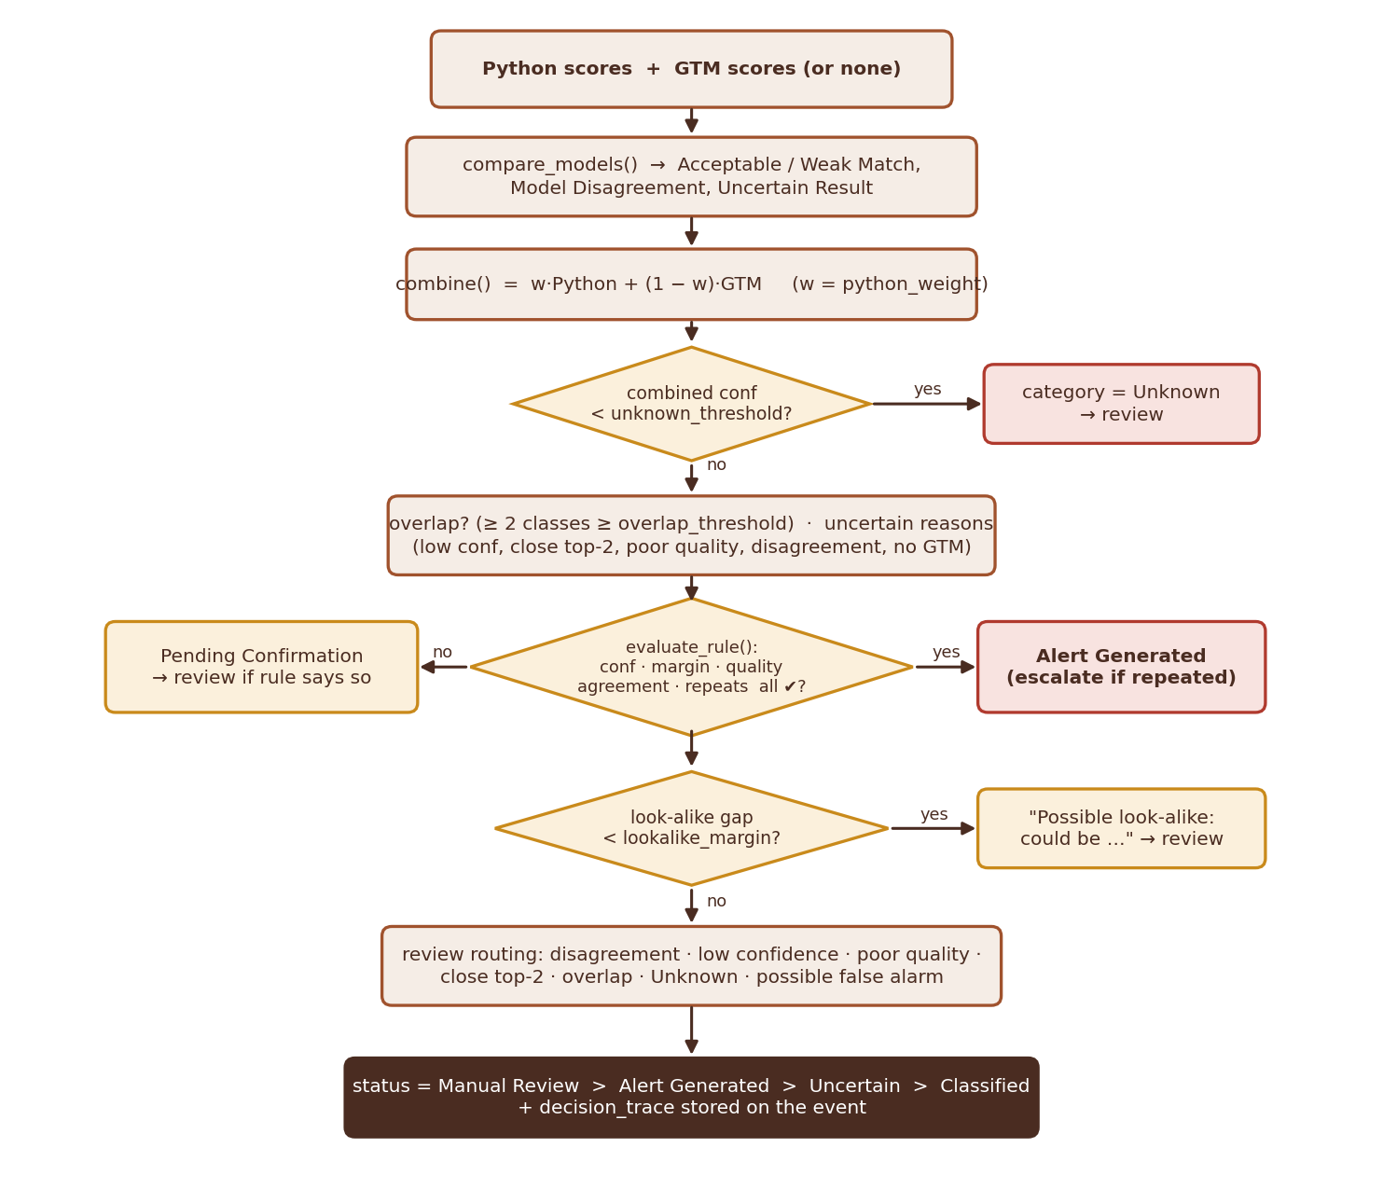
Figure 8 Decision flow inside decide()

10.3 Output
The returned dict contains all comparison fields plus combined_scores, final_category, final_confidence, combined_margin, confidence_level (High ≥ 0.85 / Medium ≥ min_confidence / Low), overlap_detected, overlap_classes, uncertain, uncertain_reasons, repeated_count, severity, alert_status, recommended_action, manual_review_required, review_reasons, status, rule_checks, audience, lookalike_checks, trace. finalize() copies them onto AudioEvent and creates an Alert (message e.g. "Critical – Gunshot detected (91%)") when alert_status == "Alert Generated".

10.4 Example trace
● ● ● AudioEvent.decision_trace – example TEXT
1 Python → Panic Scream (0.81); GTM → Panic Scream (0.58); |Δconf| = 0.23 → Weak Match
2 Combined scores (Python 70% / GTM 30%) → Panic Scream (0.74), top-2 margin 0.61
3 Rule 'Panic Scream': confidence=✔, top2_margin=✔, quality=✔, model_agreement=✔, repeated_detection=✔ (repeated 1×)
4 All conditions met → Critical alert
5 Look-alike check: Panic Scream vs normal shouting or loud voices (Background Noise) – gap 0.66 ≥ 0.20 → distinguished
6 Final: Panic Scream | severity Critical | Alert Generated | status Alert Generated

 CHAPTER 11

Data model
Tables, relationships, identifiers and the event life cycle.
SRS Step 20 · FR lxii, lxxii, lxxv

11.1 Entity relationships
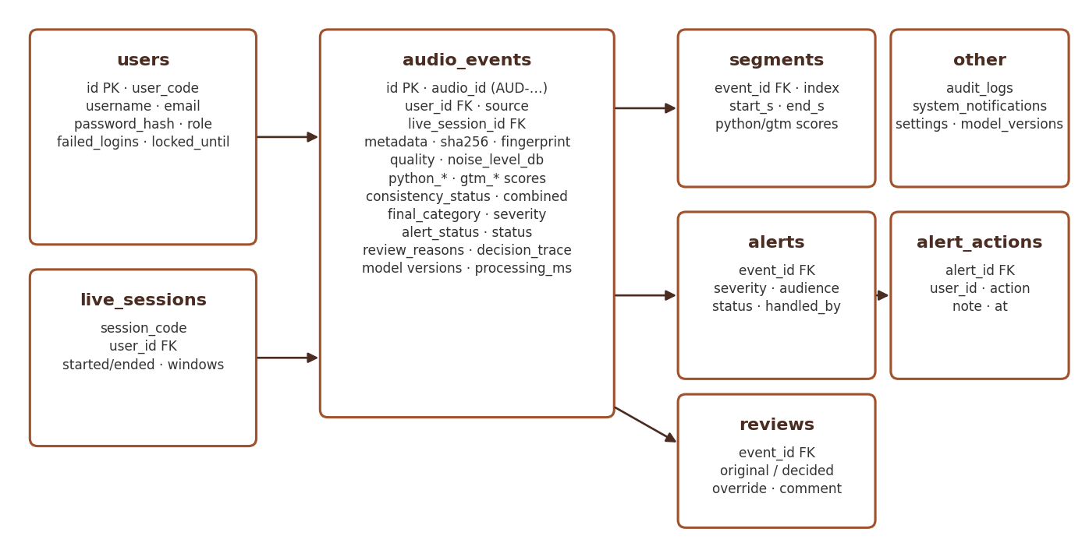
Figure 9 Entity-relationship overview
Models are defined in src/models.py (Flask-SQLAlchemy). JSONText is a TypeDecorator that stores dicts and lists as JSON text, so the schema stays portable to PostgreSQL. now() returns a naive UTC-local timestamp used for all defaults.
Table 22 Entity relationships
Table | Key columns | Notes
users | user_code (USR-00001), username, email, password_hash, role, is_active_flag, failed_logins, locked_until, last_login | Werkzeug password hashing; has_role(*roles) lets admin pass every check
live_sessions | session_code, user_id, started_at, ended_at, windows | one per Start … Stop
audio_events | audio_id, source (upload | batch | live | evaluation), actual_class, file metadata, sha256, fingerprint, duplicate / near-duplicate links, quality, python_* / gtm_* (prediction, confidence, scores, margin), gtm_status, class_match, consistency_status, confidence_diff, combined_scores, overlap, uncertain, repeated_count, final_*, severity, alert_status, recommended_action, review fields, status, decision_trace, model versions, processing_ms | central table; indexes on audio_id, user_id, uploaded_at, final_category, severity, status
segments | event_id, index, start_s, end_s, audio_path (44.1 kHz WAV), rms_db, python / gtm scores and predictions | cascade delete with the event
alerts | event_id, category, severity, message, recommended_action, audience (JSON roles), status, handled_by_id, handled_at | status: Active | Acknowledged | Escalated | Dismissed
alert_actions | alert_id, user_id, action, note, at | history of every operator action
reviews | event_id, reviewer_id, original_category, decided_category, decision (Confirmed | Corrected), override, comment, recommended_action | original model output is never overwritten
audit_logs | user_id, username, action, entity, entity_id, details, ip, at | written by audit.log()
system_notifications | kind, message, at, is_read | admin anomaly alerts
settings | key, value (JSON), updated_at | runtime overrides of DEFAULT_RUNTIME_SETTINGS
model_versions | model_type (python | gtm), version, details, registered_at | registered on first use of a new version

11.2 Event life cycle
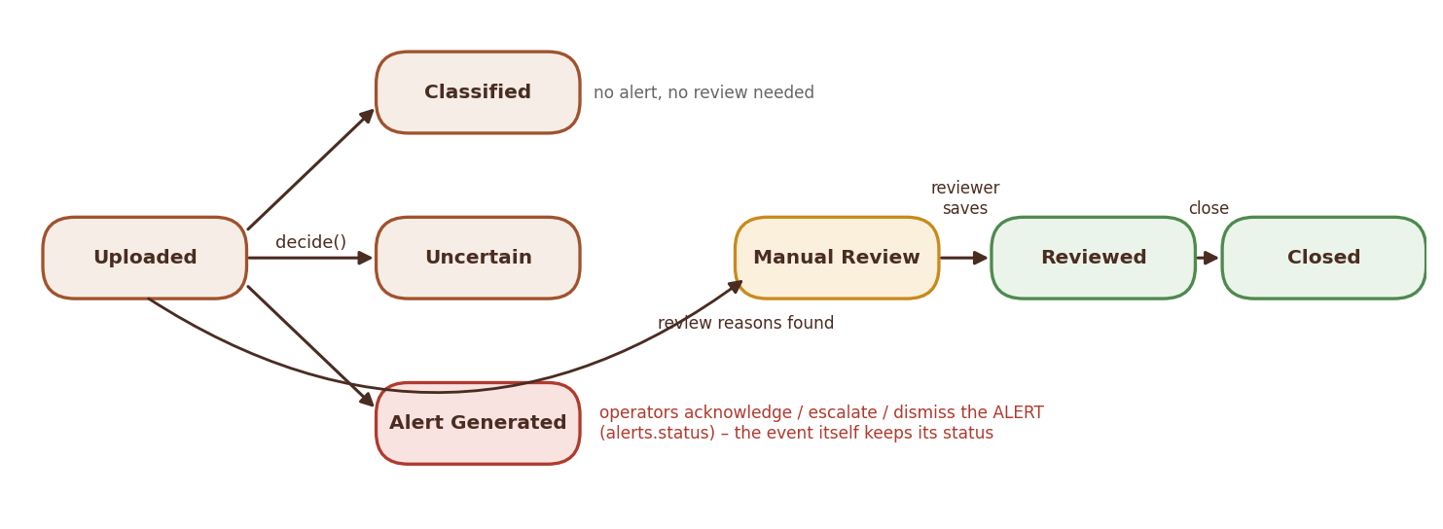
Figure 10 Event status life cycle (EVENT_STATUSES)
IDs: events AUD-YYYYMMDD-HHMMSS-XXXX (4 hex characters), live windows LIV-…, sessions LS-…. Files: data/uploads/ (originals), data/segments/<audio_id>/seg_NNN.wav, data/images/. database/init_db.py → seed_defaults() creates the five default accounts if they do not exist.
 CHAPTER 12

Web application
Application factory, security, routes and the front end – including an annotated tour of the event page.
SRS FR i–iii, lxiii–lxvii, lxxi, lxxvii, lxxix

12.1 Application factory (src/__init__.py)
- create_app(test_config=None) configures Flask (secret key, SQLite URI, MAX_CONTENT_LENGTH = 25 MB × 20 for batch requests, HttpOnly + SameSite=Lax cookies), initialises SQLAlchemy and Flask-Login, registers six blueprints and the CSRF hook.
- A context processor injects csrf_token, CLASSES, SEVERITY_LEVELS, ROLES and the navigation badge counts (active alerts, unread notifications, pending reviews) according to the role.
- Template filters: pct (0.742 → "74.2%") and dt.
- Error handlers for 400, 401, 403, 404, 413 and 500 return JSON for /api/* and errors/error.html otherwise; 500 rolls back the session.
- On start-up: db.create_all(), seed_defaults(), apply_retention() and warm_up() (skipped in tests).
- GET /healthz returns {"status", "uptime_s", "checks": {database, python_model, gtm_model}} with HTTP 200, or 503 if the database fails.

12.2 Security (src/security.py)
Table 23 Security (src/security.py)
Mechanism | Implementation
Authentication | Flask-Login sessions; login by username or email; "remember me" cookie
Password policy | ≥ 8 characters with letters and digits (password_problems)
Lock-out | 5 failed attempts → locked_until = now + 5 min; each failure audited; ≥ 3 failures in 15 min → admin notification
CSRF | per-session token (secrets.token_hex(16)), checked in before_request for POST / PUT / PATCH / DELETE; forms send csrf_token, fetch sends X-CSRFToken; compared with secrets.compare_digest
Authorisation | @roles_required(*roles) (admin always allowed); admin blueprint guarded in before_request; can_view_event() limits Normal Users to their own events; can_handle_alert() uses the alert audience
Media | audio and images are served only through routes that call can_view_event(); Lab files are checked against the owner of the token
Open redirect | next parameter accepted only when it starts with "/" and not "//"

SECURITY Rule of thumb for new routes
Every new route needs @login_required, a role check (@roles_required) where staff-only, and can_view_event() for anything that returns event data or audio. POST handlers get CSRF protection automatically; fetch calls must go through SS.api().

12.3 Page routes
Table 24 Page routes
Route | Methods | Access | Purpose
/register, /login, /logout, /profile | GET, POST | public / logged in | accounts (blueprint auth)
/, /dashboard | GET | logged in | dashboard (class counts, KPIs, lists)
/upload | GET, POST | logged in | upload page / form upload
/batch | GET | reviewer, security, maintenance, admin | batch page (uploads go through /api/upload)
/live, /lab | GET | logged in | live monitoring, Robustness Lab
/events/<audio_id> | GET | owner or staff | event page
/events/<audio_id>/report | GET | owner or staff | printable report
/media/event/<audio_id>/<kind> | GET | owner or staff | audio, waveform, spectrogram, explain image
/media/segment/<seg_id> | GET | owner or staff | segment WAV (GTM input, reviewer playback)
/gtm/<filename> | GET | logged in | GTM model files
/history, /timeline | GET | logged in | filtered list (paged) / chronological view
/alerts/, /alerts/history | GET | security, maintenance, admin | alert list and history
/alerts/<id>/<acknowledge|dismiss|escalate> | POST | security, maintenance, admin (+ audience) | alert action (JSON for fetch)
/review/, /review/<audio_id> | GET, POST | reviewer, admin | queue, review form
/admin/… | GET, POST | admin | dashboard, users, settings, retention, rules, audit, notifications, models, confusion matrix, evaluation, export
/healthz | GET | public | health check

12.4 Front end
- templates/base.html loads Tailwind from the CDN with a custom tailwind.config (Mocha palette), static/css/app.css (components: cards, badges, .hero, .kpi, .class-tile, .cls-chip, .auth-shell, .dropzone …) and app.js.
- app.js exposes the global SS helper: SS.api() (fetch with CSRF header and JSON errors), SS.toast(), badge renderers, alert polling (/alerts/poll) for toasts.
- partials/macros.html (badges, event_row), partials/icons.html (original stroke-SVG icon set and one icon per sound class: icon(), class_icon(), class_chip()), partials/gtm_status.html, partials/auth_art.html.
- wav.js encodes Float32 audio as 16-bit PCM WAV for live windows; batch.js uploads files one by one and runs GTM on each; lab.js drives the Robustness Lab.

12.5 Anatomy of the event page
The event page (templates/events/detail.html) shows every stage of the pipeline for one recording. The numbers in the screenshot map each block to the code that produces it.
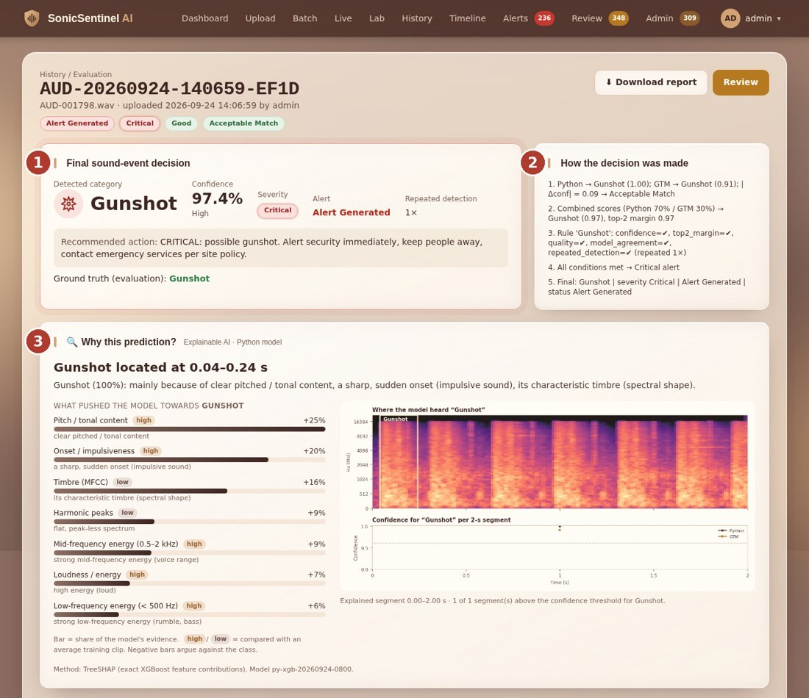
Figure 11 Event page (blocks 1–3) – a correctly detected Gunshot: Acceptable Match, Critical alert, TreeSHAP explanation
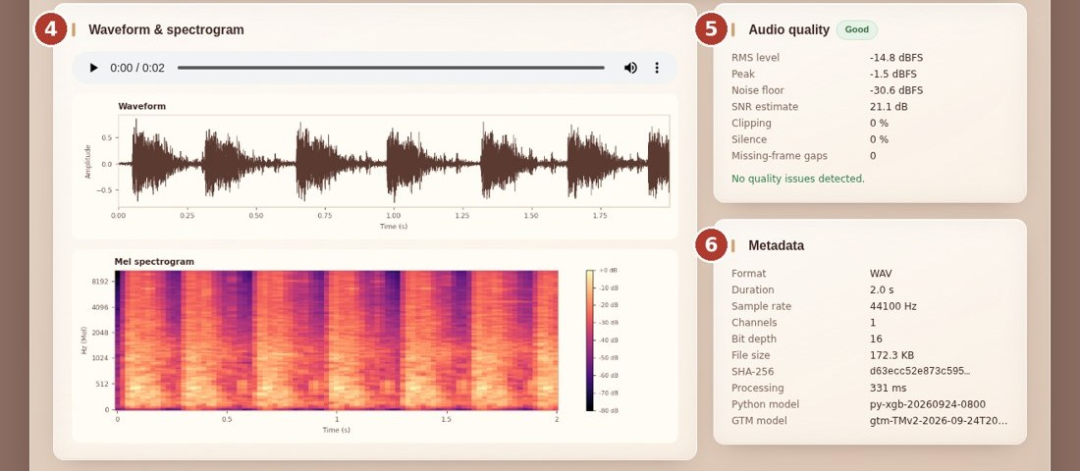
Figure 12 Event page (blocks 4–6) – waveform, spectrogram, audio quality and metadata
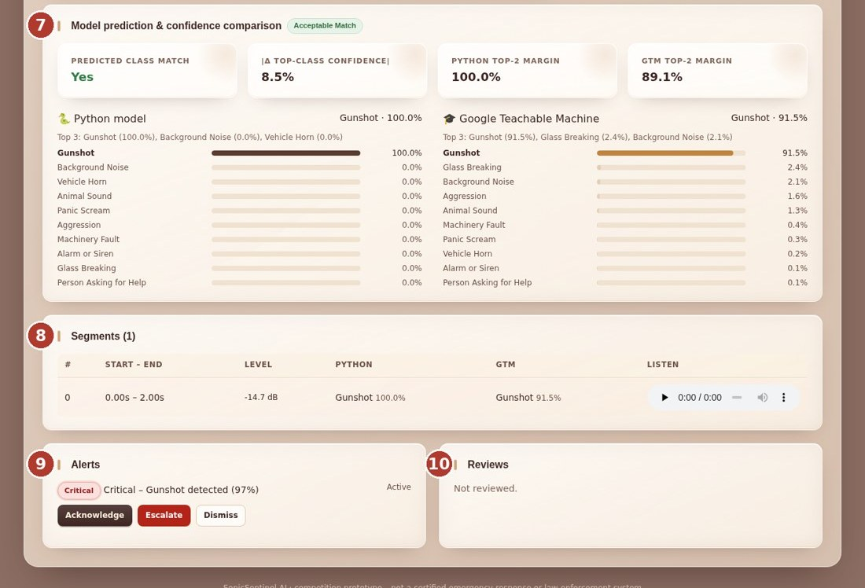
Figure 13 Event page (blocks 7–10) – model comparison, segments, alerts and reviews
Table 25 Event page blocks and the code behind them
# | Block | Produced by | Data
1 | Final sound-event decision | analysis.finalize() → decision.decide() | final_category, final_confidence, confidence_level, severity, alert_status, recommended_action, repeated_count
2 | How the decision was made | decide() trace lines | decision_trace (JSON list)
3 | Why this prediction? (XAI) | GET /api/events/<id>/explain → services/explain.py | TreeSHAP groups, span, <audio_id>_explain.png
4 | Waveform & spectrogram | feature_extraction/visuals.py | /media/event/<id>/audio|waveform|spectrogram
5 | Audio quality | audio_preprocessing/quality.py → analyze_quality() | quality JSON, quality_label, noise_level_db
6 | Metadata | AudioData.metadata(), sha256_file(), model registry | format, duration, SR, channels, bit depth, size, SHA-256, versions, processing_ms
7 | Model prediction & confidence comparison | compare_models(); GTM scores from gtm.js | python_scores, gtm_scores, class_match, confidence_diff, margins, top-3
8 | Segments | analyze_upload() segmentation | segments rows, /media/segment/<id>
9 | Alerts | finalize(); POST /alerts/<id>/<action> | alerts, alert_actions
10 | Reviews | /review/<audio_id> | reviews (original output preserved)

 CHAPTER 13

JSON API reference
Every JSON endpoint with its request and response.
SRS FR iv–vii, xxix, liv
All endpoints are under /api, require a logged-in session and, for POST, the X-CSRFToken header. Errors are returned as {"error": "message"} with 400, 403, 404, 422 or 500.
Table 26 JSON API reference
Endpoint | Request | Response
POST /api/upload | multipart audio file | {event, warnings}; {duplicate: true, event, message}; 422 {error} on validation failure. Source is "batch" for staff, "upload" for users
GET /api/events/<audio_id> | – | event JSON with segments
POST /api/events/<audio_id>/gtm | {"segments": [{class: score}, …]} (one per segment) or {"error": "…"} | final event JSON; 400 if the segment count differs; idempotent once GTM is done
GET /api/events/<audio_id>/explain | – | {target, confidence, headline, summary, against, span, segment_used, segments, groups, method, model_version, image_url, …}
POST /api/live/start | – | {session}
POST /api/live/window | multipart: session, audio (WAV), gtm (JSON scores) or gtm_error | event JSON + alert or {silent: true, quality, message}
POST /api/live/stop | {"session": code} | {ok: true}
GET /api/live/recent | – | last 15 live events
GET /api/stats | query days (default 14) | chart data for dashboards
GET /api/evaluate/testset | admin; query per_class (default 10) | list of unseen TEST clips to evaluate
POST /api/evaluate/file | admin; {"audio_id": "AUD-…"} of a TEST clip | analyses one test clip as source "evaluation" with actual_class
POST /api/lab/load | multipart audio or {class} for a random test clip | {token, meta}
POST /api/lab/run | {token, params} | Python result + URL of the degraded 44.1 kHz WAV for GTM
POST /api/lab/sweep | {token, params, kind} | confidence curve over 7 noise levels
GET /api/lab/audio/<name> | – | degraded WAV (owner only)

Event JSON fields: audio_id, url, filename, source, status, uploaded_at, duration, quality, gtm_status, python_prediction, python_confidence, gtm_prediction, gtm_confidence, python_scores, gtm_scores, consistency_status, confidence_diff, final_category, final_confidence, confidence_level, severity, alert_status, recommended_action, manual_review, review_reasons, repeated_count, overlap, overlap_classes, trace, actual_class, processing_ms and, with segments, segments: [{id, index, start, end, url}].
 CHAPTER 14

Supporting services
Audit, analytics, explainable AI, Robustness Lab, retention and settings.
SRS FR lxviii–lxx, lxxvi, lxxviii, lxxx
Table 27 Supporting services
Module | Functions | Details
audit.py | log(), notify(), check_failed_uploads(), check_failed_logins(), check_after_event() | audit rows with IP; notifications de-duplicated for 10 min. Triggers: ≥ 3 rejected uploads in 10 min, ≥ 3 failed logins in 15 min, ≥ 6 of the last 10 detections below 0.50, ≥ 10 critical alerts in 10 min, duplicates, model and report failures
analytics.py | summary(events), comparison_dataframe(events) | dashboard KPIs, FP / FN from reviews and evaluation, response times; one row per event with every SRS comparison column + summary sheet
explain.py | explain_event(ev, model), explain_vector() | XGBoost: exact TreeSHAP (pred_contribs=True) summed over 13 feature groups; other models: group occlusion in log-odds. Locates the loud span inside the deciding segment and draws <audio_id>_explain.png
lab.py | load_file(), load_test_clip(), degrade(), python_analyse(), run(), sweep() | uses the training augmentation functions; tokens and WAVs in data/lab/ cleaned after 3 h; nothing written to the event tables
retention.py | apply_retention() | deletes audio older than audio_retention_days (record kept) and records older than record_retention_days
settings_service.py | get_settings(), update_settings() | defaults merged with DB overrides; type-safe casting
rules.py | load_rules(), save_rules(), default_rule(), validate_rule(), evaluate_rule(), quality_ok() | alert-rule file handling and evaluation

The 13 explanation groups are: onset / impulsiveness, loudness, brightness, frequency spread, noisiness, low- (< 500 Hz), mid- (0.5 – 2 kHz) and high-frequency (> 2 kHz) energy, timbre (MFCC), timbre change (Δ-MFCC), pitch / tonal content, harmonic peaks and rhythm.
 CHAPTER 15

Testing
Automated tests, benchmarks and hidden-test evidence.
SRS SRS 1.8 hidden tests · NFR 1–2 · Deliverable 8

15.1 Test suite
Run python -m pytest -q. The suite has 70 tests and runs in isolation: tests/conftest.py sets SONIC_DATA_DIR, SONIC_DB_PATH, SONIC_MODEL_PATH, SONIC_GTM_DIR (empty → GTM "not installed") and SONIC_RULES_PATH to a temporary folder before the app is imported, and trains a tiny Random Forest on synthetic tones (one frequency per class). Your real database, model and rules are never touched.
Table 28 Test suite
File | Tests | What is covered
test_app.py | 18 | login required, CSRF, wrong password and lock-out, registration and User ID, role access, full upload flow with posted GTM scores, disagreement → review, invalid / silent uploads, duplicates, low quality, live-window flow, repeated live Gunshot confirmation, every page renders, exports, admin settings and rules, audit trail, database tables, /healthz
test_audio_pipeline.py | 22 | WAV / FLAC / OGG / MP3 (FFmpeg) loading, unsupported / empty / corrupt / silent / too short files, stereo metadata, resampling, normalisation, segmentation and padding, silence trimming, every quality rule, feature vector length and finiteness, augmentations, near-duplicate detection of trimmed and quieter copies
test_decision_rules.py | 20 | Acceptable Match → critical alert, |Δconf| formula, Gunshot confirmation, disagreement, low confidence and Unknown, overlap, close top-2, poor quality blocks alerts, background quiet vs loud, non-critical logged only, Aggression escalation, GTM unavailable, false alarm, rule validation, strong-confidence single detection, short-event aggregation, python_weight, look-alike checks
test_explain_lab.py | 8 | XAI contributions, explain API and image, login required; Lab page, upload → run → sweep → audio, bad input, clip ownership, deterministic degrade()
test_gtm_samples.py | 2 | TM spectrogram frame shape and peak, TM zip format

15.2 Writing a new test
● ● ● tests/test_my_feature.py PYTHON
1 def test_my_feature(client, wav_file):
2 login(client) # helper in conftest (admin by default)
3 path = wav_file(class_signal(5)) # synthetic "Gunshot" tone
4 with open(path, "rb") as f:
5 r = client.post("/api/upload", data={"audio": (f, "clip.wav")},
6 headers={"X-CSRFToken": csrf(client)})
7 assert r.status_code == 200
8 ev = r.get_json()["event"]
9 assert ev["python_prediction"] == "Gunshot"

Decision tests call decide() directly with hand-made score dicts – no audio or database needed. Keep new decision rules covered by at least one positive and one negative test.

15.3 Evaluation and benchmark scripts
Table 29 Evaluation and benchmark scripts
Script | Output | Latest result
scripts/benchmark_performance.py | reports/performance.md/json | 30-s upload 1.47 s mean (max 1.74 s); live window 0.11 s; 20,020 events; dashboard 0.07 s, history 0.18 s, admin 0.48 s, CSV export 1.34 s; 5 concurrent users, 0 errors (2-CPU Linux)
scripts/hidden_test_robustness.py | reports/hidden_test_robustness.md/csv | 266 unseen TEST clips, 2,926 runs, 0 crashes: clean 0.90, echo 0.87, MP3 re-encode 0.88, low volume 0.90, distant 0.77, other device 0.76, partial 0.75, overlap 0.74, real background 10 dB 0.72, white noise 20 dB 0.71 / 10 dB 0.55
scripts/lookalike_report.py | reports/lookalike_pairs.md/csv | recall of each event, false-alarm rate of its look-alike, training coverage (e.g. scream vs voices: 33 % of voices mistaken; backfire: no data yet)
Admin → Model comparison | reports/model_comparison_report.xlsx | 695 TEST clips, both models in the real browser + server path: Python 0.865, GTM 0.606, final 0.868 (weight 0.7)

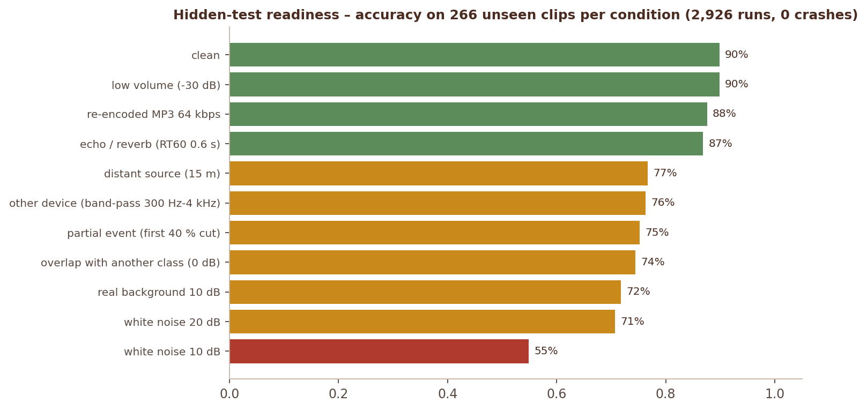
Figure 14 Hidden-test readiness per degradation (reports/hidden_test_robustness.csv)
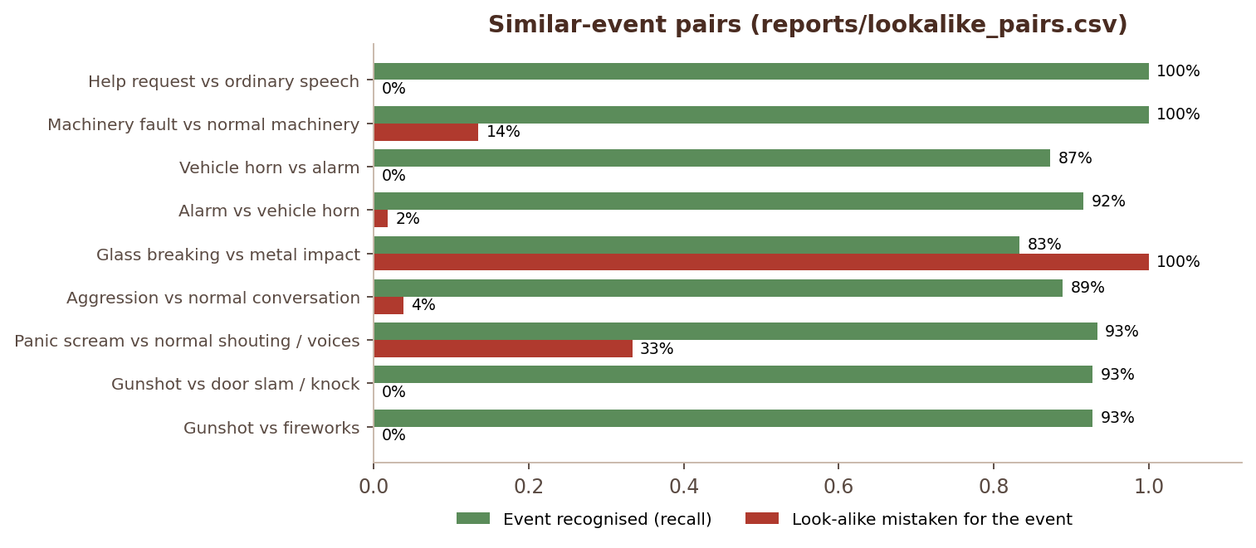
Figure 15 Similar-event pairs – event recall vs. look-alike false alarms
 CHAPTER 16

Dataset and data scripts
Building the common dataset and its current state.
SRS Steps 1, 5 · FR xvi–xix · Dataset hint

16.1 Build pipeline
● ● ● Dataset build POWERSHELL / SHELL
1 # 1. collect clips into audio_dataset/raw/<Class Name>/
2 python scripts/import_public_datasets.py --urbansound8k D:/data/UrbanSound8K --esc50 D:/data/ESC-50-master
3 python scripts/import_local_downloads.py --sources urbansound8k,esc50,mimii,gunshot,... [--dry-run]
4 python scripts/generate_help_phrases_tts.py --per-phrase 10 # offline TTS, safety phrases only
5 python scripts/record_samples.py --class "Person Asking for Help" --speaker S01 --count 20
6
7 # 2. validate, de-duplicate, Audio IDs, 44.1 kHz mono WAV, stratified 70/15/15 split
8 python scripts/build_dataset.py [--min-per-class 300] [--seed 42]
9
10 # 3. augment the TRAIN split only
11 python -m augmentation.augment --per-clip 2

data/dataset_metadata.csv columns: audio_id, filename, original_filename, class_label, source, license, duration, sample_rate, channels, original_sample_rate, original_channels, environment, device, distance_m, is_augmented, parent_audio_id, augmentation, split, quality, sha256, path. The split is made by original clip, so segments and augmented copies always stay with their parent. Also written: dataset_statistics.json, dataset_quality_report.csv, dataset_rejected.csv. See documentation/DATA_DICTIONARY.md and DATASET_GUIDE.md for sources and licences.

16.2 Current state of the data
Table 30 Current state of the data
Build | Original clips | Split (train / val / test) | Used by
Build used for the installed model | 4,629 (≈ 6.6 h) | 3,240 / 694 / 695 | py-xgb-20260924-0800, GTM run 3, all reports in this guide
Current data/dataset_statistics.json (rebuilt 2026-09-24 21:28 UTC, includes look-alike clips) | 7,061 (≈ 10.7 h), 345 rejected | 4,942 / 1,059 / 1,060 | not yet trained – retrain both models to use it

Table 31 Current state of the data – Class (current build)
Class (current build) | Clips | Class | Clips
Background Noise | 1,609 | Machinery Fault | 538
Animal Sound | 1,157 | Vehicle Horn | 390
Gunshot | 1,065 | Aggression | 298
Alarm or Siren | 867 | Person Asking for Help | 221
Panic Scream | 800 | Glass Breaking | 116

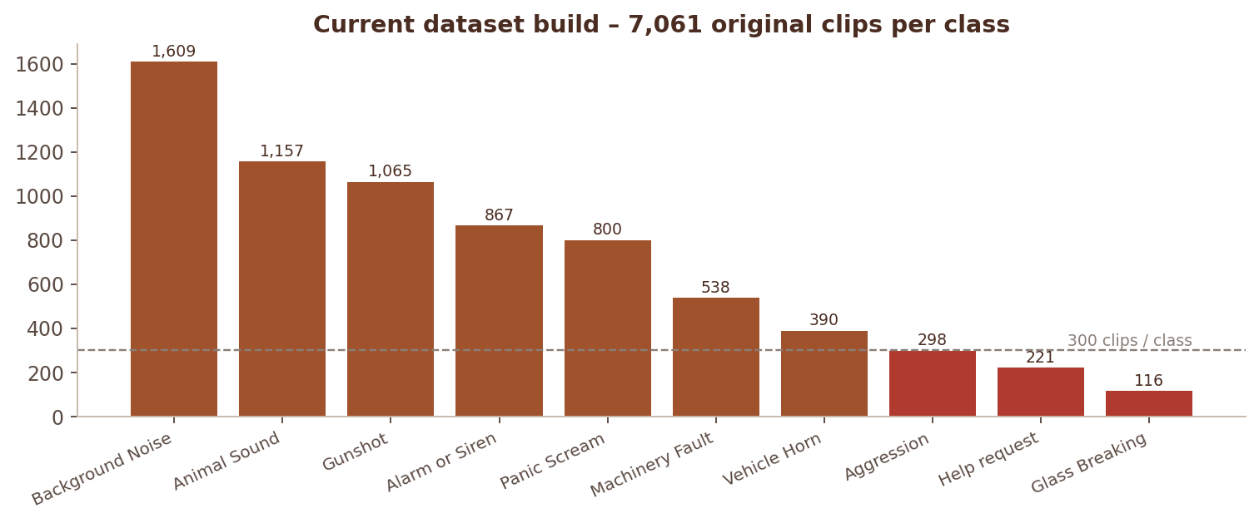
Figure 16 Clips per class in the current dataset build
WARNING Action for the team
The dataset was rebuilt after the model was trained, so the files in audio_dataset/processed/ no longer match the build the model was evaluated on. Before the next evaluation run: python -m augmentation.augment --per-clip 2 → python -m python_models.train_models --models xgb,mlp,rf → regenerate the GTM zips and retrain GTM → Admin → Model comparison. Glass Breaking (116 clips, imbalance ratio 13.9) is still the weakest class.

 CHAPTER 17

Deployment
Running SonicSentinel AI on Windows, Docker and Render.
SRS NFR 5 availability · Deliverable 12

17.1 Windows (demo laptop)
- run_server.bat – waitress with 8 threads on port 5000, automatic restart if the process exits, log in logs/server.log.
- Manual: waitress-serve --port 5000 run:app.
- The microphone requires a secure context: open the app on the same machine via http://127.0.0.1:5000 / localhost, or serve it over HTTPS.

17.2 Docker
● ● ● Dockerfile DOCKERFILE
1 FROM python:3.11-slim
2 RUN apt-get install ffmpeg libsndfile1 # MP3/M4A decoding, soundfile
3 RUN pip install -r requirements.txt gunicorn
4 ENV PORT=10000 MPLCONFIGDIR=/tmp/matplotlib NUMBA_CACHE_DIR=/tmp/numba
5 HEALTHCHECK CMD python -c "urllib.request.urlopen('http://127.0.0.1:$PORT/healthz')"
6 CMD python -m database.init_db && gunicorn -w 1 --threads 4 --timeout 180 -b 0.0.0.0:$PORT run:app

One worker keeps a single copy of the model in memory; threads handle concurrency. Build with docker build -t sonicsentinel . and run with docker run -p 10000:10000 -e SONIC_SECRET_KEY=… sonicsentinel.

17.3 Render
render.yaml defines a Docker web service sonicsentinel-ai with healthCheckPath: /healthz and a generated SONIC_SECRET_KEY. On the free plan the disk is temporary, so the SQLite database resets on every redeploy – attach a persistent disk (and point SONIC_DATA_DIR at it) or switch to PostgreSQL for real use. Full steps: documentation/DEPLOYMENT.md.

17.4 Production checklist
- Set SONIC_SECRET_KEY and change all default passwords.
- Serve over HTTPS (required for the microphone from other devices).
- Commit python_models/saved/sonic_model.joblib and gtm_model/model/* with the release (or mount them).
- Back up data/ (database, uploads) and configure retention.
- Watch /healthz and Admin → Notifications.
CHAPTER 18

Extending the system
Recipes for the most common changes and surprise modifications.
SRS SRS 1.8 surprise modification

18.1 Add a new sound class
- Add the name to CLASSES in config/settings.py (and to CRITICAL_RECALL_CLASSES / LOOKALIKE_PAIRS if relevant).
- Create audio_dataset/raw/<New Class>/ with ≥ 300 licensed or consented clips; rebuild and augment the dataset.
- Retrain the Python model; regenerate GTM zips and add a class with exactly the same name in Teachable Machine; export and replace gtm_model/model/.
- Add a rule in Admin → Alert rules (or alert_rules.json) and an icon in templates/partials/icons.html → _cls plus a colour in app.css (.cls-<name>).
- Add decision tests for the new class.

18.2 Common changes
Table 32 Common changes
Change | Where
Confidence threshold, margins, weight, windows | Admin → Settings (DEFAULT_RUNTIME_SETTINGS for new defaults)
Alert behaviour of a class | Admin → Alert rules / alert_rules.json
New audio format | add the extension to SUPPORTED_FORMATS (FFmpeg decodes it)
Maximum upload size / duration | MAX_UPLOAD_MB, MIN_DURATION_S, MAX_DURATION_S
Segment length | Admin → Settings and retrain (the Settings page warns when they differ from the model bundle)
New history filter | filtered_events() in src/routes/main.py + form in templates/history.html
New role | ROLES, @roles_required on routes, navigation in base.html, rule audience
New feature | extract_features() + feature_names(), bump FEATURE_VERSION, retrain
New Python algorithm | add a candidate in train_models.candidates(); anything with predict_proba works with inference and occlusion-based XAI
New review reason | decide() review-routing block + a test
New admin notification | audit.notify(kind, message) + a check function
PostgreSQL | change SQLALCHEMY_DATABASE_URI in create_app() (JSON columns are stored as text, so no schema change)

 CHAPTER 19

Known limitations
What the system cannot do yet and how to improve it.
SRS NFR 4 · Dataset hint
Table 33 Known limitations
Limitation | Impact | Mitigation / next step
GTM accuracy ≈ 0.61 (1-s speech-commands transfer model) | GTM alone misses the 85 % target | python_weight 0.7; disagreements go to review; a larger GTM training set or longer windows are not possible in TM audio projects
Glass Breaking has few clips (116 now, 6 test clips in the evaluated build) | precision 0.56, uncertain recall estimate | add licensed recordings (FSD50K, Freesound CC0) and retrain
Look-alike data gaps (vehicle backfire, metal impact) | those pairs cannot be measured | import_local_downloads.py --sources lookalikes + Freesound clips in downloads/extra/Background Noise/
GTM runs in the browser | uploads need an open tab for GTM; without it the result is Python-only and "Uncertain Result" | server-side TF.js would remove this but would break the SRS independence demonstration
Help detection = fixed safety phrases | not general speech recognition | documented; add phrases to the training data
SQLite | one server process for writes | PostgreSQL for multi-instance deployments
Strong white noise (≤ 10 dB SNR) | accuracy 0.55 – 0.71 | more noise augmentation; noise-robust features

 CHAPTER 20

Developer troubleshooting
Symptoms, causes and fixes for common developer problems.
SRS SRS 1.8 deliberate defect
Table 34 Developer troubleshooting
Symptom | Cause and fix
ModelNotAvailable: No trained Python model found | run python -m python_models.train_models or copy sonic_model.joblib into python_models/saved/
MP3 upload: "FFmpeg is not installed" | install FFmpeg and restart the terminal so PATH is refreshed
400 "Security token missing or expired" | the session changed (restart with a new secret key); reload the page. fetch calls must use SS.api() so the X-CSRFToken header is sent
First request after start is slow | librosa / numba JIT – warm_up() handles it; it is skipped when WARM_UP=False or in tests
GTM "missing classes" warning | label spelling in metadata.json differs from CLASSES
GTM scores all similar / wrong | check the TM export timestamp; an under-trained export scores ≈ 20 % on its own training data (see GTM_TRAINING_LOG.md)
Tests touch real data | never import src before conftest.py sets the environment variables; run tests from the project root
database is locked | long-running script and server writing to SQLite at the same time; stop one or use a separate SONIC_DB_PATH
Changes to templates / CSS not visible | restart the server and hard-refresh (Ctrl + F5)
Teachable Machine rejects zips / crashes while training | paste gtm_model/tm_upload_fix.js into the browser console first

CHAPTER 21

Glossary
Plain definitions of the terms used in this guide.
Table 35 Glossary
Term | Meaning
Audio ID | unique identifier of an analysed recording (AUD-YYYYMMDD-HHMMSS-XXXX; dataset clips AUD-000001)
Segment / window | fixed-length piece of audio classified by the models (2 s; hop 1 s for uploads)
Clip-level aggregation | turning segment scores into one score vector per recording (aggregate_scores)
Combined score | python_weight · Python + (1 − python_weight) · GTM
Consistency status | Acceptable Match, Weak Match, Model Disagreement or Uncertain Result
|Δconf| | absolute difference of the two models' top-class confidences
Top-2 margin | difference between the best and second-best class score
Look-alike | a harmless sound that resembles a critical one (fireworks vs gunshot); see LOOKALIKE_PAIRS
Repeated detection | number of consecutive segments / live windows with the same class
Strong confidence | rule field: if both models agree at or above it, one detection confirms the event
Macro-F1 | mean F1 over all classes – every class counts equally, regardless of size
Critical recall | recall of Gunshot, Glass Breaking, Panic Scream, Aggression and Help (CRITICAL_RECALL_CLASSES)
GroupKFold | cross-validation that keeps all segments / augmented copies of one recording in the same fold
TreeSHAP | exact feature-contribution method for tree models, used for the XGBoost explanation
BROWSER_FFT | the speech-commands model type exported by Teachable Machine audio projects
SNR | signal-to-noise ratio in dB; lower = noisier
RT60 | reverberation time – how long an echo takes to fade by 60 dB
CSRF | cross-site request forgery; blocked with a per-session token on every POST
TMv2 | Teachable Machine export format version stored in metadata.json

APPENDIX

Appendix A. Command reference
● ● ● Command reference POWERSHELL / SHELL
1 # environment
2 python -m venv .venv ; .venv\Scripts\activate ; pip install -r requirements.txt
3 python -m database.init_db
4
5 # run
6 python run.py [--host 0.0.0.0] [--port 5000] [--debug]
7 run_server.bat # waitress + auto-restart
8 waitress-serve --port 5000 run:app # Windows production
9 gunicorn -w 1 --threads 4 -b 0.0.0.0:$PORT run:app # Linux production
10
11 # data
12 python scripts/build_dataset.py
13 python -m augmentation.augment --per-clip 2
14
15 # models
16 python -m python_models.train_models [--fast] [--models xgb,mlp,rf]
17 python -m gtm_model.prepare_gtm_samples --max-per-class 400 --zip
18
19 # quality
20 python -m pytest -q
21 python scripts/benchmark_performance.py
22 python scripts/hidden_test_robustness.py
23 python scripts/lookalike_report.py

APPENDIX

Appendix B. Related documents
Table 36 Appendix B. Related documents
Document | Content
README.md | overview, installation, usage, surprise modifications
documentation/ARCHITECTURE.md | architecture notes
documentation/DATASET_GUIDE.md, DATA_DICTIONARY.md | data sources, licences, columns
documentation/TESTING.md | test plan and hidden-test checklist
documentation/GTM_TRAINING_LOG.md | Teachable Machine runs and evidence
documentation/DEPLOYMENT.md | Render / Docker deployment
documentation/PROJECT_REPORT.md, TECHNICAL_BLOG.md | report with diagrams, blog
documentation/SRS_COMPLIANCE.md | requirement-by-requirement compliance
documentation/VIVA_PREP.md | module owners, key functions, debugging checklist
AI_USAGE.md, DEVELOPMENT_LOG.md | AI declaration, development log
documentation/SonicSentinel_AI_User_Guide.docx | end-user guide

Appendix C. Index
A
Aggregation (clip level) 19
Alert rules 10
Alerts – routes 28
API reference 32
Application factory 27
Architecture 3
Audit trail 34
Augmentation 12
B
Benchmark 36
C
Configuration 9
CSRF 27
D
Data model 25
Dataset build 38
Decision engine 22
Deployment – Docker 40
Deployment – Render 40
Deployment – Windows 40
E
Environment variables 7
Event life cycle 26
Event page anatomy 29
Explainable AI (TreeSHAP) 34
Extending – new class 41
F
Feature extraction 14
Fingerprint / near-duplicates 14
G
GTM – model format 20
GTM – results 21
GTM – spectrogram 20
GTM – training data 20
H
Hidden-test robustness 36
K
Known limitations 42
L
Live sequence 5
Loading audio 11
Look-alike check 22
M
Model bundle 19
Model independence 5
P
Pre-processing 12
Python model – results 17
Python model – training 16
Q
Quality analysis 11
R
Repository structure 6
Routes 28
Runtime settings 9
S
Security 27
T
Test suite 35
Troubleshooting 43
U
Upload sequence 4
V
Validation 11
W
Writing tests 36

