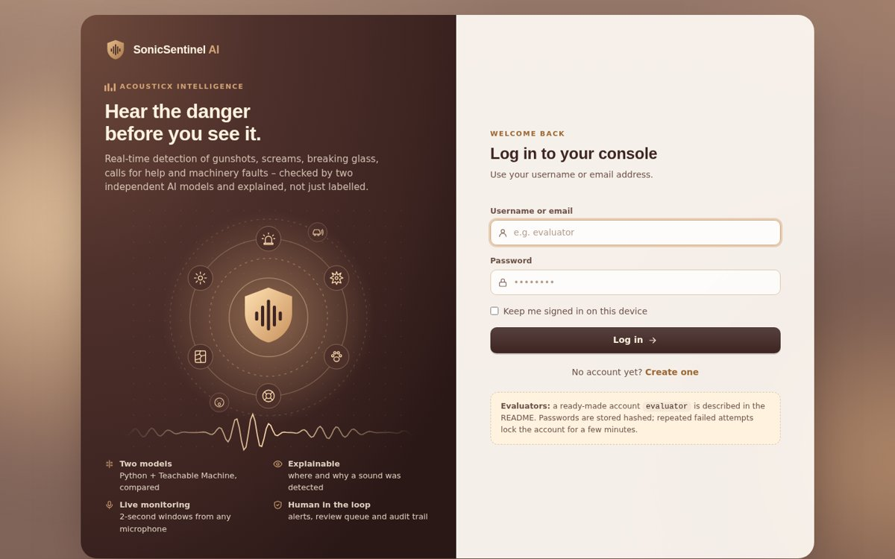
SonicSentinel AI
User Guide
AI-powered real-time sound-event detection with two independent models
Theme: AcousticX Intelligence · Category: NextWave AI and ML
Covers all functional and non-functional requirements of SRS v1.0
Version 1.0 · September 2026

Contents

1. Introduction

1.1 What SonicSentinel AI does
SonicSentinel AI is a web application that listens for important sounds and helps people act on them. It analyses uploaded audio files and live microphone input, recognises ten sound categories, and raises alerts with a severity level and a recommended action.
Every recording is classified by two independently trained models:
- Python model (XGBoost on 299 acoustic features) runs on the server.
- Google Teachable Machine (GTM) model runs in your browser (TensorFlow.js) on the same audio segments. It never sees the Python result.
The application compares both predictions and their confidence scores, checks audio quality, detects uncertain, overlapping and look-alike sounds, applies configurable alert rules and sends doubtful results to a human reviewer. Everything is stored for history, dashboards, reports and audits.
Important
SonicSentinel AI is a competition prototype built for the NextWave AI and ML SRS. It is not a certified emergency-response or law-enforcement system. Always confirm critical alerts through normal site procedures.

1.2 The ten sound categories
# | Category | Type | Typical examples
1 | Machinery Fault | Maintenance | grinding, knocking, abnormal pump or fan noise
2 | Glass Breaking | Security | window or bottle shattering
3 | Alarm or Siren | Attention | fire alarm, police / ambulance siren, clock alarm
4 | Vehicle Horn | Traffic (logged) | car, truck or motorbike horn
5 | Animal Sound | Non-critical (logged) | dog bark, cat, birds, cow
6 | Gunshot | Critical | pistol or rifle shot
7 | Panic Scream | Critical | fearful or distressed scream
8 | Aggression | Security | violent shouting, fighting
9 | Person Asking for Help | Critical | defined safety phrases such as "Help!", "Help me please"
10 | Background Noise | Informational | room tone, traffic hum, normal machinery, ordinary speech
– | Unknown | Review | shown when neither model is confident enough

1.3 Who this guide is for
Reader | Read these chapters
Every user | 2 Installation (if you run it yourself), 3 Getting started, 4 Roles, 5 Tour, 6 Analysing a recording, 10 Understanding results, 13 History
Security / Maintenance operator | plus 7 Batch, 8 Live monitoring, 11 Alerts
Audio reviewer | plus 12 Manual review
Administrator | everything, especially 14 Administration and 15 Models
Evaluator / judge | 16 Requirements traceability (every SRS requirement and where to see it) and 9 Robustness Lab

2. System requirements and installation

2.1 Hardware and software
Item | Requirement
Computer | Intel i5 / i7 or equivalent, 8 GB RAM minimum (16 GB recommended for training)
Operating system | Windows 10 / 11 (also works on Linux and macOS)
Python | 3.10 – 3.12 (Anaconda is fine)
FFmpeg | needed to decode MP3 and M4A: winget install Gyan.FFmpeg and add it to PATH
Browser | Google Chrome or Microsoft Edge (live microphone and GTM run in the browser)
Microphone | any built-in or USB microphone for live monitoring
Network | internet for the first page load (Tailwind and TensorFlow.js are loaded from a CDN)

2.2 Installing
- Open a Command Prompt / PowerShell in the project folder SonicSentinel AI.
- Create a virtual environment: python -m venv .venv, then activate it: .venv\Scripts\activate.
- Install the libraries: pip install -r requirements.txt.
- Create the database and default accounts: python -m database.init_db.
- Windows shortcut: double-click setup_windows.bat once; it performs steps 2 – 4.

2.3 Starting the application
- Run python run.py (or double-click run_windows.bat). For an always-on server use run_server.bat – it restarts automatically if it stops.
- Open http://127.0.0.1:5000 in Chrome or Edge.
- Optional health check: http://127.0.0.1:5000/healthz shows a short status report for the database, the Python model and the GTM model.
- After updating any template or style, press Ctrl + F5 in the browser so the new version is loaded.

2.4 Default accounts
python -m database.init_db creates one account for every role. Change the passwords after the first login (avatar menu → Profile → Change password).
Username | Password | Role
admin | Admin@12345 | Administrator
reviewer | Review@12345 | Audio Reviewer
security | Secure@12345 | Security Operator
maintenance | Maint@12345 | Maintenance Operator
evaluator | Eval@12345 | Normal User (for evaluators)

3. Getting started

3.1 Creating an account (Register)
The registration page is at /register (for example http://127.0.0.1:5000/register). You can also open it from the login page with the link "No account yet? Create one".
Why can't I see the Register page?
Registration is only shown to visitors who are not logged in. If you are already logged in, /register sends you straight to the Dashboard.
Log out first (avatar menu → Log out) or open /register in an Incognito window (Ctrl + Shift + N).

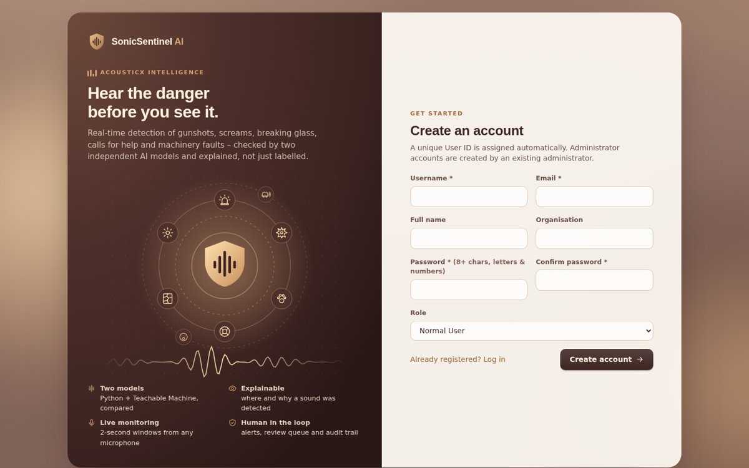
Figure 1. Register page
- Enter a username (3 – 30 letters or numbers; dot and underscore allowed) and a valid email.
- Optionally enter your full name and organisation.
- Choose a password with at least 8 characters containing letters and numbers, and type it again in Confirm password.
- Select your role (Normal User, Audio Reviewer, Security Operator or Maintenance Operator). Administrator accounts can only be created by an existing administrator.
- Click Create account. A unique User ID such as USR-00006 is assigned automatically and you can log in.
If a field is wrong, the page shows a clear message (for example "Username or email is already registered." or "Passwords do not match.") and keeps what you typed.

3.2 Logging in
Figure 2. Login page
- Open /login, enter your username or email and your password.
- Tick Keep me signed in on this device if you want to stay logged in.
- Click Log in. You arrive on the Dashboard.
Security
After 5 failed attempts the account is locked for 5 minutes. Every login, failed login and lock-out is written to the audit trail, and repeated failed logins create an administrator notification.
All forms are protected against CSRF and passwords are stored only as secure hashes.

3.3 Your profile
Click your avatar (top right) → Profile. Here you can see your User ID, role, member-since date and last login, update your name, email, phone and organisation, and change your password (current password required).
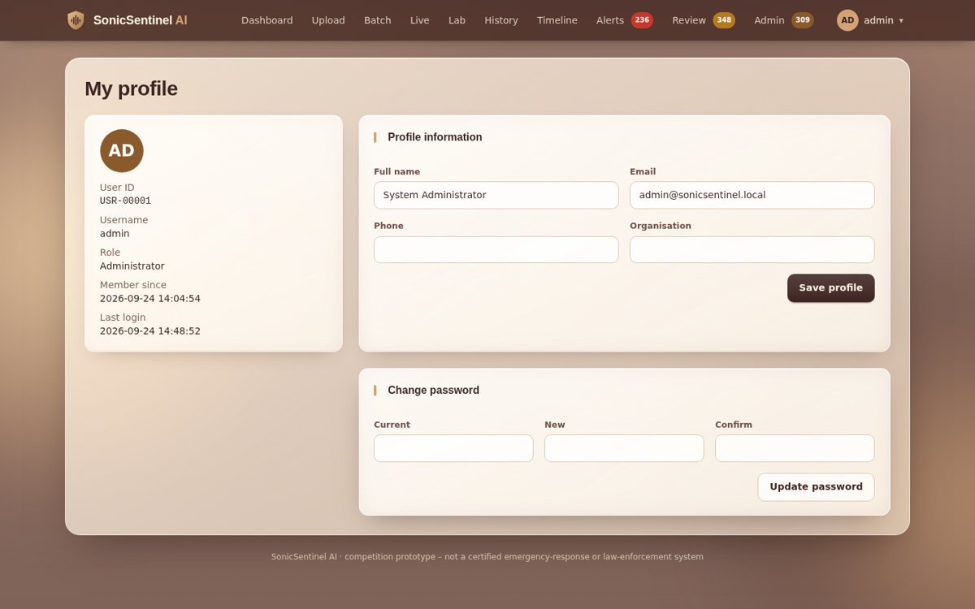
Figure 3. Profile page

3.4 Logging out
Avatar menu → Log out. If live monitoring is running, stop it first – the browser stops the microphone when you leave the page anyway.

4. User roles and permissions
Every account has exactly one of five roles. The navigation bar only shows the pages your role may use; opening a page that is not allowed shows a clear "Access denied" message.
Page / action | Normal User | Audio Reviewer | Security Operator | Maintenance Operator | Administrator
Dashboard, Upload, Live, Lab, History, Timeline | ✓ | ✓ | ✓ | ✓ | ✓
Batch upload | – | ✓ | ✓ | ✓ | ✓
See events of other users / filter by user | own only | ✓ | ✓ | ✓ | ✓
Alerts (acknowledge / escalate / dismiss), Alert history | – | – | security alerts | maintenance alerts | all
Manual-review queue, confirm / correct | – | ✓ | – | – | ✓
Admin pages (analytics, settings, rules, users, audit, models, exports) | – | – | – | – | ✓

Alert routing follows the audience of each alert rule: Machinery Fault goes to Maintenance, Alarm or Siren to Security and Maintenance, the other critical classes to Security. The administrator always sees everything.

5. A tour of the interface

5.1 Navigation bar
The dark bar at the top is visible on every page:
- Dashboard · Upload · Batch · Live · Lab · History · Timeline – main work pages.
- Alerts (red badge = active alerts), Review (amber badge = events waiting for review), Admin (purple badge = unread notifications) – shown only to the roles that use them.
- Avatar menu (top right) – your User ID and role, Profile, Alert history and Log out.
- On a phone or tablet the menu folds into a ☰ button. Every page works at phone width.
New alerts appear as toast pop-ups in the corner of every page for Security, Maintenance and Admin users, so nobody has to keep the Alerts page open.

5.2 Dashboard
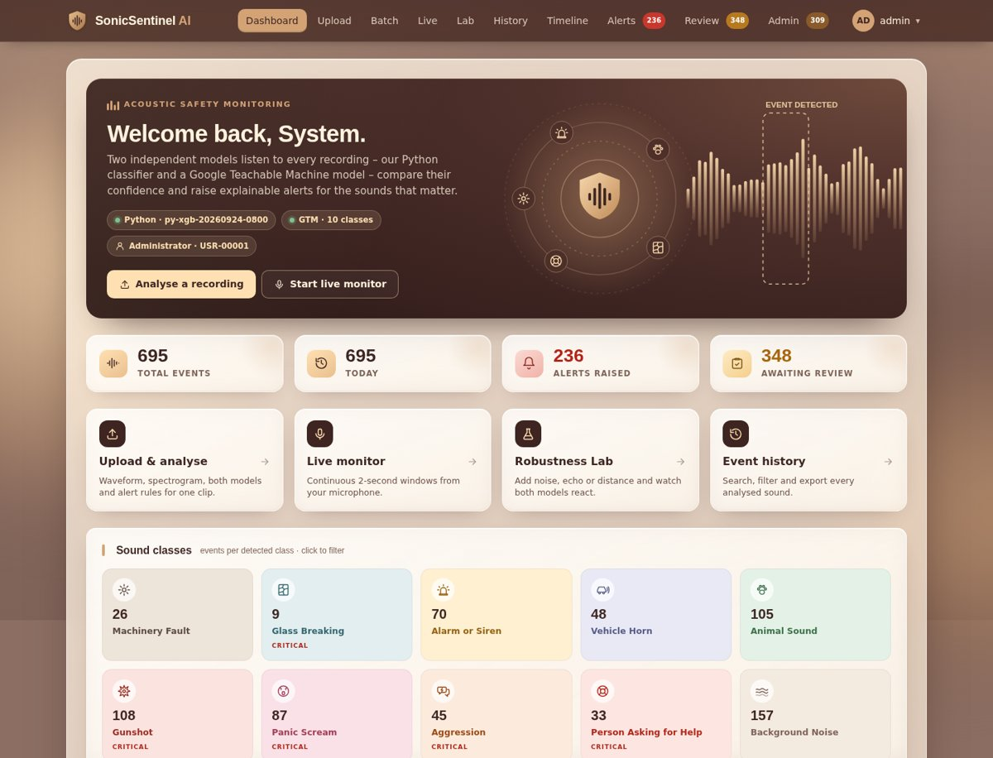
Figure 4. Dashboard
Area | What it shows
Welcome banner | status pills for the Python model version, the GTM model (number of classes) and your role; buttons Analyse a recording and Start live monitor
GTM status bar | warning if the Teachable Machine model is missing or has missing / extra class names
Four number tiles | Total events, Today, Alerts raised (click → Alerts), Awaiting review (click → Review queue)
Quick actions | shortcuts to Upload & analyse, Live monitor, Robustness Lab, Event history
Sound classes | one tile per class with its icon and number of events; critical classes are tagged CRITICAL; click a tile to see those events in History
Latest detections | the most recent events with class, confidence, severity, quality and status
Critical events · Recent uploads · Audio-quality warnings · Manual-review queue | short lists that link straight to each event

6. Analysing a recording (Upload)

6.1 Supported files
Rule | Value
Formats | WAV, MP3, FLAC, OGG, M4A
Maximum size | 25 MB
Duration | 0.5 s to 5 minutes
Channels / sample rate | any; converted to mono 22,050 Hz (Python) and 44,100 Hz (GTM)

6.2 Step by step
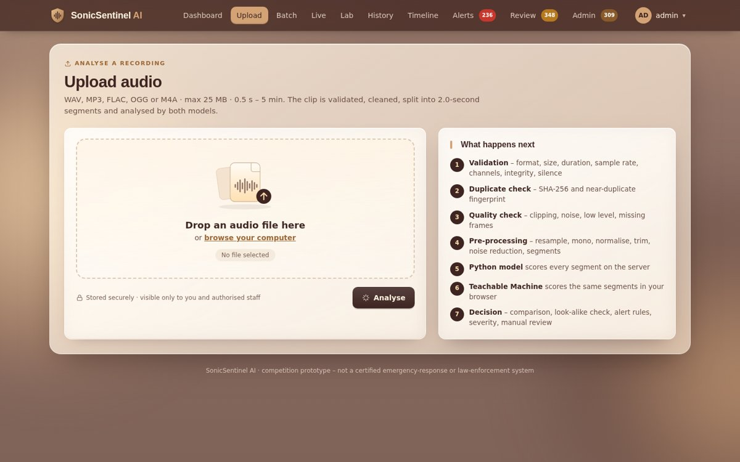
Figure 5. Upload page
- Click Upload in the navigation bar.
- Drag and drop a file onto the drop area or click browse your computer.
- Listen to the file in the preview player (play, pause, replay, seek, volume) to make sure it is the right one.
- Click Analyse. The steps on the right run automatically: validation → duplicate check → quality check → pre-processing → Python model → Teachable Machine → decision.
- The event page opens. Keep the tab open for a moment: the GTM model runs in your browser and its scores are added to the event automatically.
If the upload is rejected
You get a plain message that says what is wrong – for example unsupported format, file too large, too short or too long, cannot be decoded (install FFmpeg for MP3/M4A), silent recording, or identical to an earlier upload (the earlier Audio ID is shown).

6.3 What happens to the audio
Stage | What the application does
Validation | checks format, size, duration, sample rate, channels, file integrity and whether there is any signal
Duplicate check | SHA-256 hash finds identical files; an audio fingerprint finds re-encoded, trimmed or volume-changed copies (near-duplicates)
Quality analysis | silence, clipping, background noise / SNR, low level, duration, encoding problems and missing frames → Good, Acceptable, Poor or Unusable
Pre-processing | resample, convert to mono, normalise, trim silence, reduce noise, split into 2-second segments with 1-second hop, pad or truncate
Features | 299 acoustic features per segment (MFCC, Mel, chroma, ZCR, RMS, spectral centroid / bandwidth / roll-off, onset, tempo …)
Python model | scores all 10 classes for every segment; the strongest segment decides
GTM model | classifies the same segments in the browser and returns scores for all 10 classes
Comparison and decision | compares both models, combines the scores, runs the look-alike, overlap and repeat checks, applies the alert rule, sets severity, alert and review status
Storage | saves the file, images, both models' scores and versions, quality, decision, alerts and the full decision trace

6.4 Reading the event page
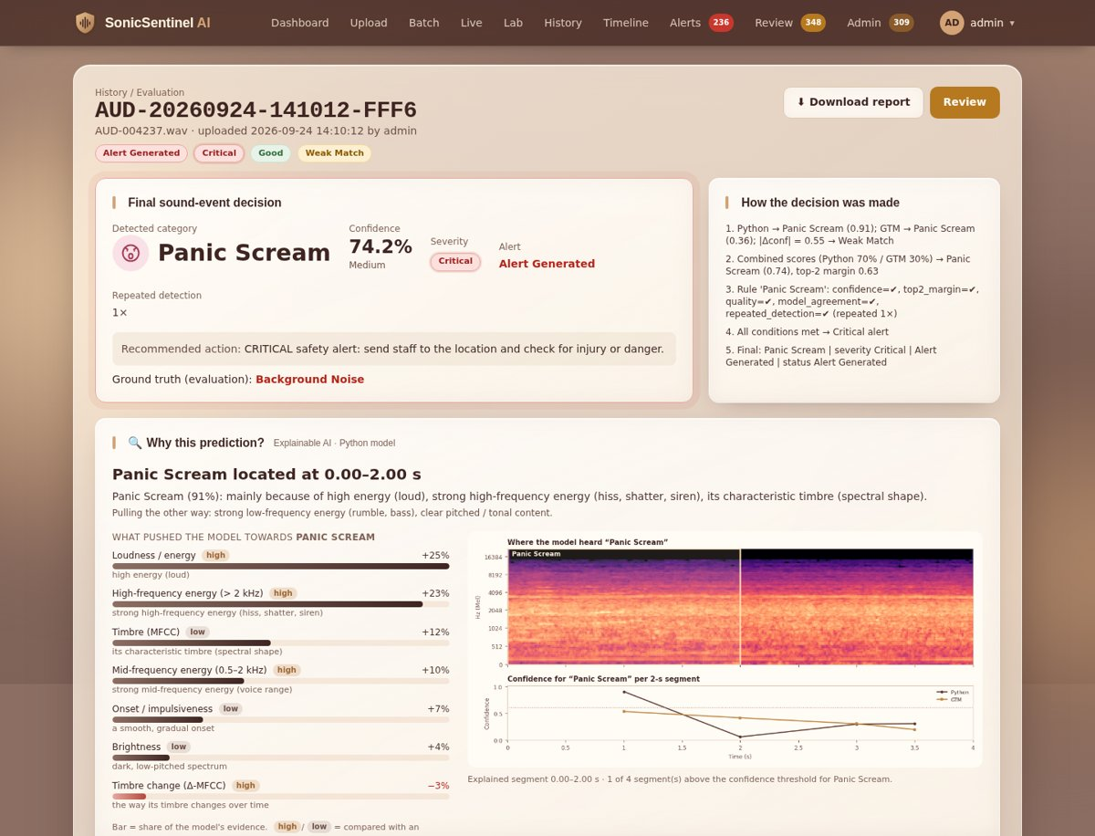
Figure 6. Event page (top part)
Each event has a unique Audio ID such as AUD-20260924-141012-FFF6. The page is divided into sections:
Section | What you find there
Header | Audio ID, file name, upload time, status badges and the buttons Download report and Review (reviewers)
Final sound-event decision | detected category with its icon, confidence and confidence level (High / Medium / Low), severity, alert status, repeated-detection count and the recommended action
How the decision was made | numbered trace of every step: both predictions, combined scores, rule checks, look-alike check, repeats and the final result
Why this prediction? (Explainable AI) | the time span that decided the result, the feature groups that pushed the model towards or away from the class (loudness, high-frequency energy, timbre, onset …) and a heat-map on the spectrogram
Waveform & spectrogram | waveform with the segments marked and the deciding segment highlighted, plus the Mel spectrogram
Audio quality | quality label, estimated noise level in dB and every issue found (silence, clipping, low level …)
Metadata | format, duration, sample rate, channels, bit depth, size, upload time, SHA-256, duplicates, model versions and processing time
Model prediction & confidence comparison | Python and GTM side by side: top-3 of each model, confidence bars for all 10 classes, class match, |Python − GTM| confidence difference, top-2 margins and the consistency status
Segments | every segment with start / end time, both predictions and an audio player
Alerts / Reviews | alerts raised for this event with their actions, and all reviewer decisions

6.5 Downloading a report
On the event page click Download report. A printable report opens with all results, images and the decision trace. Click Print / Save as PDF and choose Save as PDF as the printer.

7. Batch upload
Use Batch (all roles except Normal User) to analyse many clips at once.
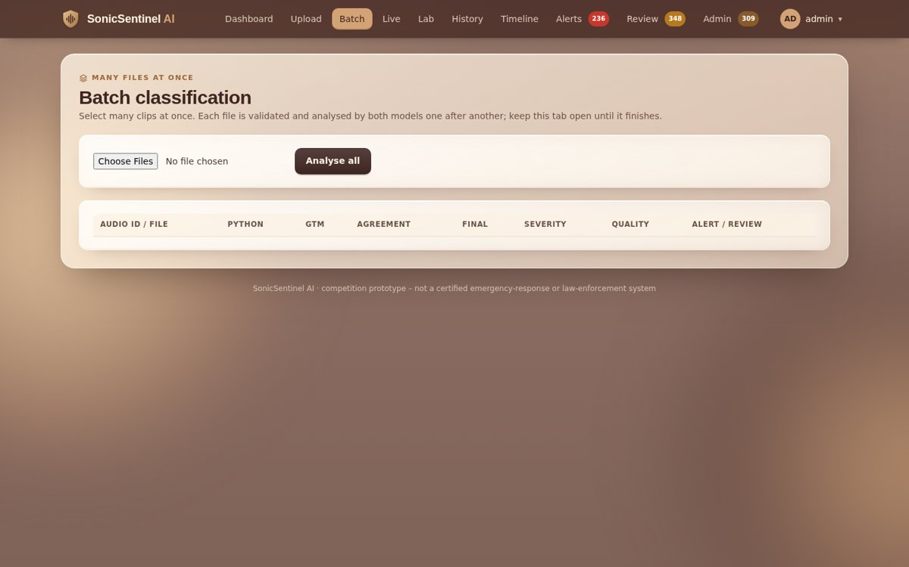
Figure 7. Batch classification page
- Click Choose Files and select several audio files.
- Click Analyse all. Each file is validated and analysed by both models, one after another.
- The table fills row by row with Audio ID, Python, GTM, agreement, final class, severity, quality and alert / review status. Keep the tab open until it finishes.
- Click any Audio ID to open its event page.

8. Live microphone monitoring
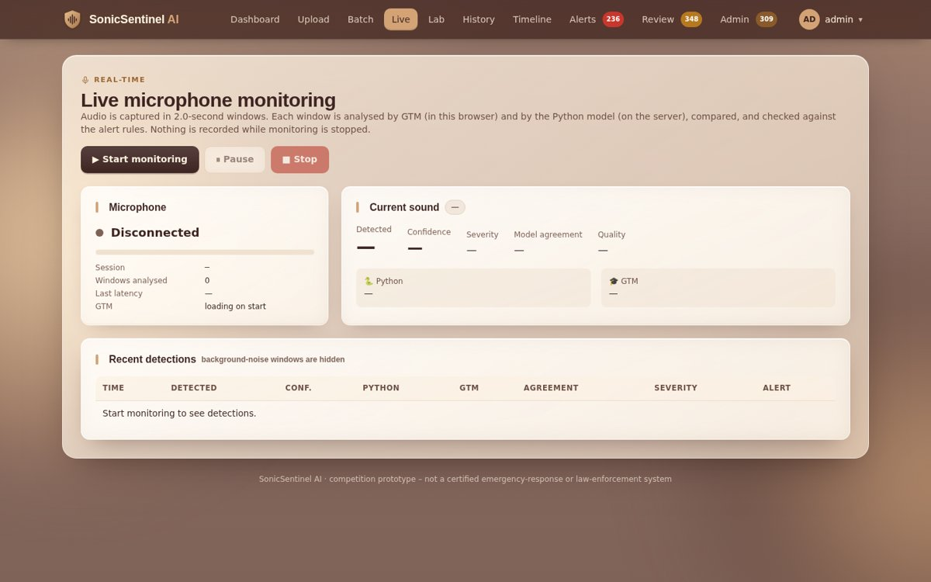
Figure 8. Live monitoring page
- Click Live and then ▶ Start monitoring.
- The browser asks for microphone permission – click Allow.
- A red privacy banner appears on every page while the microphone is active. Nothing is recorded while monitoring is stopped.
- Audio is analysed in 2-second windows: GTM in the browser and the Python model on the server. Current sound shows the latest result, confidence, severity, model agreement and quality.
- Recent detections lists every window that is not background noise; alerts appear there and as toasts.
- Use ⏸ Pause to stop listening for a moment and ■ Stop to end the session.
Microphone status | Meaning
Available | a microphone was found and can be started
Active | monitoring is running
Paused | monitoring is paused; the microphone is not being analysed
Disconnected | no microphone found or it was unplugged
Permission denied | the browser blocked the microphone – click the lock icon in the address bar → Microphone → Allow, then reload

Tips for good live results
Use Chrome or Edge on http://127.0.0.1:5000 (the microphone needs localhost or https).
Keep the sound source close and the room reasonably quiet; play test sounds at normal volume, not distorted.
Critical classes such as Gunshot need 2 detections in a row (see chapter 10) – short single sounds may go to review instead of raising an alert.

9. Robustness Lab
The Lab shows how the models behave when a recording gets worse. Nothing in the Lab is stored as an event.
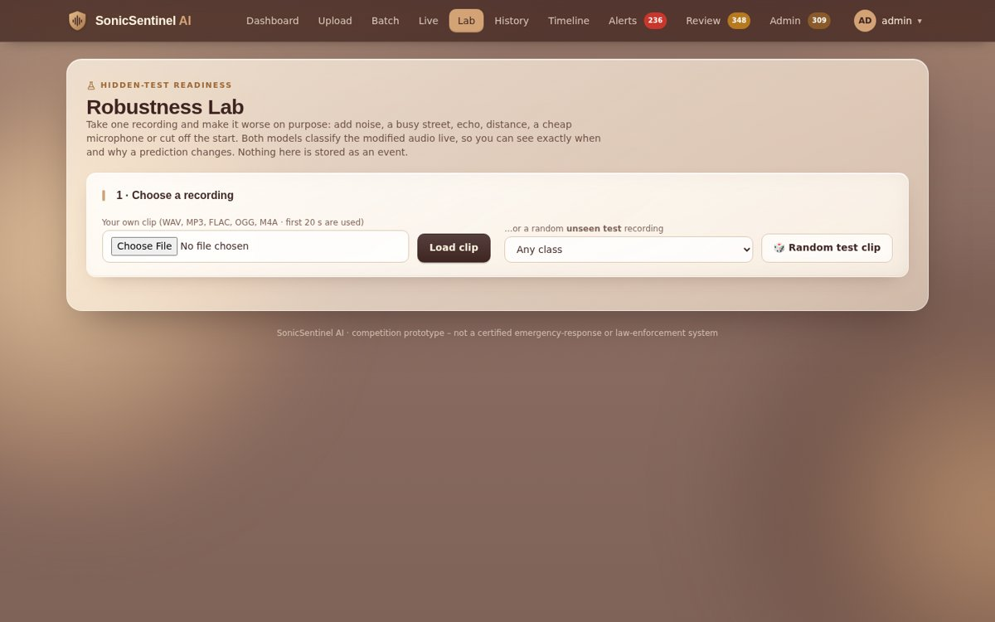
Figure 9. Robustness Lab
- Choose a recording – upload your own clip (first 20 s are used) or click Random test clip to load an unseen test recording (optionally of one class).
- Degrade the recording – pick a preset (Clean, Busy street, Echoing hall, Far away, Cheap phone, Very quiet, Half cut off, Worst case) or move the sliders: white noise (SNR), real background noise, echo (RT60), distance, volume, cut-off start, cheap phone microphone.
- Live result – both models classify the modified audio immediately; listen to it and compare the confidence bars.
- Stress test – click Run with white noise or Run with real background noise. Seven versions from clean to 0 dB SNR are classified and a curve shows how confidence falls.

10. Understanding the results

10.1 Confidence levels
Level | Rule (default settings)
High | combined confidence ≥ 85 %
Medium | combined confidence ≥ minimum confidence (60 %)
Low | below the minimum confidence – the event is marked uncertain
Unknown | combined confidence below the unknown threshold (35 %) – the sound is not given a class

The combined confidence is a weighted average of both models: python_weight × Python + (1 − python_weight) × GTM. If GTM is not available the Python score is used alone.

10.2 Model consistency status
Status | Meaning
Acceptable Match | both models predict the same class, both are above the minimum confidence and their confidences differ by ≤ 0.20
Weak Match | same class, but one model is unsure or the confidence difference is larger
Model Disagreement | the two models predict different classes – the event goes to manual review
Uncertain Result | both models are below the minimum confidence, or the GTM result is missing

10.3 Audio-quality levels
Quality | Meaning
Good | clean signal, no problems found
Acceptable | small problems (some noise, low level) – results are still reliable
Poor | strong noise, clipping, very low level or very short – results may be wrong; the event can be sent to review
Unusable | silent, broken or missing frames – no reliable classification is possible

10.4 Severity levels and default alert rules
There are five severity levels: Informational → Low → Medium → High → Critical. The default rule for every class is shown below. An administrator can change all of them in Admin → Alert rules.
Class | Severity | Alert? | Min. conf. | Detections needed | Sent to | Recommended action (short)
Machinery Fault | High (→ Critical after 5 repeats) | Yes | 0.65 | 2 (1 if both ≥ 0.85) | Maintenance | stop / isolate the machine, schedule inspection
Glass Breaking | High (→ Critical after 3) | Yes | 0.65 | 2 (1 if both ≥ 0.80) | Security | check location / CCTV for break-in
Alarm or Siren | High | Yes | 0.65 | 2 (1 if both ≥ 0.85) | Security, Maintenance | verify alarm source, follow emergency procedure
Vehicle Horn | Low (→ Medium after 6) | No – stored as traffic event | 0.60 | 1 | – | logged, no action unless it persists
Animal Sound | Low | No – non-critical event | 0.60 | 1 | – | logged, check context
Gunshot | Critical | Yes | 0.70 | 2 (1 if both ≥ 0.85) | Security | alert security, keep people away, call emergency services
Panic Scream | Critical | Yes | 0.65 | 1 | Security | send staff, check for injury or danger
Aggression | High (→ Critical after 2) | Yes | 0.65 | 1 | Security | dispatch a security officer
Person Asking for Help | Critical | Yes | 0.65 | 1 | Security | respond to the location immediately
Background Noise | Informational | No (alert only if noise floor > −20 dB) | 0.50 | 1 | – | no action
Unknown | Low | No – manual review | – | 1 | Reviewers | review the sound manually

Repeated-detection confirmation
For classes that need 2 detections, the event must be found in consecutive segments or live windows within the repeat window (10 s). If it is detected only once and the rule says manual review if unconfirmed, the event goes to the review queue with the reason "Critical event without sufficient confirmation". If both models agree above the strong confidence, one detection is enough.

10.5 Look-alike check (similar events)
The SRS asks the application to tell similar sounds apart. Look-alike recordings are trained as Background Noise (or the other class), and every decision also runs a look-alike check: if the gap between the event and its look-alike is smaller than lookalike_margin (0.20), the event goes to review with the reason "Possible look-alike: could be …". If a sound is classified as Background Noise but a critical class is still strong, it is flagged as "Possible <class> that sounds like …".
Event | Look-alike it is checked against
Gunshot | fireworks, vehicle backfire, door slam
Panic Scream | normal shouting or loud voices
Aggression | normal conversation
Glass Breaking | metal impact or other impact sounds
Alarm or Siren ↔ Vehicle Horn | each other
Machinery Fault | normal machinery
Person Asking for Help | ordinary speech

10.6 Uncertain, overlapping and unknown sounds
- Uncertain – the event is marked uncertain when confidence is below the threshold, the top-2 classes are too close (margin < 0.15), quality is Poor, the models disagree, GTM is unavailable or sounds overlap. The reasons are listed on the event page.
- Overlapping sounds – when two or more non-background classes are above 0.25 in the same segment, both classes are shown and the event goes to review.
- Unknown – when the combined confidence is below the unknown threshold, the category is Unknown, no alert is raised and the event goes to review.

10.7 Event statuses
Status | Meaning
Uploaded | file received and validated
Classified | analysed, no alert and no review needed
Uncertain | analysed, but the result is not reliable
Alert Generated | an alert was raised
Manual Review | waiting in the review queue
Reviewed | a reviewer confirmed or corrected it
Closed | handling finished

11. Alerts
Security Operators, Maintenance Operators and Administrators see the Alerts page. Each role sees only the alerts routed to it; the administrator sees all.
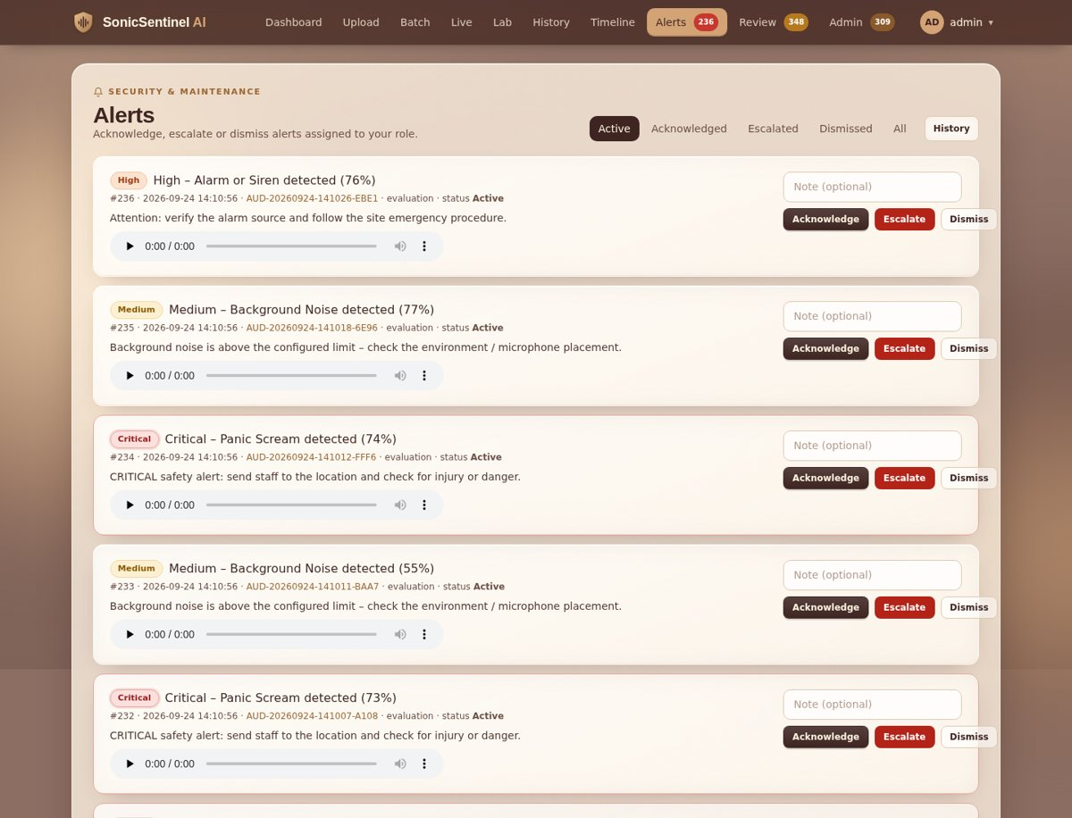
Figure 10. Alerts page
- Open Alerts. The tabs filter by status: Active, Acknowledged, Escalated, Dismissed, All.
- Each card shows severity, class, confidence, time, Audio ID, the recommended action and an audio player – listen before you act.
- Optionally type a note, then click one of:
Action | Effect
Acknowledge | you have seen the alert and are handling it
Escalate | raises the alert and the event to Critical
Dismiss | false alarm or no action needed

Every action is saved with your name, time and note. Alert history (avatar menu → Alert history) lists all alerts and all user actions.
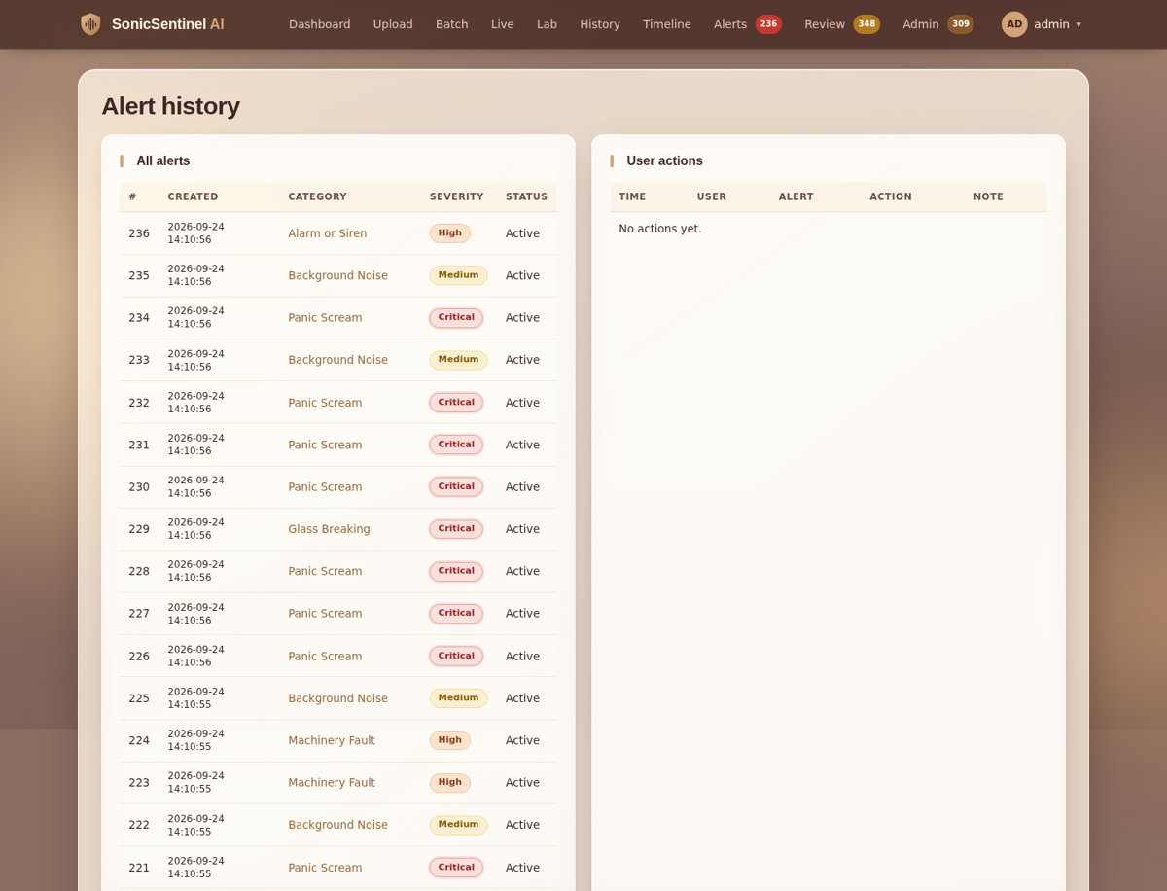
Figure 11. Alert history

12. Manual review
Audio Reviewers and Administrators open Review to see the queue of events that need a human decision.
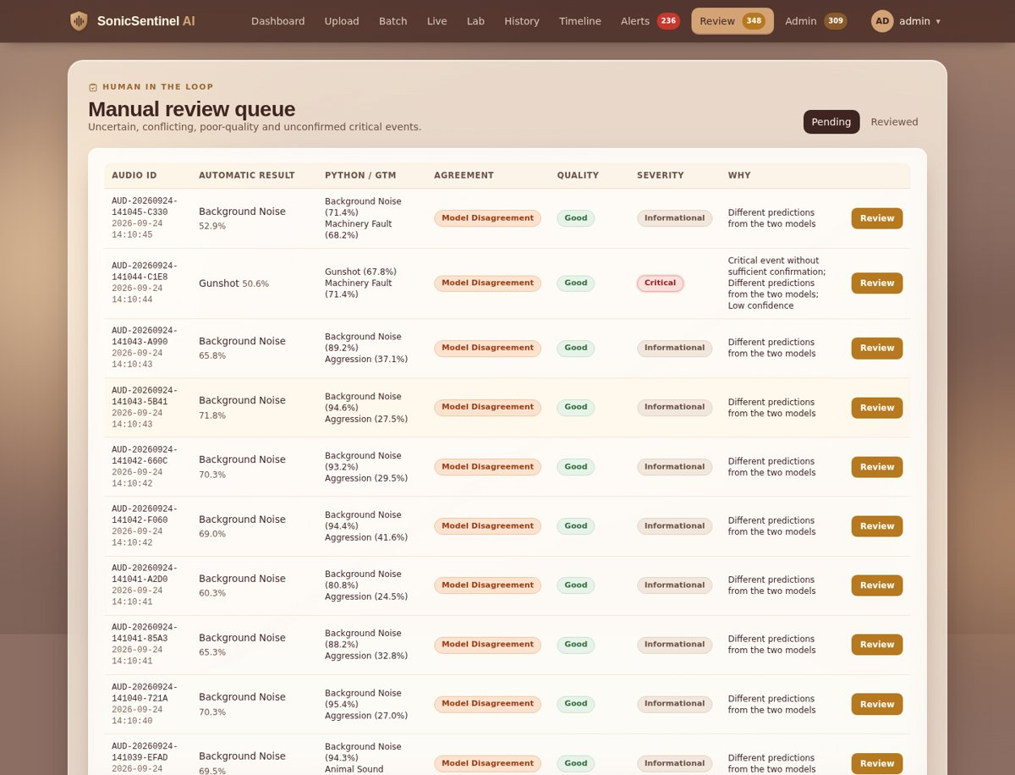
Figure 12. Manual-review queue

12.1 Why an event is sent to review
Reason shown | Cause
Different predictions from the two models | Python and GTM disagree
Low confidence | combined confidence below the minimum
Poor audio quality | quality is Poor or Unusable
Similar top-class confidence scores | top-2 margin below the setting
Overlapping sounds | two or more event classes at once
Unsupported / unknown sound pattern | result is Unknown
Critical event without sufficient confirmation | critical class detected but not repeated / not agreed
Possible false alarm | one model gives the class less than 0.20
Possible look-alike: could be … | look-alike check failed

12.2 Reviewing an event
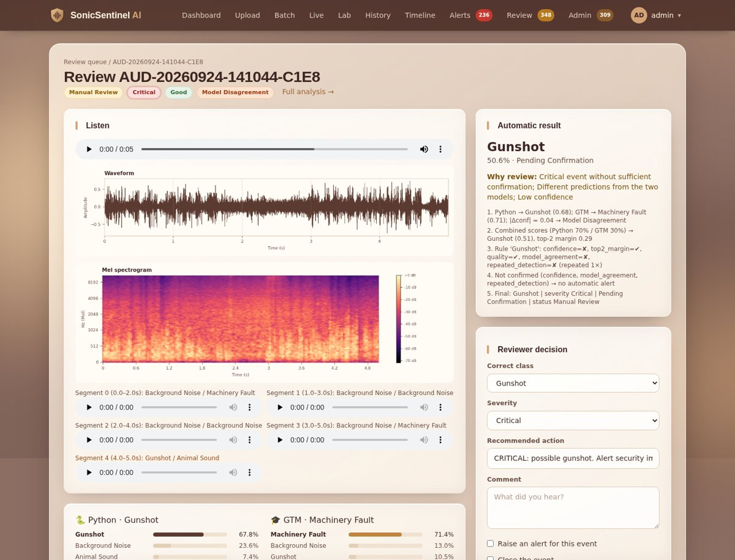
Figure 13. Review page
- Click Review on an event in the queue.
- Listen to the whole recording and to each segment; look at the waveform, spectrogram and both models' scores.
- In Reviewer decision choose the correct class and severity, edit the recommended action and write a comment.
- Tick Raise an alert for this event if it needs one, and/or Close the event.
- Click Save review. The original Python and GTM outputs are kept; your decision is stored separately as an override and appears in history and analytics (false positives / negatives).

13. History, search and timeline

13.1 Event history
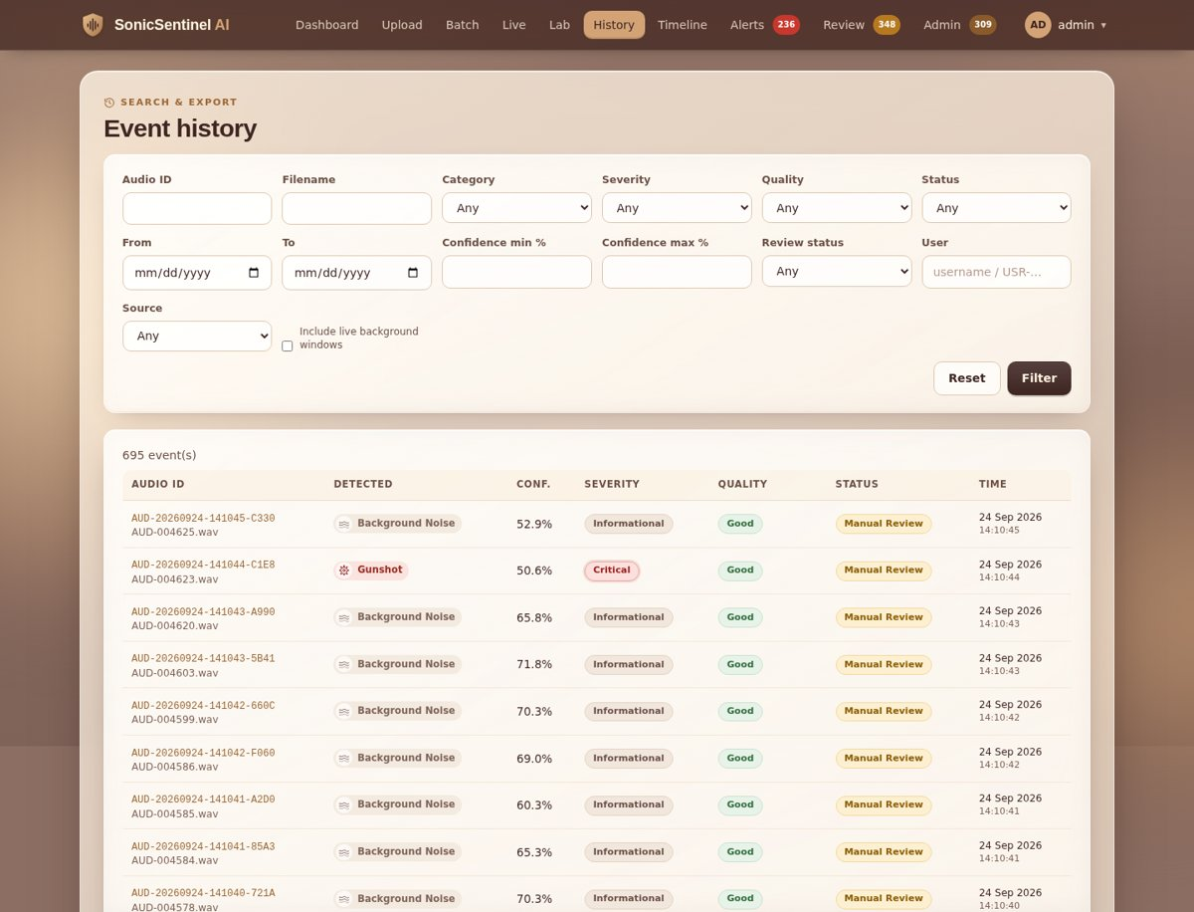
Figure 14. Event history with filters
History lists all events you are allowed to see (Normal Users see their own). Filter by any combination of:
Filter | Filter | Filter
Audio ID | File name | Category (incl. Unknown)
Severity | Quality | Status
Date from / to | Confidence min / max % | Review status (pending / reviewed)
User (not for Normal User) | Source (upload, batch, live, evaluation) | Include background noise

Click Filter to apply and Reset to clear. Click an Audio ID to open the event.

13.2 Timeline
Timeline shows detected events in time order, grouped by day, with class, severity and status. Choose the period (last 1, 7, 30 or 90 days) at the top right. Background noise is hidden.
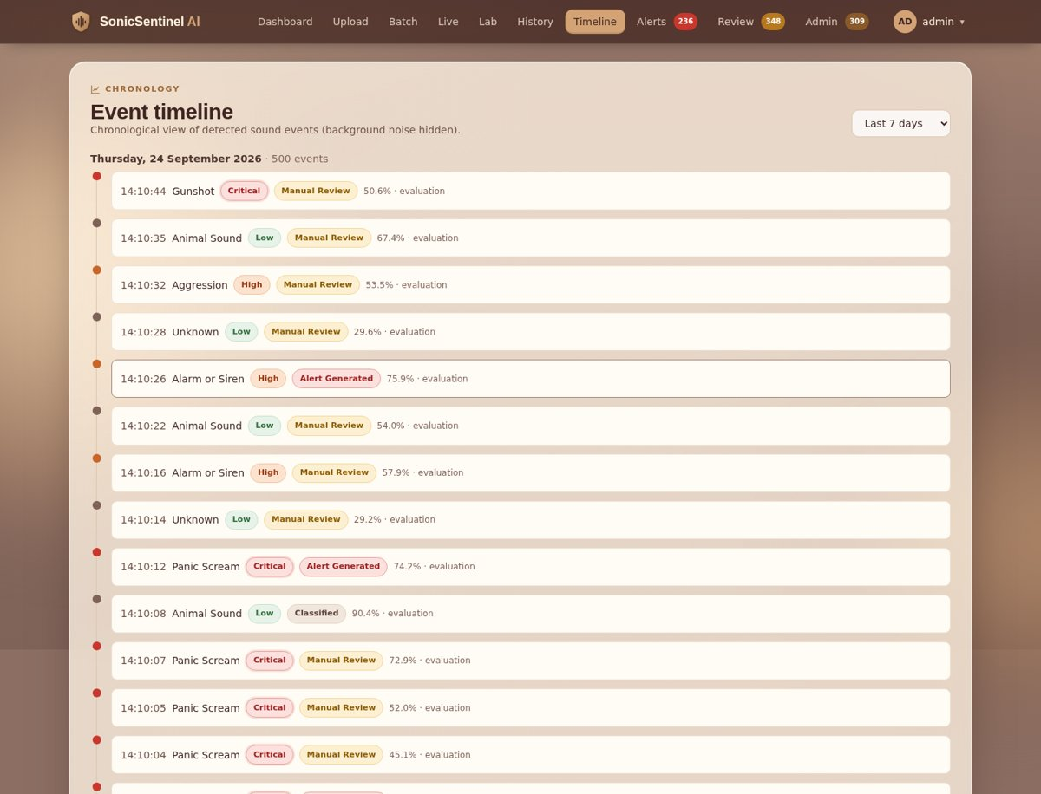
Figure 15. Event timeline

14. Administration
Administrators open Admin in the navigation bar. The tabs at the top of every admin page are: Analytics · Model comparison · Models · Alert rules · Settings · Users · Audit trail · Notifications.

14.1 Analytics dashboard
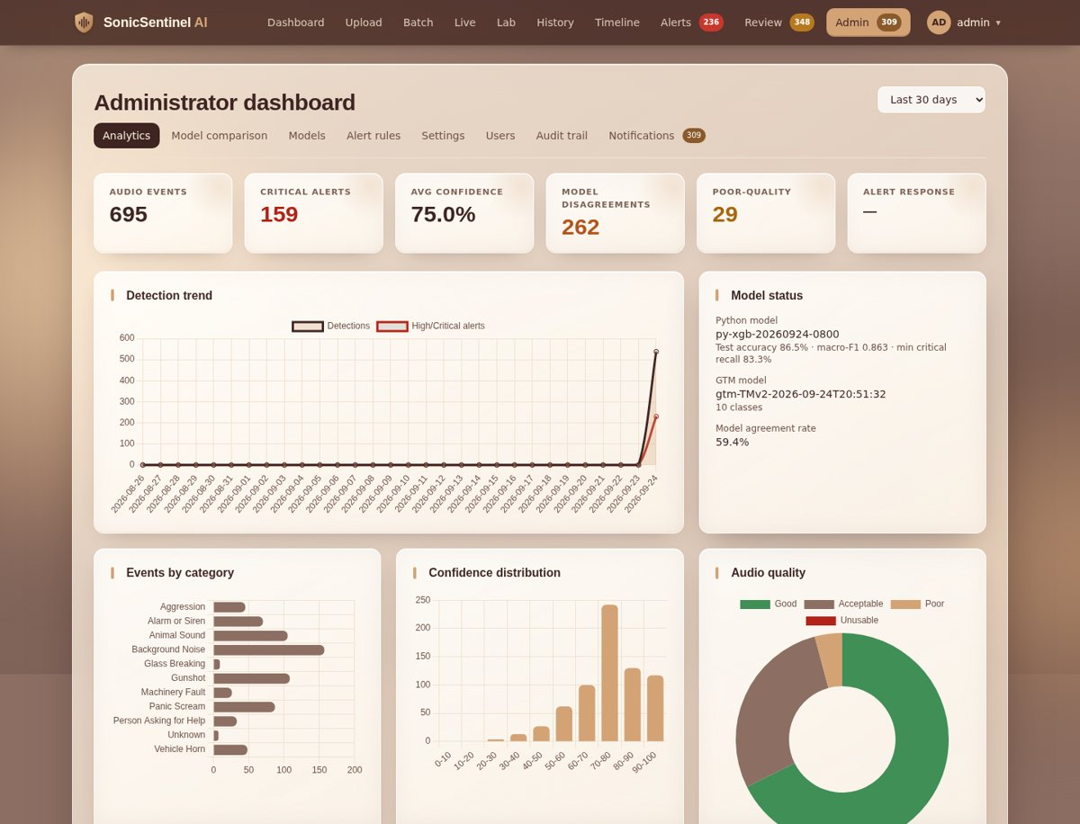
Figure 16. Administrator dashboard
Choose the period (last 7, 30, 90 or 365 days) at the top right. The page shows:
- Key numbers: audio events, critical alerts, average confidence, model disagreements, poor-quality recordings and average alert response time.
- Detection trend (events and high / critical alerts per day) and Model status (Python and GTM versions, test accuracy, model agreement rate).
- Events by category, Confidence distribution and Audio quality charts.
- False positives / negatives from reviews and evaluation, Alert response times, and the latest anomaly notifications.
- Exports – download events, alerts, reviews, audit, comparison or evaluation data as CSV or Excel (.xlsx).

14.2 Model comparison (SRS comparison report)
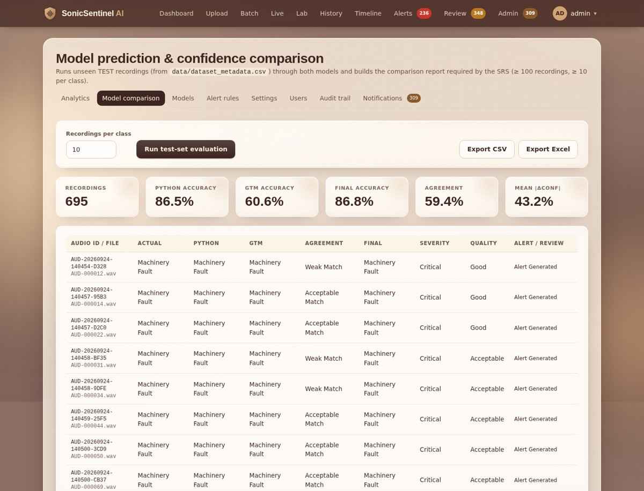
Figure 17. Model prediction & confidence comparison
- Open Admin → Model comparison.
- Set Recordings per class (at least 10) and click Run test-set evaluation. Unseen TEST recordings are analysed by both models exactly like normal uploads (keep the tab open – GTM runs in the browser).
- The page shows Python accuracy, GTM accuracy, final accuracy, agreement rate and mean |Δconf|, plus one row per recording (actual class, both predictions, agreement, final class, severity, quality, alert / review).
- Click Export Excel (or Export CSV) to save the report required by the SRS (reports/model_comparison_report.xlsx).

14.3 Alert rules
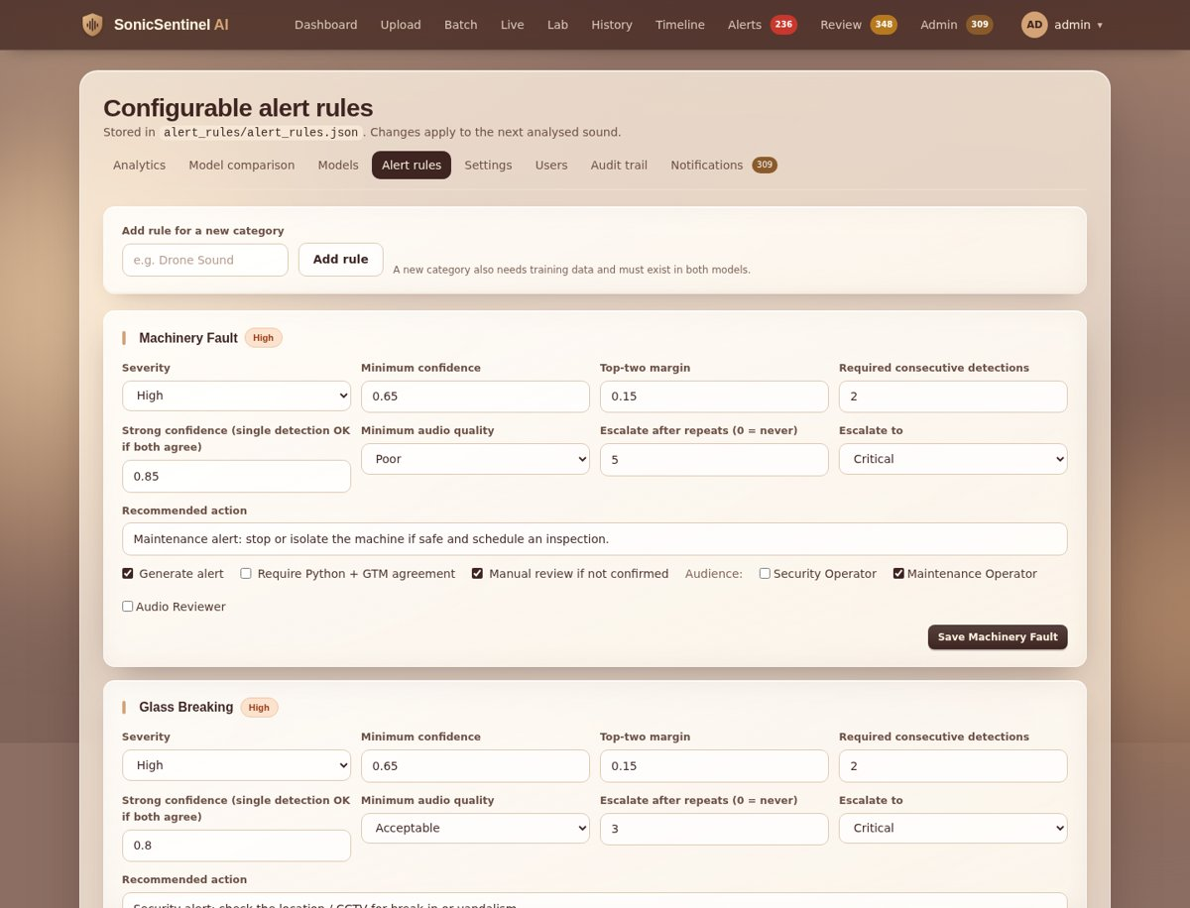
Figure 18. Alert-rule editor
Each class has one rule. Change any field and click Save <class>; the change applies to the next analysed sound and is written to alert_rules/alert_rules.json.
Field | Meaning
Severity | Informational, Low, Medium, High or Critical
Minimum confidence | combined confidence needed for the rule
Top-two margin | minimum gap between the best and second-best class
Required consecutive detections | repeats needed within the repeat window
Strong confidence | if both models agree at or above this, one detection is enough (0 = never)
Minimum audio quality | worst quality accepted for an automatic alert
Escalate after repeats / Escalate to | raise severity when the event keeps repeating
Recommended action | text shown to operators
Generate alert · Require Python + GTM agreement · Manual review if not confirmed | switches
Audience | which roles receive the alert (Security Operator, Maintenance Operator, Audio Reviewer)

Add rule for a new category – type a new category name and click Add rule. A new category also needs training data and must exist in both models.

14.4 Detection settings
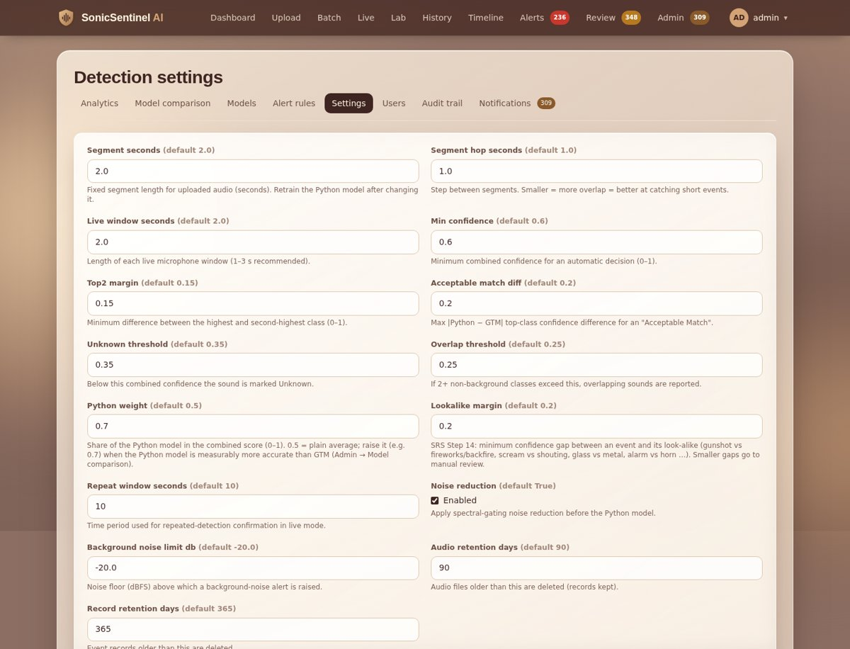
Figure 19. Detection settings
Setting | Default | Recommended | What it does
Segment seconds | 2.0 | 2.0 | segment length for uploads (retrain the Python model after changing it)
Segment hop seconds | 1.0 | 1.0 | step between segments; smaller catches short events better
Live window seconds | 2.0 | 2.0 | length of each live window (1 – 3 s)
Min confidence | 0.60 | 0.60 | minimum combined confidence for an automatic decision
Top-2 margin | 0.15 | 0.15 | minimum gap between best and second-best class
Acceptable match diff | 0.20 | 0.20 | max |Python − GTM| confidence difference for "Acceptable Match"
Unknown threshold | 0.35 | 0.35 | below this combined confidence → Unknown
Overlap threshold | 0.25 | 0.25 | two or more classes above this → overlapping sounds
Python weight | 0.5 | 0.7 | share of the Python model in the combined score; 0.7 gave the best test accuracy (86.8 %)
Look-alike margin | 0.20 | 0.20 | minimum gap between an event and its look-alike
Repeat window seconds | 10 | 10 | time window for repeated-detection confirmation
Noise reduction | on | on | spectral-gating noise reduction before the Python model
Background noise limit dB | −20 | −20 | noise floor above which a background-noise alert is raised
Audio retention days | 90 | 90 | audio files older than this are deleted (records kept)
Record retention days | 365 | 365 | event records older than this are deleted

Click Save settings. Run retention applies the data-retention policy immediately (it also runs every time the application starts).

14.5 Users and roles
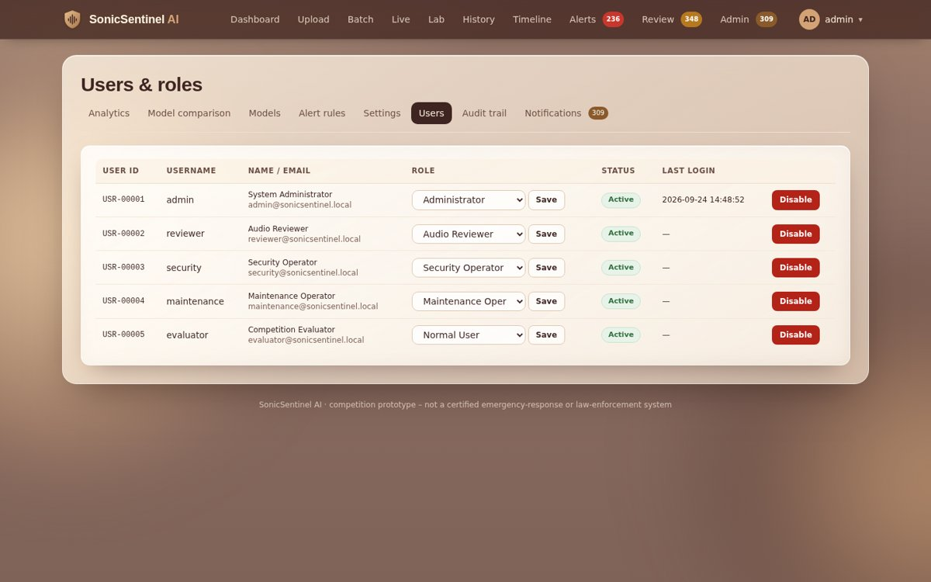
Figure 20. Users & roles
Change any user's role with the drop-down and Save, or Disable / Enable an account. Disabled users cannot log in. All changes are audited.

14.6 Audit trail
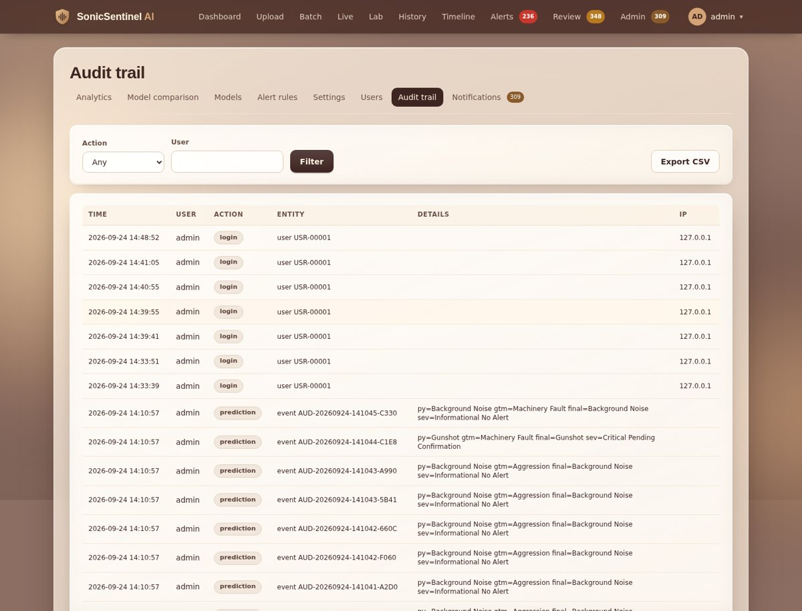
Figure 21. Audit trail
Every important action is recorded with time, user, IP address and details: logins, failed logins, lock-outs, uploads, microphone sessions, predictions, alerts and alert actions, reviews and overrides, exports, setting and rule changes, and model updates. Filter by action or user and click Export CSV.

14.7 Notifications (anomaly alerts)
The system notifies administrators automatically about:
Notification | Trigger
Failed uploads | a user has several rejected uploads within 10 minutes
Failed logins | repeated failed logins for one account within 15 minutes
Low-confidence spike | many of the last 10 detections have confidence below 0.50
Excessive critical alerts | many critical alerts within 10 minutes (possible false alarms)
Duplicate file | identical or near-identical file uploaded again
Model failure | the Python or GTM model failed on a recording or live window
Report failure | an event report could not be generated

15. Models and Google Teachable Machine

15.1 Models page
Admin → Models shows the three Python models that were compared (XGBoost, MLP, Random Forest) with cross-validation and validation scores, the selected model's results on the unseen test split (accuracy, macro-F1, precision / recall, critical-class recall, noise robustness), the confusion matrix, the installed GTM model (labels and version) and the version history.
Model | Test accuracy | Macro-F1 | Notes
Python (XGBoost) py-xgb-20260924-0800 | 0.865 | 0.863 | critical recall: Gunshot 0.93, Panic Scream 0.93, Aggression 0.89, Help 1.00, Glass 0.83
GTM run 3 (export 2026-09-24 20:51) | 0.606 | 0.607 | runs in the browser, 1-second windows
Combined decision (Python weight 0.7) | 0.868 | 0.866 | better than either model alone

15.2 Retraining the Python model
- Put new clips in audio_dataset/raw/<Class name>/ (or use the import scripts).
- Rebuild the dataset: python scripts/build_dataset.py (validation, duplicates, Audio IDs, 70 / 15 / 15 split).
- Augment the training split: python -m augmentation.augment --per-clip 2.
- Train and compare: python -m python_models.train_models. The new model and reports are saved and shown on Admin → Models after a restart.

15.3 Retraining the GTM model
- Create upload archives from the TRAIN split: python -m gtm_model.prepare_gtm_samples --max-per-class 400 --zip → one zip per class in gtm_model/training_samples/_tm_upload/.
- Open https://teachablemachine.withgoogle.com → Audio Project. Name the classes exactly like the app (Background Noise first).
- On Windows, first paste the one-line fix from gtm_model/tm_upload_fix.js into the browser console (F12 → Console) – it lets Teachable Machine accept the zip files and load thousands of samples.
- For each class click Upload and choose the matching zip. Open Advanced, set epochs to 100 and click Train Model. Keep the tab visible until "Model Trained".
- Export Model → TensorFlow.js → Download. Copy model.json, weights.bin and metadata.json into gtm_model/model/ and restart the app.

16. Requirements traceability
This chapter lists every requirement of the SonicSentinel AI – NextWave AI and ML SRS v1.0 and shows where it is implemented and how you can see it in the application. Status: Done = implemented and tested · Partial = implemented with a known limitation · Team = a task only the team can complete (not code).
SRS section | Items | Status
1.2 Development phase (Steps 1 – 20) | 20 | 100 % Done
Dataset requirements (Hint) | 8 | 7 Done, 1 Partial (Glass Breaking has few clips)
1.6 Functional requirements (i – lxxx + responsive UI) | 81 | 100 % Done
1.7 Non-functional requirements | 5 | 4 Done, 1 Partial (GTM accuracy)
1.8 Competition integrity | 14 | code items Done; commits and viva by the team
1.9 Interface requirements | 2 | 100 % Done
1.10 Project deliverables | 16 | 12 Done, rest team tasks (deployment, video, screenshots)

16.1 Development phase (SRS 1.2, Steps 1 – 20)
Step | Requirement | Where / how | Status
1 | Audio data collection with unique Audio ID and metadata | data/dataset_metadata.csv – 4,629 original clips, all 10 classes | Done
2 | Upload and live-microphone input | Upload, Batch and Live pages | Done
3 | Validation (format, size, duration, SR, channels, integrity, signal, mic, permission) | automatic on upload and live start | Done
4 | Pre-processing | resample, mono, normalise, trim, noise reduction, segmentation | Done
5 | One common dataset for both models | GTM samples cut from the same TRAIN recordings | Done
6 | Feature extraction | 299 features (MFCC, Mel, chroma, ZCR, RMS, spectral, onset, tempo) | Done
7 | Train and compare ≥ 3 models | XGBoost, MLP, Random Forest – Admin → Models | Done
8 | Python scores for all ten classes | comparison panel | Done
9 | GTM project with the same ten classes | 10-class TM export in gtm_model/model/ | Done
10 | GTM predicts independently | browser inference, Python result never shared | Done
11 | Compare categories and confidences | comparison panel | Done
12 | Continuous live windows 1 – 3 s | 2-second windows on the Live page | Done
13 | Audio-quality assessment | quality label and issues | Done
14 | Critical-event recognition and similar-event pairs | look-alike training + look-alike check (ch. 10.5), reports/lookalike_pairs.md | Done
15 | Repeated-detection confirmation | required consecutive detections | Done
16 | Alerts with five severity levels | alert rules (ch. 10.4) | Done
17 | Manual-review routing | review reasons (ch. 12.1) | Done
18 | Dashboard and history | Dashboard, Live, History, Timeline | Done
19 | Final decision inputs and outputs | "How the decision was made" trace | Done
20 | Event storage | events, segments, alerts, reviews tables | Done

16.2 Dataset requirements
Requirement | Current state | Status
≥ 3,000 unique original clips | 4,629 clips (≈ 6.6 hours) | Done
≈ 300 clips per class, balanced | most classes 221 – 1,189; Glass Breaking 40, Machinery Fault 138; training split balanced to ≈ 600 per class by augmentation | Partial
Variation (device, distance, environment, noise, echo, speakers) | 8 sources + augmentation | Done
Help class: safety phrases only, voluntary / TTS | 221 clips: offline TTS + consented team recordings | Done
Stratified 70 / 15 / 15 split | 3,240 / 694 / 695 | Done
Same split for both models, GTM from TRAIN only | build and GTM sample scripts | Done
Segments and augmented copies stay in the parent split | parent_audio_id + GroupKFold | Done
Augmentation types | noise, shift, pitch, stretch, volume, reverb, distance, device | Done

16.3 Functional requirements (SRS 1.6)
# | Requirement | Where to see / how to use it | Status
i | Registration and secure login | /register, /login – hashed passwords, CSRF, lock-out after 5 failures (ch. 3) | Done
ii | Role-based access (5 roles) | navigation and pages depend on the role (ch. 4) | Done
iii | Profile management + unique User ID | avatar menu → Profile; USR-00001 (ch. 3.3) | Done
iv | Upload WAV, MP3, FLAC, OGG, M4A | Upload page (ch. 6) | Done
v | Batch upload | Batch page (ch. 7) | Done
vi | Start / stop live microphone after permission | Live → Start / Pause / Stop (ch. 8) | Done
vii | Microphone status | Live → Microphone card: Available, Active, Paused, Disconnected, Permission denied | Done
viii | File validation | automatic; clear rejection messages (ch. 6.2) | Done
ix | Audio preview (play, pause, replay, seek, volume) | Upload preview player; players on event, review and alert pages | Done
x | Metadata extraction | Event page → Metadata (format, duration, SR, channels, bit depth, size, time) | Done
xi | Pre-processing | automatic (ch. 6.3); noise reduction switch in Settings | Done
xii | Silence detection | Event page → Audio quality | Done
xiii | Clipping detection and warning | Event page → Audio quality; Dashboard quality warnings | Done
xiv | Background-noise estimation | noise level in dB on the event page; limit in Settings | Done
xv | Segmentation with start / end timestamps | Event page → Segments | Done
xvi | Common dataset with all ten classes | scripts/build_dataset.py → data/dataset_metadata.csv | Done
xvii | Dataset metadata management | dataset_metadata.csv, documentation/DATA_DICTIONARY.md | Done
xviii | Dataset balance checking | build warnings, data/dataset_statistics.json | Done
xix | Augmentation | python -m augmentation.augment (training split only) | Done
xx | Acoustic feature extraction | 299 features per segment (automatic) | Done
xxi | Waveform generation | Event page → Waveform & spectrogram | Done
xxii | Spectrogram generation | Event page → Mel spectrogram | Done
xxiii | Train and compare ≥ 3 models | Admin → Models (XGBoost, MLP, Random Forest) | Done
xxiv | Hyperparameter tuning | GridSearchCV + GroupKFold in python_models/train_models.py | Done
xxv | Python model predicts one of ten classes | Event page → comparison panel | Done
xxvi | Python confidence for all classes | confidence bars for all 10 classes | Done
xxvii | Separately trained GTM model | gtm_model/model/ (Teachable Machine export) | Done
xxviii | GTM integrated into the web app | runs automatically in the browser (TensorFlow.js) | Done
xxix | GTM classifies the same segment independently | same segments; Python result never sent to GTM | Done
xxx | GTM confidence for all classes | comparison panel; Admin → Models checks labels | Done
xxxi | Prediction comparison | Event page → Model prediction & confidence comparison | Done
xxxii | Absolute top-class confidence difference | |Δconf| in the comparison panel | Done
xxxiii | Consistency status | Acceptable Match / Weak Match / Model Disagreement / Uncertain Result (ch. 10.2) | Done
xxxiv | Top-3 predictions per model | comparison panel | Done
xxxv | Configurable confidence threshold | Admin → Settings → Min confidence; per class in Alert rules | Done
xxxvi | Configurable top-2 margin | Admin → Settings → Top-2 margin | Done
xxxvii | Quality classification | Good / Acceptable / Poor / Unusable (ch. 10.3) | Done
xxxviii | Uncertain-sound detection | uncertain reasons on the event page (ch. 10.6) | Done
xxxix | Overlapping-sound detection | overlap threshold; "Overlapping sounds" review reason | Done
xl | Repeated event confirmation | required consecutive detections + repeat window (ch. 10.4) | Done
xli | Machinery Fault → maintenance alert + inspection | rule sent to Maintenance | Done
xlii | Glass Breaking → high security alert | rule: High, Security | Done
xliii | Alarm / Siren → high attention alert | rule: High, Security + Maintenance | Done
xliv | Vehicle Horn → stored as traffic event | rule: Low, no alert | Done
xlv | Animal Sound → non-critical event | rule: Low, no alert | Done
xlvi | Gunshot → critical alert after confirmation | rule: Critical, 2 detections | Done
xlvii | Panic Scream → critical safety alert | rule: Critical | Done
xlviii | Aggression → high / critical alert | rule: High, escalates to Critical | Done
xlix | Person Asking for Help → critical alert | rule: Critical | Done
l | Background noise non-critical unless above limit | Background noise limit dB in Settings | Done
li | Unknown-sound handling | Unknown category + manual review | Done
lii | Severity assignment | 5 levels (ch. 10.4) | Done
liii | Configurable alert rules | Admin → Alert rules (ch. 14.3) | Done
liv | Real-time visible alerts | toasts on every page, badge in the navigation | Done
lv | Acknowledge / dismiss / escalate | Alerts page (ch. 11) | Done
lvi | Alert history with user actions | avatar menu → Alert history | Done
lvii | Manual-review queue | Review page (ch. 12) | Done
lviii | Reviewer audio playback | whole file + every segment on the review page | Done
lix | Reviewer confirm / correct | Reviewer decision → correct class | Done
lx | Reviewer comments and actions | comment, severity, action, raise alert, close | Done
lxi | Override keeping original outputs | original Python and GTM results preserved | Done
lxii | Event statuses (7) | ch. 10.7 | Done
lxiii | User dashboard | Dashboard (ch. 5.2) | Done
lxiv | Live dashboard | Live page (ch. 8) | Done
lxv | Admin dashboard | Admin → Analytics (ch. 14.1) | Done
lxvi | Event timeline | Timeline page (ch. 13.2) | Done
lxvii | Search and filtering | History filters (ch. 13.1) | Done
lxviii | Analytics (frequency, confidence, FP / FN, disagreement, quality, alert response) | Admin → Analytics | Done
lxix | Downloadable analysis report | Event page → Download report → Save as PDF | Done
lxx | CSV / Excel export | Admin → Exports, Model comparison, Audit trail | Done
lxxi | Secure audio storage | files served only to logged-in users who may see the event | Done
lxxii | Database storage | SQLite, 11 tables (events, segments, alerts, reviews, users, audit …) | Done
lxxiii | SHA-256 duplicate detection | identical uploads recognised (ch. 6.3) | Done
lxxiv | Near-duplicate detection | audio fingerprint similarity | Done
lxxv | Model version per prediction | Event page → Metadata | Done
lxxvi | Audit trail | Admin → Audit trail (ch. 14.6) | Done
lxxvii | Understandable error messages | error pages and flash messages | Done
lxxviii | Admin anomaly alerts | Admin → Notifications (ch. 14.7) | Done
lxxix | Privacy: mic-active indicator | red banner while the microphone is on | Done
lxxx | Configurable data retention | Admin → Settings → retention days, Run retention | Done
– | Responsive UI (desktop, tablet, mobile) | every page works at phone width | Done

16.4 Non-functional requirements (SRS 1.7)
Requirement | Target | Measured result | Status
Performance | 30-s clip ≤ 8 s; live window ≤ 3 s | 30-s upload 1.47 s (max 1.74 s); live window 0.11 s | Done
Scalability | ≥ 20,000 events; multiple users | 20,020 events stored; dashboard 0.07 s, history 0.18 s; 5 concurrent users, 0 errors | Done
Usability | easy to use | role-based pages, drag-and-drop, badges, toasts, icons, responsive design, this guide | Done
Accuracy | ≥ 85 % accuracy, macro-F1 ≥ 0.80, critical recall ≥ 85 % for both models | Python 0.865 / 0.863 ✓; combined 0.868 / 0.866 ✓; GTM 0.606 / 0.607 (limit of the 1-s Teachable Machine model) | Partial
Availability | ≥ 99 % during evaluation | auto-restart server (run_server.bat), /healthz, Docker health check | Done

Hidden-test readiness: on 266 unseen test clips (2,926 runs, 0 crashes) accuracy stayed at 0.90 clean, 0.87 with echo, 0.88 after MP3 re-encoding, 0.77 far away and 0.72 with real background noise (reports/hidden_test_robustness.md).

16.5 Competition integrity (SRS 1.8)
Requirement | How it is met | Status
Each member explains assigned modules / any function | documentation/VIVA_PREP.md – module owners and key functions | Team
Meaningful GitHub commits by all members over five days | commit plan in TEAM_CONTRIBUTIONS.md | Team
Development log | DEVELOPMENT_LOG.md | Done
Surprise modification / deliberate defect | where-to-change list and debugging checklist in VIVA_PREP.md; 70 automated tests | Done
No hard-coded predictions or invented confidences | all results come from the two trained models | Done
Tested with unseen recordings / hidden-test conditions | 695 unseen test clips + 2,926 degraded versions; Robustness Lab | Done
AI tools declared | AI_USAGE.md | Done
No external generative-AI API for classification | only the local Python model and the GTM export | Done
Both models predict independently; Python output never given to GTM | separate pipelines (server vs browser) | Done

16.6 Interface requirements (SRS 1.9)
Requirement | Used | Status
Hardware | Intel i5 / i7 laptop, 8 – 16 GB RAM, microphone | Done
Software | HTML, CSS (Tailwind), JavaScript, Flask, SQLite, Python, scikit-learn, XGBoost, Google Teachable Machine, TensorFlow.js, librosa, soundfile, SciPy, NumPy, Pandas, Matplotlib, Joblib, pytest, Git / GitHub | Done

16.7 Project deliverables (SRS 1.10)
# | Deliverable | Where | Status
1 | Project report with diagrams | documentation/PROJECT_REPORT.md | Done
2 | Source code | project folder | Done
3 | Dataset + metadata + statistics | data/, audio_dataset/ (upload audio zip and add link) | Team
4 | Python model evidence | reports/, Admin → Models | Done
5 | GTM evidence | documentation/GTM_TRAINING_LOG.md (add screenshots) | Team
6 | Model comparison report | reports/model_comparison_report.xlsx | Done
7 | Alert-rule file | alert_rules/alert_rules.json | Done
8 | Test cases | tests/, documentation/TESTING.md | Done
9 | Installation instructions | README.md, this guide ch. 2 | Done
10 | Execution instructions | README.md, this guide ch. 2.3 | Done
11 | Public GitHub repository | make public, screenshots, all members' commits | Team
12 | Deployed application | documentation/DEPLOYMENT.md (Render / Docker ready) | Team
13 | Demonstration video | documentation/DEMO_VIDEO_SCRIPT.md | Team
14 | Technical blog | documentation/TECHNICAL_BLOG.md | Done
15 | AI_USAGE.md | root folder (members fill modifications) | Done
16 | Submission checklist + team contributions | documentation/SUBMISSION_CHECKLIST.md, TEAM_CONTRIBUTIONS.md | Done

17. Troubleshooting and FAQ
Problem | Solution
I cannot find the Register page | Registration is only shown when you are logged out. Log out or use an Incognito window and open /register.
New design / changes not visible | Restart python run.py and press Ctrl + F5 in the browser.
Too many results are "Unknown" | Admin → Settings: Python weight 0.7, Unknown threshold 0.35, Min confidence 0.60; restart. Make sure the sound is clear and not too quiet.
The two models often disagree | Expected for GTM (≈ 61 % accuracy). The combined decision uses the Python model more (weight 0.7) and sends disagreements to review.
"Permission denied" on the Live page | Click the lock icon in the address bar → Microphone → Allow, then reload. Use http://127.0.0.1:5000 or https.
GTM shows "not installed" / missing classes | Copy the three exported files into gtm_model/model/ and check that the class names match exactly.
MP3 or M4A upload fails to decode | Install FFmpeg and add it to PATH, then restart.
"Identical file already uploaded" | The file is a duplicate; open the earlier Audio ID that is shown.
Account locked | Wait 5 minutes after 5 failed attempts, or ask the administrator.
"Access denied" | Your role does not include that page (see chapter 4).
Teachable Machine rejects the zip files | Paste the console fix from gtm_model/tm_upload_fix.js first (chapter 15.3).
The page is slow the first time | The models load on first use; later analyses take about 1.5 s for a 30-s clip.

18. Glossary
Term | Meaning
Audio ID | unique identifier of every analysed recording, e.g. AUD-20260924-141012-FFF6
User ID | unique identifier of every account, e.g. USR-00001
Segment / window | a short piece of audio (2 s) that the models classify
Confidence | the model's probability for a class (0 – 1 or 0 – 100 %)
Combined confidence | weighted average of the Python and GTM confidences
Top-2 margin | difference between the best and the second-best class
|Δconf| | absolute difference between the Python and GTM top-class confidences
GTM | Google Teachable Machine – the browser model trained with Google's tool
XGBoost | gradient-boosted decision trees – the selected Python model
Macro-F1 | average F1 score over all classes (treats every class equally)
Recall | share of real events of a class that were found
SNR | signal-to-noise ratio in dB – lower means noisier
Look-alike | a harmless sound that resembles a critical one (fireworks vs gunshot)
Explainable AI (XAI) | the "Why this prediction?" panel that shows what the model listened to

