**LAB #1**

**Objective:** Exploring different hashing algorithms using HashCalculator.  
  
 **TASKS:**1)Explore different types of hash algorithms on any random file

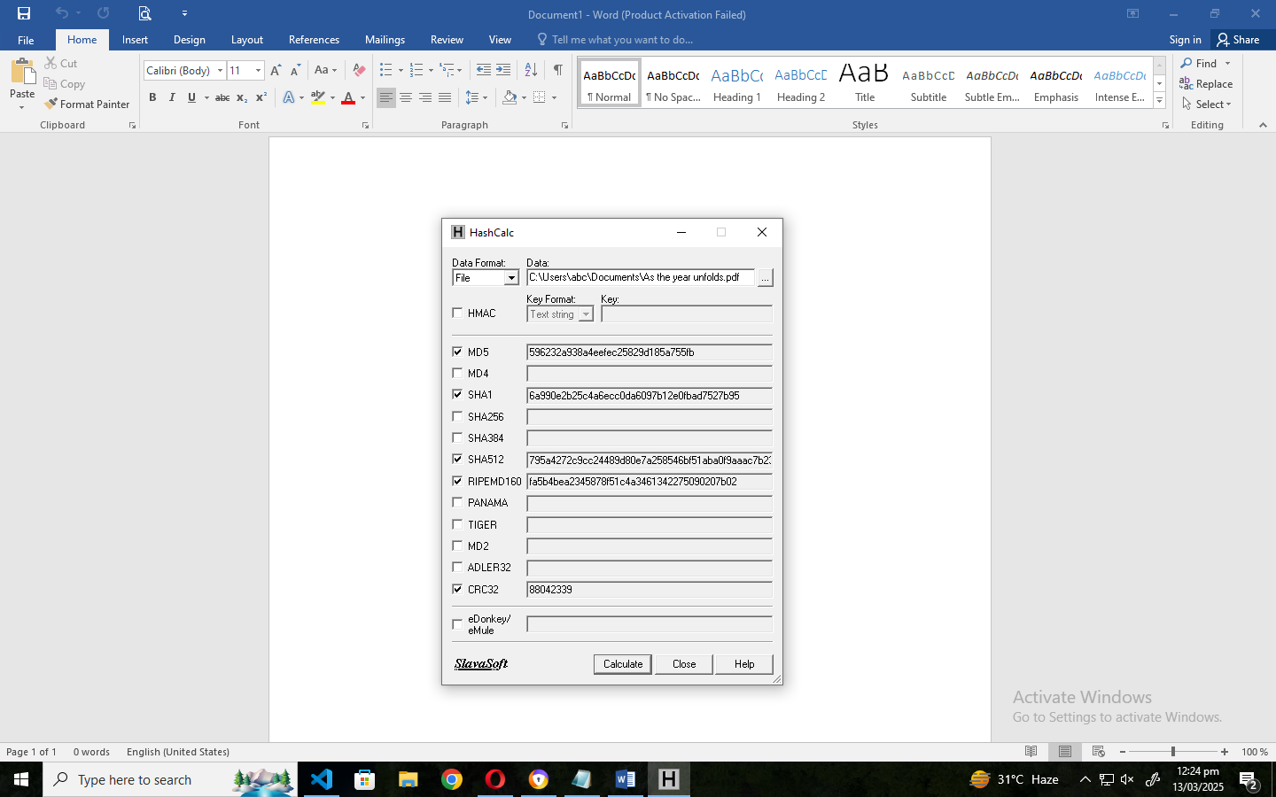

2)Using MD5 hash algorithm on Empty File  
 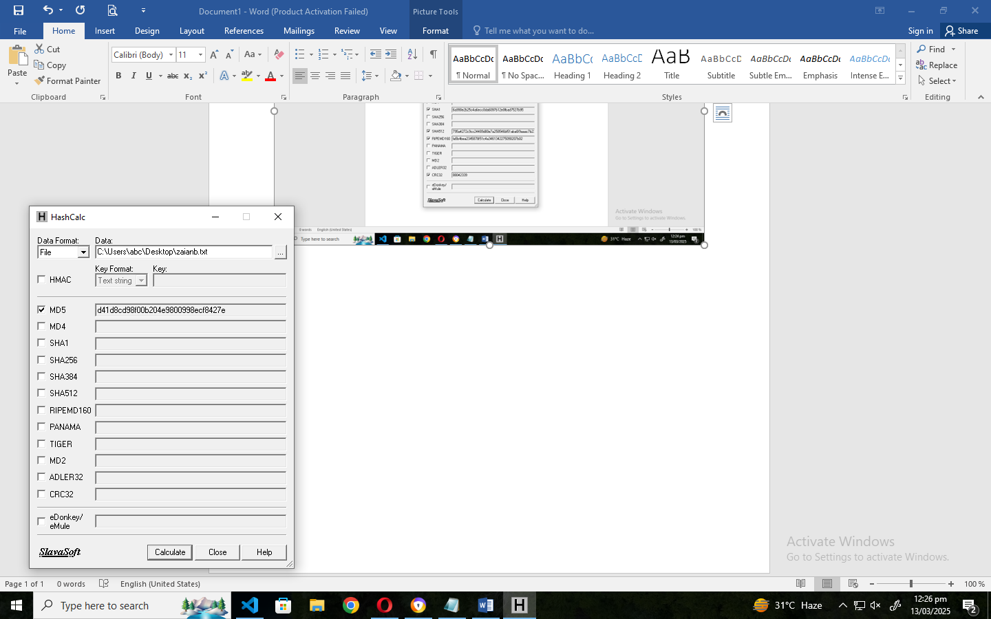  
3)Using SHA512 hash algorithm on Empty File  
 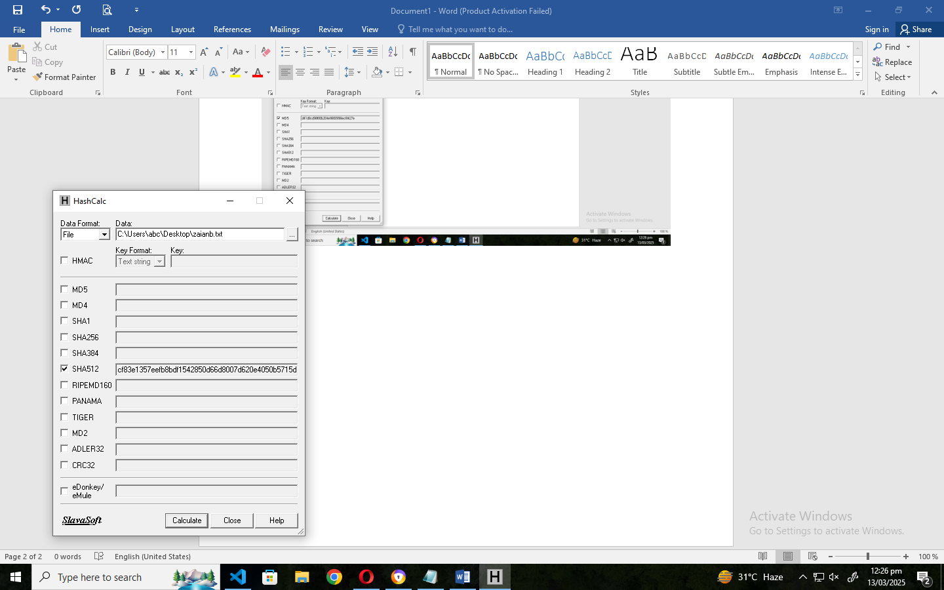

4)Using MD5 hash algorithm on Filled File  
 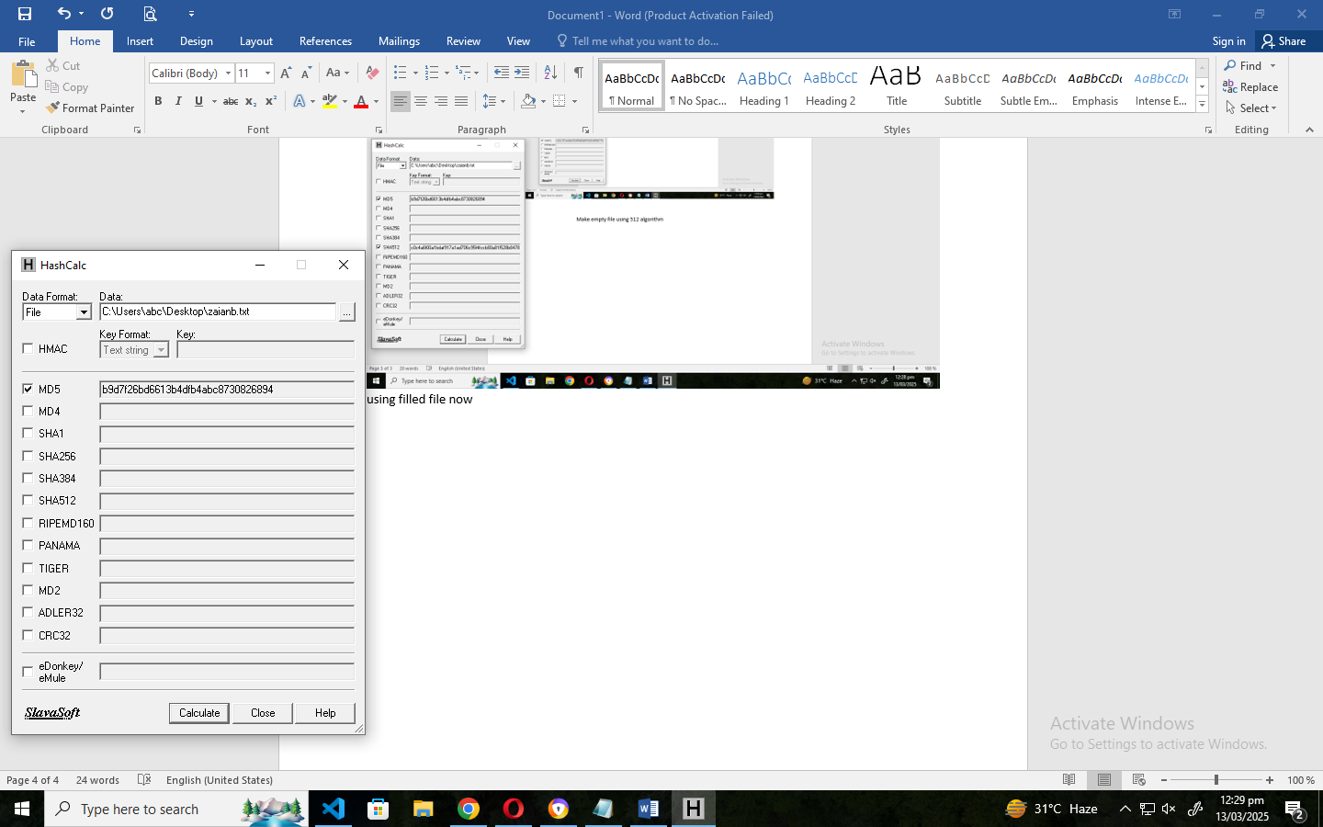

5)Using SHA512 hash algorithm on Filled File  
 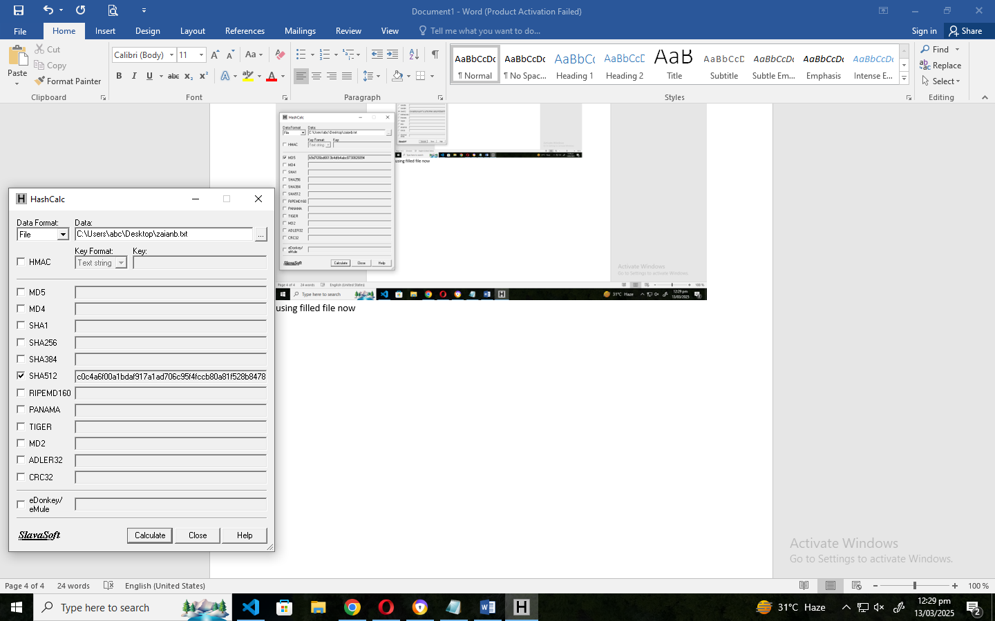

6)Using CRC32 hash algorithm on Filled File  
 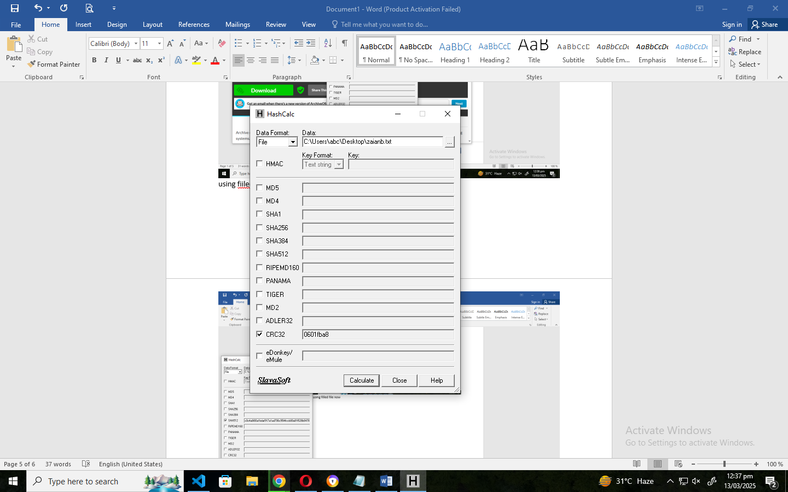

7)Using MD4 hash algorithm on Filled File  
 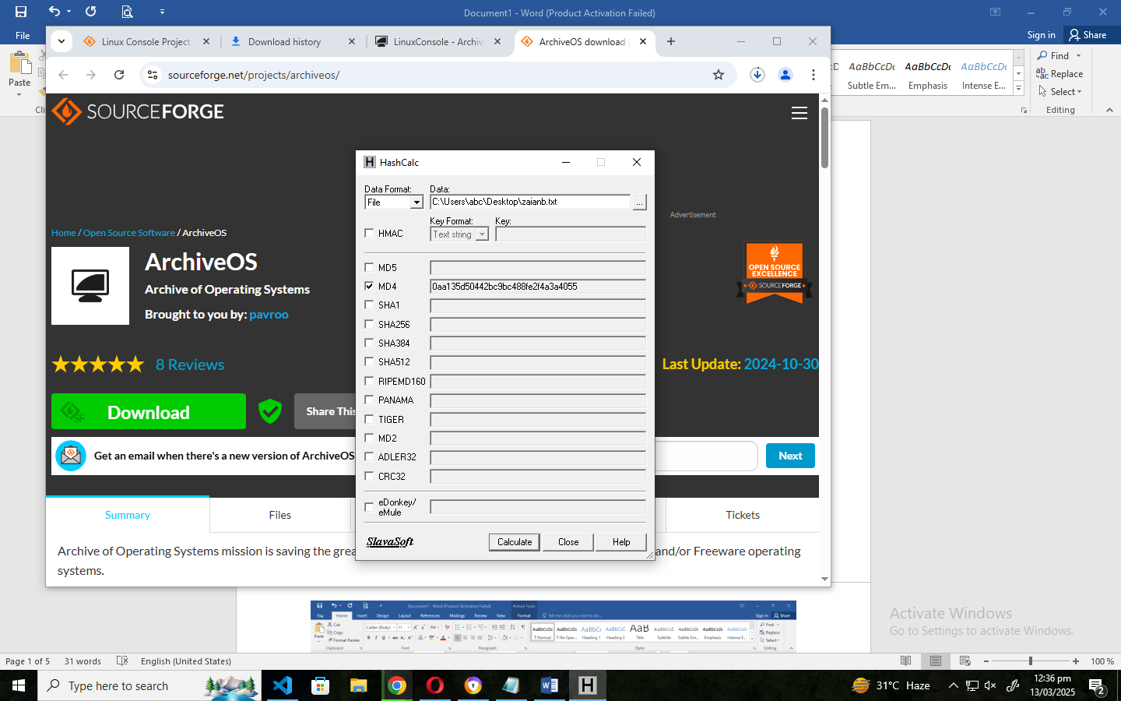

8) Using HMAC with password on MD5 algorithm on File Format  
 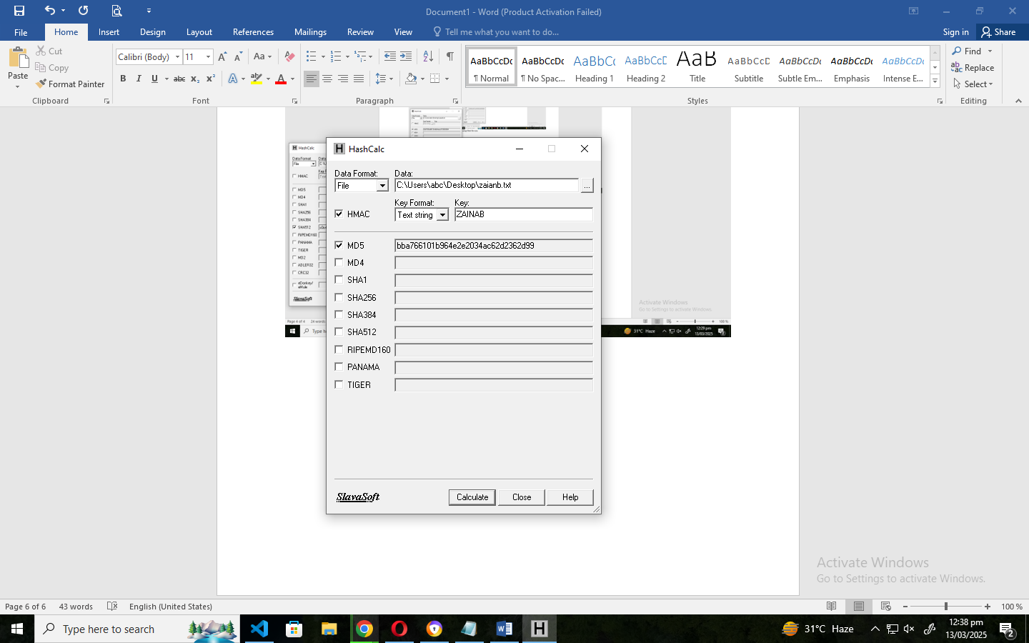  
9) Using HMAC with password on MD5 algorithm on Text Format  
 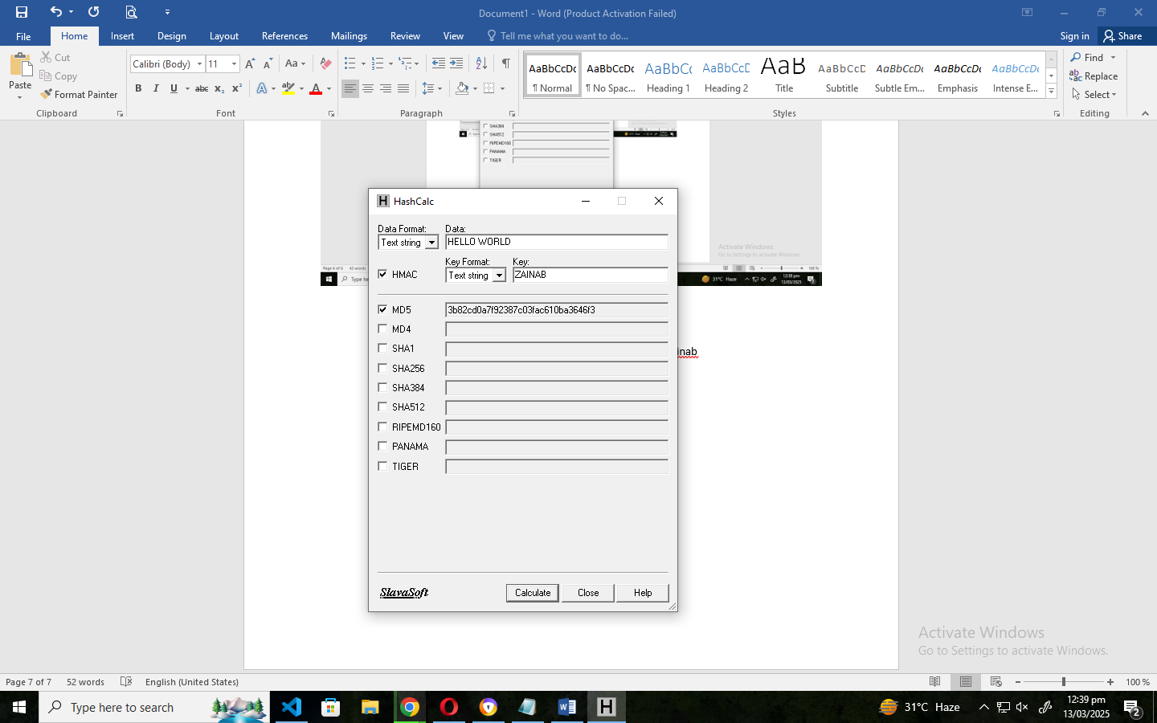

10) Comparing MD5 Hash Value of downloaded LinuxConsole ISO File in Hash Calculator and LinuxConsole MD5SUM value already mentioned on website.

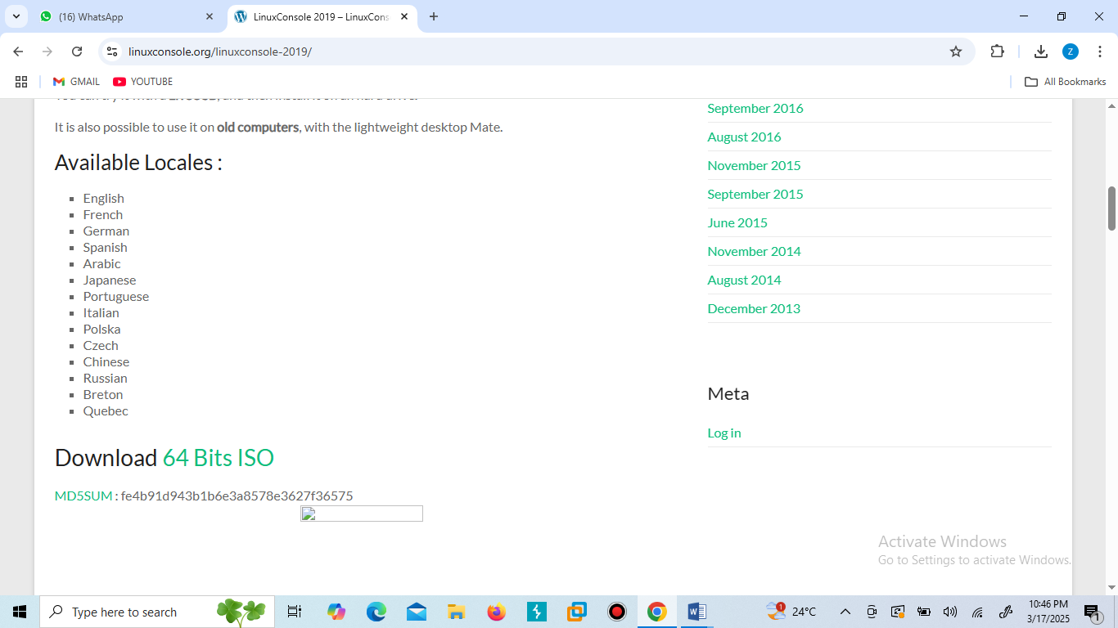 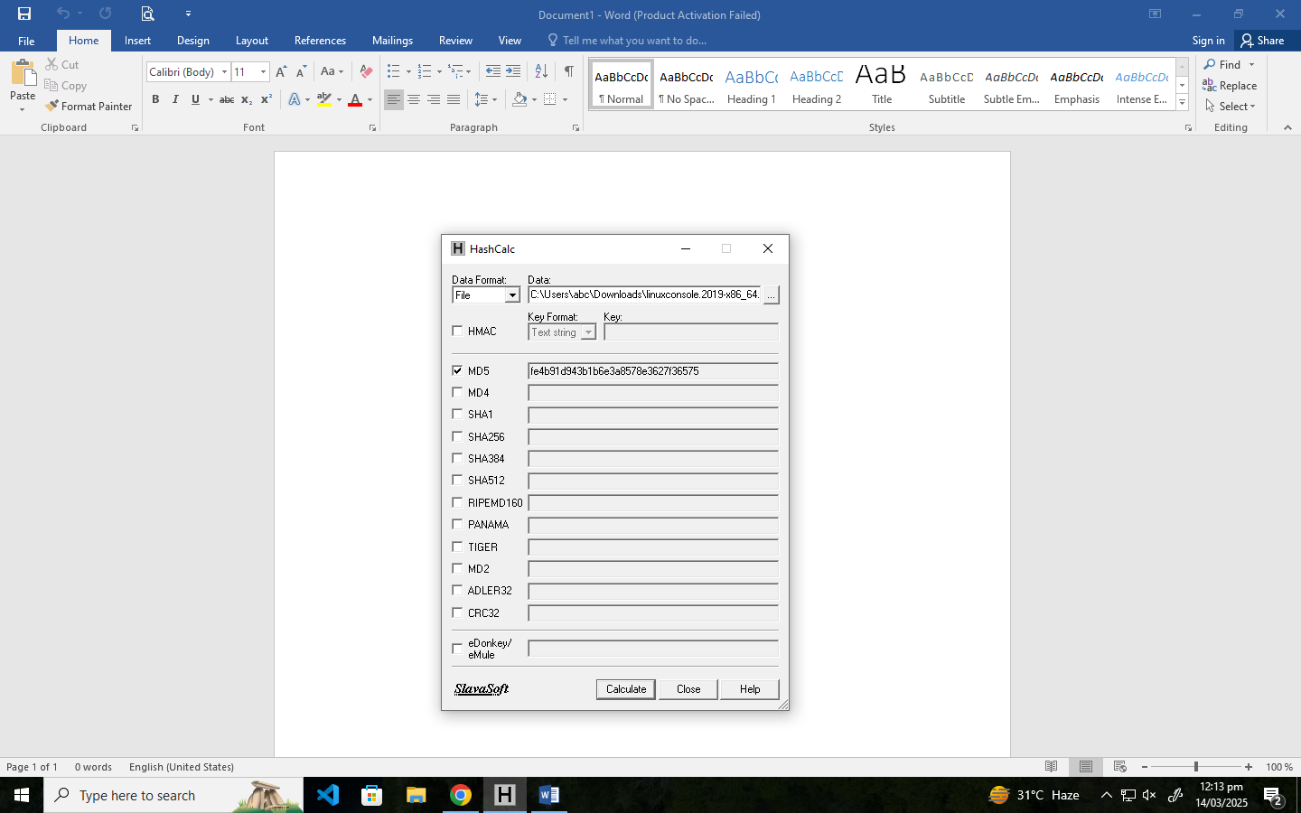

LinuxConsole MD5SUM value mentioned on website

LinuxConsole MD5SUM value calculated on Hash Calculator

BOTH FOUND SIMILAR