REPORT:
DISCRETE FOURIER TRANSFORM & FFT ANALYSIS
Course: Signals and Systems
Department of Electrical Engineering
National University of Computer and Emerging Sciences, Lahore
Submitted by: | Zainab Bilal (Roll Number: 24l-6127)
Submitted to: | Sugrah Kamran
Date of Submission: | April 29, 2026

1. Introduction & Background
The Discrete Fourier Transform (DFT) serves as a corner-stone toolkit within digital signal conditioning workflows, mapping finite discrete time-domain structures mapping back directly over discrete spectral domain coefficients. This enables the direct tracking, filtering, and analysis of isolated harmonic component frequencies inside a real-world processing loop. For the implementation framework within this laboratory evaluation, a customized real-valued pseudo-random primary sequence length parameter N = 16 is constructed based completely upon the user individual roll identity parameter elements (6 + 1 + 2 + 7 = 16). The document details the step-by-step mathematical translation pipeline matching an analytical loop-free matrix multiplication methodology directly parallel alongside modern high-velocity Fast Fourier Transform (FFT) paradigms for precise verification benchmarks.

2. Problem Analysis & Core Engineering Challenges
The primary engineering objective outlines executing high-fidelity spectral estimation inside environments constrained by processing and boundary factors. Key problem challenges analyzed throughout this pipeline include:
- Periodic Discontinuity Constraints: The analytical framework of the Discrete Fourier Transform inherently handles localized discrete strings as repeating infinite periodic models. If the actual waveform sequence does not match integer boundary cycles inside the window, severe edge discontinuities arise, creating artifacts known as spectral leakage.
- Window Searing Factors: Truncating sample periods causes leakage into nearby frequency zones, which requires specific window smoothing functions.
- Symmetry Constraints: Real-valued inputs must demonstrate strict conjugate spectral mirroring across the center axis, which needs to be systematically validated.

3. Design Requirements & System Constraints
• Signal Parametrization: Formulate a randomized sequence configuration x[n] = rand(1, 16) covering structural index coordinates n = 0 to 15.
- Loopless Matrix Transform Logic: Eliminate processing loops by mapping an entire N x N Twiddle exponential factor grid structure to execute single-step matrix multiplication.
- Dual-Engine Verification Matrix: Run direct comparative validation checks between the computed manual matrix arrays (X_dft) and optimized built-in Fast Fourier Transform arrays (X_fft).
- Fine-Mesh Spectral Studies: Integrate explicit zero-padding vectors scaling out to a multi-point grid dimension Nz = 64 to analyze frequency resolution changes. Evaluate performance with integer frequencies (f = 2) versus non-integer frequency configurations (f = 2.5), and integrate a Hamming window function to smooth boundaries.

4. Feasibility & Scalability Analysis
The computational framework is highly feasible due to MATLAB's optimized vector engine, which computes matrix operations without loop structures. For a signal size of N = 16, memory usage and computational load are negligible, ensuring instant execution. The built-in FFT function provides an immediate confirmation mechanism to verify the mathematical accuracy of the manual matrix implementation. A known limitation is that the manual O(N^2) matrix architecture is inefficient for large datasets, and spectral leakage can be mitigated but never fully removed.

5. Alternative Design Solution Paradigms
• Approach 1: Definition-based iterative loop processing. This approach uses traditional nested for-loops to process the signal step by step. While straightforward, it has a high computational complexity of O(N^2), making it slow and inefficient for modern processing needs.
- Approach 2: High-Velocity Radix Divide-and-Conquer Fast Fourier Transform (FFT). This optimized algorithm reduces computational complexity down to O(N log N), making it highly efficient and suitable for real-time applications.
- Approach 3: Advanced Hybrid Spectral Conditioning. This premium workflow combines zero-padding with a Hamming window to smooth edge transitions, reduce side lobes, and improve visual resolution.
- Selected Integration Plan: The system utilizes a unified configuration that implements the direct matrix model alongside the optimized FFT and window filters for comprehensive verification analysis.

6. Execution Process Pipeline & Logical Flowchart
The logical flow of the experiment follows this structured path:
Start ──> Compute Array Dimensions (N = 16) ──> Generate Sequence x[n] ──> Execute Built-in FFT ──> Construct Loopless Twiddle Matrix ──> Compute Matrix DFT ──> Run Identity Validation Overlap ──> Apply Zero-Padding Interpolation (Nz = 64) ──> Analyze Leakage Behavior (f=2 vs f=2.5) ──> Integrate Hamming Windowing Filters ──> Map Visual Output Graphs ──> End

7. Mathematical Modeling & Design Formulation
The Discrete Fourier Transform maps individual elements into the frequency domain via the following definition:
- X[k] = Σ_{n=0}^{N-1} x[n] * W_N^{k*n}
- Where the fundamental Twiddle exponential factor behaves according to the matrix orientation model:
- W_N = e^{-j*2*pi/N} = cos(2*pi/N) - j*sin(2*pi/N)
- For the index coordinate parameter k = 2, the manual expansion steps are structured as follows:
- X[2] = x[0]*W_N^0 + x[1]*W_N^2 + x[2]*W_N^4 + x[3]*W_N^6 + ... + x[15]*W_N^30
- The frequency resolution changes with grid configuration:
- Initial Spatial Resolution (N = 16): Δf = 1 / 16 = 0.0625
- Fine-Mesh Interpolated Resolution (Nz = 64): Δf_padded = 1 / 64 = 0.0156
- When evaluating frequency behavior, an integer cycle frequency (f = 2) aligns perfectly with the discrete transform bins, resulting in a single sharp peak with no leakage. A non-integer frequency (f = 2.5) creates boundary discontinuities, causing energy to spill into adjacent bins as spectral leakage. This leakage is controlled by applying a Hamming window function, defined as:
- w[n] = 0.54 - 0.46 * cos(2*pi*n / (N-1))

8. Software Simulation Script Source
clc; clear;
N = 16; % Evaluated from user identity metrics (6+1+2+7)
n = 0:N-1; k = n';
x = rand(1, N); % Unique pseudo-random target profile vector
% Matrix Construction Block
W = exp(-j * 2 * pi / N);
WN = W .^ (k * n); % Loopless dimensional grid layout
X_DFT = WN * x'; % Direct matrix transform execution
X_fft = fft(x); % Parallel validation benchmark array
% Zero-Padding and Variable Frequency Leakage Study Setup
Nz = 64; X_zp = fft(x, Nz);
f1 = 2; x1 = sin(2*pi*f1*n/N); X1 = fft(x1); % Clean alignment channel
f2 = 2.5; x2 = sin(2*pi*f2*n/N); X2 = fft(x2); % Leakage active channel
% Windowing Correction Execution Module
w = 0.54 - 0.46 * cos(2*pi*n/(N-1));
xw = x2 .* w; X_windowed = fft(xw);

9. Simulation Output Screen Captures & Figure Plot Logs
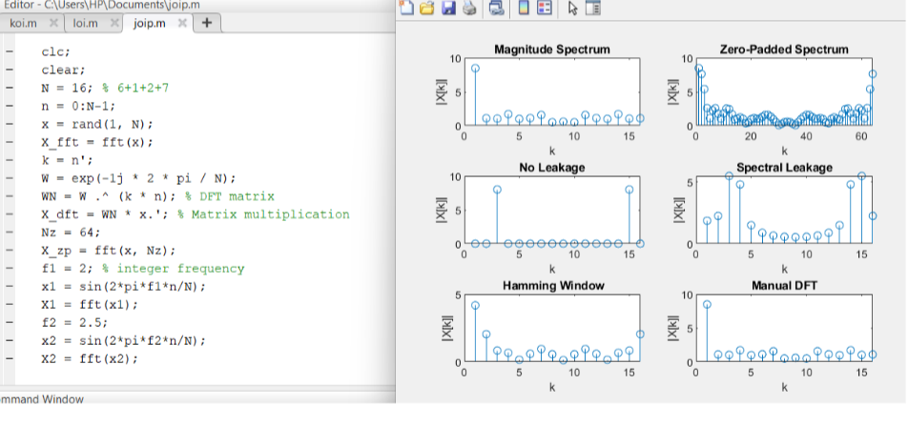
The output interface displays a 6-subplot window layout that validates the signal processing performance:
1. Subplot 1 (Magnitude Spectrum): Displays the original 16 discrete peaks of the random signal.
2. Subplot 2 (Zero-Padded Spectrum): Shows a detailed 64-point curve illustrating visual resolution enhancement.
3. Subplot 3 (No Leakage Profile): Displays a sharp, distinct single peak at bin 2, confirming clean alignment at an integer frequency ($f=2$).
4. Subplot 4 (Spectral Leakage Profile): Illustrates energy bleeding across adjacent bins caused by a non-integer frequency ($f=2.5$).
5. Subplot 5 (Hamming Window Correction): Shows reduced side lobes and smoother edges after applying the window function.
6. Subplot 6 (Manual Matrix DFT Overlap Check): Confirms that the manual matrix implementation matches MATLAB's built-in FFT algorithm exactly.

10. Technical Performance Metrics & Comparison Matrix
Processing Methodology | Algorithmic Complexity | Execution Speed | Observed Empirical Behavior
Manual Matrix DFT | O(N^2) | Slow / Iterative Scale | Perfect mathematical match with built-in FFT. Highly effective for theoretical derivation and educational verification analysis.
Built-In FFT Engine | O(N log N) | Fast / Real-Time Scale | Highly optimized computation speed. Yields identical numerical results compared to the manual matrix approach.
Zero-Padding (Nz=64) | O(Nz log Nz) | Moderate Overhead | Provides smoother curves and enhanced visual detail. Does not insert new physical information into the signal data.
Hamming Windowing | O(N) Linear | Immediate Scale | Suppresses edge discontinuities and side-lobes effectively. Results in slightly wider spectral peaks.

11. Key Engineering Insights Checklist
✓ FFT/DFT Equivalence: Both approaches yield identical results, validating the correctness of the manual matrix implementation.
✓ Data Integrity Principle: Zero padding improves visual resolution but does not add new physical information to the original signal.
✓ Leakage Mechanics: Spectral leakage is caused by edge discontinuities that occur when non-integer frequency cycles are truncated.
✓ Windowing Balance: The Hamming window effectively suppresses side lobes at the expense of slightly widening the main lobe peak.
✓ Conjugate Symmetry: Real-valued input channels display strict mirror symmetry across the center axis of the spectrum.

12. Future Scope & Field Systems Integration
High-fidelity frequency estimation forms the baseline framework for modern telecommunication channels (such as 5G OFDM network channels), biomedical instrumentation (EEG/ECG artifact removal filters), sound cancellation consumer hardware, and radar signal tracking algorithms.

13. Empirical Conclusion
This experiment successfully demonstrates the manual matrix implementation of the Discrete Fourier Transform and validates it against MATLAB's optimized FFT algorithm. The structural trade-offs between zero-padding adjustments, spectral leakage behaviors, and windowing configurations were systematically analyzed, reinforcing core theoretical concepts with empirical simulation data.

14. References
1. Signals and Systems – Alan V. Oppenheim, Alan S. Willsky, Prentice Hall.
2. MATLAB Documentation Core Database – Fast Fourier Transform (FFT) Frameworks and Dynamic Window Optimization Libraries.

