[EMS]

[OPEN ENDED LAB]



SPEED CONTROL CIRCUIT FOR DC SHUNT MOTOR

Submitted by:

Name:  Zainab Bilal | Roll No:  24L-6127

Submitted to:
Muhammad Ismail

[26- May,2026]

Department of Electrical Engineering
National University of Computer and Emerging Sciences, Lahore

Introduction
- Problem Analysis

Design Requirements

Possible Solutions
- Preliminary Design

Design Description

Software Simulation

Experimental Results
- Performance Analysis
- Conclusion References
This project focuses on speed control of a DC shunt motor using two important methods:
- Flux (Field) Control Method
- Armature Control Method
The implementation is carried out using MATLAB/Simulink, where motor speed is controlled by varying circuit parameters and analyzed mathematically using DC motor equations.

The objective is to:
- Control motor speed at different values
- Design appropriate resistances
- Verify results using simulation

Key Idea:
Speed of DC motor depends on:
- Armature voltage
- Armature resistance
- Magnetic flux
So we use:
- Flux variation → Field control
- Voltage drop → Armature control

Given:
- Voltage = 110 V
- Rated Speed = 1000 RPM
- Field Current ≈ 0.25 A

Required Speeds:
- 50 RPM
- 100 RPM
- 150 RPM

Design Condition:
- Use resistors to control speed
- Maintain stable operation

1. Flux Control Method
- Control field current
- Changes magnetic flux

2. Armature Control Method
- Add resistance in armature circuit
- Changes voltage across armature

Best Approach:
Use both methods for comparison

Start
↓
Initialize System Parameters
(Voltage, Motor, Resistance)
↓
Apply Input Voltage
↓
Set Resistance Value (Control Variable)
↓
DC Motor Operation
(Conversion of Electrical → Mechanical Energy)
↓
Measure Outputs
(Speed, Current, Torque)
↓
Display Results
↓
Change Resistance Value?
↓ ↓
Yes No
↓ ↓
Update R End
↓
Repeat Process

Basic DC Motor Speed Equation
N=kϕV−IaRa

A. Flux (Field) Control Method

Step 1: Flux Relation
ϕ∝If

Step 2: Field Current
If=RfV

Step 3: Speed Relation
N∝ϕ1 N∝If1

Final Formula:
N∝VRf

Key Concept:
- Increase Rf → decrease If
- Decrease flux → speed increases
Used for high-speed control

B. Armature Control Method

Step 1: Voltage Equation
V=Eb+IaRa
Where: Eb = Back EMF

Step 2: Back EMF Relation
Eb∝Nϕ

Step 3: Speed Equation
N∝ϕV−IaRa

With Extra Resistance Rext:
N∝ϕV−Ia(Ra+Rext)

Key Concept:
- Increase armature resistance → voltage drop increases
- Speed decreases
Used for low-speed control

In MATLAB:
- DC motor block used
- Field resistance varied → flux control
- Armature resistance added → armature control
Outputs:
- Speed
- Current
- Torque

CIRCUIT MODEL:
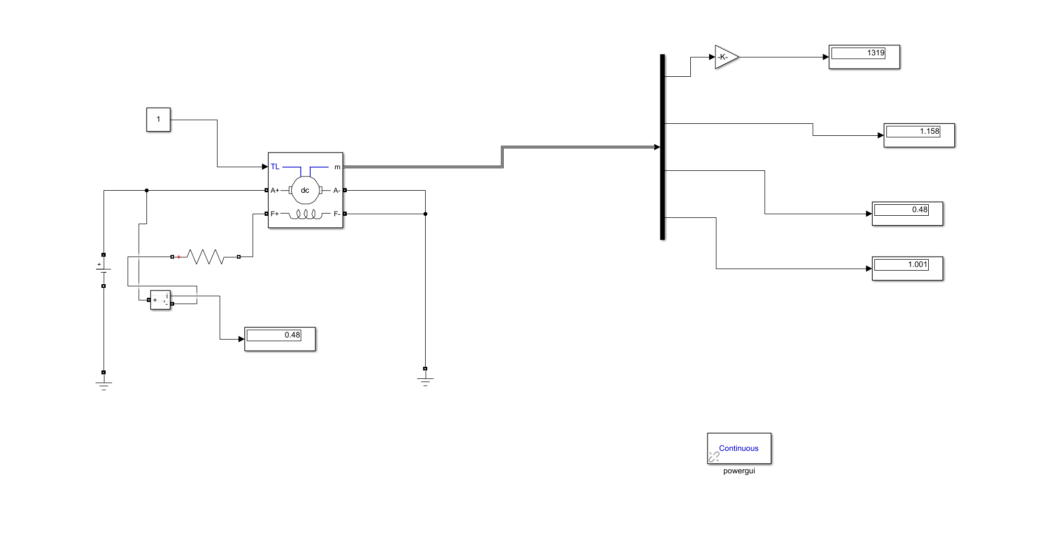

AT S2:

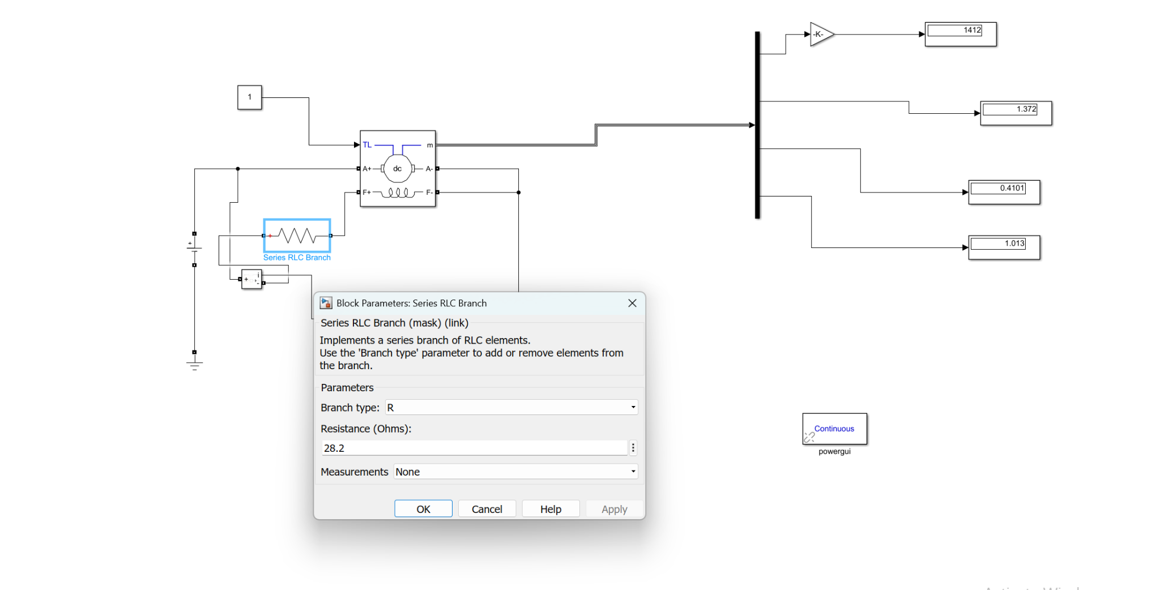
AT S2-50:
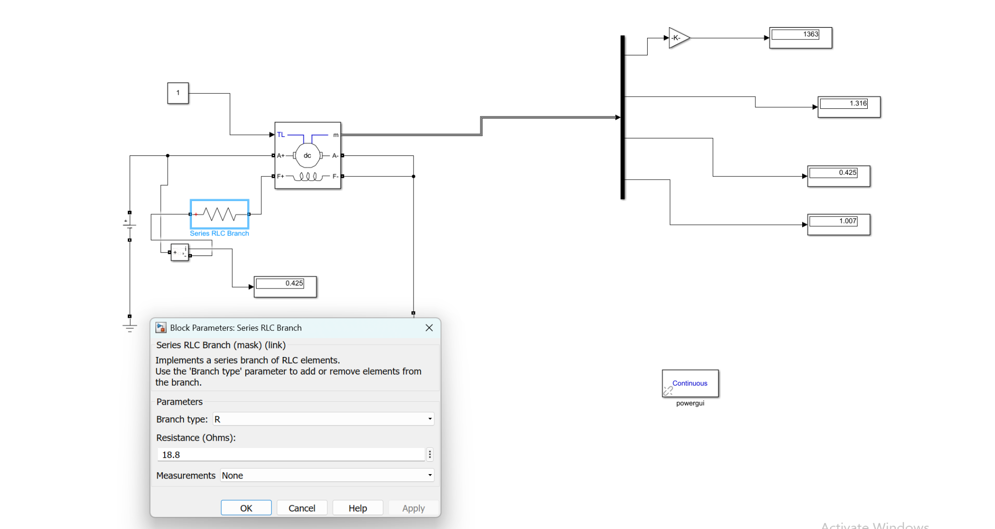
AT S2-100:
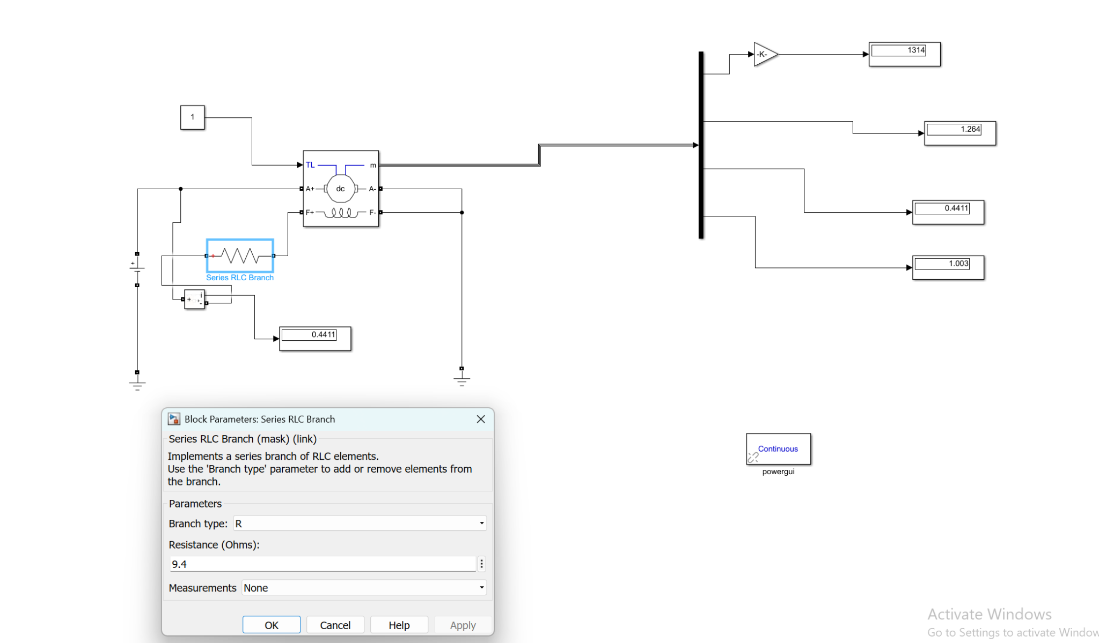
AT S2-150:

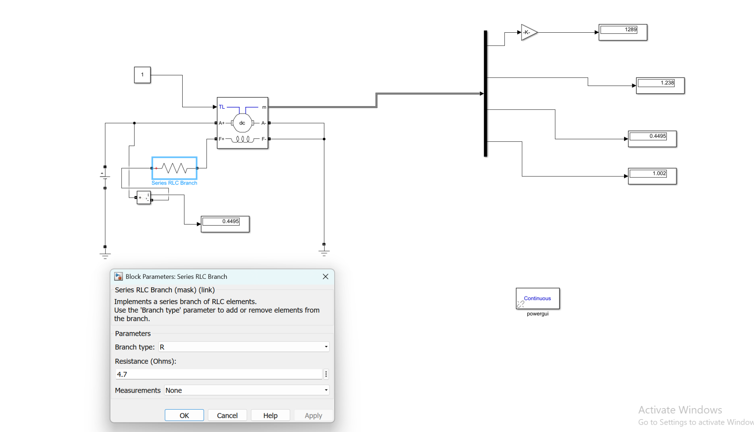

Flux Control:
- Efficient
- Less power loss
- Good for high speed

Armature Control:
- Simple
- More power loss
- Better for low speed

The project successfully demonstrated DC motor speed control using both flux and armature methods.

Final Understanding:
- Speed increases when flux decreases
- Speed decreases when armature resistance increases
- MATLAB simulation verified all theoretical equations

