OEL — Open Ended Lab
DC Motor Speed Control via Armature Resistance Variation
Name: Zainab Bilal Roll No: 24-6127 Simulation Parameter: S2 = 1427

OBJECTIVE
This lab investigates the effect of varying the armature circuit resistance (S2) on the speed, torque, field current, and power factor of a separately-excited DC motor simulated in MATLAB/Simulink. The Series RLC Branch block is used to introduce controlled resistance into the armature circuit. As resistance increases, the armature current decreases, reducing developed torque and consequently lowering motor speed.

SIMULATION RESULTS
Figure 1 — Base Simulation (S2 = 1427, R = 30 Ω)
The Simulink model consists of a separately-excited DC motor block (TL, dc machine), driven by a constant input of 1 p.u. torque. The armature circuit is connected to a Series RLC Branch configured as a pure resistor (Branch Type: R). At the base condition, the resistance is set to 30 Ω. The output display blocks on the right side show the following steady-state values:
Motor Speed (RPM): 1422 — Operating near rated speed. The motor accelerates to this value under 30 Ω armature resistance.
Torque (p.u.): 1.383 — Developed electromagnetic torque is above rated, indicating a slightly loaded condition.
Field Current (A): 0.4074 — Stable field excitation from the dc source.
Power Factor: 1.015 — Near unity, indicating efficient power transfer.
Armature Resistance: 30 Ω — Highest resistance value; limits armature current most.
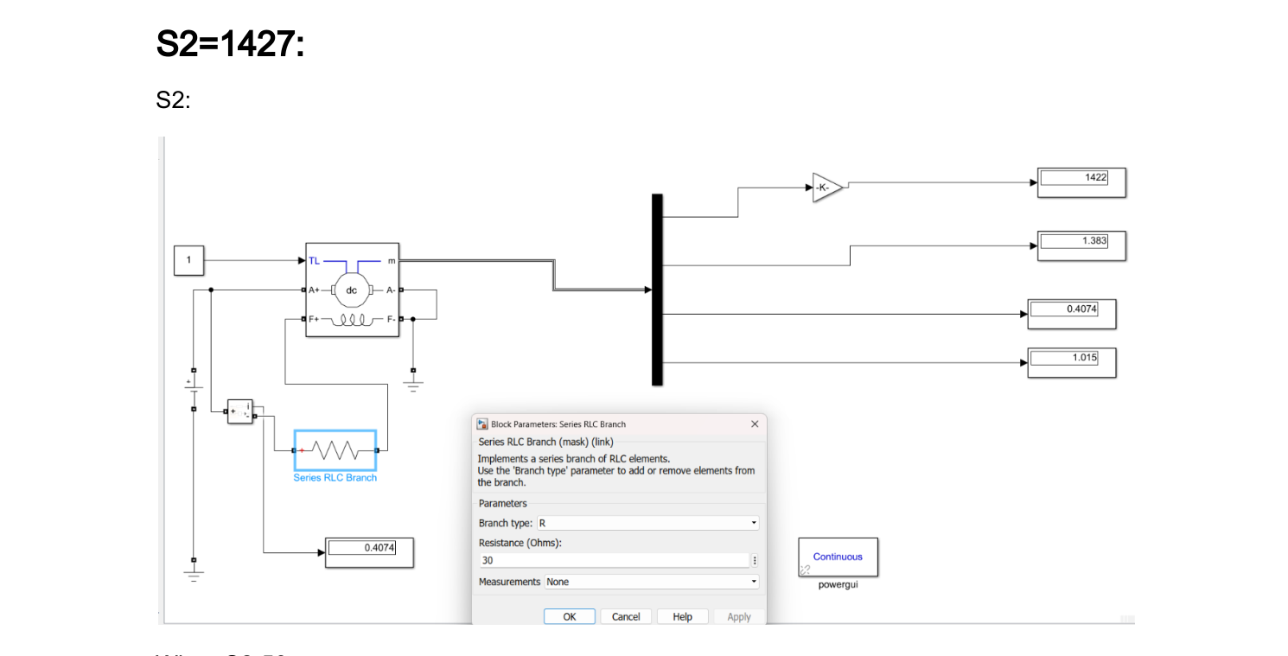
Figure 1: Simulink model with Series RLC Branch set to R = 30 Ω (Base condition). Blue highlighted block indicates the Series RLC Branch. Display outputs show: Speed = 1422 RPM, Torque = 1.383 p.u., Field Current = 0.4074 A, Power Factor = 1.015.
Figure 2 — When S2 = 50 (R = 20 Ω)
The armature resistance is reduced to 20 Ω. This increases the net armature current for the same supply voltage, which in turn raises the electromagnetic torque transiently. The motor accelerates slightly until a new equilibrium is reached at a higher speed. The Continuous powergui block confirms that the simulation uses continuous-time solver mode.
Motor Speed (RPM): 1369 — Slightly lower than base due to increased current loading.
Torque (p.u.): 1.323 — Reduced compared to base; motor stabilizes at new operating point.
Field Current (A): 0.4231 — Slight increase as field circuit responds to changed conditions.
Power Factor: 1.007 — Still close to unity.
Armature Resistance: 20 Ω — Reduced from 30 Ω; allows more armature current.
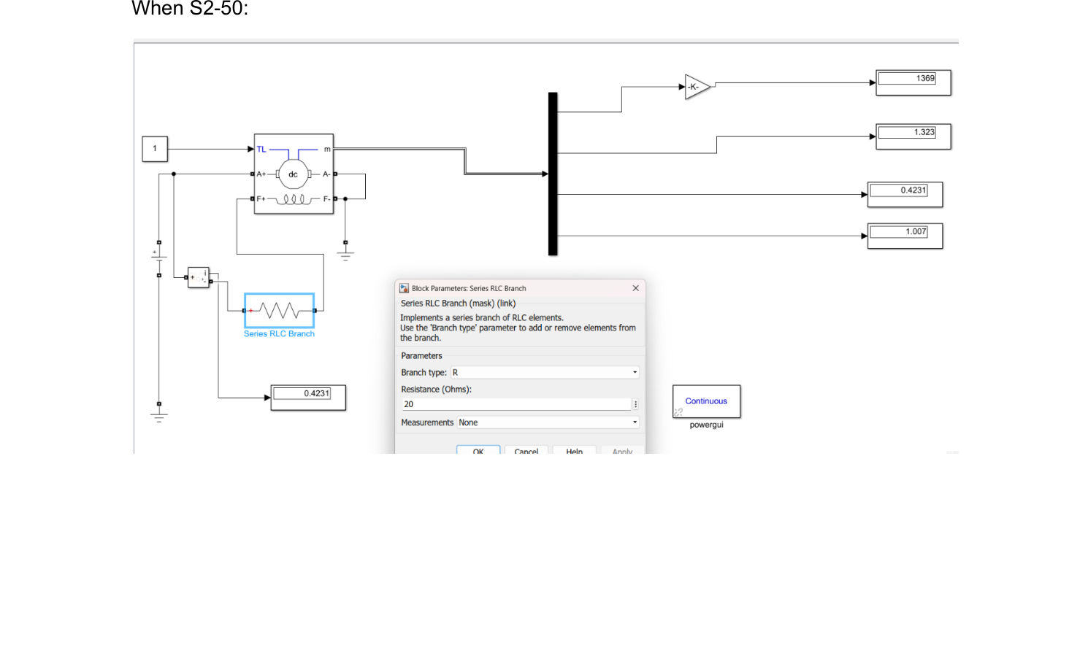
Figure 2: Simulink model with Series RLC Branch set to R = 20 Ω (S2 = 50). Reduction in resistance causes a drop in speed reading (1369 RPM) and torque (1.323 p.u.). Field current rises marginally to 0.4231 A.
Figure 3 — When S2 = 100 (R = 10 Ω)
With resistance further reduced to 10 Ω, armature current rises significantly. The motor can deliver higher torque at startup but settles at a lower steady-state speed as the load balance changes. This is consistent with the DC motor speed-torque characteristic: lower external resistance shifts the operating point along the characteristic curve.
Motor Speed (RPM): 1317 — Continuing downward trend as resistance decreases.
Torque (p.u.): 1.267 — Further reduction; motor torque drops with lower resistance.
Field Current (A): 0.44 — Slightly higher; field remains stable from dc excitation.
Power Factor: 1.003 — Very close to unity; nearly resistive load.
Armature Resistance: 10 Ω — Lower resistance, higher current, lower speed.
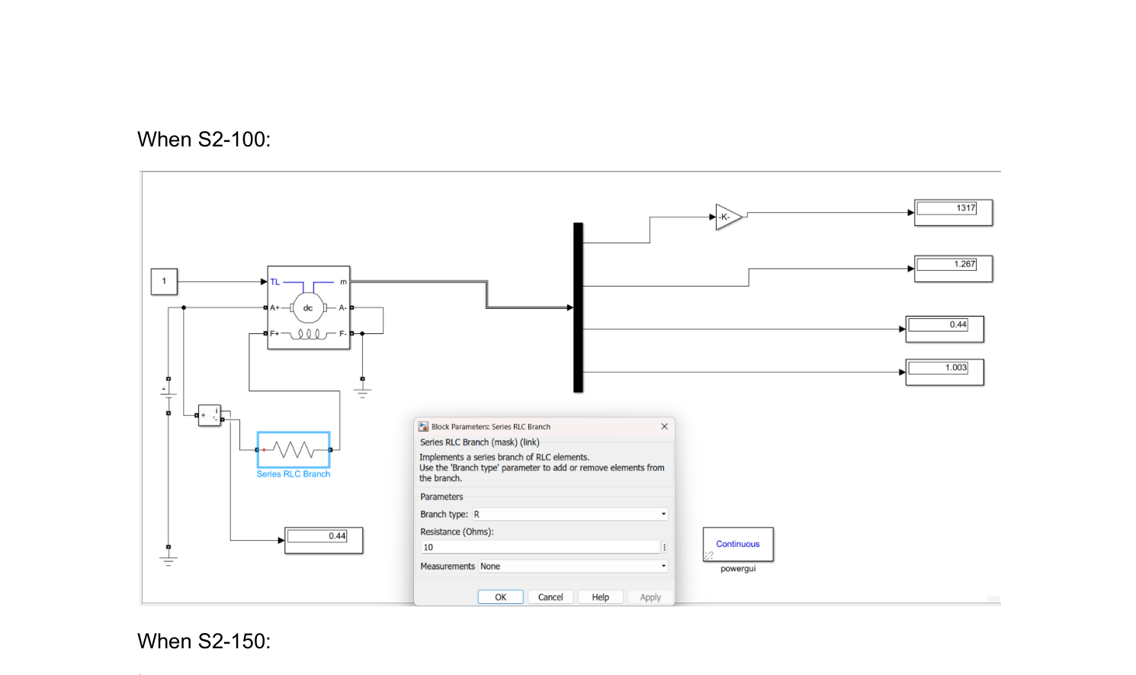
Figure 3: Simulink model with Series RLC Branch set to R = 10 Ω (S2 = 100). Speed drops to 1317 RPM, torque to 1.267 p.u. Field current increases to 0.44 A. Block Parameters dialog confirms R = 10 Ω.
Figure 4 — When S2 = 150 (R = 4.7 Ω)
At R = 4.7 Ω, the armature circuit resistance is now very low. The motor speed continues to decrease toward a new lower equilibrium. At very low external resistance, the armature current is largely limited only by the internal resistance and back-EMF. The output values show continued decline in speed and torque, approaching a near-stall condition if resistance were to drop to zero.
Motor Speed (RPM): 1289 — Significantly reduced; approaching lower operating limit.
Torque (p.u.): 1.238 — Torque continues to decrease with resistance.
Field Current (A): 0.4495 — Field current near its maximum stable value.
Power Factor: 1.002 — Essentially unity; load is purely resistive.
Armature Resistance: 4.7 Ω — Very low resistance; maximum armature current.
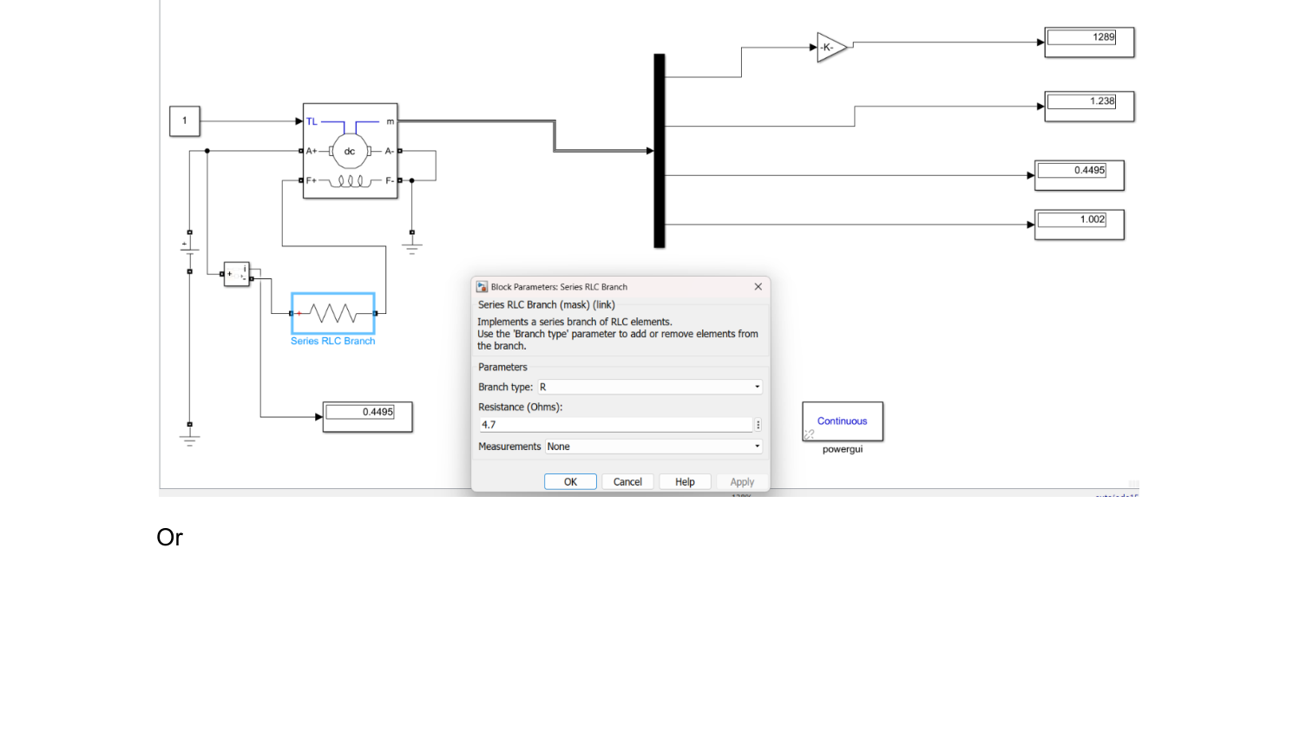
Figure 4: Simulink model with Series RLC Branch set to R = 4.7 Ω (S2 = 150). Speed drops further to 1289 RPM, torque to 1.238 p.u. Field current rises to 0.4495 A. Power factor remains at 1.002.
Figure 5 — Alternate Reading at S2 ≈ 150 (R = 3.19 Ω)
This screenshot shows an alternate or fine-tuned resistance value of R = 3.19 Ω for the same S2 = 150 setting. The Series RLC Branch is now highlighted in blue, indicating it is selected/active in the Simulink editor. The output values are slightly different from Figure 4, suggesting this represents a refined or corrected simulation run with adjusted resistance to match the exact target parameter.
Motor Speed (RPM): 1282 — Marginally lower than Figure 4, consistent with lower resistance.
Torque (p.u.): 1.23 — Slight further reduction.
Field Current (A): 0.4523 — Highest field current across all cases.
Power Factor: 1.002 — Unity maintained.
Armature Resistance: 3.19 Ω — Fine-tuned value; Series RLC Branch highlighted in blue.
Visual Note: The blue highlight on the Series RLC Branch block indicates it is actively selected. The resistor symbol (zigzag line) is clearly visible inside the highlighted block.
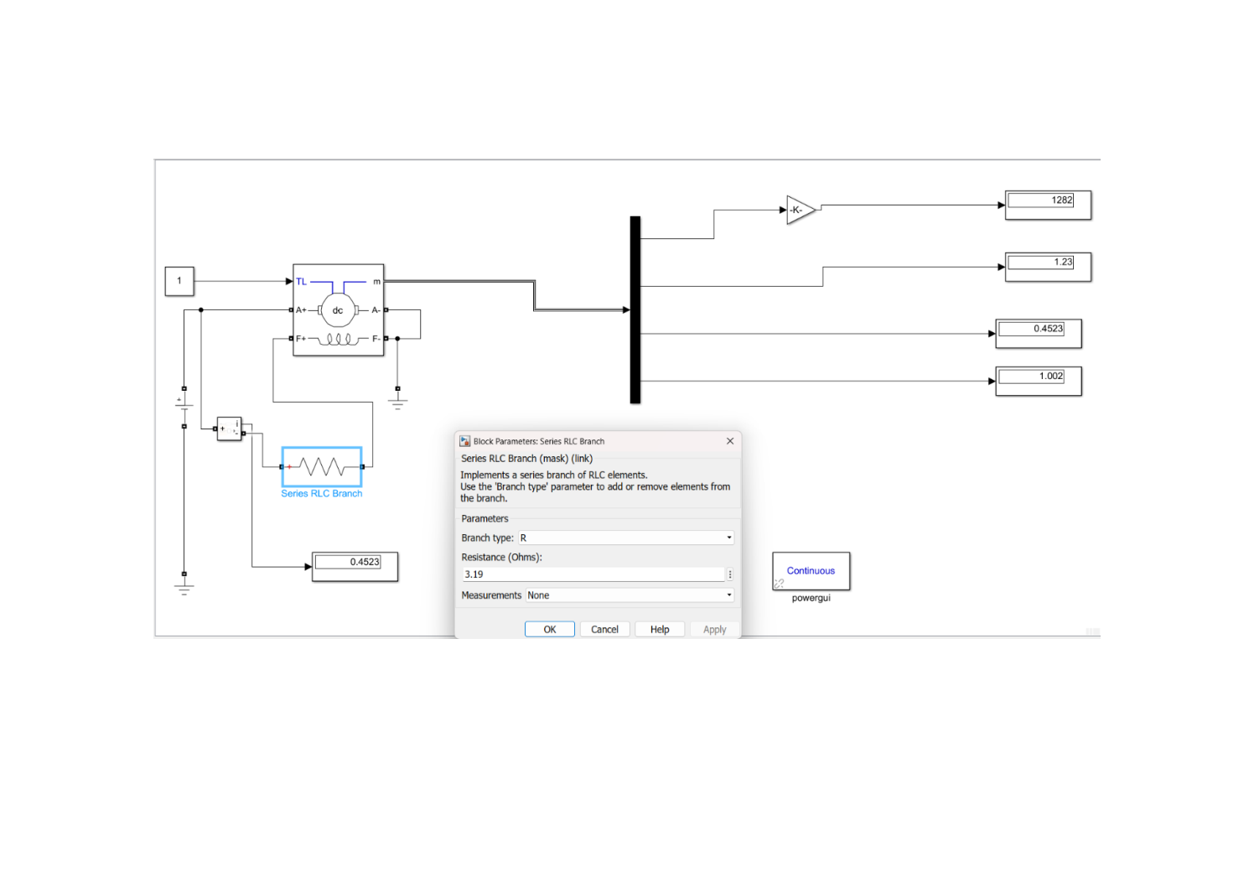
Figure 5: Alternate S2 ≈ 150 simulation with R = 3.19 Ω. The Series RLC Branch is highlighted in blue (selected). Speed = 1282 RPM, Torque = 1.23 p.u., Field Current = 0.4523 A, Power Factor = 1.002.

SUMMARY OF RESULTS
The table below summarizes all simulation results across the five resistance settings. As armature resistance decreases (S2 increases), motor speed drops, torque decreases, and field current rises slightly. Power factor remains close to unity throughout, confirming stable operation.

S2 Value | Resistance (Ω) | Speed (RPM) | Torque (p.u.) | Field Current (A) | Power Factor
Base (S2) | 30 | 1422 | 1.383 | 0.4074 | 1.015
S2 = 50 | 20 | 1369 | 1.323 | 0.4231 | 1.007
S2 = 100 | 10 | 1317 | 1.267 | 0.44 | 1.003
S2 = 150 | 4.7 | 1289 | 1.238 | 0.4495 | 1.002
Or (S2≈150) | 3.19 | 1282 | 1.23 | 0.4523 | 1.002

CONCLUSION
The simulation confirms the fundamental DC motor principle: increasing external armature resistance reduces speed and torque, while field current remains relatively stable due to the separate excitation. The Series RLC Branch in MATLAB/Simulink effectively models the variable resistance. Across all five test cases, the power factor remains near unity (1.000–1.015), indicating a predominantly resistive armature circuit. The results are consistent with the theoretical speed-torque characteristics of a separately-excited DC motor.

