Trying 5:
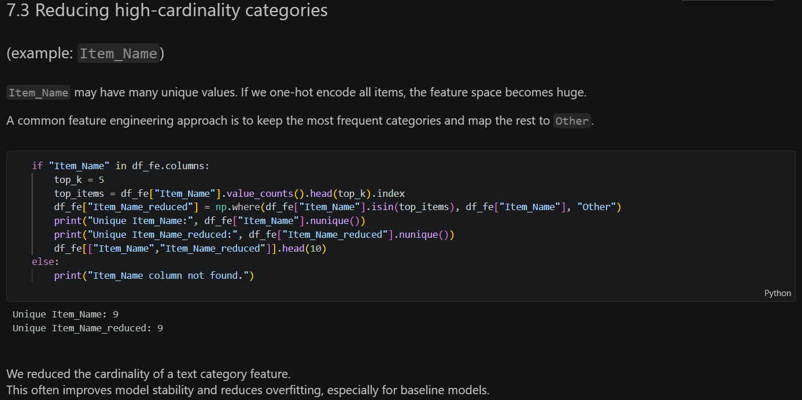

Trying 3:
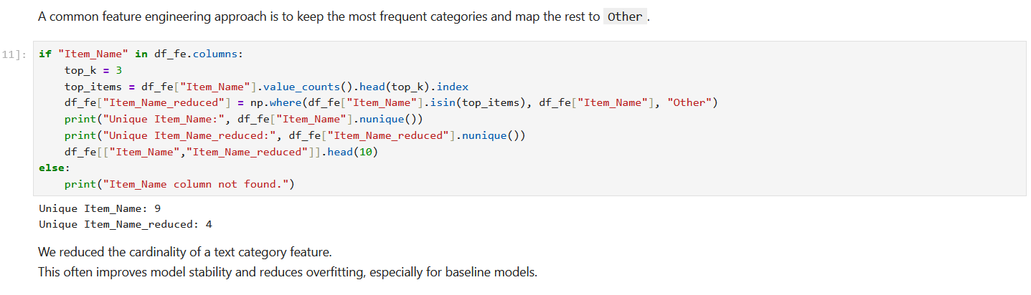
Trying 6:
