**University of Engineering and Technology, Peshawar**

Department of Computer Systems Engineering.

*Course : CSE-403 Database Management System Spring-22*



**Zainab Khalid 19** PWCSE **1743**

**Zubair Khan 19** PWCSE **1797**

Section A

Batch 21 (Spring_2022)

**Submitted to** Mam. Sumayyea Salahuddin

**PROJECT:**

**PHARMACY MANAGEMENT SYSTEM**

**1. Entity Description**

**2. Detailed Business Rules**  
**3. Entity Relationship Diagram (ERD)**

**4. Enhanced Entity Relationship Diagram (EERD)**

**ENTITY DESCRIPTION:**

**PHARMACY:**

A store that sells medicines and different medical products to customers.

**EMPLOYEE:**

The workers that work in the pharmacy.

**CUSTOMER:**

A person or organization which has ordered or might order products from a store. (medicines, drugs, etc).

**PRODUCT:**

Medicines that pharmacy company sells to customers.

**ORDER:**

Products that the customer has requested to buy will be considered as orders.

**SUPPLIER:**

Another company that may provide medical products to a pharmacy store.

**SHIPMENT:**

The transaction that is associated with the item received by the pharmacy store from suppliers.

**BILL:**

A dedicated amount that is paid by the customer on behalf of products purchased.

**REPORT:**

History that contains information about the customers.

**BUSINESS RULES:**

* A pharmacy may have one or more employees and a particular employee works in exactly one pharmacy.
* A customer may submit many orders or no order at all. Similarly, each order is submitted by exactly one customer.
* Each order contains one or more products. Each product may be a part of many orders or not a part of any order at all.
* A supplier may send many shipments or no shipment at all. Similarly, each shipment must be sent by only one supplier.
* A supplier may supply many products or no product at all. Each item is supplied by at least one supplier or any number of suppliers.
* A product may be included in many shipments. Similarly, each shipment must include one or more products.
* A customer may have any number of bills. Each bill is associated with exactly one customer.
* An order must have exactly one bill. Each bill is associated with only one order.
* A customer may have many reports. Each report belongs to exactly one customer.

**ERD:**

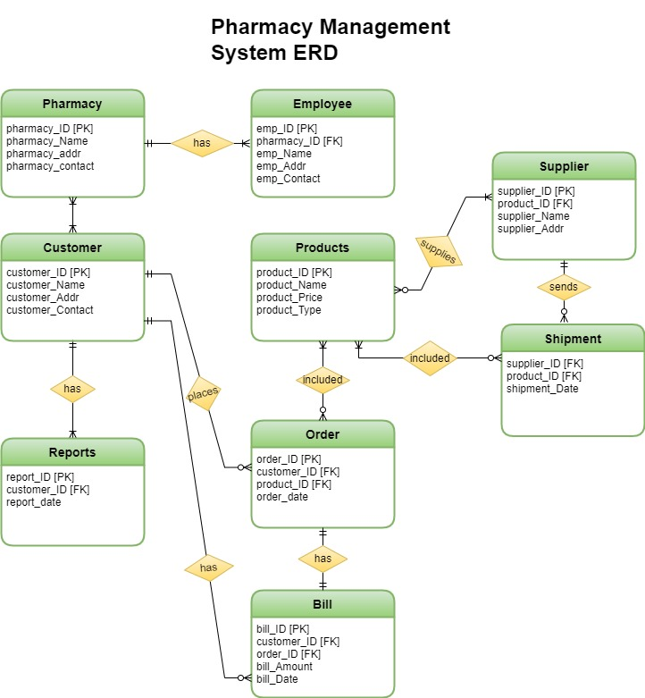

**EERD:**

