**University of Engineering and Technology, Peshawar**

Department of Computer Systems Engineering.

*Course : CSE-303 Microprocessor Based System Design*



**Zubair Khan 19** PWCSE **1797**

Section A

Batch 21 (Spring_2022)

**Submitted to** Dr, Bilal Habib

**TASK 9:**

**Design the following two cases A and B, and then answer questions in C.**

**A. Frequency of input sine wave (f_in) is 50Hz.**

**a. Sampling rate (fs) of ADC = 500 samples/sec.**

**b. Transmission rate of serial data is 9600 bps between MCU-1 and MCU-2.**

**c. Oscillator frequency = 11.059MHz.**

**CODE:**

**MCU-1**

#include <reg51.h>

#include <stdio.h>

sbit RD_n = P3^4; //P3.4 is connected to the RD pin of ADC

sbit WR_n = P3^5; //P3.5 is connected to the WR pin of ADC

sbit INTR = P3^2; //P3.2 is connected to the INTR pin of ADC

void main(void)

{

P1 = 0xFF; //Set P1 as an input Port

INTR = 1; //Set P3.2 as an input pin

TMOD = 0x20; //Timer 1 mode 2

TH1 = 0xFD; //9600 bps

SCON = 0x40; //Mode 1 serial communication

PCON = 0x00; //SMOD = 0

TR1= 1; //Start timer 1

while (1)

{

RD_n = 1; //Set the RD pin to High

WR_n = 0;//WR = Low

WR_n = 1;//Low-->High

while(INTR==1); //Wait for the ADC to Convert the given voltage

RD_n = 0; //Set the RD pin of ADC from HIGH to LOW

//The ADC sends the converted value to P1

SBUF = P1; //Send the value at P1 to SBUF

while(TI==0); //While the SBUF is not transmitted, do nothing

TI = 0; //Reset the TI bit to 0

}

}

**MCU-2**

#include <reg51.h>

#include <stdio.h>

void main(void)

{

P1 = 0x00; //Set P1 as an Output Port

TMOD = 0x20; //Timer 1 mode 2

TH1 = 0xFD; //9600 bps

SCON = 0x50; //Mode 1 serial communication with REN bit set to 1

PCON = 0x00; //SMOD = 0

TR1= 1; //Start timer 1

while (1)

{

while(RI == 0); //While the value is not recieved, do nothing

RI = 0; //Reset the RI bit to 0

P1 = SBUF; //Send the value recieved at SBUF to P1

}

}

**CIRCUIT:**

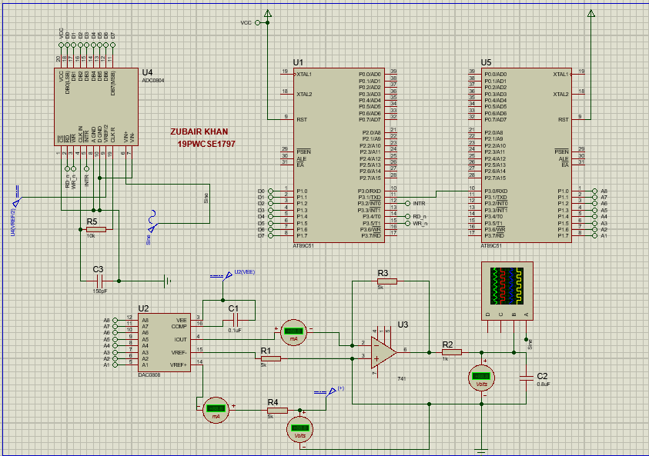

**OUTPUT:**

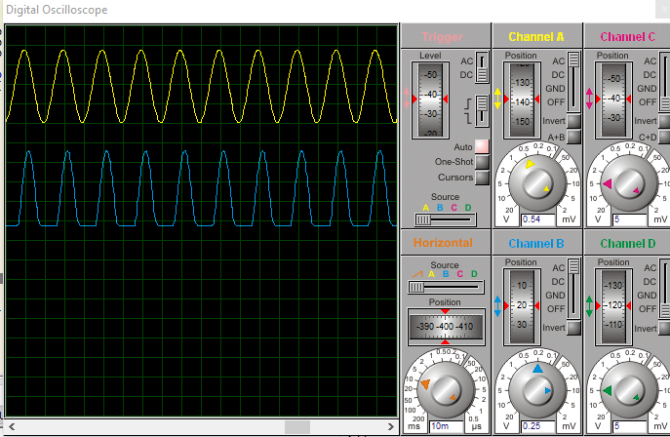

**B. If oscillator frequency is fixed at 22.118MHz for both microcontrollers. Keeping in view the fastest possible transmission rate of serial communication and ADC conversion rate. How much the frequency of input signal can be increased? Run the system at that frequency in Proteus.**

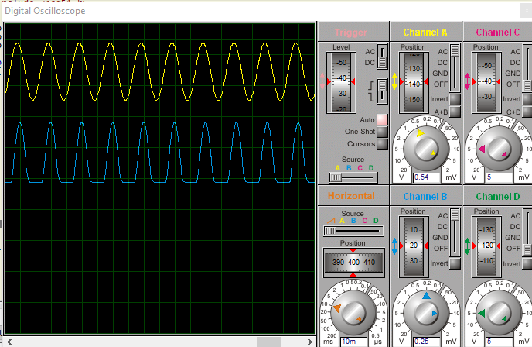

# **C. Discuss,**

**• Input signal to ADC has a frequency (f_in) of 50Hz. How you supplied it.**

The input frequency 50Hz to the input signal can be supplied by editing the properties of the sine wave generator.

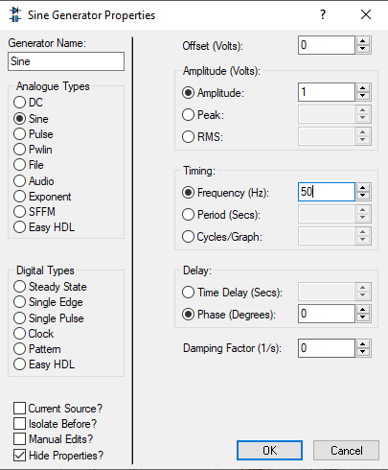

**• What happens if you decrease the sampling rate (fs) from 500Hz, 400Hz to 100Hz samples**

**per second for ADC?**

As the sampling frequency decreases, **the signal separation also decreases**. When the sampling frequency drops below the Nyquist rate, the frequencies will crossover and cause aliasing.

When we decrease sampling frequency then there will be distortion in the original signal because the samples required to reconstruct the original signal are not enough.

**fs=500Hz**

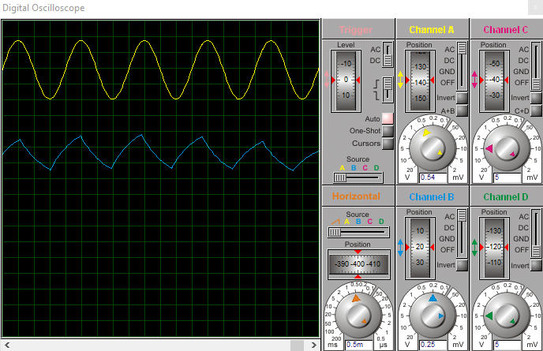

**fs=400Hz**

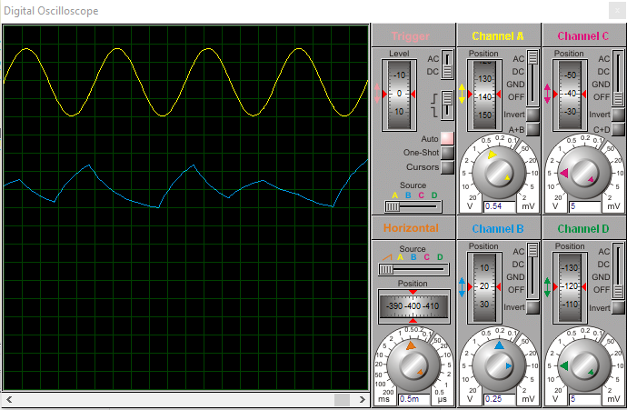

**fs=100Hz**

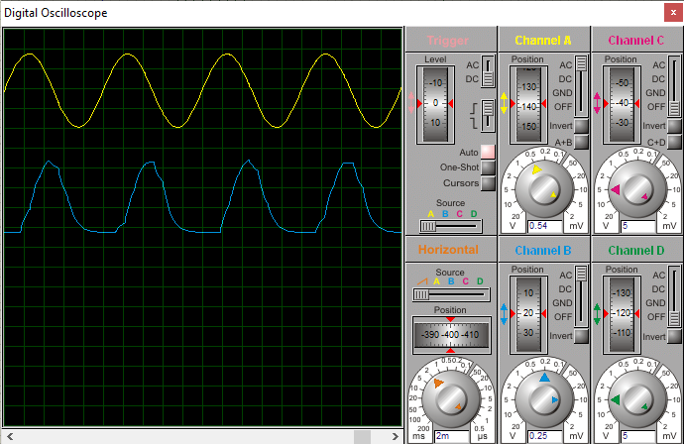

**• What reference voltage (V_ref) has been used for ADC?**

The reference voltage used for ADC in this task is 1V and this can be obtained by supplying 0.5V at the Vref/2 Pin of the ADC.

**• What is the relationship of V_ref to the amplitude of input signal?**

The vref has a direct relationship with the amplitude of the signal. The amplitude of signal varies directly with the vref.

***Amplitude ∝ Vref***

**• What will be the step-size?**

***Step-size = Vin/2n***

So step-size = 1V/28 = 1V/256 = 3.90mV

**• What is the input voltage range of ADC?**

As my reference voltage is 1V so, the input voltage range of my ADC is 0V -1V.

**• Can we increase the frequency of input signal (f_in) to 10KHz, if not then why?**

No, we cannot increase the frequency of the input signal to 10KHz because we will need a sampling frequency of 1MHz for that, which is practically not possible to achieve.

**• If transmission rate is increased to 19,200 bps. Is your design able to handle input frequency**

**(f_in) equal to 10KHz, without any loss of information? Assuming fs = = 10 x f_in.**

It is not possible for my design to handle input frequency of 10KHz without any loss of information even if the transmission rate is increased to 19200 bps.

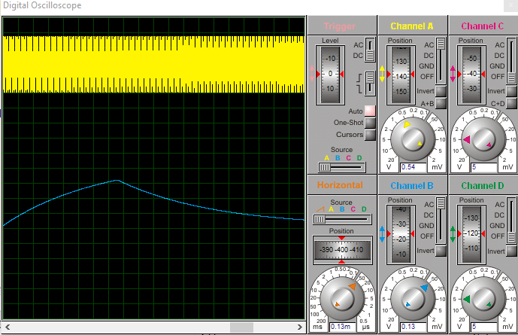

**• What is the limit of DAC, how fast it can work?**

DAC can work faster at the setting time of **150 ns** and number of DAC outputs **= 2n = 28 = 256.**