***Course: CSE-303 Microprocessor Based System Design***



**Semester 6**

**Name: Zainab Khalid**

**Reg no: 19 PWCSE 1743**

**Section: A**

**Batch: 21 (Spring_2022)**

**Submitted to: Dr Bilal Habib**

**University of Engineering and Technology, Peshawar**

**Department of Computer Systems Engineering.**

**TASK 6:**

**CALCULATOR DESIGN**

In this assignment, you are required to design a calculator that should be able to do the following operations,

Addition, Subtraction, Multiplication, and Division.

The result is displayed as soon the user press the “=” button on the keypad. Additionally, pressing the

“C\ON”, clears the contents of the LCD.

Use as many LCD commands to make it user-friendly.

**CODE:**

#include <reg51.h>

#include <stdio.h>

#define ERROR 0 // Any value other than 0 to 9 is good here

//Function declarations

void ports_initialization(void);

void delay(int);

void Lcd_initialization(void);

void write_command(int);

void write_data(char);

void Return(void);

char READ_SWITCHES(void);

char get_key(void);

int get_number(char);

char get_operation(char);

void display_result(int);

sbit RowA = P1^0; //RowA

sbit RowB = P1^1; //RowB

sbit RowC = P1^2; //RowC

sbit RowD = P1^3; //RowD

sbit C1 = P1^4; //Column1

sbit C2 = P1^5; //Column2

sbit C3 = P1^6; //Column3

sbit C4 = P1^7; //Column4

sbit E = P3^6; //Enable pin for LCD

sbit RS = P3^7; //RS(to check command or data) pin for LCD

// Main program

void main(void)

{

char key; // key char for keeping record of pressed key

int number1,number2;

char operation;

ports_initialization(); // Make input and output pins as required

Lcd_initialization(); // Initilize LCD

write_command(0x80);

while(1)

{

key = get_key(); // Get pressed key

number1=get_number(key);

if (number1 != ERROR)

{

write_data(key); // Echo the key pressed to LCD

key=get_key();

operation=get_operation(key); // Clear scree

write_data(operation);

if(operation!=ERROR)

{

key=get_key();

number2=get_number(key);

if(number2!=ERROR)

{

write_data(key);

key=get_key();

if(key=='=')

{

write_data(key);

switch(operation){

case '+': display_result(number1+number2) ; break;

case '-': display_result(number1-number2); break;

case 'x': display_result(number1*number2); break;

case '/': display_result(number1/number2); break;

default: write_command(0x01); //clear screen

}

}

}

}

}

else{

write_command(0x01); //clear screen

}

}

}

void ports_initialization(void)

{

P0 = 0x00; //not used

P1 = 0xf0; //used for generating outputs and taking inputs from Keypad

P2 = 0x00; //used as data port for LCD

P3 = 0x00; //used for RS and E

}

void delay(int d)

{

int i;

for(i=0;i<d;i++); //null statement

}

void write_data(char s)

{

RS = 1; // This is data

P2 = s; //Data transfer

E = 1; // => E = 1

delay(150);

E = 0; // => E = 0

delay(150);

}

void write_command(int a)

{

RS = 0; // This is command

P2 = a; //Data transfer

E = 1; // => E = 1

delay(150);

E = 0; // => E = 0

delay(150);

}

void Lcd_initialization(void)

{

///////////// Reset process from datasheet /////////

delay(15000);

write_command(0x30);

delay(4500);

write_command(0x30);

delay(300);

write_command(0x30);

delay(650);

/////////////////////////////////////////////////////

write_command(0x38); //function set

write_command(0x0c); //display on,cursor off,blink off

write_command(0x01); //clear display

write_command(0x06); //entry mode, set increment

}

void Return(void) //Return to 0 location on LCD

{

write_command(0x02);

delay(1500);

}

char Read_Switches(void)

{

RowA = 0; RowB = 1; RowC = 1; RowD = 1; //Test Row A

if (C1 == 0){ delay(10000);while (C1==0); return '7'; }

if (C2 == 0) { delay(10000); while (C2==0); return '8'; }

if (C3 == 0) { delay(10000); while (C3==0); return '9'; }

if (C4 == 0) { delay(10000); while (C4==0); return '/'; }

RowA = 1; RowB = 0; RowC = 1; RowD = 1; //Test Row B

if (C1 == 0) { delay(10000); while (C1==0); return '4'; }

if (C2 == 0) { delay(10000); while (C2==0); return '5'; }

if (C3 == 0) { delay(10000); while (C3==0); return '6'; }

if (C4 == 0) { delay(10000); while (C4==0); return 'x'; }

RowA = 1; RowB = 1; RowC = 0; RowD = 1; //Test Row C

if (C1 == 0) { delay(10000); while (C1==0); return '1'; }

if (C2 == 0) { delay(10000); while (C2==0); return '2'; }

if (C3 == 0) { delay(10000); while (C3==0); return '3'; }

if (C4 == 0) { delay(10000); while (C4==0); return '-'; }

RowA = 1; RowB = 1; RowC = 1; RowD = 0; //Test Row D

if (C1 == 0) { delay(10000); while (C1==0); return '*'; }

if (C2 == 0) { delay(10000); while (C2==0); return '0'; }

if (C3 == 0) { delay(10000); while (C3==0); return '='; }

if (C4 == 0) { delay(10000); while (C4==0); return '+'; }

return 'n'; // Means no key has been pressed

}

char get_key(void) //get key from user

{

char key = 'n'; //assume no key pressed

while(key=='n') //wait untill a key is pressed

key = READ_SWITCHES(); //scan the keys again and again

return key; //when key pressed then return its value

}

int get_number(char character)

{

switch(character){

case '0': return 0; break;

case '1': return 1; break;

case '2': return 2; break;

case '3': return 3; break;

case '4': return 4; break;

case '5': return 5; break;

case '6': return 6; break;

case '7': return 7; break;

case '8': return 8; break;

case '9': return 9; break;

default:return ERROR; break; //it means wrong input

}

}

char get_operation(char key)

{

if(key=='+' || key=='-' || key=='x' || key=='/')

{

return key;

}

else{

return ERROR;

}

}

void display_result(int number)

{

unsigned char Unit = 0; //It will contain unit digit of numb

unsigned char Tenth= 0; //It will contain 10th position digit of numb

if(number<0)

{

number = -1*number; // Make number positive

write_data('-'); // Display a negative sign on LCD

}

Tenth = (number/10); // Findout Tenth Digit

if( Tenth != 0) // If it is zero, then don't display

write_data(Tenth+0x30); // Make Char of TenthDigit and then display it on LCD

Unit = number - Tenth*10;

write_data(Unit+0x30); // Make Char of UnitDigit and then display it on LCD

}

**OUTPUT:**

**ADDITION:**

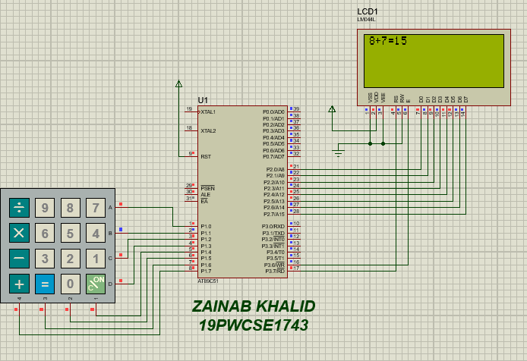

**MULTIPLICATION:**

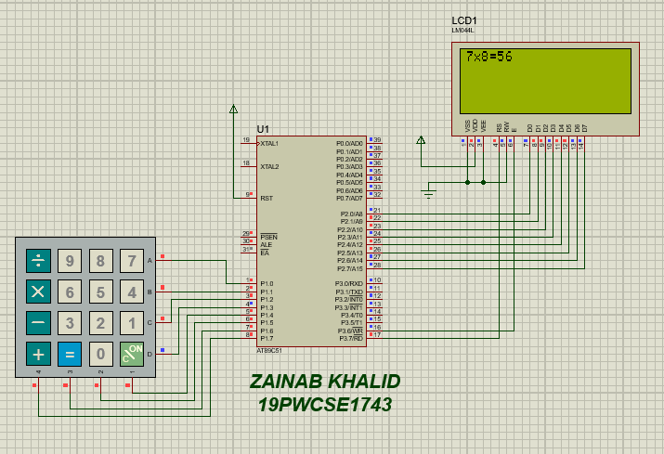

**SUBTRACTION:**

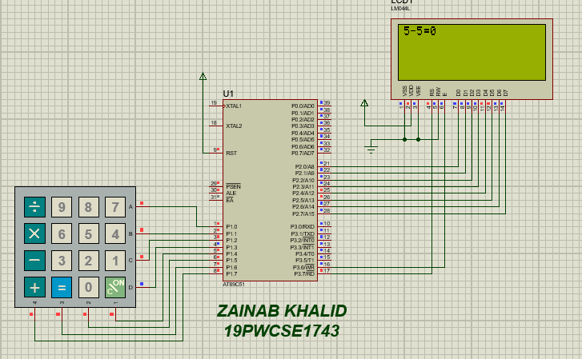

**DIVISION:**

