**University of Engineering and Technology, Peshawar**

Department of Computer Systems Engineering.

*Course : CSE-303 Microprocessor Based System Design*



**Zainab Khalid 19** PWCSE **1743**

Section A

Batch 21 (Spring_2022)

**Submitted to** Dr, Bilal Habib

**Task 03**

**A. Generate a signal on pin P1.1 having frequency equal to 10 Hz with a duty cycle of 10%.**

**B. When a user presses a button at P1.2 then frequency changes to 20Hz with a 20% duty cycle.**

**C. When a user again presses the same button then frequency changes to 40Hz with a duty cycle of 40%.**

**D. When a user again presses the same button then frequency changes to 80Hz with a duty cycle of 80%.**

**E. Show it on oscilloscope.**

**F. Each time a user presses a button the signal toggles from case A to B, then B to C, then C to D and finally from D to A, on every subsequent button press.**

**G. Program only in C, create delay using Timer.**

**Part # A**

Generate signal of frequency = 10 Hz.

duty cycle=10%

Time period is,

t=1/f , t=1/10 , t=0.1sec=100msec

Duty cycle = [(uptime) / (total time)] * 100

uptime=[(duty cycle / 100)] *total time

uptime= (10 / 100) *100ms

uptime= 10ms

uptime=10,000usec

(10,000)10=(2710)16

UP_DELAY= ffff-2710

=( D8EF)16

so off-time=total time - uptime

off-time=(100-10)ms

off-time=90msec

off-time=90,000usec

(90,000)10=(15F90)16

UP_DELAY= ffff-15F90

=( D8EF)16

**Part # B**

Generate signal of frequency = 20Hz.

duty cycle=20%

Time period is,

t=1/f , t=1/200 , t=50ms

Duty cycle = [(uptime) / (total time)] * 100

uptime=[(duty cycle / 100)] *total time

uptime= (20 / 100) *50ms

uptime= 10ms

uptime= 10000usec

(10,000)10=(2710)16

UP_DELAY= ffff-2710

=( D8EF)16

so off-time=total time - uptime

off-time=(50-10)ms

off-time=40ms

off-time=40,000microsec

(40,000)10=(9C40)16

UP_DELAY= ffff-9C40

=( 63BF)16

**Part # C**

Generate signal of frequency = 40 Hz.

duty cycle=40%

Time period is,

t=1/f , t=1/40 , t=25ms

Duty cycle = [(uptime) / (total time)] * 100

uptime=[(duty cycle / 100)] *total time

uptime= (40 / 100) *20ms

uptime= 10ms

uptime= 10,000microsec

(10,000)10=(2710)16

UP_DELAY= ffff-2710

=( D8EF)16

so off-time=total time - uptime

off-time=(25-10) ms

off-time=15ms

off-time=15,000microsec

(15,000)10=(3A98)16

UP_DELAY= ffff-3A98

=( C567)16

**Part # D**

Generate signal of frequency = 80 Hz.

duty cycle=80%

Time period is,

t=1/f , t=1/80 , t=12.5ms

Duty cycle = [(uptime) / (total time)] * 100

uptime=[(duty cycle / 100)] *total time

uptime= (80 / 100) *12.5ms

uptime= 10ms

uptime=10,000usecond

(10,000)10=(2710)16

UP_DELAY= ffff-2710

=( D8EF)16

so off-time=total time - uptime

off-time=(12.5-10)ms

off-time=2.5ms

uptime= 25,00usec

(2,500)10=(9C4)16

UP_DELAY= ffff-9C4

=( F63B)16

**Code:**

#include <reg51.h>

#include <stdio.h>

sbit delay=P1^1;

sbit toggle=P1^2;

int counter=0;

unsigned int a=0;

void start_timer0(void)

{

TR0=1;

}

void timer0(void)interrupt 1

{

if(counter==0)

{

if(delay==0 && a==0)

{

delay=1;

TH0=0xD8;

TL0=0xEF;

}

else

{

a++;

delay=0;

if(a==9)

{

a=0;

}

TH0=0xD8;

TL0=0xEF;

}

}

else if(counter==1)

{

if(delay==1)

{

TH0=0x63;

TL0=0xBF;

}

else{

TH0=0xD8;

TL0=0xEF;

}

delay=~delay;

}

else if(counter==2)

{

if(delay==1)

{

TH0=0xC5;

TL0=0x67;

}

else {

TH0=0xD8;

TL0=0xEF;

}

delay=~delay;

}

else if(counter==3)

{

if(delay==1)

{

TH0=0xF6;

TL0=0x3B;

}

else {

TH0=0xD8;

TL0=0xEF;

}

delay=~delay;

}

}

void init_timer0(void){

TMOD=0x01;

TH0=0xFB;

TL0=0x9A;

IE=0x83;

}

void main(void)

{

// Write your code here

init_timer0();

start_timer0();

while(1)

{

if(toggle==0)

{

if(counter<3)

counter++;

else if(counter==3)

counter=0;

}

}

}

**Circuit diagram:**

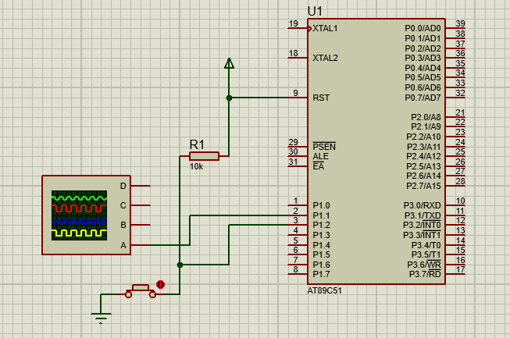

**Output:**

**Delay=100ms**

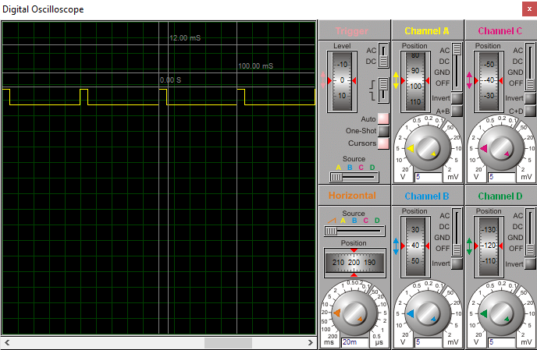

**Delay=50ms**

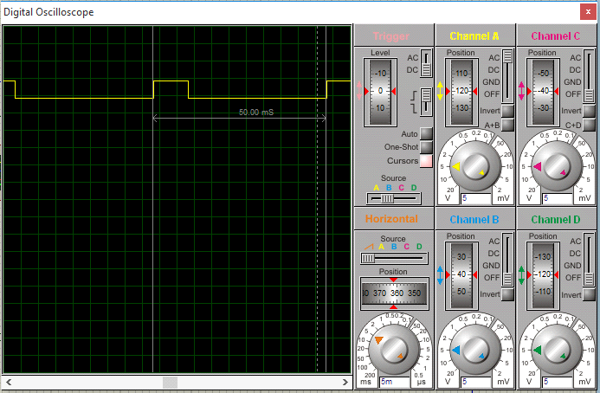

**Delay=25ms**

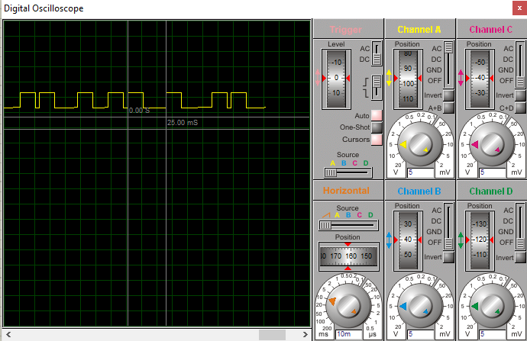

**Delay=12ms**

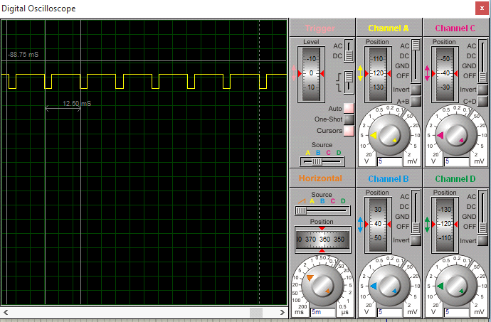

#include <reg51.h>

#include <stdio.h>

sbit led=P1^1; //led at pin 1.1

sbit button=P1^2; //button for toggling at pin 1.2

int counter=0; //variables declaration

unsigned int a=0;

int i=0;

void start_timer0(void) //starting timer 0

{

TR0=1;

}

void timer0(void)interrupt 1

{

if(counter==0)

{

if(led==0 && a==0)

{

led=1;

TH0=0xD8;

TL0=0xEF;

}

else

{

a++;

led=0;

if(a==9)

{

a=0;

}

TH0=0xD8;

TL0=0xEF;

}

}

else if(counter==1)

{

if(led==1)

{

TH0=0x63;

TL0=0xBF;

}

else{

TH0=0xD8;

TL0=0xEF;

}

led=~led;

}

else if(counter==2)

{

if(led==1)

{

TH0=0xC5;

TL0=0x67;

}

else {

TH0=0xD8;

TL0=0xEF;

}

led=~led;

}

else if(counter==3)

{

if(led==1)

{

TH0=0xF6;

TL0=0x3B;

}

else {

TH0=0xD8;

TL0=0xEF;

}

led=~led;

}

}

void init_timer0(void){

TMOD=0x01; //mode 1 16 bit timer

TH0=0xFB; //loading high 8 bit values

TL0=0x9A; //loading low 8 bit values

IE=0x83; //interrupt enable

}

void main(void)

{

// Write your code here

init_timer0(); //function calling

start_timer0();

led=1;

button=1;

while(1)

{

if(button==0) //when button is pressed

{

if(counter<3)

counter++; //increment counter until reaches 3

else if(counter==3) //when counter=3 ,set counter to 0

counter=0;

}

}

}