EXERCISE 1: CONTROL STRUCTURES
OBJECTIVE
To demonstrate the use of PL/SQL control structures such as loops, conditional statements, cursors, and database updates in a banking system.
SAMPLE DATA:
CREATE TABLE Customers (
CustomerID NUMBER PRIMARY KEY,
CustomerName VARCHAR2(50),
Age NUMBER,
Balance NUMBER,
IsVIP VARCHAR2(5)
);

CREATE TABLE Loans (
LoanID NUMBER PRIMARY KEY,
CustomerID NUMBER,
InterestRate NUMBER,
DueDate DATE,
FOREIGN KEY (CustomerID) REFERENCES Customers(CustomerID)
);
INSERT INTO Customers VALUES (101, 'John', 65, 12000, 'FALSE');
INSERT INTO Customers VALUES (102, 'Mary', 45, 8000, 'FALSE');
INSERT INTO Customers VALUES (103, 'David', 70, 15000, 'FALSE');
INSERT INTO Customers VALUES (104, 'Sarah', 55, 5000, 'FALSE');

INSERT INTO Loans VALUES (1001, 101, 10, SYSDATE + 15);
INSERT INTO Loans VALUES (1002, 102, 12, SYSDATE + 40);
INSERT INTO Loans VALUES (1003, 103, 11, SYSDATE + 20);
INSERT INTO Loans VALUES (1004, 104, 9, SYSDATE + 10);
COMMIT;
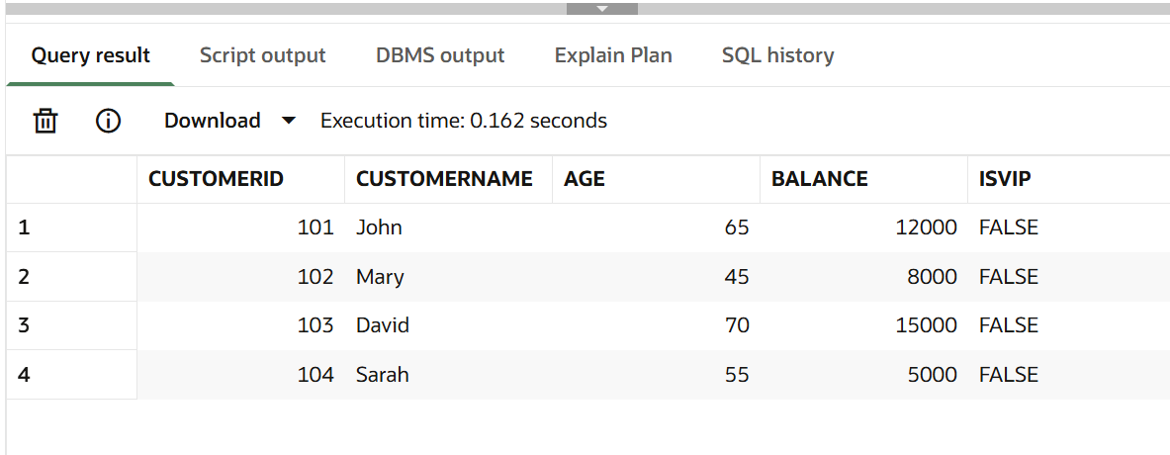
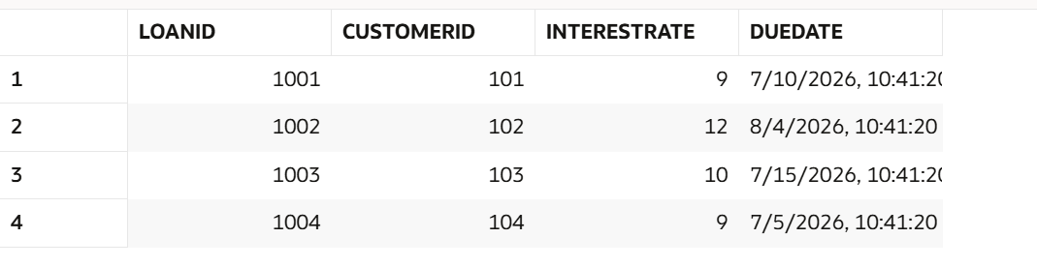
SCENARIO 1: Apply Interest Rate Discount for Senior Customers
Problem Statement:
The bank wants to apply a 1% discount to loan interest rates for customers above 60 years old.
PL/SQL Code:
BEGIN
FOR cust_rec IN (
SELECT CustomerID, Age
FROM Customers
) LOOP
IF cust_rec.Age > 60 THEN
UPDATE Loans
SET InterestRate = InterestRate - 1
WHERE CustomerID = cust_rec.CustomerID;
END IF;
END LOOP;
COMMIT;
END;
/
Output:
SELECT * FROM Loans
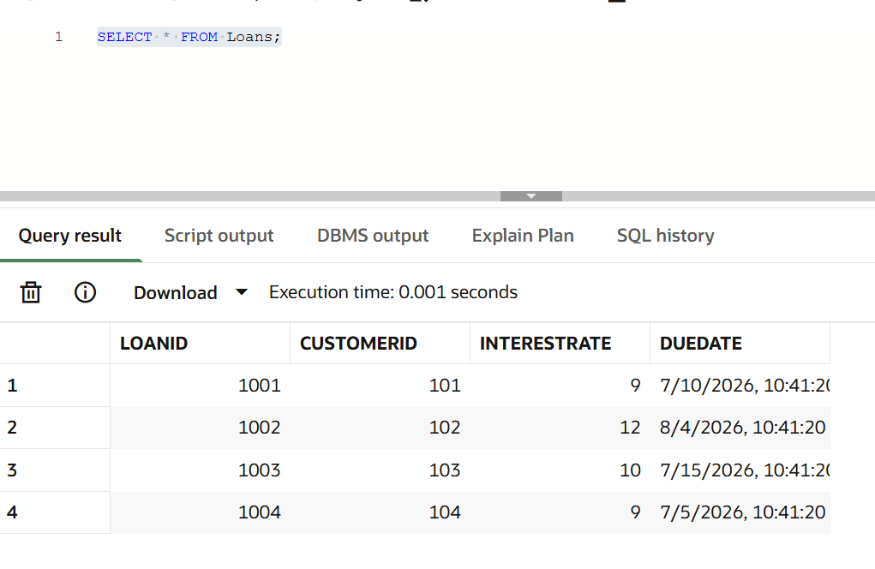

SCENARIO 2: Promote Customers to VIP Status
Problem Statement:
A customer can be promoted to VIP status if their account balance exceeds $10,000.
PL/SQL Code:
BEGIN
FOR cust_rec IN (
SELECT CustomerID, Balance
FROM Customers
) LOOP
IF cust_rec.Balance > 10000 THEN
UPDATE Customers
SET IsVIP = 'TRUE'
WHERE CustomerID = cust_rec.CustomerID;
END IF;
END LOOP;
COMMIT;
END;
/
Output:
SELECT * FROM Customers
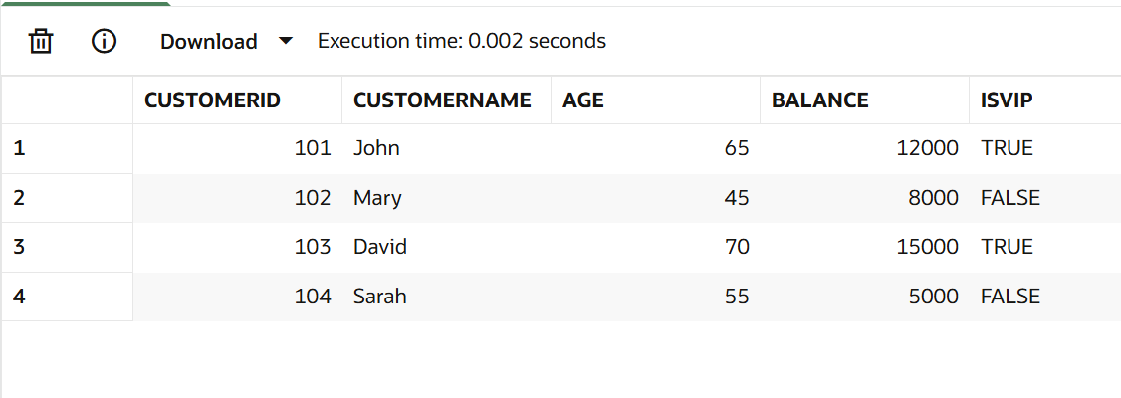
SCENARIO 3: Send Loan Due Reminders
Problem Statement:
The bank wants to send reminders to customers whose loans are due within the next 30 days.
PL/SQL Code:
BEGIN
FOR loan_rec IN (
SELECT LoanID, CustomerID, DueDate
FROM Loans
WHERE DueDate BETWEEN SYSDATE AND SYSDATE + 30
) LOOP
DBMS_OUTPUT.PUT_LINE(
'Reminder: Customer ' ||
loan_rec.CustomerID ||
' Loan ' ||
loan_rec.LoanID ||
' Due on ' ||
TO_CHAR(loan_rec.DueDate,'DD-MON-YYYY')
);
END LOOP;
END;
/
Output:
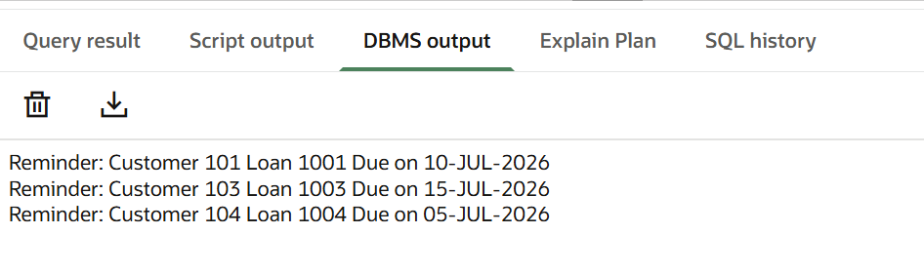
RESULT
Thus, the PL/SQL program for implementing control structures using loops, conditional statements, and cursors was successfully executed and verified.

