Infosys_HotelRevAI – AI Driven Revenue Analysis for Hotels

MILESTONE-1: Orientation Presentation Document

1. Introduction
The hospitality industry generates large volumes of data related to bookings, pricing, customer behaviour, and seasonal demand. Managing and analyzing this data manually is challenging and time-consuming. Infosys_HotelRevAI is an AI-driven revenue analysis approach designed to help hotels make smarter, data-driven decisions.
In this project, we focus on building Power BI dashboards to analyze hotel revenue performance using historical data and AI-based insights. The goal is to understand revenue trends, identify key factors affecting profitability, and support strategic decision-making.

2. Problem Statement
Hotels face several challenges in revenue management, such as:
- Fluctuating demand due to seasons, holidays, and events
- Frequent booking cancellations
- Difficulty in setting optimal room prices
- Lack of real-time and visual insights for decision-making
Traditional reporting methods are not sufficient to handle complex and large datasets. Hence, an AI-driven and visualization-based solution is required.

3. Project Objective
The main objectives of Infosys_HotelRevAI are:
- To analyze hotel revenue data using Power BI
- To identify trends in bookings, cancellations, and revenue
- To calculate key performance indicators (KPIs) such as ADR and occupancy rate
- To provide interactive dashboards for easy understanding
- To support revenue optimization decisions using data insights

4. What is AI-Driven Revenue Analysis?
AI-driven revenue analysis uses advanced techniques such as:
- Data analytics
- Pattern recognition
- Predictive insights
In the context of hotels, AI helps in:
- Understanding customer booking behavior
- Predicting demand patterns
- Identifying high and low revenue periods
- Supporting dynamic pricing strategies
Although the dashboards are built in Power BI, AI concepts are applied through trend analysis, forecasting visuals, and data-driven insights.

5. Dataset Overview
The hotel revenue dataset typically includes the following attributes:
- Hotel type (City Hotel / Resort Hotel)
- Booking status (Canceled / Not Canceled)
- Lead time
- Arrival date (year, month, week)
- Number of adults, children, and babies
- Room type and meal plan
- Average Daily Rate (ADR)
- Number of nights stayed
This raw dataset is cleaned and transformed using Power Query before visualization.

6. Key Metrics Used
Some important metrics used in the analysis are:
- Revenue
Revenue = ADR × Number of Nights Stayed
- ADR (Average Daily Rate)
Average revenue earned per occupied room per day
- Occupancy Rate
Percentage of rooms occupied during a given period
- Cancellation Rate
Percentage of bookings that were canceled
These metrics help evaluate hotel performance clearly.

7. Role of Power BI in the Project
Power BI plays a crucial role in this project by:
- Connecting to hotel revenue datasets
- Cleaning and transforming data using Power Query
- Creating interactive dashboards and reports
- Using filters, slicers, and visuals for analysis
Power BI dashboards make complex data easy to understand for both technical and non-technical users.

8. Dashboards Created
The Power BI dashboards include:
- Revenue trend analysis (monthly and yearly)
- ADR comparison across hotel types
- Booking vs cancellation analysis
- Seasonal and demand-based insights
- Performance comparison between City Hotels and Resort Hotels
These dashboards allow users to explore data interactively.

9. Benefits of Infosys_HotelRevAI
- Improves revenue forecasting accuracy
- Helps management make informed pricing decisions
- Identifies revenue leakages due to cancellations
- Saves time through automated analysis
- Enhances strategic planning using visual insights

10. Conclusion
Infosys_HotelRevAI demonstrates how AI-driven analytics combined with Power BI can transform hotel revenue management. By converting raw hotel data into meaningful dashboards, hotels can better understand their performance, predict trends, and maximize revenue.
This project highlights the importance of data visualization and AI-based insights in the modern hospitality industry.

11. Future Scope
- Integration of real-time hotel data
- Advanced AI-based demand forecasting models
- Personalized pricing strategies
- Expansion to multi-hotel or chain-level analysis

MILESTONE-2 : Data Loading and Data Modeling

DATA LOADING
1. Introduction to Data Source
The Hotel Revenue Analysis report was developed using structured hotel booking and revenue datasets imported into Power BI Desktop. The dataset contains information related to hotel bookings, customer details, room types, stay duration, booking dates, and revenue generated.
The data was imported into Power BI using the “Get Data” feature from supported sources such as Excel, CSV files, or databases.

2. Data Import Process
The following steps were followed to load the data into Power BI:
- Opened Power BI Desktop.
- Selected the “Get Data” option from the Home tab.
- Chose the appropriate data source.
- Selected the required tables.
- Loaded the data into Power BI.
Multiple related tables were imported to support detailed revenue and booking analysis.
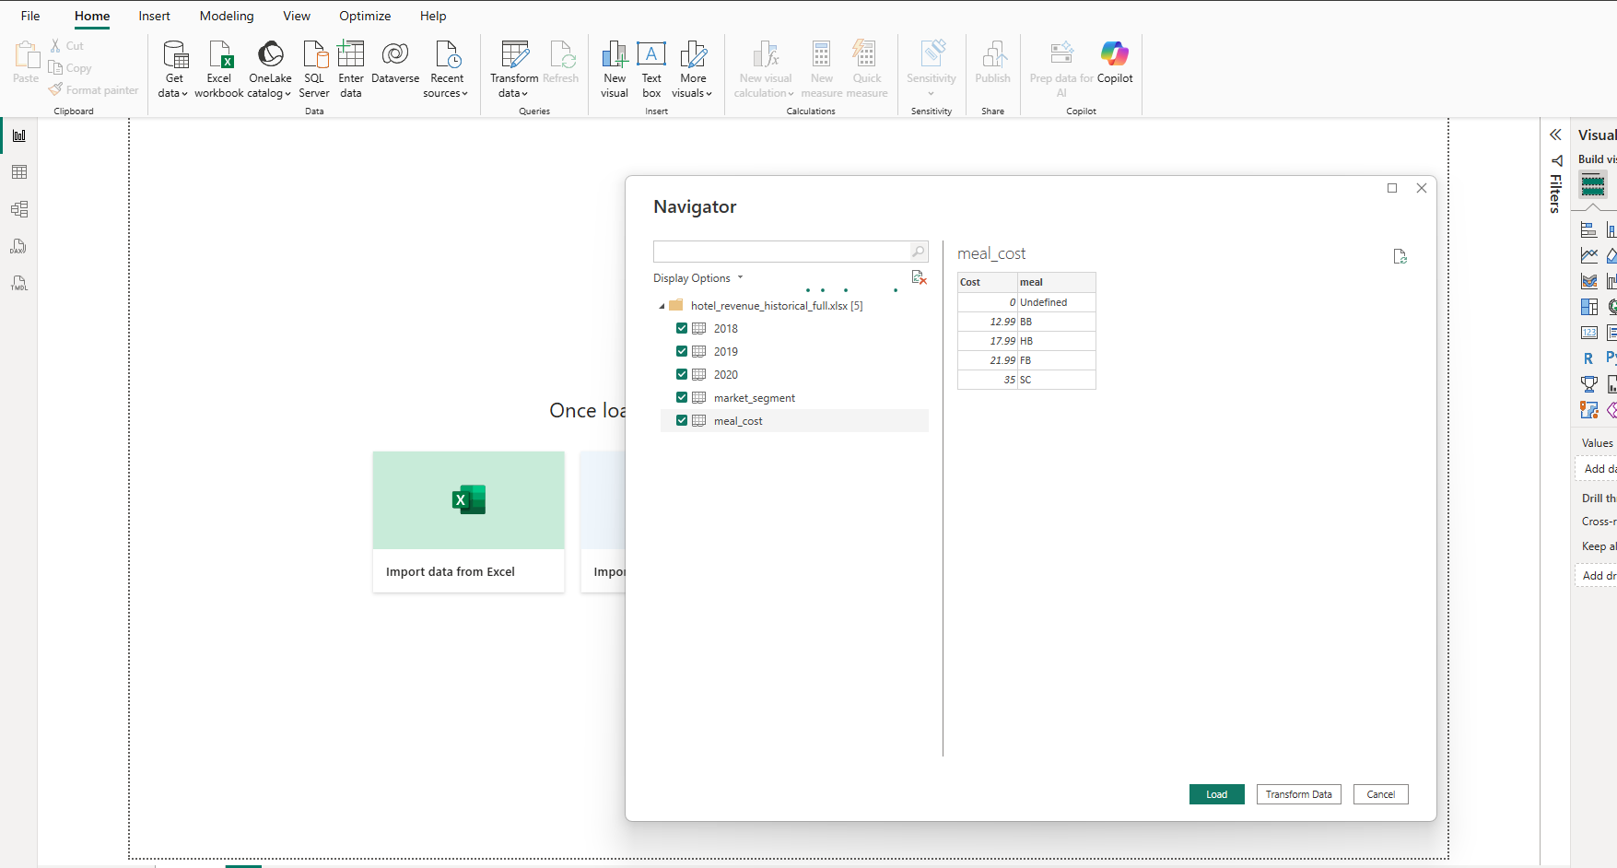

3. Data Cleaning and Transformation
Before loading the data into the report, necessary data transformations were performed using Power Query Editor. These transformations ensured that the dataset was clean, consistent, and ready for analysis.
The following data preparation steps were carried out:
- Removed unnecessary or duplicate columns.
- Renamed columns for better clarity and readability.
- Handled missing or null values.
- Corrected data types (Date, Currency, Whole Number, Text).
- Created calculated columns where required (e.g., Total Revenue = Room Rate × Number of Nights).
- Standardized categorical values such as booking status and room types.
After completing these steps, the cleaned data was applied and loaded into the Power BI data model.
Filtering Errors:
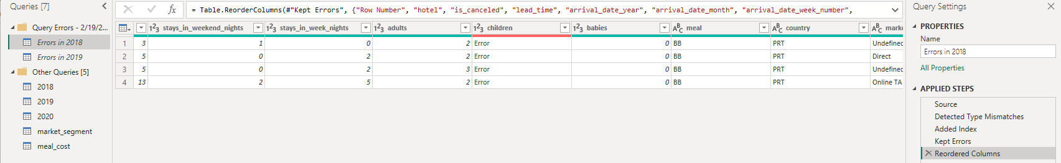
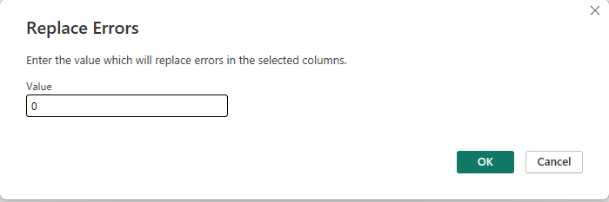

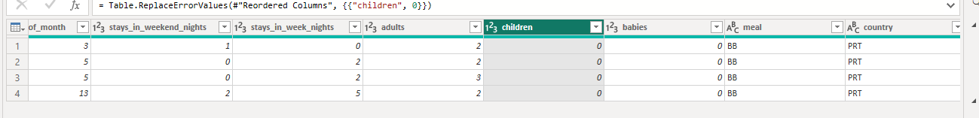
Filtered Columns:
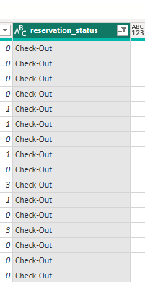
Adding Custom Columns: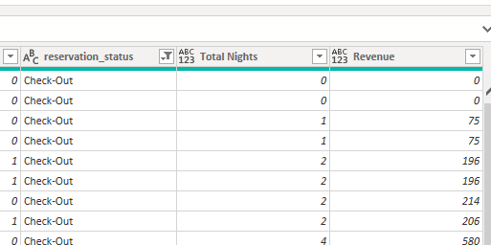

4. Data Validation
Basic validation checks were performed to ensure data accuracy:
- Verified that there were no duplicate booking records.
- Confirmed correct date formats.
- Checked revenue calculations for accuracy.
- Ensured consistency in customer and hotel identifiers.

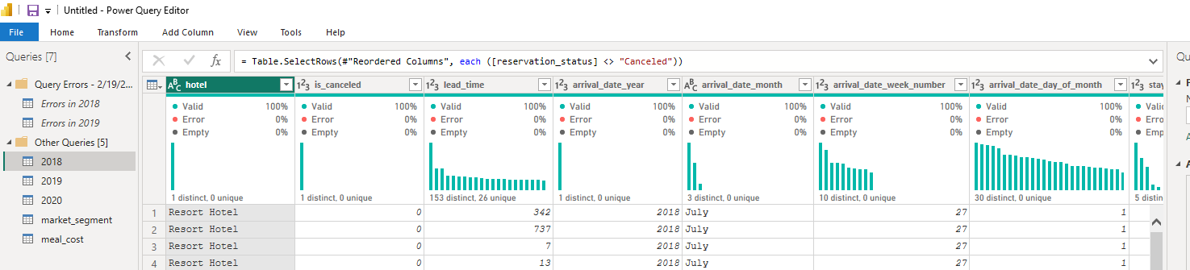This ensured the reliability of the dataset before proceeding to data modeling.
DATA MODELING
1. Model Structure
The data model was designed using a star schema approach to ensure efficient performance and simplified analysis.
The model consists of:
Fact Table:
- Booking/Revenue Table containing transactional data such as Booking ID, Hotel ID, Customer ID, Room Type, Stay Duration, and Revenue.
Dimension Tables:
- Date Table
- Customer Table
- Hotel Table
- Room Type Table
The fact table is centrally placed and connected to multiple dimension tables using key relationships.
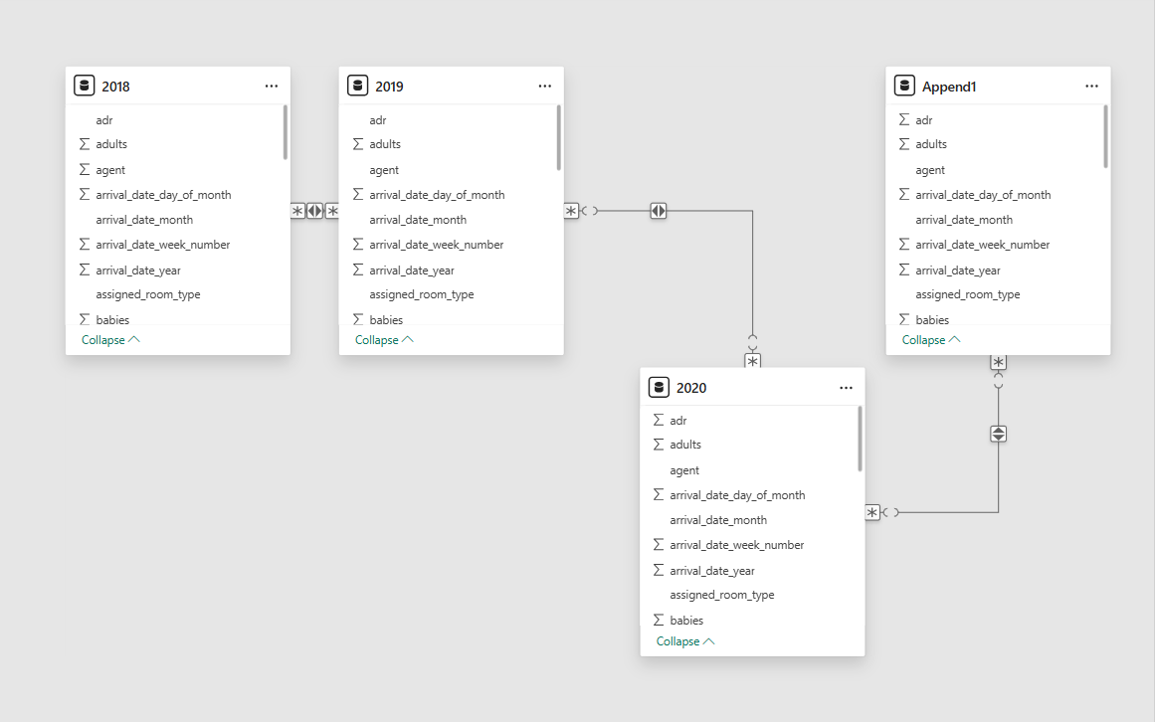

2. Relationships
Relationships were created between tables using One-to-Many (1:*) relationships.
Examples of relationships include:
- Date Table connected to Booking Table using Booking Date.
- Customer Table connected to Booking Table using Customer ID.
- Hotel Table connected to Booking Table using Hotel ID.
- Room Type Table connected to Booking Table using Room Type ID.
These relationships allow accurate filtering and aggregation across reports.

3. Keys and Data Types
Primary keys were defined in dimension tables and linked to corresponding foreign keys in the fact table.
Appropriate data types were assigned:
- Date fields → Date format
- Revenue fields → Currency
- Numerical counts → Whole Number
- Categorical fields → Text
This ensures proper calculations and report performance.
4. DAX Measures
Several DAX measures were created to support hotel revenue analysis. These include:
- Total Revenue
- Total Bookings
- Average Daily Rate (ADR)
These measures allow dynamic and interactive analysis based on filters such as date, hotel, and room type.

5. Model Optimization
To improve performance and efficiency:
- Unnecessary columns were removed.
- Calculated measures were preferred over calculated columns.
- Relationships were optimized to avoid ambiguity.
- Data was structured in a star schema format.
- This ensures faster report performance and better analytical capabilities.

Conclusion
The data loading and data modeling process ensured that the dataset was clean, structured, and logically connected. By implementing a star schema model and creating relevant DAX measures, the Power BI report effectively supports detailed hotel revenue analysis across multiple dimensions such as time, customer type, hotel, and room category.

