DATA VISUALIZATION, STORYTELLING AND AI
Hotel Revenue Analysis Report
Zainabh

TABLE OF CONTENTS
- Introduction
- Data Visualization
2.1 KPI Cards
2.2 Revenue Trend Charts
2.3 Revenue Distribution Analysis
2.4 Occupancy and Performance Analysis
2.5 Growth and Performance Analysis
- Data Storytelling
- AI Features in Power BI
4.1 Smart Insights
4.2 Natural Language Query (Q&A)
4.3 Key Influencers Visual
4.4 Forecasting
- Benefits of Visualization and AI
- Conclusion
1. Introduction
Data visualization plays a crucial role in transforming raw hotel booking and revenue data into meaningful insights. In this project, Power BI visualizations were used to present complex datasets in a clear and interactive manner. Through dashboards, charts, and key performance indicators (KPIs), stakeholders can easily understand hotel performance, revenue trends, occupancy patterns, and customer behavior.
Additionally, storytelling techniques were applied to guide users through the insights, while AI-powered features in Power BI were used to enhance analytical capabilities. 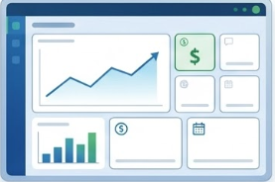

2. Data Visualization
Power BI provides a wide range of visualization tools that allow users to explore and analyze hotel performance effectively. In this report, several visualizations were implemented to highlight key business metrics.
2.1 KPI Cards
KPI cards were used to display important business indicators such as:
- Total Revenue
- Total Bookings
- Average Daily Rate (ADR)
- Occupancy Rate
These visual elements provide a quick overview of hotel performance and allow users to monitor key metrics at a glance.
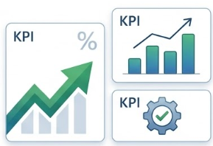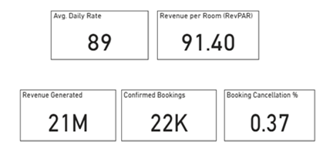
2.2 Revenue Trend Charts
Line charts and bar charts were used to visualize revenue trends over time.
Purpose:
- Identify seasonal patterns in hotel bookings.
- Track revenue performance monthly and yearly.
- Detect periods of high and low demand.
These charts help management understand how revenue changes across different time periods 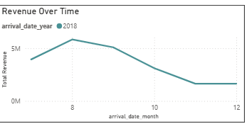
2.3 Revenue Distribution Analysis
Pie charts and bar charts were used to analyze revenue distribution across different dimensions, such as:
- Revenue by Hotel
- Revenue by Room Type
- Revenue by Customer Segment
This helps identify the most profitable hotels and room categories.
2.4 Occupancy and Performance Analysis
Specialized visualizations were used to analyze hotel capacity utilization:
- Occupancy Rate Trend Charts
- Revenue per Available Room (RevPAR)
- Comparative analysis between hotels
These visuals help hotel managers understand how efficiently rooms are being utilized.
2.5 Growth and Performance Analysis
Additional visualizations were used to measure growth and performance indicators, including:
- Month-over-Month Revenue Growth
- Year-to-Date (YTD) Revenue
- Year-over-Year (YoY) Performance
These insights help track the progress of hotel operations and revenue growth.
3. Data Storytelling
Data storytelling is the process of presenting data insights in a narrative format that is easy to understand and interpret. In this project, storytelling techniques were used to guide users through the hotel revenue analysis.
The dashboard was designed in a logical sequence:
- Overview Section – Displays key KPIs such as total revenue and bookings.
- Revenue Trends – Shows how revenue changes over time.
- Revenue Distribution – Identifies which hotels or room types generate the most revenue.
- Performance Metrics – Highlights occupancy rate and RevPAR.
- Growth Analysis – Evaluates revenue growth and performance trends.
This structure allows users to move from high-level insights to detailed analysis.
The storytelling approach ensures that decision-makers can quickly identify important patterns, such as:
- Which hotel generates the highest revenue
- Which room type is most popular
- Seasonal booking trends
- Areas where revenue can be improved
4. AI Features in Power BI
Power BI includes built-in Artificial Intelligence features that help users discover deeper insights from the data. In this project, AI-assisted analytics were used to enhance data exploration.
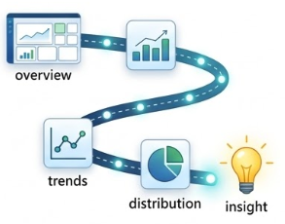
Some of the AI capabilities used include:
4.1 Smart Insights
Power BI can automatically generate insights from visualizations, highlighting patterns and anomalies in the dataset. This helps identify unusual changes in revenue or booking patterns.
4.2 Natural Language Query (Q&A)
The Q&A feature allows users to ask questions about the data using natural language.
Examples:
- "What is the total revenue this year?"
- "Which hotel has the highest bookings?"
- "Show revenue by month."
Power BI automatically generates visualizations based on these questions.

4.3 Key Influencers Visual
The Key Influencers visual helps identify factors that influence certain metrics such as revenue or bookings. For example, it can reveal which factors contribute most to higher revenue levels.
4.4 Forecasting
Power BI forecasting capabilities allow prediction of future revenue trends based on historical data. This helps hotel management in planning pricing strategies and resource allocation.
5. Benefits of Visualization and AI
Combining visualization and AI provides several advantages:
- Simplifies complex datasets
- Identifies patterns and trends quickly
- Improves data-driven decision-making
- Enhances business forecasting
- Supports strategic planning
For hotel management, these insights can help optimize room pricing, improve occupancy rates, and maximize overall revenue.
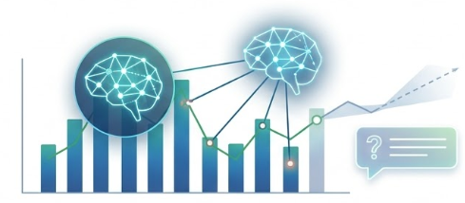
6. Conclusion
The use of data visualization, storytelling, and AI-powered features in Power BI significantly enhances the ability to analyze hotel revenue data. Through interactive dashboards and intelligent insights, stakeholders can easily monitor performance, identify trends, and make informed business decisions.
This approach ensures that raw data is transformed into meaningful and actionable insights that support hotel revenue growth and operational efficiency.

