B72 Bahadur eraser is very famous because of its quality and simple design. B72 eraser is almost used by all age of students. Its result is very good.

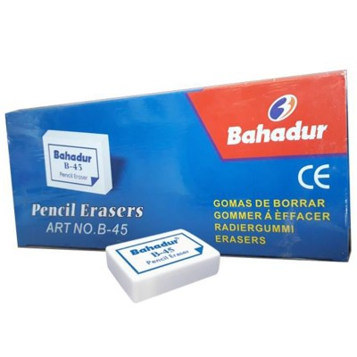

The Pentel Hi-Polymer erasers are high quality, latex-free erasers that remove lead easily and cleanly with very little pressure with no smudges, no paper tears.

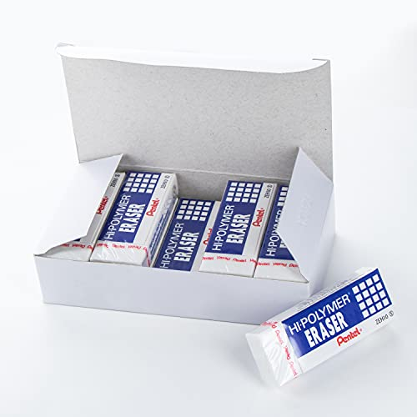

This innovative Nakabayashi Logical Eraser is actually two erasers in one! The large white section of the eraser is soft—perfect for erasing large areas.

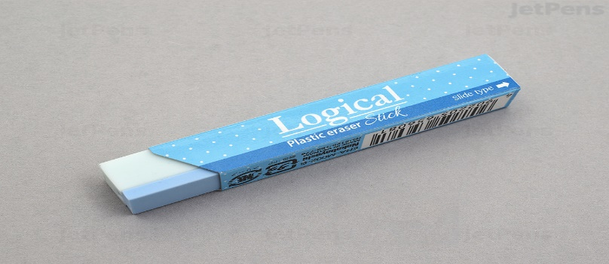

Foam Eraser. This Pilot special foam eraser is both light and smooth. The new technology enables it to clearly all mistakes clearly and easily.

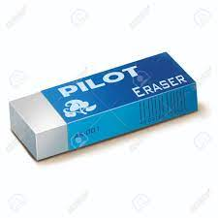

The STAEDTLER karat art eraser is primarily used for hobby and artistic applications. This special-purpose art eraser is easy to knead, allowing you to create changes.

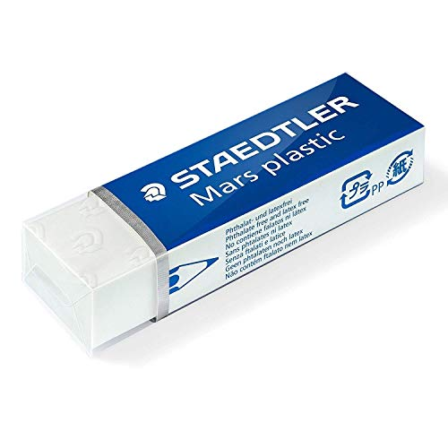

From erasers for homework, to high-quality art erasers used by artists. All rubber erasers and a large proportion of the plastic erasers produced by Faber-Castell eraser.

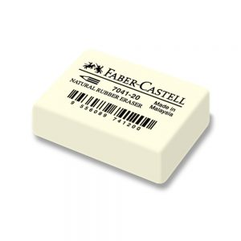

The erasers are soft and gentle on paper, allowing you to erase without tearing your document. They come with Staples brand 100 percent satisfaction guarantee.

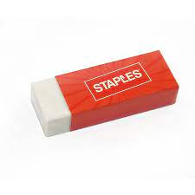

Designed to remove both graphite and India ink, the Magic Rub Art Eraser cleanly erases on delicate surfaces without smudging or marring your work.

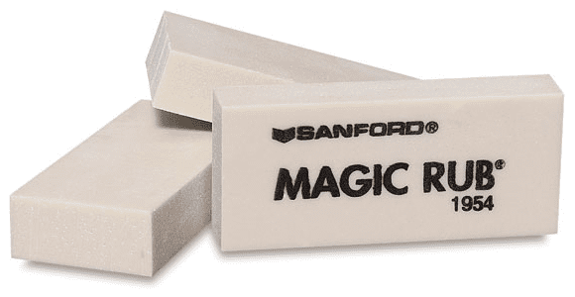

Premium soft plastic eraser removes marks cleanly with little pressure and no paper damage. Designed for use on paper. Won't smear or smudge.



Paper Mate Pink Pearl Erasers are made from 100 percent latex-free, self-cleaning rubber that won't tear paper and offers quick and smudge-free.

