Specially formulated break-resistant lead, in combination with premium quality wood, gives the ultimate writing experience and trouble-free sharpening.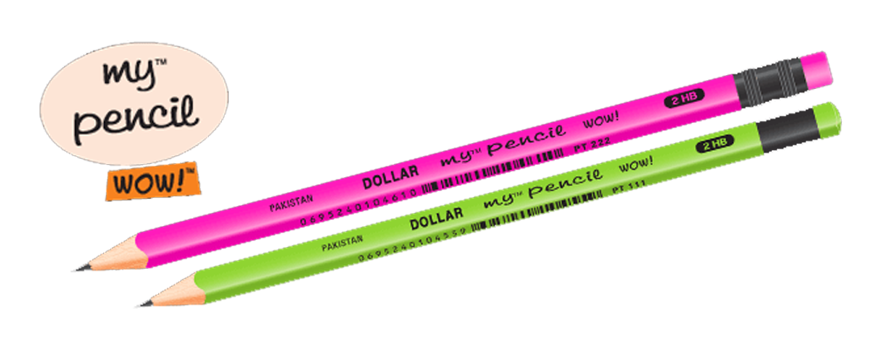

 Caran d'Ache Luminance is **GREAT wax pencils**. The colors are vibrant, they are buttery, soft cores and easy to blend, and they are great for both beginners and experienced artists

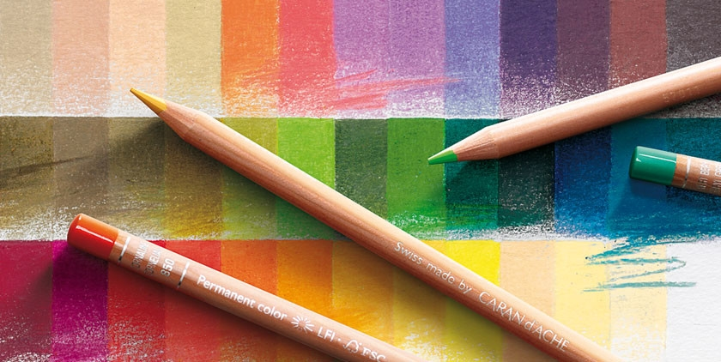

"Ticonderoga pencils are **produced with premium wood from certified sustainable wood sources**,"

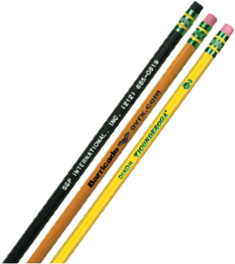

The STAEDTLER Noris pencil is one of our absolute classics. Its iconic black and yellow stripes are instantly recognisable. Millions of people have used this pencil to learn to write, make notes, write letters, draw and sketch.



 Learner No Roll™ is a great pencil for young writers or those who have trouble holding a standard diameter pencil.



For many users the **MONO 100** is the best **pencil** ever made. Soft touch when writing, unbreakable high-density graphite lead and a superb paint finish.

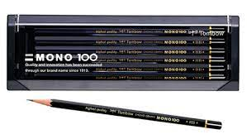

Faber-Castell is the world's oldest pencil manufacturer - founded in 1761. Select from the best quality graphite pencils in a wide variety of designs and colours. Collections of the Castell 9000, Grip 2001 pencils and many other premium quality pencils are the key to enjoying your creative experience.

e.

Uni are brands of pens and pencils, made by the Mitsubishi Pencil Company Limited of Japan. The brand was introduced in 1979 as a rollerball pen model, then expanding to the rest of Mitsubishi Pencil products

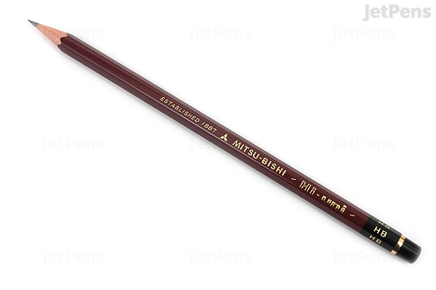

Our high-quality woodcase and mechanical pencils are perfect for writing, drawing, and creative expression.

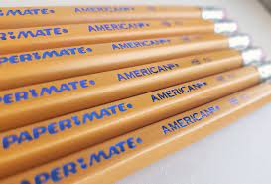

Faber-castell grip jumbo pencil are Triangular pencils also encourage a proper grip, and this one from German company Faber-Castell has raised nubs to prevent slipping.

