The fact is, **this is a good pen, if not a great one**. Released to the public in 1950, it has had a 65-plus year run and shows no signs of slowing down. The design is revered too, with its clear hex-barrel being featured in the Museum of Modern Art.

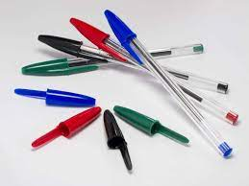

**Parker pens** are exquisitely crafted fine writing instruments with a rich history of innovation and belief in the importance of the written word.

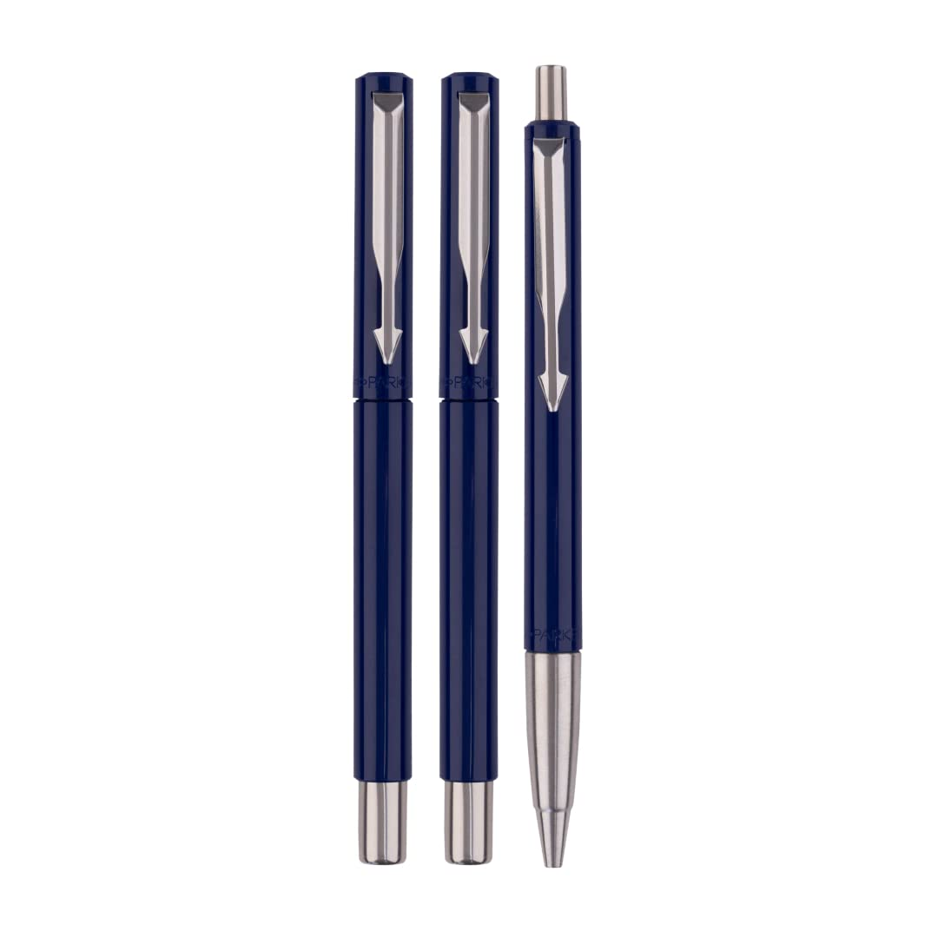

Sheaffers aren't as pricey as other vintage pens, so they're a great entry-level purchase.



An exquisite writing instrument acts as a key to the mind, allowing you to effortlessly transfer the contents of your thoughts onto the page.

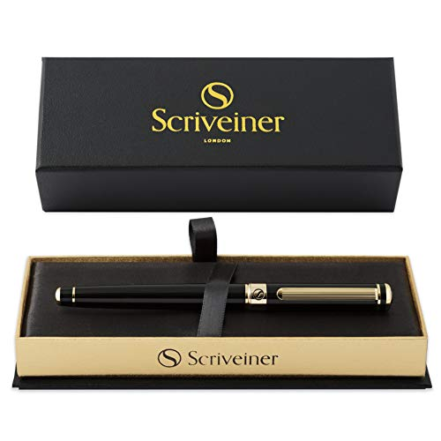

**Dollar Note Ball pen** · Comfortable Rubber Grip. · Transparent & Opaque Barrel. · Smooth ink flow and paper friendly. · A comfortable non-slip grip made of rubber.

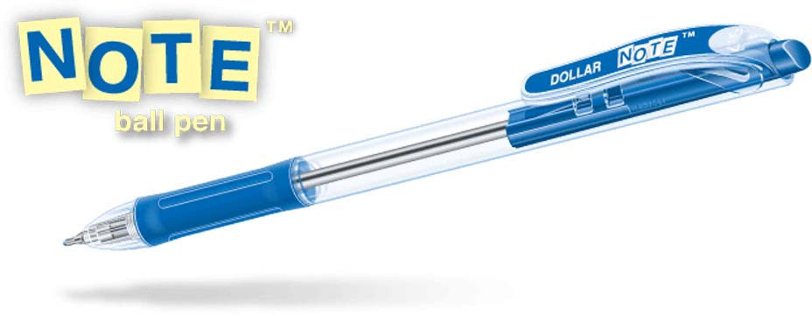

**In most situations, the Uni-ball Jetstream RT is the best pen for the job**. It dries quickly, so it's great for lefties and anyone concerned about smudging (especially when writing on slick paper, labels, or receipts).

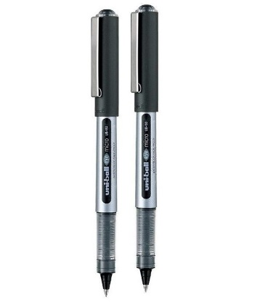

Timeless Perfection. Piano Yellow Ball Point Pen has a P-83 type brass tip with 1 mm stainless steel ball and the traditional yellow barrel.



Reliable and convenient Picasso ball pen and pencils available at affordable rates. Easy to use, smooth handwriting and made with high quality strong wood.

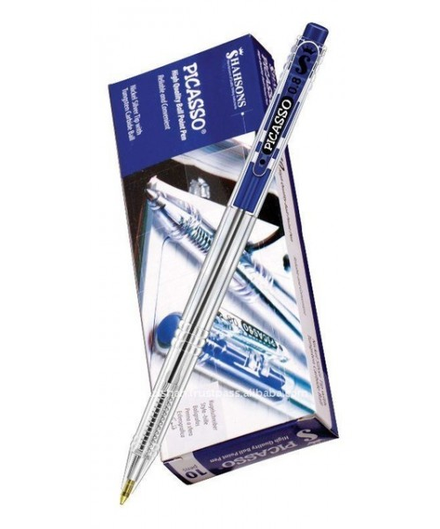

Tinted body- colour coordinated with ink, push button and imprint - Handy and capless retractable design.

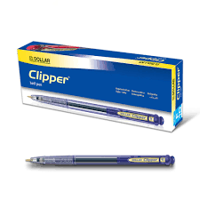

Comfortable and smooth ball pen with steel tip and tungsten carbide ball for consistent writing till last drop. Transparent window shows ink level.

