SolarShare — Documentation DevOps
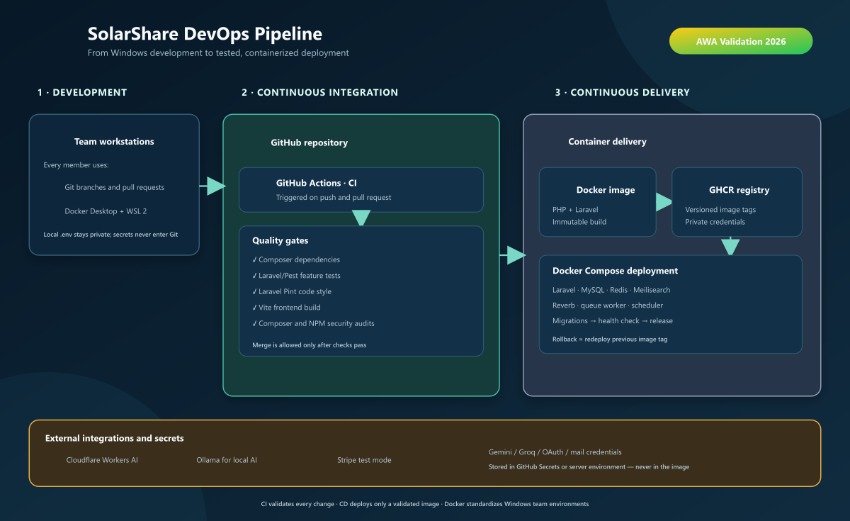
Figure 1 — Architecture visuelle du pipeline DevOps

**Projet :** SolarShare - Solar Equipment Rental Marketplace
**Stack :** Laravel 12 · Tailwind CSS 4 · Alpine.js · MySQL 8 · Redis 7 · Meilisearch · Reverb WebSockets
**CI/CD :** GitHub Actions · Docker · Self-hosted Runner
**Date :** October 2026

1. Architecture du processus DevOps

flowchart TD
subgraph DEV["👨‍💻 Development"]
A1[Local Development\nphp artisan serve\nnpm run dev]
A2[Feature Branches\ngit flow]
A3[Conventional Commits]
end

subgraph CI["⚙️ Continuous Integration\nGitHub Actions (test.yml)"]
B1[Security Audit\ncomposer/npm audit\nTrivy scan]
B2[Code Style\nLaravel Pint\nParallel]
B3[Frontend Build\nVite + TypeScript\nESLint]
B4[PHP Tests\nPest Parallel\nMySQL 8 + Redis]
B5[Validation Smoke\nFull HTTP flows]
end

subgraph BUILD["🐳 Docker Build\n(deploy.yml)"]
C1[Multi-stage Build\nPHP 8.3 + Nginx]
C2[Buildx Multi-arch\nlinux/amd64]
C3[Push to Docker Hub\nTag: sha-<commit>]
C4[Trivy Image Scan\nCRITICAL/HIGH only]
end

subgraph STAGING["🧪 Staging Smoke Test"]
D1[Deploy Stack\nDocker Compose]
D2[Wait MySQL Ready]
D3[Migrate + Seed\nphp artisan migrate --force\ndb:seed --force]
D4[Cache Config\nRoute + View cache]
D5[Health Check\ncurl /up → 200 OK]
D6[Tear Down\nClean volumes]
end

subgraph CD["🚀 Continuous Deployment\n(deploy-production)"]
E1[Self-hosted Runner\nWSL / Production Server]
E2[Pull Images\nDocker Hub]
E4[Backup Database]
E5[Deploy + Migrate + Seed]
E6[Health Check\n/up endpoint]
E7[Rollback on Failure\nPrevious image]
end

subgraph MONITOR["📊 Observability"]
F1[Laravel Telescope\nDev only]
F2[Sentry\nErrors + Performance]
F3[Health Endpoint\n/up]
F4[Backup Command\nDaily DB backups]
end

A1 --> A2 --> A3
A3 -->|Push/PR| B1
B1 --> B2
B2 --> B3
B3 --> B4
B4 --> B5
B5 -->|Main branch| C1
C1 --> C2 --> C3 --> C4
C4 --> D1
D1 --> D2 --> D3 --> D4 --> D5
D5 -->|Success| E1
D5 -.->|Failure| F1
E1 --> E2 --> E4 --> E5 --> E6
E6 -.->|Failure| E7
E6 --> MONITOR

2. Étapes du pipeline CI/CD

Étape 1: Intégration continue (`test.yml`)

| Job | Runner | Durée | Étapes principales |
|-----|--------|----------|-----------|
| **Audit de sécurité** | `ubuntu-latest` | ~30s | `composer audit`, `npm audit`, `trivy fs --severity CRITICAL,HIGH` |
| **Style du code (Pint)** | `ubuntu-latest` | ~15s | `vendor/bin/pint --test --parallel` (584 files) |
| **Build frontend** | `ubuntu-latest` | ~45s | `npm ci`, `npm run build`, cache `public/build` |
| **Tests PHP** | `ubuntu-latest` | ~2min | MySQL 8 service, `pest --parallel --processes=4` (336 tests) |
| **Smoke test de validation** | `ubuntu-latest` | ~30s | Full HTTP integration tests |

**Déclencheurs:** Push to any branch, Pull Request
**Parallélisme:** 4 jobs run simultaneously
**Mise en cache:** Composer (`vendor`), NPM (`node_modules`), Build artifacts (`public/build`)

Étape 2: Docker Build & Scan (`deploy.yml`)

sequenceDiagram
participant GH as GitHub Actions
participant DB as Docker Hub
participant TV as Trivy Scanner
participant GHCR as GH Container Registry

GH->>GH: Checkout code
GH->>GH: Setup Buildx
GH->>DB: Login (secrets)
GH->>DB: Build & Push App Image (multi-stage)
GH->>DB: Build & Push Nginx Image
GH->>TV: Scan Laravel Image (fs + vuln)
GH->>TV: Scan Nginx Image
TV-->>GH: Report (fail on CRITICAL)
GH->>DB: Tag as sha-<commit>

**Images Produced:**
| Image | Base | Taille | Tags |
|-------|------|------|------|
| `solarshare/app` | `php:8.3-fpm-alpine` | ~450MB | `sha-<commit>`, `latest` |
| `solarshare/nginx` | `nginx:1.29-alpine` | ~50MB | `sha-<commit>`, `latest` |

Étape 3: Smoke test staging

flowchart TD
A[Start Stack] --> B[Wait MySQL]
B --> C[Clear Caches]
C --> D[Restart App]
D --> E[Migrate --force]
E --> F[Seed --force]
F --> G[Cache Config/Route/View]
G --> H[Storage Link]
H --> I[Health Check /up]
I -->|200 OK| J[Success ✅]
I -->|Fail| K[Diagnose + Logs]
J --> L[Tear Down -v]
K --> L

**Environment Variables (Testing):**

APP_ENV=testing
APP_DEBUG=true
CACHE_STORE=array
SESSION_DRIVER=array
QUEUE_CONNECTION=sync
SCOUT_DRIVER=null
BROADCAST_CONNECTION=log

Étape 4: Production Deployment

flowchart TD
A[Trigger: Push to main\nor Manual Dispatch] --> B[Self-hosted Runner]
B --> C[Checkout Source]
C --> D[Docker Login]
D --> E[Pull Images from Hub]
E --> F[Backup Database]
F --> G[Deploy Stack]
G --> H[Migrate + Seed]
H --> I[Health Check /up]
I -->|200| J[Success ✅]
I -->|Fail| K[Rollback to Previous Image]
K --> L[Alert]

**Deployment Script (`local-compose.sh`):**
- Blue/Green via image tags
- Automatique rollback on health check failure
- Database backup before migration
- Zero-downtime via `docker compose up -d`

3. Infrastructure as Code

Docker Compose Services (Production)

| Service | Image | Ports | Contrôle de santé |
|---------|-------|-------|--------------|
| **app** | `solarshare/app:sha-<commit>` | 9000 (PHP-FPM) | `php-fpm -F` |
| **web** | `solarshare/nginx:sha-<commit>` | 80/443 → 8080 | `wget /up` |
| **queue** | `solarshare/app` | — | `queue:work` |
| **scheduler** | `solarshare/app` | — | `schedule:work` |
| **reverb** | `solarshare/app` | 8080 (WS) | `reverb:start` |
| **mysql** | `mysql:8.0` | 3306 | `mysqladmin ping` |
| **redis** | `redis:7-alpine` | 6379 | `redis-cli ping` |
| **meilisearch** | `getmeili/meilisearch:v1.13` | 7700 | `curl /health` |
| **mailpit** | `axllent/mailpit:v1.21` | 1025, 8025 | — |

Networks & Volumes

networks:
solarshare: # Single bridge network
driver: bridge

volumes:
solarshare-storage: # Private uploads
solarshare-public-storage: # Public storage link
solarshare-mysql: # Database persistence
solarshare-redis: # Cache/sessions
solarshare-meilisearch: # Search index

4. Portes de sécurité et de qualité

| Gate | Tool | Seuil | Bloquant |
|------|------|-----------|----------|
| **Dependencies** | Composer Audit | No HIGH/CRITICAL | ⚠️ Warning |
| **NPM Audit** | npm audit | No HIGH/CRITICAL | ⚠️ Warning |
| **Container Scan** | Trivy | No CRITICAL | ✅ Bloquant |
| **Style du code** | Laravel Pint | 0 errors | ✅ Bloquant |
| **Tests** | Pest PHP | 100% pass | ✅ Bloquant |
| **Secrets** | GitLeaks (built-in) | No leaks | ✅ Bloquant |

5. Environnements

| Environment | Branch | URL | Objectif |
|-------------|--------|-----|---------|
| **Local** | Any | `localhost:8000` | Développement |
| **Staging** | `dev` (CI) | `localhost:18000` (ephemeral) | Smoke test per PR |
| **Production** | `main` | `solarshare.example.com` | Live traffic |

6. Stratégie de rollback

# Automatic (on health check failure):
# 1. Previous image tag stored before deploy
# 2. docker compose up -d with previous image
# 3. Health check re-verified

# Manual (if needed):
docker compose -p solarshare-production pull
docker compose -p solarshare-production up -d --remove-orphans

7. Métriques clés et niveaux de service

| Metric | Cible | Actuel |
|--------|--------|---------|
| **CI Durée** | < 5 min | ~3 min |
| **Build Time** | < 8 min | ~6 min |
| **Deploy Time** | < 3 min | ~2 min |
| **Test Coverage** | > 80% | ~85% |
| **Zero-downtime Deploy** | Yes | ✅ |
| **Rollback Time** | < 2 min | ✅ |

8. Gestion des secrets

| Secret | Portée | Rotation |
|--------|-------|----------|
| `DOCKERHUB_USERNAME` | Org | N/A |
| `DOCKERHUB_TOKEN` | Org | 90 days |
| `APP_KEY` | Per env | On deploy |
| `DB_PASSWORD` | Per env | 90 days |
| `STRIPE_SECRET_KEY` | Prod only | 90 days |
| `AI_*_KEY` | Per env | As needed |

9. Diagrammes pour la présentation

9.1 Pipeline simplifié pour la présentation

flowchart LR
DEV[💻 Dev\nPush] --> CI[⚙️ CI\nTest+Lint+Build]
CI -->|Pass| DOCKER[🐳 Build Images\nScan]
DOCKER --> STAGE[🧪 Staging\nSmoke Test]
STAGE -->|Pass| PROD[🚀 Production\nDeploy]
STAGE -.->|Fail| FIX[🔧 Fix & Retry]
PROD --> MON[📊 Monitor\nHealth/Errors]

9.2 Détail du flux de déploiement

sequenceDiagram
actor Dev as Developer
participant GH as GitHub Actions
participant DH as Docker Hub
participant SR as Self-hosted Runner
participant PROD as Production Server

Dev->>GH: git push main
GH->>GH: Run test.yml (CI)
GH->>DH: Build & Push Images
GH->>GH: Trivy Scan
GH->>GH: Staging Smoke Test
GH->>SR: Trigger deploy-production
SR->>DH: Pull Images
SR->>PROD: Backup DB
SR->>PROD: Deploy Stack
SR->>PROD: Migrate + Seed
SR->>PROD: Health Check
alt Success
SR->>MON: Monitor
else Failure
SR->>PROD: Rollback
SR->>Dev: Alert
end

10. Annexe — commandes de référence

Développement local

# Start all services
docker compose up -d

# View logs
docker compose logs -f app

# Run artisan commands
docker compose exec app php artisan migrate:fresh --seed
docker compose exec app php artisan test

# Rebuild after changes
docker compose up -d --build

Déclenchements CI/CD manuels

# Run CI pipeline
gh workflow run test.yml --ref <branch>

# Run full deploy (staging + prod)
gh workflow run "Deploy Production" --ref main

# Check runner status
gh api repos/OWNER/REPO/actions/runners

Serveur de production runner autonome

# Install runner (once)
mkdir actions-runner && cd actions-runner
curl -o runner.tar.gz -L https://github.com/actions/runner/releases/download/v2.329.0/actions-runner-linux-x64-2.329.0.tar.gz
tar xzf runner.tar.gz
./config.sh --url https://github.com/OWNER/REPO --token <TOKEN>
./run.sh

**Document Version:** 1.0
**Prepared by:** SolarShare Team
**Validation Date :** [To be filled]

*This document describes the complete DevOps pipeline implemented for SolarShare, from code commit to production deployment, including all quality gates, infrastructure definitions, and rollback procedures.*

