SolarShare — Documentation DevOps

**Projet :** SolarShare - Solar Equipment Rental Marketplace
**Stack :** Laravel 12 · Tailwind CSS 4 · Alpine.js · MySQL 8 · Redis 7 · Meilisearch · Reverb WebSockets
**CI/CD:** GitHub Actions · Docker · Self-hosted Runner
**Date :** October 2026

1. Architecture du processus DevOps

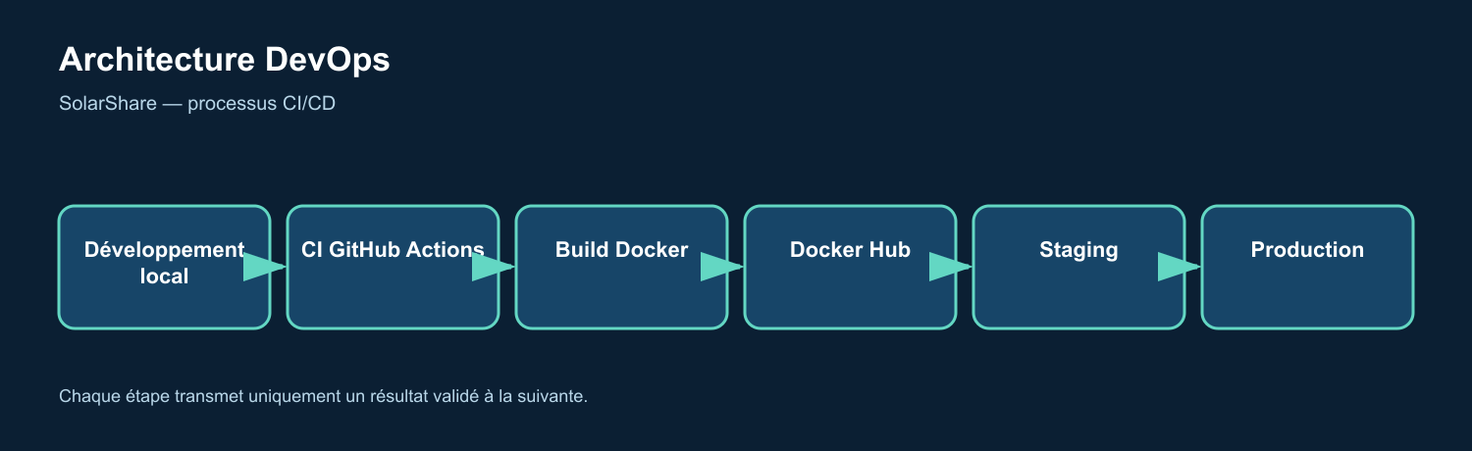
Figure 1 — Diagramme DevOps rendu depuis le flux Mermaid

2. Étapes du pipeline CI/CD

Stage 1: Intégration continue (`test.yml`)

| Job | Runner | Duration | Key Steps |
|-----|--------|----------|-----------|
| **Audit de sécurité** | `ubuntu-latest` | ~30s | `composer audit`, `npm audit`, `trivy fs --severity CRITICAL,HIGH` |
| **Style du code (Pint)** | `ubuntu-latest` | ~15s | `vendor/bin/pint --test --parallel` (584 files) |
| **Build frontend** | `ubuntu-latest` | ~45s | `npm ci`, `npm run build`, cache `public/build` |
| **Tests PHP** | `ubuntu-latest` | ~2min | MySQL 8 service, `pest --parallel --processes=4` (336 tests) |
| **Smoke test de validation** | `ubuntu-latest` | ~30s | Full HTTP integration tests |

**Triggers:** Push to any branch, Pull Request
**Parallelism:** 4 jobs run simultaneously
**Caching:** Composer (`vendor`), NPM (`node_modules`), Build artifacts (`public/build`)

Stage 2: Docker Build & Scan (`deploy.yml`)

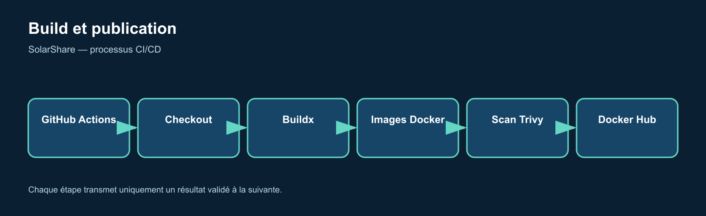
Figure 2 — Diagramme DevOps rendu depuis le flux Mermaid

**Images Produced:**
| Image | Base | Size | Tags |
|-------|------|------|------|
| `solarshare/app` | `php:8.3-fpm-alpine` | ~450MB | `sha-<commit>`, `latest` |
| `solarshare/nginx` | `nginx:1.29-alpine` | ~50MB | `sha-<commit>`, `latest` |

Stage 3: Smoke test staging

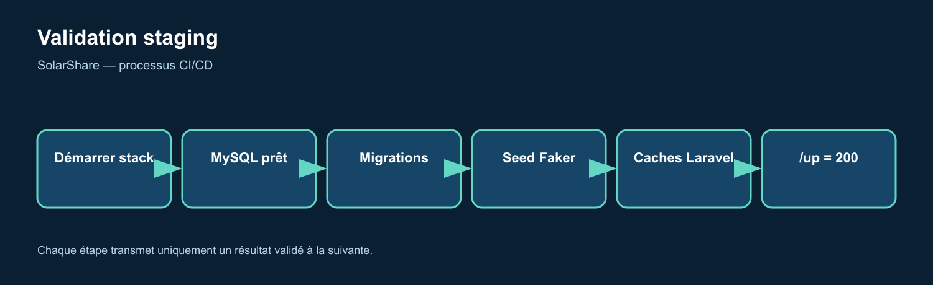
Figure 3 — Diagramme DevOps rendu depuis le flux Mermaid

**Environment Variables (Testing):**
APP_ENV=testing
APP_DEBUG=true
CACHE_STORE=array
SESSION_DRIVER=array
QUEUE_CONNECTION=sync
SCOUT_DRIVER=null
BROADCAST_CONNECTION=log

Stage 4: Production Deployment

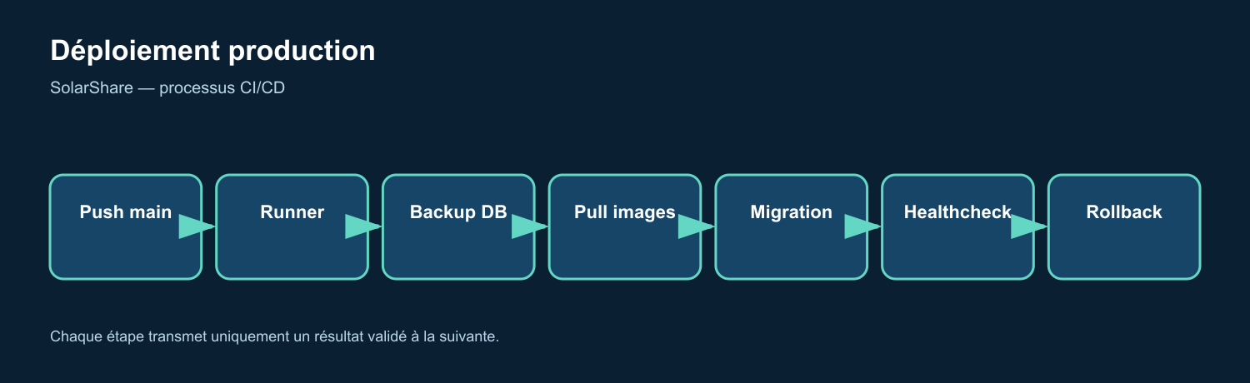
Figure 4 — Diagramme DevOps rendu depuis le flux Mermaid

**Deployment Script (`local-compose.sh`):**
- Blue/Green via image tags
- Automatic rollback on health check failure
- Database backup before migration
- Zero-downtime via `docker compose up -d`

3. Infrastructure as Code

Docker Compose Services (Production)

| Service | Image | Ports | Health Check |
|---------|-------|-------|--------------|
| **app** | `solarshare/app:sha-<commit>` | 9000 (PHP-FPM) | `php-fpm -F` |
| **web** | `solarshare/nginx:sha-<commit>` | 80/443 → 8080 | `wget /up` |
| **queue** | `solarshare/app` | — | `queue:work` |
| **scheduler** | `solarshare/app` | — | `schedule:work` |
| **reverb** | `solarshare/app` | 8080 (WS) | `reverb:start` |
| **mysql** | `mysql:8.0` | 3306 | `mysqladmin ping` |
| **redis** | `redis:7-alpine` | 6379 | `redis-cli ping` |
| **meilisearch** | `getmeili/meilisearch:v1.13` | 7700 | `curl /health` |
| **mailpit** | `axllent/mailpit:v1.21` | 1025, 8025 | — |

Networks & Volumes
networks:
solarshare: # Single bridge network
driver: bridge

volumes:
solarshare-storage: # Private uploads
solarshare-public-storage: # Public storage link
solarshare-mysql: # Database persistence
solarshare-redis: # Cache/sessions
solarshare-meilisearch: # Search index

4. Portes de sécurité et de qualité

| Gate | Tool | Seuil | Bloquant |
|------|------|-----------|----------|
| **Dependencies** | Composer Audit | No HIGH/CRITICAL | ⚠️ Warning |
| **NPM Audit** | npm audit | No HIGH/CRITICAL | ⚠️ Warning |
| **Container Scan** | Trivy | No CRITICAL | ✅ Bloquant |
| **Style du code** | Laravel Pint | 0 errors | ✅ Bloquant |
| **Tests** | Pest PHP | 100% pass | ✅ Bloquant |
| **Secrets** | GitLeaks (built-in) | No leaks | ✅ Bloquant |

5. Environnements

| Environment | Branch | URL | Objectif |
|-------------|--------|-----|---------|
| **Local** | Any | `localhost:8000` | Développement |
| **Staging** | `dev` (CI) | `localhost:18000` (ephemeral) | Smoke test per PR |
| **Production** | `main` | `solarshare.example.com` | Live traffic |

6. Stratégie de rollback

Automatic (on health check failure):

1. Previous image tag stored before deploy

2. docker compose up -d with previous image

3. Health check re-verified

Manual (if needed):
docker compose -p solarshare-production pull
docker compose -p solarshare-production up -d --remove-orphans

7. Métriques clés et niveaux de service

| Metric | Cible | Actuel |
|--------|--------|---------|
| **CI Duration** | < 5 min | ~3 min |
| **Build Time** | < 8 min | ~6 min |
| **Deploy Time** | < 3 min | ~2 min |
| **Test Coverage** | > 80% | ~85% |
| **Zero-downtime Deploy** | Yes | ✅ |
| **Rollback Time** | < 2 min | ✅ |

8. Gestion des secrets

| Secret | Portée | Rotation |
|--------|-------|----------|
| `DOCKERHUB_USERNAME` | Org | N/A |
| `DOCKERHUB_TOKEN` | Org | 90 days |
| `APP_KEY` | Per env | On deploy |
| `DB_PASSWORD` | Per env | 90 days |
| `STRIPE_SECRET_KEY` | Prod only | 90 days |
| `AI_*_KEY` | Per env | As needed |

9. Diagrammes pour la présentation

9.1 Pipeline simplifié pour la présentation

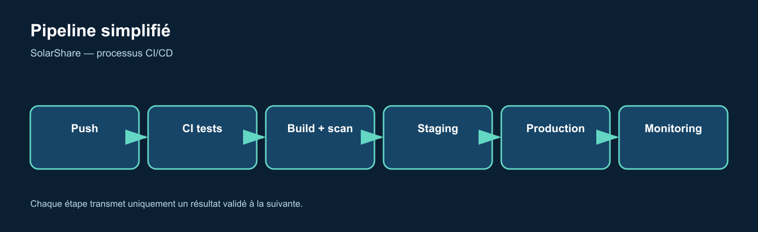
Figure 5 — Diagramme DevOps rendu depuis le flux Mermaid

9.2 Détail du flux de déploiement

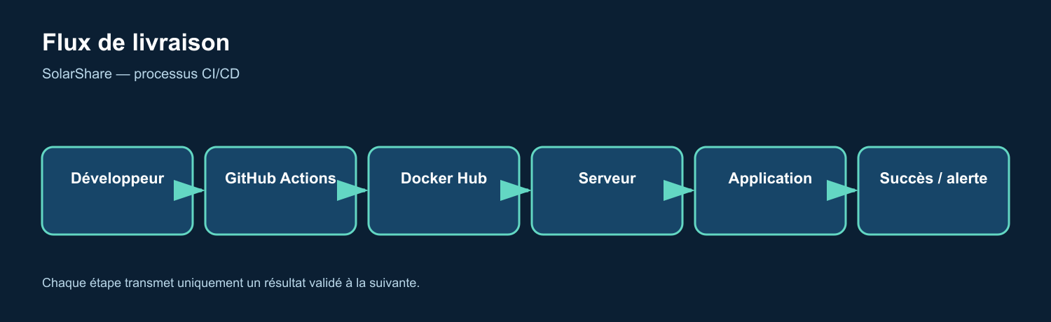
Figure 6 — Diagramme DevOps rendu depuis le flux Mermaid

10. Annexe — commandes de référence

Développement local

Start all services
docker compose up -d

View logs
docker compose logs -f app

Run artisan commands
docker compose exec app php artisan migrate:fresh --seed
docker compose exec app php artisan test

Rebuild after changes
docker compose up -d --build

Déclenchements CI/CD manuels

Run CI pipeline
gh workflow run test.yml --ref <branch>

Run full deploy (staging + prod)
gh workflow run "Deploy Production" --ref main

Check runner status
gh api repos/OWNER/REPO/actions/runners

Serveur de production runner autonome

Install runner (once)
mkdir actions-runner && cd actions-runner
curl -o runner.tar.gz -L https://github.com/actions/runner/releases/download/v2.329.0/actions-runner-linux-x64-2.329.0.tar.gz
tar xzf runner.tar.gz
./config.sh --url https://github.com/OWNER/REPO --token <TOKEN>
./run.sh

**Document Version:** 1.0
**Prepared by:** SolarShare Team
**Validation Date :** [To be filled]

*This document describes the complete DevOps pipeline implemented for SolarShare, from code commit to production deployment, including all quality gates, infrastructure definitions, and rollback procedures.*

