Style Guidelines for Final Year Project ReportsPSL Recognizer: Empowering Communication through AI

Final Year Project Proposal

Session Fall 2025

Zain and GroupA 4th Year Student
BSc. (Hons.)BS in CS



Department of CS
Fast School of Computing
Fast National University, Karachi Campus
23 September 2025

Project Registration
Project ID (for office use)
Type of project |  |  | [ ] Traditional [ ] Industrial [✓ ] Continuing
Nature of project |  |  | [ ] Development [ ] Research & Development [✓] Research
Sustainable Development Goals(SDGs) |  |  | [ ] Good Health and Well-Being [✓ ] Quality Education  [✓] Industry, Innovation, and Infrastructure [ ] Gender Equality  [ ] Decent Work and Economic Growth [ ] Climate Action
Area of specialization |  |  | [✓] Artificial Intelligence (AI) [ ] Data Science and Analytics  [ ] Internet of Things (IoT) [ ] Blockchain  [ ] Mobile App Development [ ] Web Development [ ] Cybersecurity  [ ] Game Development [✓] Natural Language Processing (NLP)  [✓] Other
Project Group Members
Sr.# | Reg. # | Student Name |  | CGPA | Email ID | Phone # | Signature
(i) | Group Leader | Zain Baig |  | 3.34 | k224593@nu.edu.pk | 03332546037
(ii) | Group Member | Aarij Ali |  | 3.52 | k224264@nu.edu.pk | 03282495937 | aarijali
(iii) | Group Member | Abdul Rehman Khan |  | 3.27 | k224155@nu.edu.pk | 03061727790
Declaration: FYP group members have cleared all prerequisite courses For FYP-I as per their degree requirements.

Title
PSL Recognizer: Empowering Communication through AI — FYP Continuation
Supervised by: Dr. Anam Qureshi

Project Abstract
Pakistani Sign Language (PSL) recognition can play a vital role in reducing communication barriers for the deaf community, enabling greater accessibility in education, workplaces, and daily interactions. The previous team worked on a smaller PSL dataset but succeeded in developing well-performing deep learning models for isolated word recognition, but progress remains limited by the scarcity of diverse and large-scale PSL signs video resources.
Building on this foundation, our project focuses on expanding and diversifying the dataset through new recordings and controlled variations curated by ourselves in various settings, while also refining model architectures to improve accuracy, and ultimately moving beyond single-word recognition. The short-term objective is to refine recognition accuracy for isolated words, and the longer-term vision is to extend the system toward sentence-level translation between PSL and Urdu/English.
By progressing toward combining words into coherent sentences, we aim to tackle a challenge that has not yet been addressed in PSL research. Developing a reliable, real-time PSL-to-Urdu/English sentence translation system would represent a significant breakthrough, adding immense practical value for the deaf community and advancing the state of sign language technology in Pakistan.

Previous Project Objectives & Features
Summary of Data Collected by Previous Group:
- Built a PSL dataset of 104 signs (common daily use words).
Original sources: PSL organization (1 video/label) + three team members who each recorded 3 videos per label (3 x 3 = 9 videos/label) → 10 original videos/label).
- Using 11 frame-level augmentation transforms applied randomly, dataset expanded to 60 videos/label (final: 104×60 = 6,240 videos).
- Split per-label to train/val/test (80/15/5) → Training: 4,992, Validation: 832, Test: 416.
Models evaluated and outcomes:
- ViViT (Video Vision Transformer / tubelet embedding) — very high train accuracy (~96%) but large train-val gap → overfitting (val accuracy ~75%).
- ResNet-18 + LSTM — pretrained spatial backbone with LSTM temporal modeling; better generalization than ViViT but still validation gap.
- 3DCNN + ResidualBlock + BiLSTM (proposed hybrid) — best balanced: test accuracy 83.89%, F1 = 0.84. Achieved with ~9.3M params, 10 epochs, batch size 8.
Key conclusions from prior work: dataset scarcity and class richness (104 classes) pose the main challenge; model selection & generalization must account for limited natural samples and large label space.

Introduction
This continuation aims to transform the research artifacts produced by the last team into a robust and scalable pipeline that:
- expands and diversifies the dataset by creating new recordings in varied settings, ensuring the models are trained on richer and more representative data; and,
- improves the recognition accuracy by re-training baseline models on the expanded dataset, and where necessary, applying model refinements and architectural innovations to push performance further; and finally,
- lays the groundwork for sentence-level translation, extending from isolated word recognition to basic word sequence composition aligned with Urdu grammar. This longer-term direction is reserved for FYP-2.
Key questions driving the work:
- Is the primary limiter of generalization the quantity & diversity of real sign samples (signer variance, backgrounds, lighting)? If yes — how much real data is needed and what augmentations help most?
- If the data alone is insufficient, which model families (dual-stream, hybrid CNN→Transformer, temporal attention + language model fusion) best close the gap without overfitting?
- How to build a realistic sign-to-sentence pipeline that preserves meaning and yields grammatically reasonable Urdu sentences suitable for a demo application?
Baseline reference: 3DCNN+ResBlock+BiLSTM = 83.89% test accuracy (previous work). Target research lever: achieve ≥90% accuracy in FYP-1 and later in FYP-2 build towards a well-justified architectural pipeline for sentence-level translation.

Success Criterion
Below we list a robust, verifiable set of success criteria for FYP-I and a handover for FYP-II:

Primary (quantitative)
- Model performance improvement: Increase baseline test accuracy from 83.89% to ≥ 90% on the same 104-label test set after retraining on the expanded dataset (preferred). OR a statistically significant improvement (p<0.05) in F1 relative to baseline if exact 90% is not reached.
- Generalization gap: Reduce train vs. validation accuracy gap to ≤8 percentage points for the chosen best model.
- Robustness: Achieve per-class recall > 0.70 for ≥85% of classes.

Secondary (system / applied)
- Real-time demo: Running at ≥5 fps on a mid-range GPU server or ≤200ms inference latency on a quantized mobile model (if mobile deployment attempted).
- Deliverables: curated expanded dataset, code + reproducible training scripts, model checkpoints, evaluation report, demo app (prototype) and FYP defense slides & video.
If primary targets are not met, the project will still be successful if it provides: a reproducible dataset increase experiment, thorough ablation studies showing what helps (and what doesn’t), and a clear, validated pipeline for moving from word labels to sequence/sentence formation (to be fully implemented in FYP-II).

Related work (brief analytical review & references)

Literature Review: Overiew of the Advances in Pakistan Sign Language (PSL) Recognition
Pakistan Sign Language (PSL) is essential for the deaf community in Pakistan, but its recognition systems trail those of ASL or BSL due to scarce datasets, unique grammar, and visual-spatial challenges. Recent ML and deep learning research (2020–2025) focuses on dataset building, image/video gesture recognition, and translation, emphasizing metrics like accuracy, BLEU, and WER. This review highlights methodologies, results, and gaps, aligning with projects like PSL Recognizer that aim for dataset expansion and sentence-level translation.

Dataset Creation and Static Gesture Recognition
PSL lacks robust public datasets. Imran et al. created one for Urdu alphabet hand configurations, capturing 40 webcam images per letter (e.g., Alif) with varied orientations. Using basic preprocessing and ML classification, they developed an Android app for real-time recognition. Though accuracy details were omitted, it prioritized deployment to bridge deaf-hearing gaps, but was confined to static alphabets without dynamics. [1]
Arooj et al. advanced static recognition with a CNN-SIFT hybrid for Urdu alphabets [2]. Kinect-captured images under diverse lighting yielded features like hand shapes and finger positions; SIFT provided scale/rotation-invariant vectors for CNN input. Achieving 98.74% accuracy (1.26% error), it outperformed SVM/basic CNNs via keypoint extraction. Limitations include alphabet-only focus and Kinect reliance, hindering portability. [2]

Video-Based Gesture Recognition with Limited Data
Video PSL introduces temporal elements for realistic signing. Hamza and Wali used the sparse PSL Dictionary (two samples/sign) with models like C3D, I3D, and TSM, augmented by translation/rotation [3]. Augmentation enhanced generalization; C3D topped at 93.33% accuracy with efficient training, surpassing others. The pipeline showed limited data (100–200 post-augmentation samples/class) suffices for models, but risks overfitting and ignores continuous sequences.
Hamza and Wali converted videos to images for lightweight CNN recognition, extracting 21 MediaPipe landmarks (e.g., fingertips) and aggregating into dense class images [3]. Ensemble learning boosted spatial features from sparse data, yielding 92.5% accuracy and 0.90 F1 on the Dictionary dataset. Comparable to C3D but storage-efficient, it suits real-time apps, though struggles with subtle gestures, needing signer/background diversity.

Natural Language Translation Models
Translation from natural languages to PSL aids cognitive access. Khan et al. proposed a grammar-based NLP MT model for English-to-PSL sentences, formalizing CFG for parsing/tokenization/POS tagging, with avatar output [4]. On simple sentences, it scored 0.78 BLEU; subjective tests confirmed usability for hearing deficits. However, it faltered on complex structures due to domain limits and small corpora.
Farooq et al. improved with a multi-stack RNN (GRU-based) neural MT using Bahdanau attention and GloVe embeddings in an encoder-decoder setup [5]. Trained on 50,000 sentences, it achieved 0.83 BLEU and 0.17 WER, excelling in sequence handling over rule-based methods. Avatar visualization proved effective across levels, but synthetic augmentation couldn't fully address rare glosses, stressing dataset needs.

Hybrid and Mobile-Oriented Approaches
Hybrid models prioritize efficiency for deployment. Ghanimi et al. combined MediaPipe tracking, particle filtering, and CNN+BiLSTM for smartphone gesture recognition, using depthwise convolutions/dropout to reduce parameters. While not PSL-specific, it hit >95% accuracy on benchmarks with low latency, favoring mobility over heavy models like C3D. [6]

Summary of Gaps and Implications for PSL Research
Progress is evident: static CNN+SIFT at 98.74% accuracy thrives controlled; video C3D at 93.33% manages dynamics via augmentation; translation multi-RNN at 0.83 BLEU enables sentences. Yet, small datasets (2–10 samples/sign), isolated focus, and poor generalization persist. No full continuous PSL translation exists, aligning with PSL Recognizer's aims: diversify data (new recordings) and hybrids (e.g., 3DCNN+BiLSTM at 83.89%, targeting ≥90%). Future work should add multimodal features (e.g., faces) for real-world empowerment.

Project Rationale
In Pakistan, the deaf community faces daily struggles because very few people outside their circle understand Pakistan Sign Language (PSL). This barrier often leaves them unable to fully express their thoughts, pursue opportunities in education or work, or even communicate freely in everyday situations. For us, this is not just a technical challenge but a human one — millions of voices remain unheard simply because of a language gap.
We chose this project because we believe technology should serve everyone, especially communities that are often overlooked. By building a system that can automatically recognize PSL and translate it into text or speech, we want to create a bridge between the deaf community and the rest of society. Solving this problem would mean making classrooms more inclusive, giving employers tools to communicate better with deaf employees, and helping families and friends connect without barriers.
What motivates us most is the chance to contribute to something bigger than just an academic requirement. This project is an opportunity to learn how technology can make life more inclusive, and at the same time, it allows us to grow as learners — not just in AI and computer vision, but in understanding the real-world impact our skills can have. If successful, our work could set the stage for future systems that bring equal communication opportunities to the deaf community in Pakistan.

Objectives
Produce a reproducible expansion + modeling pipeline that improves PSL recognition performance and delivers a clear path to sentence-level translation suitable for a live demo.

Objectives (FYP-I):
- Expand dataset diversity (more signers, more environmental conditions, temporal augmentations, limited synthetic samples).
- Re-train, validate and benchmark the previous 3DCNN hybrid on expanded data and report scaling curves.
- If scaling alone is insufficient, design and test improved model families (dual-stream, hybrid 3DCNN→Transformer, I3D/SlowFast) and ensembles.
- Build a modular inference pipeline (frame capture → segmentation/detection → feature extraction → temporal modeling → post-processing) ready for integration into a mobile/demo app.
- Document all experiments, ablation studies and a reproducible codebase.

Objectives (FYP-II, planned outline):
- Collect and annotate short sign sequences mapped to Urdu sentence transcripts for a subset of templates (start small: 20 sentence templates × 200 instances).
- Implement a sentence-formation pipeline: initial rule-based concatenation with grammar + a seq2seq sign-to-Urdu translation model trained on available sentence data.
- Integrate with Urdu TTS and a demo app; perform user evaluation with PSL org.

Scope of the Project
- In-scope: dataset expansion, experiments on several modern video classification architectures, ablation studies, inference pipeline and basic demo (server or mobile prototype).
- Out of scope (for FYP-I): full large-scale sentence translation covering unconstrained Urdu — this is an intended FYP-II target once the word-level recognition and small annotated sentence corpora are available.

Proposed Methodology and Architecture (detailed / implementable)

Overview (phased approach)
Phase A (Data engineering) — months 1–2
Phase B (Baseline benchmarking & Model training) — months 3–4
Phase C (Model refinement & Results consolidation) — months 5–6
Phase D (Sentence ormation prototype) — months 6–12
Each phase contains sub-tasks below.

Phase A — Dataset expansion & preprocessing (priority)
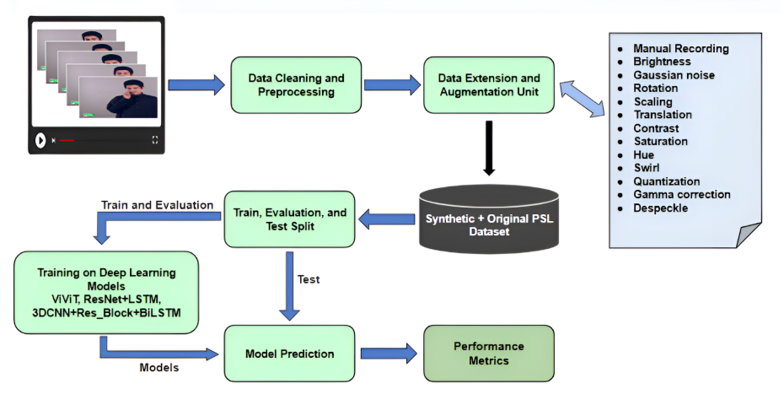

Goal: Determine the marginal utility of more real, diverse data + temporal augmentations.
A.1 Additional recordings & signer diversity
- Each member records 3 videos/label across varied environments, and lighting. This gives 9 more original videos/label with signer diversity.
- Standardized all recordings i.e 1278x780 resolution, 2 meter shoulder distance, .mp4 format.
- Annotate and version dataset (e.g., manifest.csv with class, signer, metadata).
A.2 Augmentations (spatio-temporal)
- Keep prior frame-level augmentations (11 types: brightness, gaussian noise, rotation, scale, translation, contrast, saturation, hue, swirl, quantization, gamma correction, despeckle), but also add temporal augmentations: frame dropping, and random frame jitter.
- Apply augmentation at video level rather than independently on frames for certain transforms (preserve temporal coherence).
- Target balanced per-class sample counts.

Phase B — Model experiments & hybrid architectures
Goal: If accuracy stagnates despite data scaling, evaluate model families and hybrid pipelines.
B.1 Baseline re-training
- Reproduce and retrain 3DCNN+ResBlock+BiLSTM with increased data, identical preprocessing.
- Log scaling curves (accuracy vs dataset size).
- Hyperparams: start with previous settings (batch 8, epochs variable, Adam, weight decay) and scale epochs to convergence.
B.2 Regularization & training strategies
- Label smoothing (as used earlier), stronger dropout, mixup/time-mix augmentations, larger weight decay, and data balancing per class.
- Use early stopping and ReduceLROnPlateau.
- Use mixed precision and gradient accumulation if GPU memory is a bottleneck.
B.3 Ablation studies
- Systematically test: (i) augmentation types, (ii) number of distinct signers, (iii) optical flow addition, (iv) 3DCNN depth & residual blocks, (v) transformer embedding size. Make charts and significance tests.

Phase C — Model refinement & results consolidation
C.1 Targeted Refinement
- Apply transfer learning from large gesture/action datasets.
- Use ensemble averaging or hybrid stacking of best models.
- Regularize with stronger dropout, weight decay, and augmentation.
C.2 Performance & Efficiency Optimization
- Reduce latency and model size (pruning, quantization if needed).
- Profile GPU memory/throughput for deployment readiness.
- Measure inference latency and memory; trade accuracy vs latency for a balanced demo.
C.3 Documentation & Final Results
- Prepare detailed confusion matrices, per-class metrics, and error analysis.
- Consolidate findings into reproducible reports (GitHub repo + docs).
- Finalize deliverables for FYP-1 defense.

Phase D — Sentence formation prototype – FYP-2
Context: current labels are single words / alphabet & words. To reach sentence formation we must support: (1) reliable word recognition, (2) segmentation across sign boundaries, (3) grammatical mapping to Urdu ordering, (4) optional morphological postprocessing and TTS.
Plan: FYP-I → produce a working demonstration, then in FYP-1 presentation, detailed methodologies regarding ‘Sentence Formation Prototype’ will be designed and finalized
D.1 Sentence-Level Prototyping
- Explore seq2seq or transformer encoder-decoder pipelines for PSL-to-text.
- Investigate simple sequence composition into Urdu grammar.
- Evaluate with BLEU/ROUGE + human testing for intelligibility.
D.2 Integration & Testing
- Prototype integration with TTS and basic UX flow.
- Conduct small-scale user tests with PSL org for feedback.

Individual Tasks (who does what — justify effort)
Below is the tentative individual task assignment. Each member will perform cross-checks of all deliverables.
Team Member | Primary Responsibilities (FYP-I)
Zain Baig (Leader) | Project coordination, experiment orchestration, model training pipeline (PyTorch), hyperparameter search, reproducibility scripts, final evaluation & ablation studies.
Aarij Ali | Data collection management (volunteer coordination), annotation & metadata, augmentation pipeline, data quality checks.
Abdul Rehman Khan | Model optimization & quantization, documentation and testing with PSL organization.
(Each member contributes to literature review, writing, and defense prep. Report drafting responsibilities are rotated per chapter.)

Gantt Chart (Mandatory)
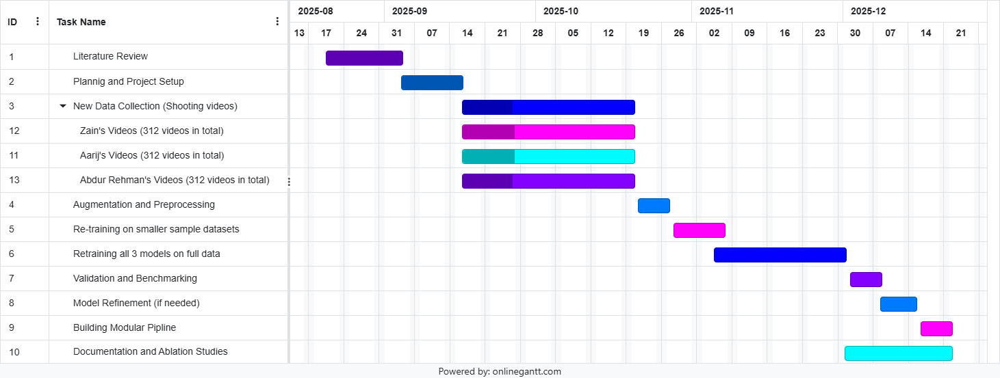

Tools & Technologies
Development & Training
  - Python
  - PyTorch (core deep learning)
  - CUDA, cuDNN (GPU acceleration, installed via PyTorch build)
  - PyTorch Lightning
  - NumPy (data handling & array ops)
  - tqdm (progress bars)
  - inspect (for debugging/model inspection)
Model Architectures
  - 3D CNN (baseline spatio-temporal)
  - Residual Blocks (to deepen CNNs)
  - BiLSTM (temporal modeling on features)
  - Transformer encoder/decoder (HuggingFace or custom implementation)
  - SlowFast / I3D (open-source variants) (for benchmarking against video SOTA)
Augmentation & Synthetic Data
  - Albumentations (image/video frame augmentations: brightness, hue, contrast, etc.)
  - Custom temporal augmentations (frame dropping, speed jittering, noise injection)
Experiment Management & Reproducibility
  - Weights & Biases (wandb)
  - GitHub (version control)
Metrics & Evaluation
  - scikit-learn (sklearn) — for metrics & utilities (accuracy, precision, recall, F1, confusion matrix, etc.)
Hardware
  - Local GPU: NVIDIA GTX 3060 (baseline training & prototyping)
  - Recommended: Larger GPU (GTX 3080/4090 or cloud GPU like Colab Pro, Lambda, or Paperspace) for ViViT / SlowFast training.

Evaluation Plan & Metrics
- Primary metrics: Top-1 Accuracy, Precision, Recall, F1-score (per class + macro average).
- Secondary metrics: Inference latency (ms), model size (MB), memory consumption.
- Protocol: Held-out test set unchanged (the original test set will remain untouched across all experiments). Use stratified k-fold validation for robust estimates; report mean ± std. Human evaluation for grammaticality and intelligibility during user testing.
- User testing: Conduct a small user test (with PSL org): 8–10 tasks per user, measure task success rate, perceived accuracy and usefulness.

Risks & Mitigations
- Insufficient new signers / Cross-signer generalization: Mitigated with multiple signers (all 3 members of team contributing equally), stronger temporal augmentations and synthetic data.
- Overfitting with large models (ViViT / Transformers): Using transfer learning, smaller transformer stacks, stronger dropout, and hybrid architectures that keep Transformers lightweight.
- Computing constraints: Using gradient accumulation, reducing batch sizes, performing hyperparam search on smaller proxies and using cloud GPU for heavy experiments if needed.
- Ethics / consent: Storing consent forms and anonymizing signer metadata unless consented otherwise.

Deliverables (FYP-I & path to FYP-II)
FYP-I (end of term deliverables):
- Expanded PSL dataset (organized, documented, with metadata and consent forms).
- Reproducible training scripts + model checkpoints for the best performing architecture.
- Benchmark report: scaling curves, ablation studies, and chosen best model rationale.
- Modular inference pipeline and a lightweight demo (server side) showing word recognition.
FYP-II (planned):
- Sentence-level annotated dataset (templates).
- Rule-based sentence assembly demo + seq2seq prototype for selected templates.
- Final defense report, code release and potential paper submission.references.

References

[1] | A. Imran, “Dataset of Pakistan Sign Language and Automatic Recognition of Hand Configuration of Urdu Alphabet through Machine Learning,” Elsevier, 2021.
[2] | S. Arooj, “Enhancing sign language recognition using CNN and SIFT: A case study on Pakistan sign language. Available at: https://www.sciencedirect.com/science/article/pii/S1319157824000235,” Elsevier, 2024.
[3] | H. M. Hamza, “Pakistan sign language recognition: leveraging deep learning models with limited dataset,” 2023.
[4] | N. S. Khan, “A Novel Natural Language Processing (NLP)–Based Machine Translation Model for English to Pakistan Sign Language Translation,” 2020.
[5] | U. Farooq, “A multi-stack RNN-based neural machine translation model for English to Pakistan sign language translation,” 2023.
[6] | S. S. V. B. S. Hayder M. A. Ghanimi, “An open‐source MP+CNN+BiLSTM model‐based hybrid model,” International Journal of Systems Assurance Engineering and Management, pp. 2-14, 5 March 2024.
[7] | L. A. F. N. Hadeel Alsolai a, “Automated sign language detection and classification using reptile search algorithm with hybrid deep learning,” Heliyon, vol. 10, pp. 1-12, 2024.
[8] | A. Dhanjee, “Sign Language Accessibility for the Deaf in Pakistan,” YES Program Froums, 2014.

Appendix
- Frame extraction: 120 frames/clip (pad/truncate), resize 112×112 or 128×128 as appropriate for model.
- Normalization: /255 → [0,1]; then standardize by dataset mean/std if available.
- Baseline hyperparams: 3DCNN+ResBlock+BiLSTM: batch=8, epochs=10–70 (scale), Adam, initial lr=1e-3–1e-4, weight_decay=1e-4–5e-4, ReduceLROnPlateau (patience=5), label smoothing 0.1.
- Checkpointing & reproducibility: seed (42), deterministic dataloaders where possible, save optimizer state, loss curves.

