Base Paper: https://www.researchgate.net/publication/372414797_Pakistan_sign_language_recognition_leveraging_deep_learning_models_with_limited_dataset

Abstract submitted:
The deaf community faces serious challenges due to communication barriers with the general population, leaving their ideas and opinions unexpressed. Significant work has been done on sign language recognition systems for various languages such as American Sign Language (ASL), Argentine Sign Language (LSA64). However, limited work has been conducted for PSL recognition systems, further increasing the communication challenges for deaf society in Pakistan. Furthermore, the limited dataset in terms of examples per sign/label has made it difficult to train deep learning-based PSL recognition systems. To address this gap, we propose a video-based Pakistan Sign Language recognition system based on the Residual Network (ResNet) and Long Short-Term Memory (LSTM) model for improved PSL video sign-to-speech translation in Urdu. Our PSL dataset consists of 104 commonly used PSL signs. Initially sourced from PSL organization, we increased dataset size with self-recorded PSL sign videos, resulting in 10 videos per label. To enhance model performance and introduce further variations in the dataset, we applied 11 different augmentation techniques – including brightness adjustment, Gaussian noise, etc. – expanding the dataset to 60 videos per label. The proposed system uses ResNet, a deep convolutional network, as the backbone for extracting spatial sign language features from videos, which improves sign language video’s feature representation. These extracted features are then processed by LSTM, which utilizes gated mechanisms to capture temporal dependencies in sign sequences. By integrating spatio-temporal learning, our approach considerably enhances PSL recognition accuracy. The evaluation metrics used to test the recognition system’s effectiveness are accuracy, F1-score, precision, and recall. Designed to improve PSL recognition, this system facilitates effective communication for the deaf community and has potential applications in education and daily interactions.

Dataset Details:
- Final dataset: 104 daily use labels; 60 videos/label
- 3 members volunteered to record. Each 3 videos per label so 9 different videos
- Collaborated with Pakistani Sign Language (PSL) Organization for original video, which has 1 video/label
- So in total, we collected 10 different and original videos per label
- Then 11 different augmentations (brightness, gaussian noise, rotation, scaling, translation, contrast, brightness saturation hue, swirl, quantization, gamma correction, and despeckle) were applied on original videos randomly [https://aclanthology.org/W19-6615.pdf] [https://www.researchgate.net/publication/372414797_Pakistan_sign_language_recognition_leveraging_deep_learning_models_with_limited_dataset]. Therefore, from 10 videos/label to 60 videos/label.
- Optional: Raw frames’ input was found to be perfect for training rather than segmentation of a human class in a frame using Yolo11 and/or drawing landmarks of the hands in a frame using mediapipe.

Training, Evaluation and Test Dataset Split:
- Each label split; randomly shuffled
- 80% of the videos/label into training set
- 15% of the videos/label into evaluation set
- 5% of the videos/label into test set

Chosen Models with Results:
- Residual Network (ResNet) and Long Short-Term Memory (LSTM)
  - https://www.mdpi.com/2313-433X/10/6/149
  - Frozen ResNet-18 feature extractor feeding a 1-layer LSTM, followed by a linear classifier
  - Input 120-frame RGB video clips resized to 128×128
  - Normalization: Pixel values scaled to [0,1], then converted to torch.FloatTensor and permuted to shape [C,H,W]
  - Padding: If <120 frames, pad with black frames (zeros) to reach exactly desired_frames = 120
  - Pretrained Weights: ResNet-18 (ImageNet-1K)
  - Layer Freezing: All parameters frozen except those in the final fully connected layer (i.e. only resnet.fc is trainable)
  - Training uses Adam (lr=1e-4, weight_decay=5e-4), label-smoothed cross-entropy, mixed-precision on CUDA, and ReduceLROnPlateau (patience = 5, factor = 0.1)
  - Mixed Precision: torch.amp.autocast + GradScaler on CUDA for faster & stable training

  - Results:
    - Train: loss 1.0666, acc 0.9587, precision 0.9596, recall 0.9587, F1 0.9588
    - Val: loss 1.3812, acc 0.8377, precision 0.8556, recall 0.8377, F1 0.8364
    - Test: loss 1.4838, acc 0.7981, precision 0.8331, recall 0.7981, F1 0.7963

  - Hyperparameters:
    - Epochs: 70
    - Batch Size: 8
    - Initial Learning Rate (LR): 1e-4
    - Weight Decay: 5×10⁻⁴
    - Optimizer: Adam
    - LR Scheduler: ReduceLROnPlateau (factor=0.1, patience=5, threshold=1e-4)
    - Loss: CrossEntropyLoss(label_smoothing=0.1)
    - GPU used for training: Nvidia GTX 1660 Ti

  - Diagram:
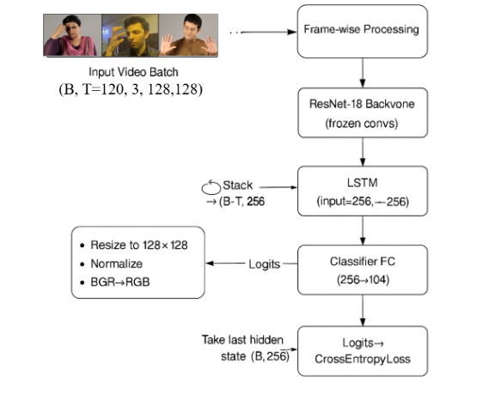

  - Plots:
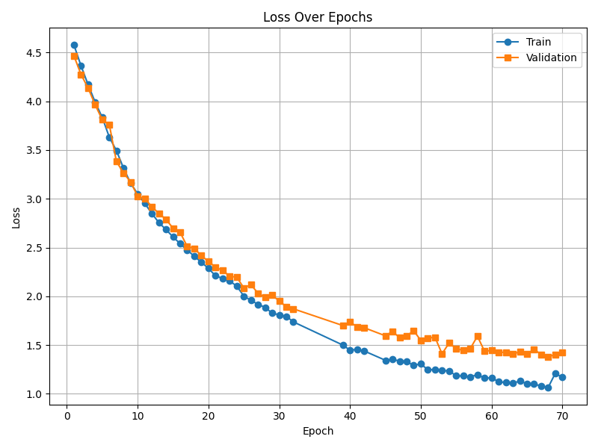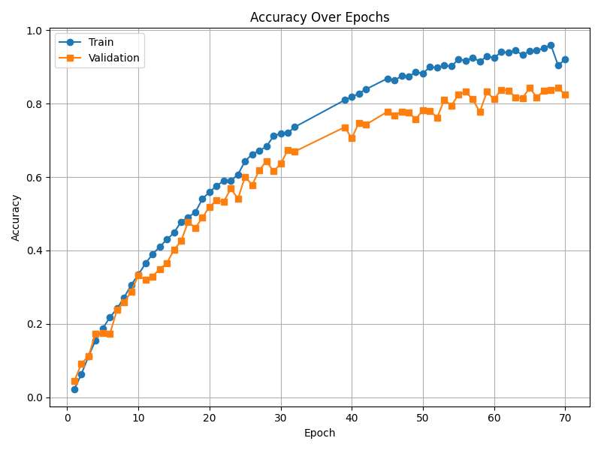
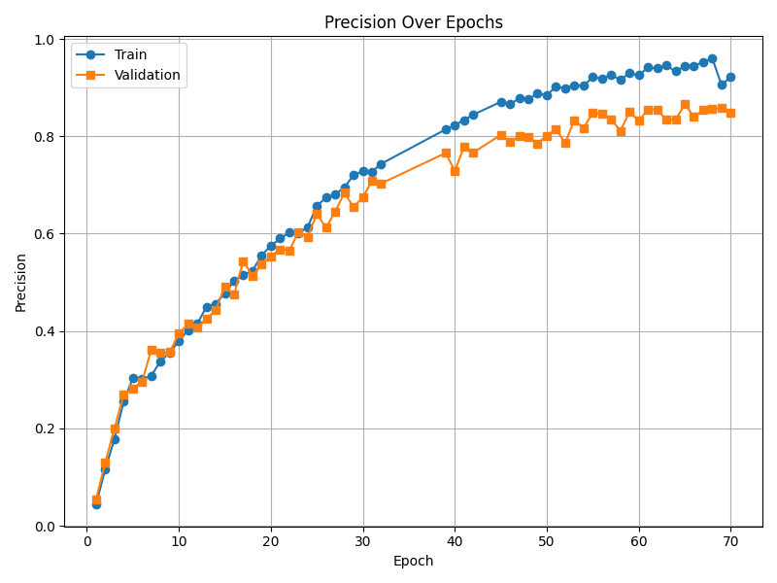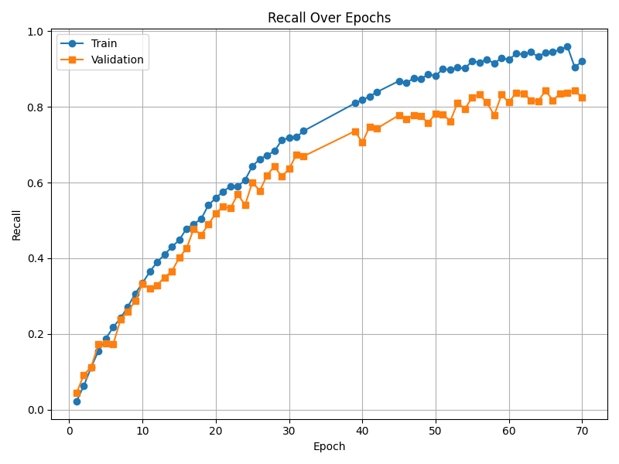

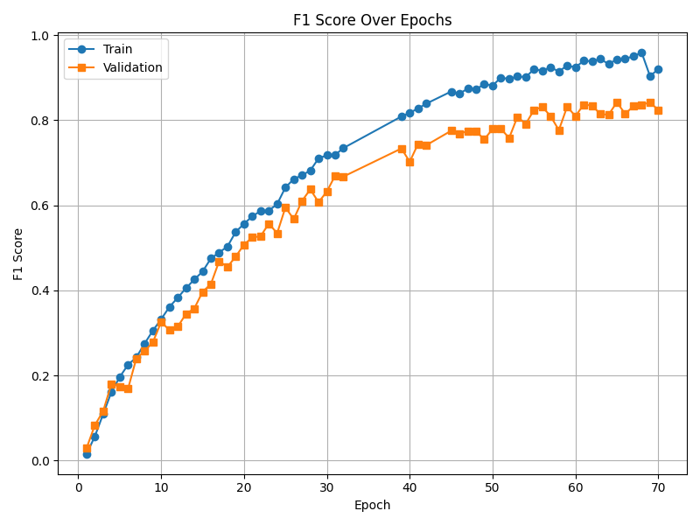

- 3DCNN+ResidualBlock+BiLSTM
  - Firstly we tried the model 3dcnn+lstm [https://www.researchgate.net/publication/357489586_Dynamic_Hand_Gesture_Recognition_Using_3D-CNN_and_LSTM_Networks] which failed drastically on 104 classes as loss fluctuated between 4.64 to 4.65 while accuracy fluctuated between 1.86% to 0.78% for training dataset for 15 epochs. However, as per the paper, the model was found to be incapable to accommodate higher number of labels, so we experimented for 15 classes for 80 epochs and the loss was around 2.0 and accuracy around 54% for training and evaluation dataset, which proved the 3DCNN+LSTM model to be ineffective for the PSL dataset.
  - Therefore, to improve the model’s performance, we made key changes as follows:
    - Introduced “BatchNorm3d” immediately after each 3D convolution to stabilize and accelerate the convergence of learning while keeping activation distributions well-conditioned.
    - Two back-to-back “ResidualBlock” to let gradients flow directly through the network's depth, while resolving the vanishing-gradient problem and helping to stack more layers without performance degradation.
    - Interleaving extra pooling layers after each ResidualBlock, which reduces spatial dimensions and forces the network to learn multi-scale features.
    - BiDirectional LSTM was introduced instead of LSTM, so while capturing each time step in both forward and backward directions, it captures context from the entire gesture sequence. This helps in capturing fine temporal cues at the end of a video clip, which are important to distinguish between somehow similar signs.
    - Weight decay (L2 regularization) was included, which penalizes large weights and further solves overfitting on each of the 104 classes.
  - The changes in the network helped boost the model’s performance and capacity to learn rich spatio-temporal sign features and generalize across 104 classes.
  - These changes were further found to be effective, as the performance of the model was increased while the computation requirements were decreased as within 10 epochs, the remarkable performance was achieved.
  - Our modified 3DCNN+RES_BLOCK+BiLSTM model ingests fixed‐length frame sequences, extracts spatiotemporal features via stacked 3D convolutions and residual blocks, then models temporal dynamics with a two‐layer bidirectional LSTM. Learning from scratch
  - Frame Extraction
    - Num frames: 120
    - Frame size: 112×112 pixels
    - Normalization: pixel values scaled to [0,1] by dividing by 255.
    - Padding: if video shorter than 120 frames, zero‐frame padding at end; if longer, truncated to first 120.
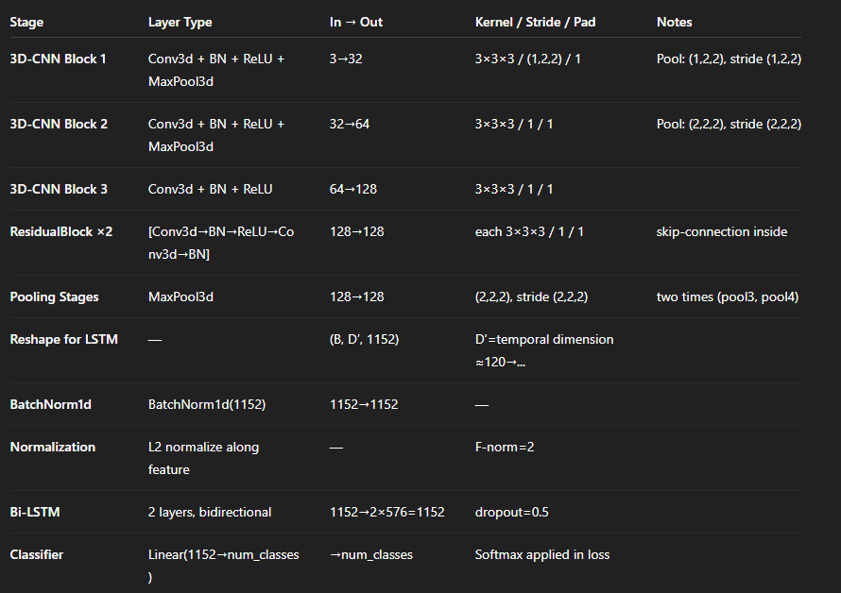
  - Layer Details:

  - Total learnable parameters: ≈9.3 M (estimate based on channel sizes).

  - Hyperparameters:
    - Batch Size: 8
    - Epochs: 10
    - Optimizer: Adam
    - Weight Decay: 1e-4
    - Initial Learning rate: 1e-3
    - Scheduler: ReduceLROnPlateau with patience=5 and monitor=validation loss.
    - Loss: CrossEntropyLoss
    - GPU used for training: Nvidia GTX 1660 Ti
  - Results:
    - Train Loss: 0.4709, Train Acc: 86.66%, Train Prec: 0.8677, Train Rec: 0.8666, Train F1: 0.8665
    - Eval Loss: 0.4834, Eval Acc: 86.42%, Eval Prec: 0.8876, Eval Rec: 0.8642, Eval F1: 0.8619
    - Test Loss: 0.5905, Test Accuracy: 83.89%, Test Precision: 0.8844, Test Recall: 0.8389, Test F1 Score: 0.8358

  - Plots:
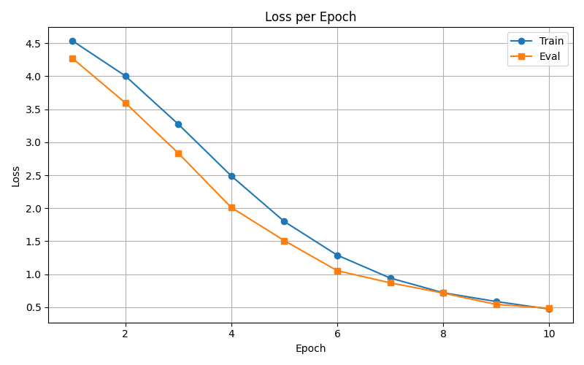
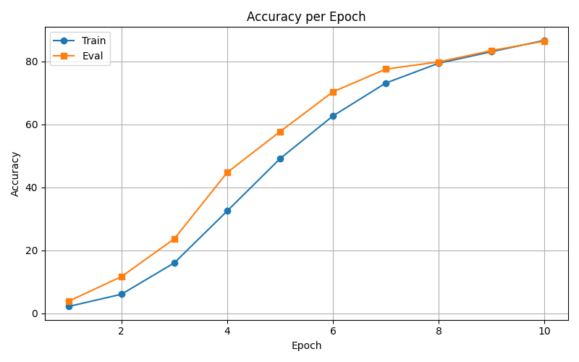

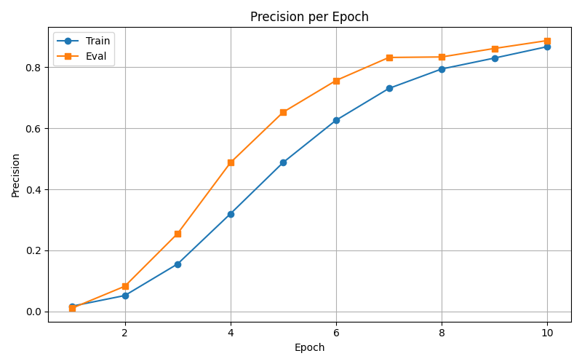
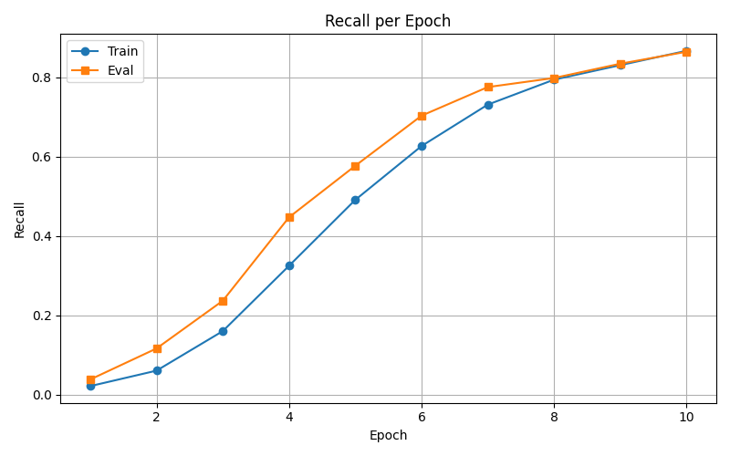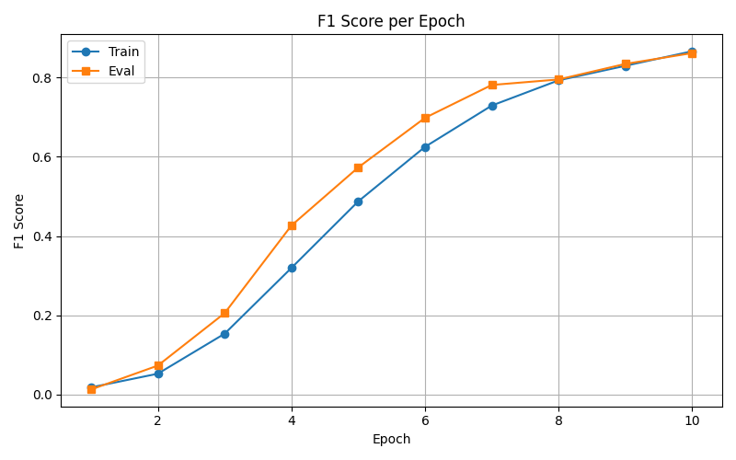

  - Diagram
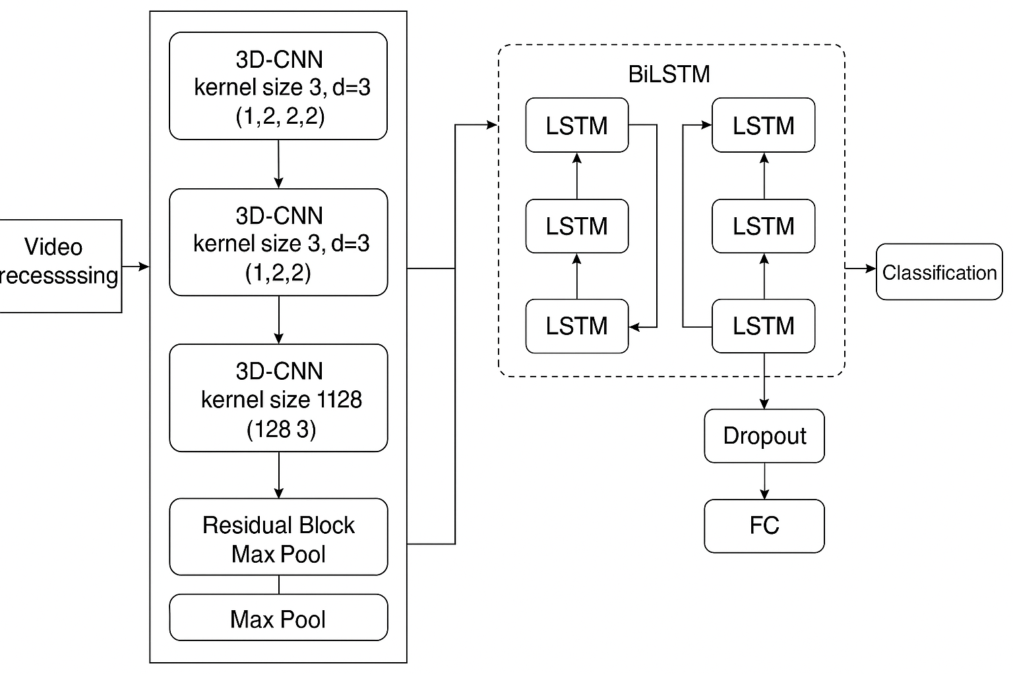

- Vision Transformer (ViViT) [https://ceur-ws.org/Vol-3392/paper13.pdf]
  - ViViT/32 chosen model (Fine-tuning)
  - It extends the Vision Transformer (ViT) by adding temporal modeling across video frames.
  - Good option because Sign Language requires understanding of hand movements over time. ViViT explicitly models time via temporal attention. Captures detailed hand gestures and facial expressions in high resolution. Captures detailed hand gestures and facial expressions in high resolution. Captures detailed hand gestures and facial expressions in high resolution.
  - Architecture Overview
    - Input: A video is split into a sequence of frames, which are then divided into spatio-temporal patches.
    - Patch Embedding: Each patch is flattened and linearly projected.
    - Positional Encoding:
      - Spatial: Encodes 2D patch position within a frame.
      - Temporal: Encodes frame sequence across time.
    - Transformer Layers: Learn both spatial and temporal dependencies.
    - Classification Head: A [CLS] token is used to aggregate information for final prediction.
  - Hyperparameters:
    - image_size: 224x224
    - num_frames: 32
    - patch_size: 16x16
    - hidden_size: 768 (ViViT-B)
    - num_attention_heads 12 (ViViT-B)
    - num_hidden_layers 12 (ViViT-B)
    - Dropout_rate: 0.1
    - Initializer_range: 0.02
    - Intermediate_size: 3072
    - Max_position_embeddings: 512

Combined Models’ Results:
Table for Training and Evaluation

 | Train  Loss | Eval  Loss | Train  Acc | Eval  Acc | Train  Precision | Eval  Precision | Train  Recall | Eval  Recall | Train  F1 Score | Eval  F1 Score
ResNet+LSTM  (70 epochs) | 1.07 | 1.38 | 0.96 | 0.84 | 0.96 | 0.86 | 0.96 | 0.84 | 0.96 | 0.84
3DCNN+RES_BLOCK+BiLSTM  (10 epochs) | 0.47 | 0.48 | 0.87 | 0.86 | 0.87 | 0.89 | 0.87 | 0.86 | 0.87 | 0.86
Video Vision Transformer (ViViT)  (25 epochs) | 0.25 | 1.2 | 0.96 | 0.75 | 0.97 | 0.79 | 0.96 | 0.75 | 0.96 | 0.75

- 3DCNN+ResBlock+BiLSTM shows almost no train–eval gap (0.01 Acc), with solid F₁ on both sets.
- ResNet+LSTM and ViT both achieve very high training metrics but drop substantially at evaluation time, indicating over-fitting or insufficient data (especially for ViT).

