**Report**

Question -1

Table:



Bar plot:

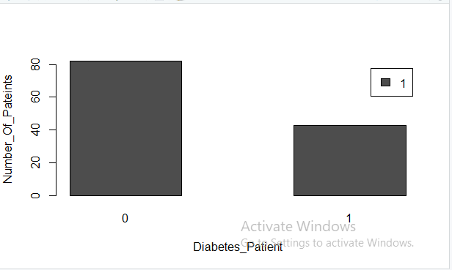

chisq.test:

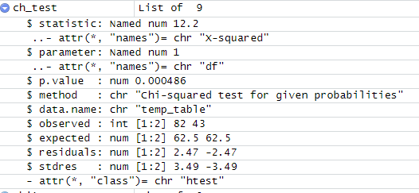

Thus from the above P value >0.05 So there is no significance relationship between diabetes and high blood pressure. Thus we reject the null hypothesis, we cant say that the diabetes peole are more likely to have Blood pressure.

Question -2

Table:



Bar plot:

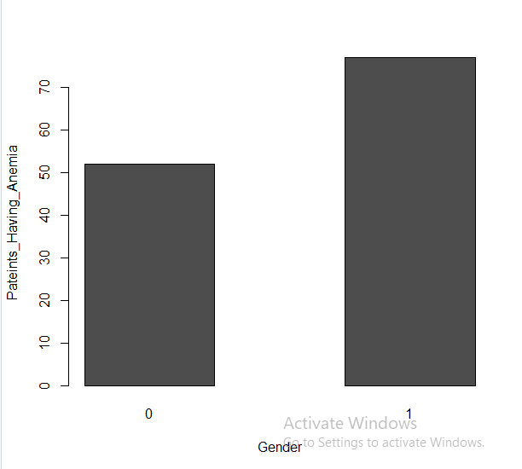

chisq.test:

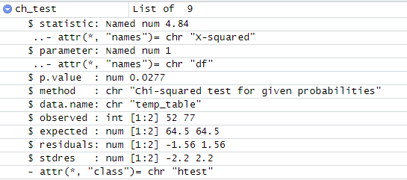

Thus from the above P value <0.05 So there is a significance relationship between anemia and gender. Thus we are fail to reject the null hypothesis, we can say that the people having anaemia are more likely females.

Question -3

Table:



Bar plot:

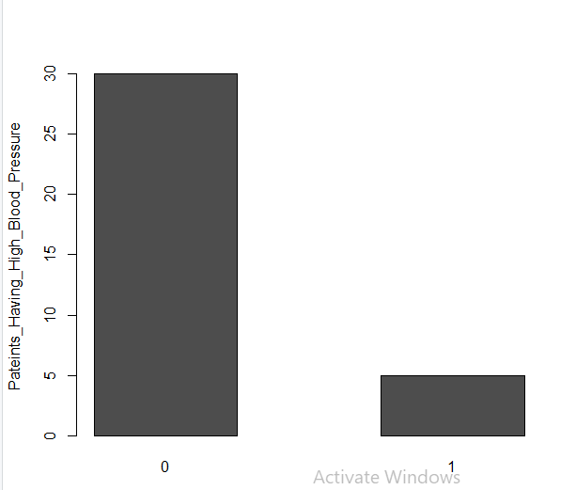

chisq.test:

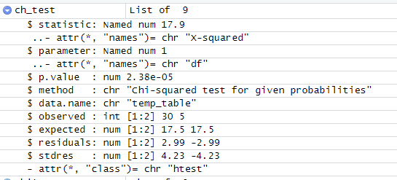

Thus from the above P value >0.05 So there is no significance relationship between

High blood pressure and death. Thus we are reject the null hypothesis, we can’t say that the people of age between 55 to 65 and having high blood pressure are less likely to survive.

Question -4

Table:



Bar plot:

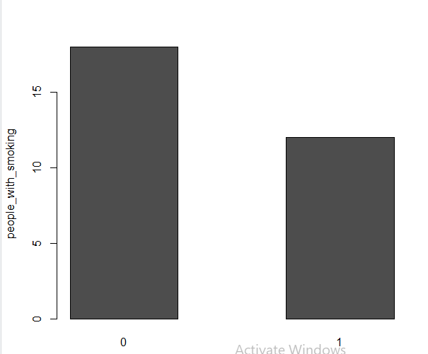

chisq.test:

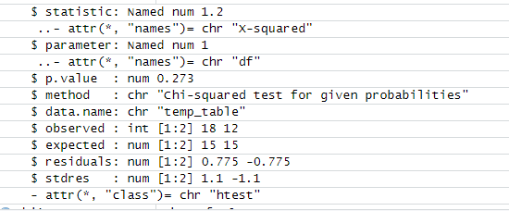

Thus from the above P value >0.05 So there is no significance relationship between

Smoking and death event of diabetes people. Thus we reject the null hypothesis, we can’t say that diabetic peoples who smokes are less likely to survive.