1、Pay attention to the spacing between the fonts and the font size.

2、The font used is Bahnschrift  
3、Background color 1f2630 。 Red: ed4a5b  
Green: 37b188  
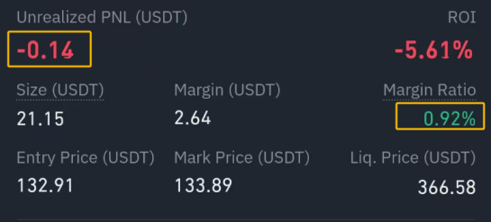  
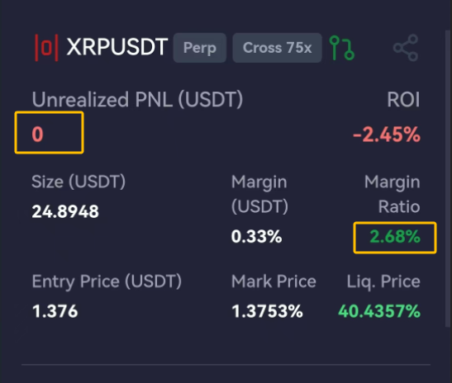  
4、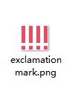 change  
