

**Assignment No 1**

**Name:**

**M Zain Ul Abideen**

**Reg No:**

**FA22-BCS-090**

**Section:**

**FA22-BCS-5-B**

**Subject:**

**Web Technologies**

**Submitted to:**

**Mr. Imran Shahzad**

**Task 1.**

**HTML Section**

**1. HTML Review**

**Introduction to HTML:**

HTML, or Hypertext Markup Language, is the standard language used to create and design web pages. It provides the fundamental structure for web content by utilizing a system of tags and attributes that define the content's presentation and organization. HTML documents are interpreted by web browsers to display content, allowing users to view text, images, and other multimedia on the internet.

**Structure of a Basic HTML Document:**

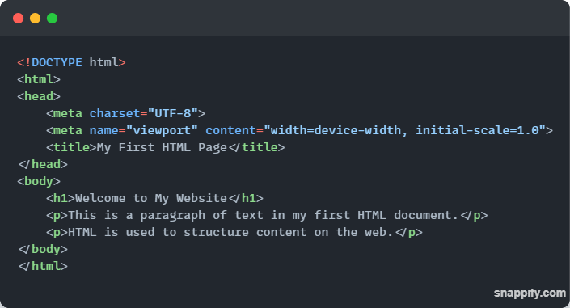

1. **<!DOCTYPE html>** defines the document type and version of HTML.
2. **<html>** is the root element that encloses all content.
3. **<head>** contains meta-information about the document, such as its character encoding and title.
4. **<body>** includes the visible content of the page, such as headings and paragraphs.

**2. Distinguishing Between Different HTML Tags and Elements**

**Headings (<h1> to <h6>):**

Headings are used to define the structure of content and create a hierarchy. The <h1> tag represents the highest level of heading, while <h6> represents the lowest. Each heading level is displayed in decreasing size to show the importance and structure of the content.

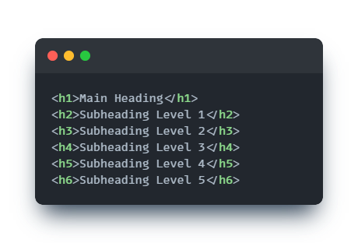

**Paragraph (<p>):** The <p> tag is used to define paragraphs of text. It automatically adds space before and after the paragraph to separate it from other content. 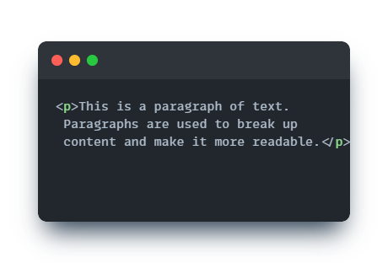

**Anchor (<a>):**

The <a> tag defines hyperlinks that allow users to navigate to other web pages or resources. The href attribute specifies the destination URL.

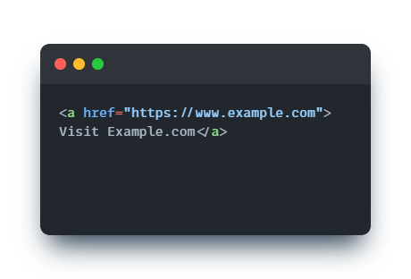

**Image (<img>):**

The <img> tag is used to embed images in a web page. It requires the src attribute to specify the image source and the alt attribute for alternative text.

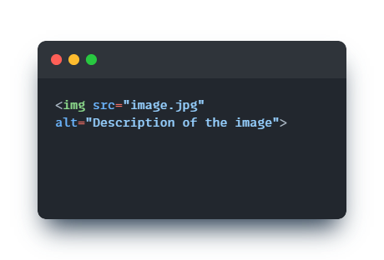

**Lists (<ul>, <ol>, <li>):**

* **<ul>** creates an unordered (bulleted) list.
* **<ol>** creates an ordered (numbered) list.
* **<li>** defines a list item in either type of list

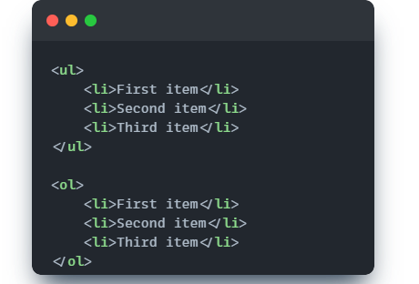

**3. Express Forms and Input Elements**

**Input Types**

Forms collect user input and are an essential part of interactive web pages. Various input types are available, each serving a specific purpose:

**text:** For single-line text input.

**email:** For email addresses.

**password:** For password input, obscuring the text.

**checkbox:** For selecting multiple options.

**radio:** For selecting one option from a set.

**Example of a Form:**

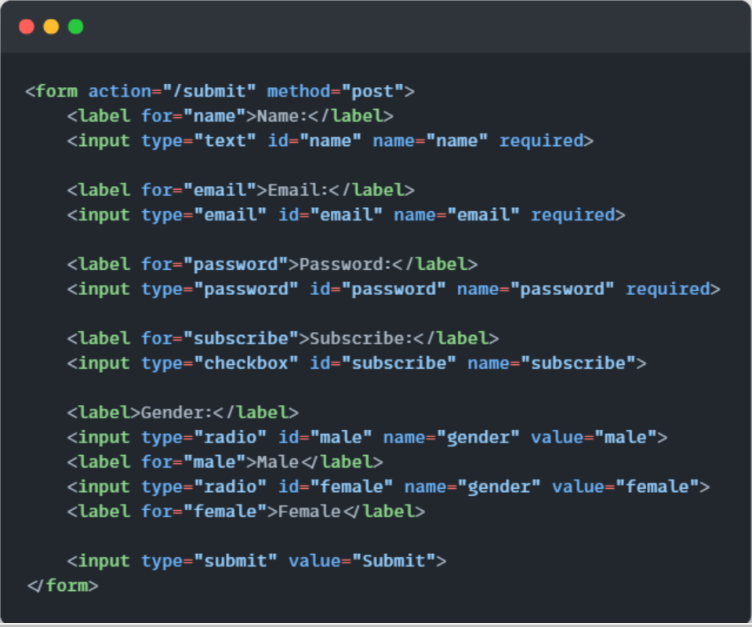

**4.Interpolating Semantic HTML**

**Semantic HTML**

Semantic HTML refers to the use of HTML tags that convey the meaning of the content they enclose. It improves accessibility and search engine optimization (SEO) by providing context and structure to web content. Examples of semantic HTML tags include <header>, <footer>, <article>, and <section>.

**Importance for Accessibility and SEO**

* **Accessibility:** Semantic elements help screen readers and other assistive technologies interpret and navigate content more effectively.
* **SEO:** Search engines use semantic tags to better understand the structure and relevance of content, potentially improving search rankings.

**Use semantic elements like<main>, <header>, <section>, and<footer>**

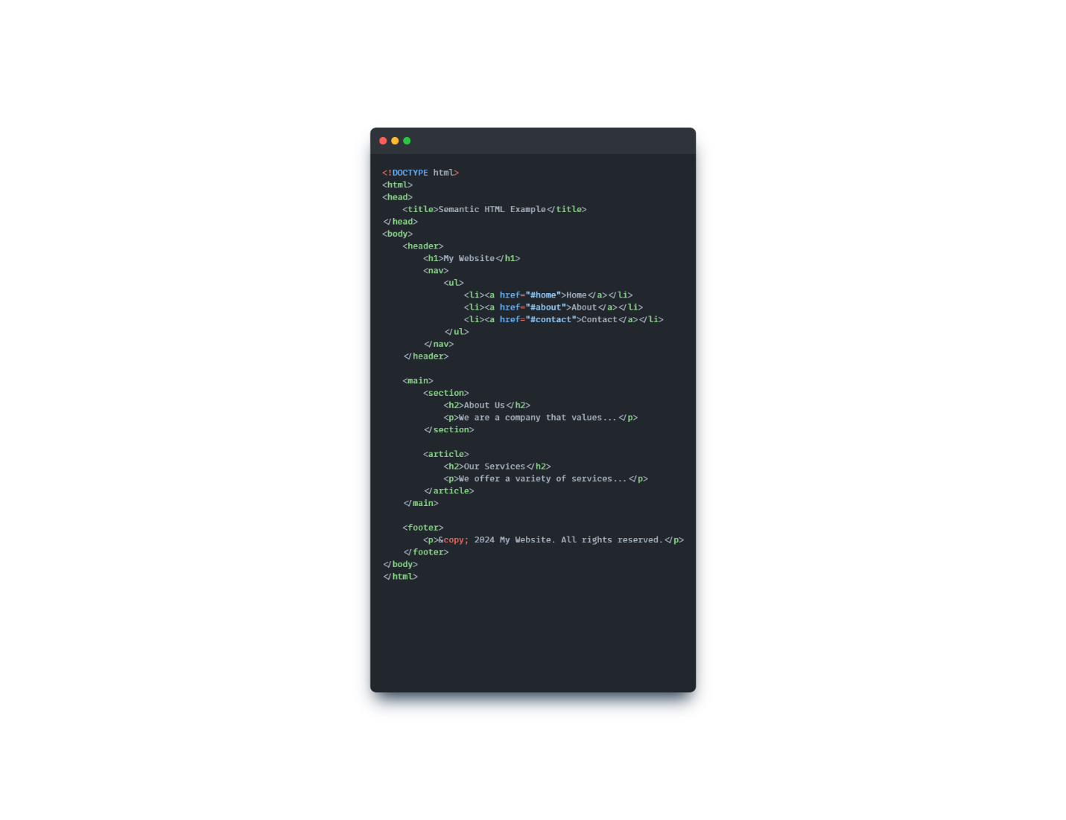

**Embedding Multimedia (Videos and Audio)**

HTML provides native support for embedding multimedia content such as videos and audio. The <video> and <audio> tags allow web developers to integrate these media types directly into web pages.

**Video Example:**

To embed a video, use the <video> tag. You can specify multiple video sources to ensure compatibility across different browsers.

**For Video:**

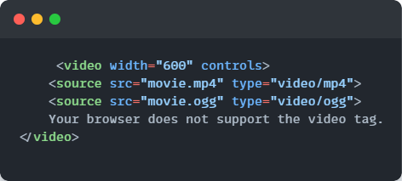

For Audio:

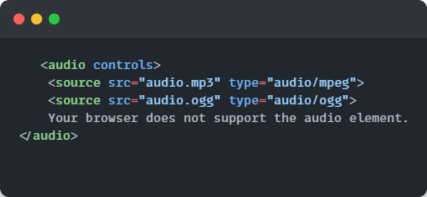

**Working of Iframes:**

**The <iframe> tag is used to embed another HTML document within the current document. It’s often used for embedding external content like videos from YouTube or interactive maps.**



**CSS Section:**

**1. CSS Overview**

**CSS Fundamentals**

Cascading Style Sheets (CSS) is used to control the presentation of HTML elements on a web page. CSS defines styles such as colors, fonts, layouts, and spacing, allowing for separation of content (HTML) from design (CSS).

**Linking CSS with HTML**

CSS can be applied to HTML documents in three main ways: inline, internal, and external.

* Inline CSS: Styles are applied directly within HTML elements using the style attribute.

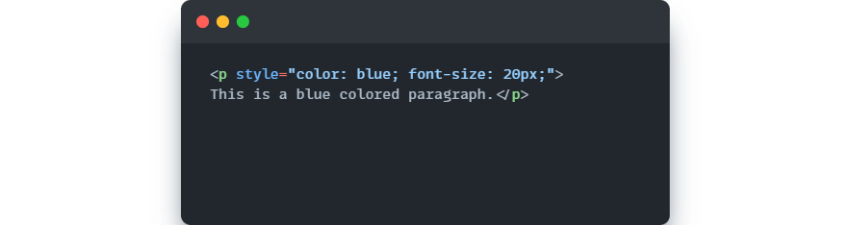

* **Internal CSS**: Styles are defined within a <style> tag inside the <head> section of the HTML document.

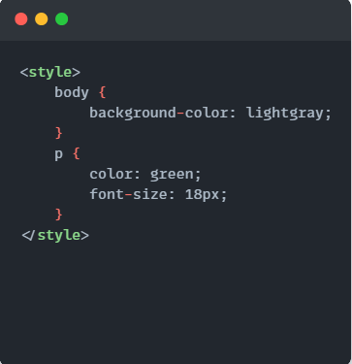

* **External CSS**: Styles are defined in a separate .css file and linked to the HTML document using the <link> tag.

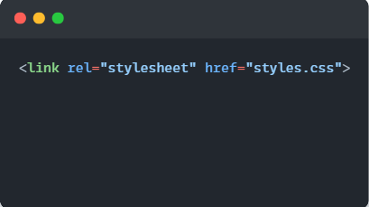

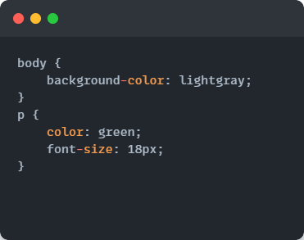

**2. CSS Box Model:**

CSS Box Model

The CSS box model describes the rectangular boxes generated for elements in the document tree. It consists of four parts: content, padding, border, and margin.

* Content: The actual content of the box, such as text or images.
* Padding: Space between the content and the border, inside the element.
* Border: Surrounds the padding (if any) and content.
* Margin: Space outside the border, separating the element from other elements.

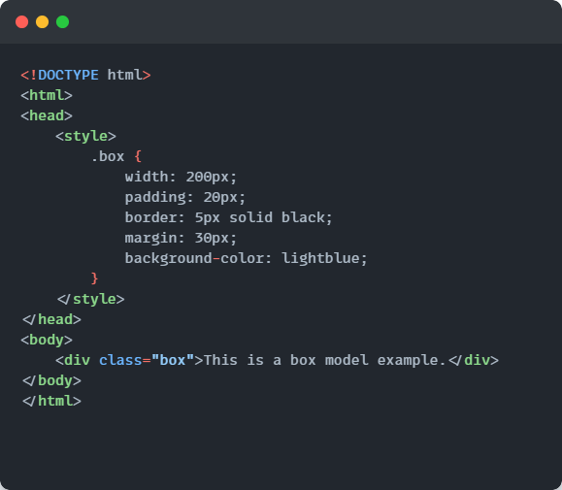

**3. CSS Selectors:**

**Element Selector**

Selects HTML elements by their tag name.

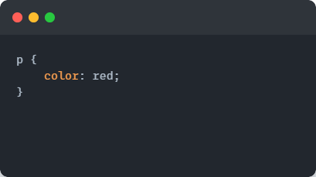

**Class Selector:**

Selects HTML elements with a specific class attribute.

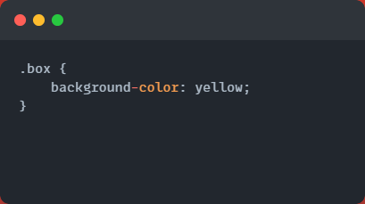

**ID Selector:**

Selects a single HTML element with a specific id attribute.

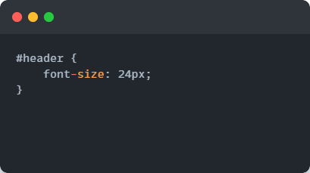

**Pseudo-classes**

Pseudo-classes are used to define the special states of elements.

* **: hover**: Applies styles when the mouse is over an element.
* **: nth-child(n)**: Selects elements based on their position in a parent element.

**Example:**

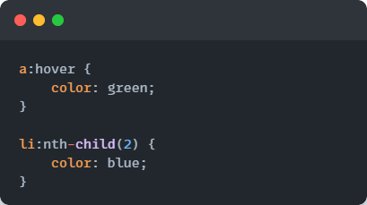

**4. CSS Positioning**

**Positioning Types**

* **Static: Default positioning. Elements are placed according to the normal document flow.**
* **Relative: Positioned relative to its normal position, allowing for adjustment using top, right, bottom, left.**
* **Absolute: Positioned relative to the nearest positioned ancestor (non-static). Removed from the normal document flow.**
* **Fixed: Positioned relative to the viewport. Stays in the same place even when scrolling.**
* **Sticky: Acts as relative until a specified scroll position is reached, then acts as fixed.**

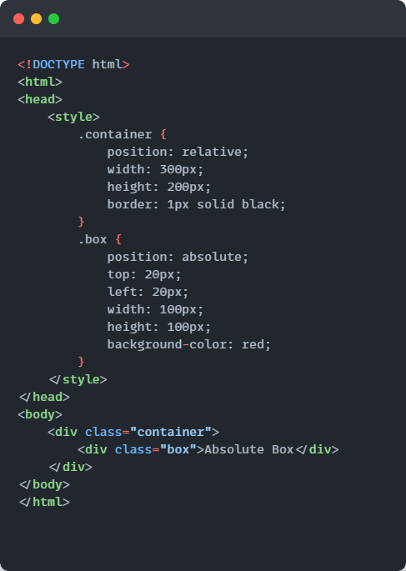

1. **Responsive Web Design with CSS:**

**Media Queries:**

Media queries are used to apply different styles based on the device's characteristics, such as screen size, orientation, or resolution.

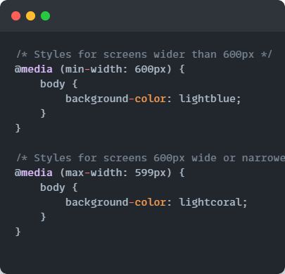

**6. Flexbox and Grid Layouts**

**Flexbox**

Flexbox is a one-dimensional layout system for aligning items in rows or columns. It is useful for distributing space and aligning items within a container.

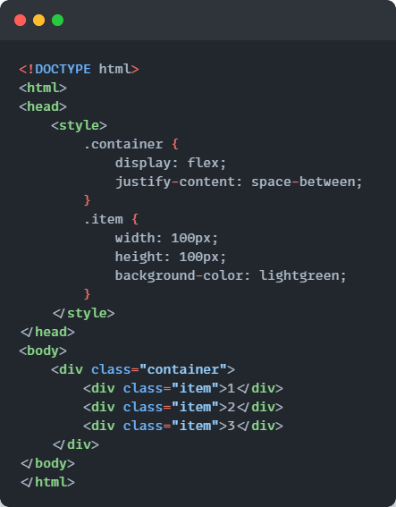

**Grid Layout**

Grid layout is a two-dimensional layout system for creating complex designs with rows and columns.

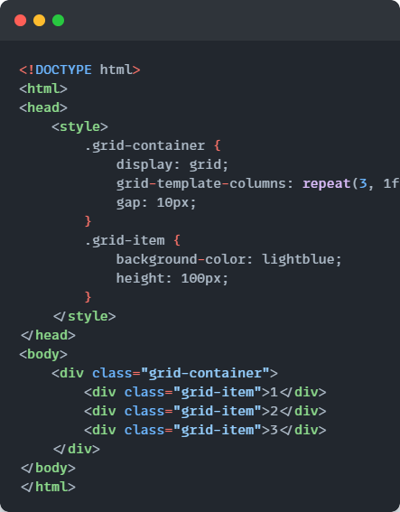

1. **CSS Transitions and Animations:**

**CSS Transitions**

Transitions allow for smooth changes in CSS properties over time.

