***Team members:***

* **Project leader:**

Zaira Lia Reyes

* **Programming Leader:**

Zaira Lia Reyes

* **Data Base Leader:**

Oswaldo Rojas Ortiz.

* **Documentation Leader:**

Luis Fernando Hernandez

* **Data Base Team:**

Ulises Guadalupe Escareño Vega

* **Programming Team:**

Sebastian Mendez Sanchez

* **Documentation Team:**

Ulises Guadalupe Escareño Vega

***Index:***

Indice

***General project definition:*** 2

***Useless tools for the development of HIDROENOVA*** 2

***Server tools installation*** 3

# ***General project definition:***

The undesirable water consumption it’s a problem in a big scale in Mexico, that’s why the distribution of water in Aguascalientes requires a page to know the sector that waste the most and to supply water distribution.

The porpoise of design this web page is that any citizen of Aguascalientes certainly knows the water quantity that they consume, and if they reach some predetermined range use of water, to get lower prices and make sense of the excessive waste of water in Mexico.

## ***Useless tools for the development of HIDROENOVA***

**Hypertext languages:**

**HTML:**

Hypertext markup language, it’s the most basic piece of web construction and it’s used to define the structure sense of the content of a web page.

Another technologies apart of HTML are generally used to describe the web page presentation (CSS) or his functionalities

**PHP:**

Hypertext preprocessor is a open code language so popular especially suitable for the web development and it can be used in HTML.

**Database gestion**

**MySQL:**

It’s a database manager and it can create multiple threads and multiple users, was developed like a free software (it can be used In multiple platforms it’s used in Linux)its free for web server’s. offers advantages like easy adaptation in different development environment, interaction with programming languajes like PHP, JAVA SCRIPT, and a easy integration with distinct SO’s

**Xampp:**

It’s a support language that consist in the database gestion system MySQL, web server apache and the interpreter to script languages PHP and PEARL. The name is an acronym: X, apache MariaDB-MySQL, PHP, PEARL

### ***Server tools installation***

**XAMPP:**

* Before installing a web server, it is advisable to check if there is not already one installed, or at least if it is not already running. To do this, simply open the browser and type the address http://localhost. If you get an error message, there is no web server running (although there may be a server installed, but not running).

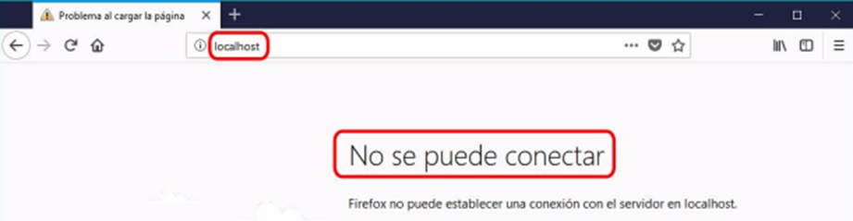

* Once the XAMPP installation file is obtained, double click on it to start it. When starting the XAMPP installer XAMPP shows a warning that appears if the User Account Control is activated and reminds us that some directories have restricted permissions:

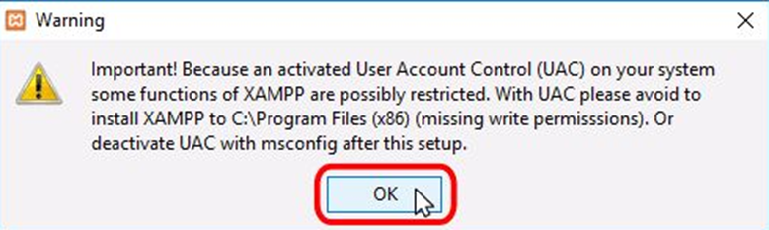

* The installation wizard then starts. To continue, click on the "Next" button.

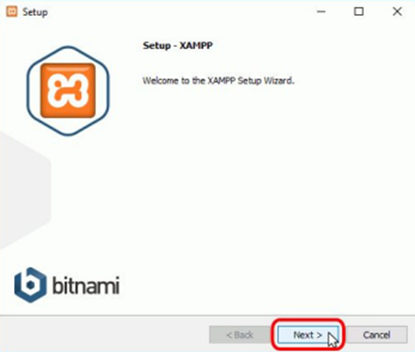

* The minimum components that XAMPP installs are the Apache server and the PHP language, but XAMPP also installs other elements. In the component selection screen you can choose whether or not to install these components.
* To follow these notes you need at least MySQL and phpMyAdmin installed.

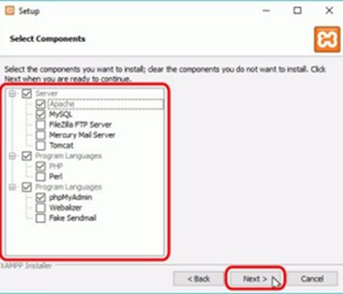

* On the next screen you can choose the XAMPP installation folder. The default installation folder is C:xampp. If you want to change it, click on the folder icon and select the folder where you want to install XAMPP. To continue the installation setup, click the "Next" button.

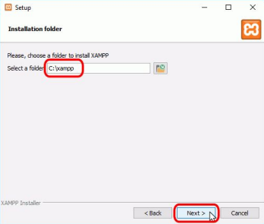

* The next screen provides information about the application installers for XAMPP created by Bitnami. Click the "Next" button to continue. If you leave the box checked, a Bitnami web page will open in your browser.

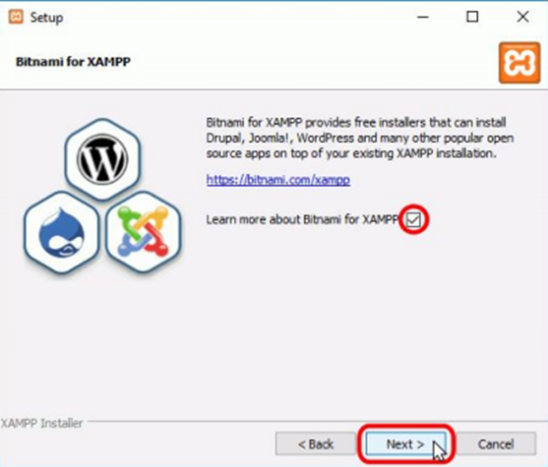

* Once the installation options have been chosen in the previous screens, this screen is the installation confirmation screen. Click on the "Next" button to start the installation on the hard disk.

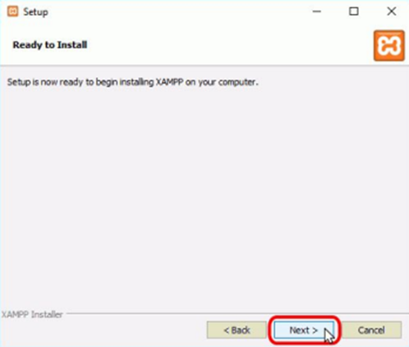

* The file copying process may take a few minutes.

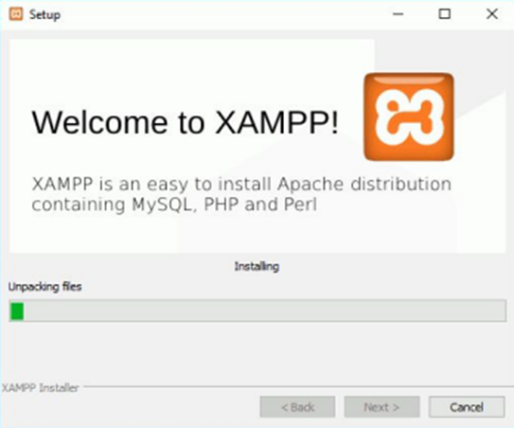

* During installation, if Apache was not previously installed on the computer, at some point a Windows firewall prompt will be displayed to allow Apache to communicate on private or public networks. Once you have chosen the desired options (in these notes it is recommended to allow private networks and deny public networks), click on the "Allow access" button.

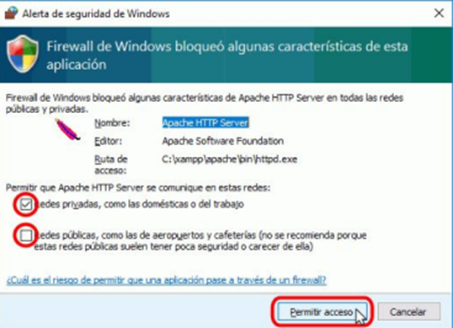

* Once the file copy is complete, the final screen confirms that XAMPP has been installed. If the box is left checked, the XAMPP control panel will open. To close the installation program, click the "Finish" button.

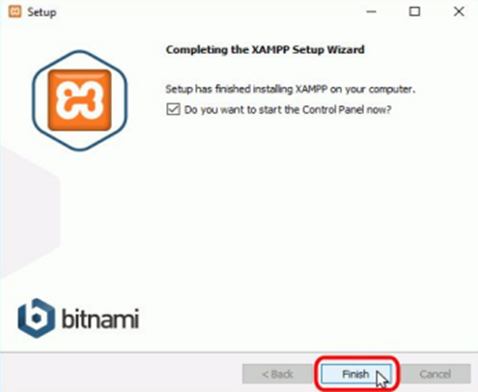

* The XAMPP control panel is divided into three zones:
* The module area, which indicates for each XAMPP module: whether it is installed as a service, its name, the process identifier, the port used and includes buttons to start and stop the processes, manage them, edit the configuration files and open the activity log files.
* The notification area, where XAMPP informs about the success or failure of the actions performed.
* The utilities area, for quick access.

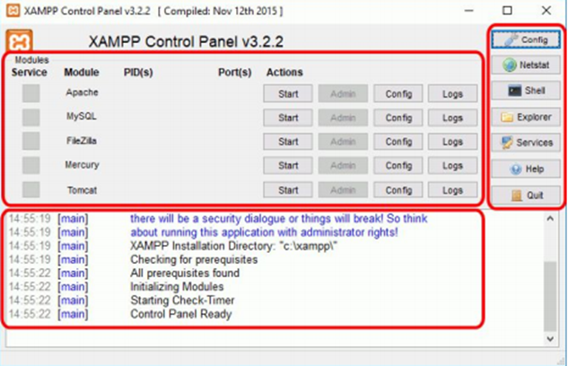

#### **Use cases**

system blocks:

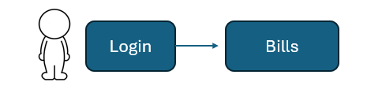

##### ***User story***

**System administration**

**User Story: Epic**

**E1**

How: system administrator

I want: administrate the access.

To: have control and a user manage in the page.

**E1-H1**

How: System administration

I want: proporcionate to the user his own water bills.

To: manage the water consume of the user.

**E1-H2**

How: As the administrator of the page

I want: To manage water bills of users

To: verify that no one will have debit.

###### **Data dictionary**

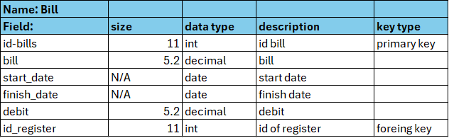

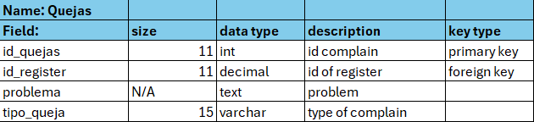

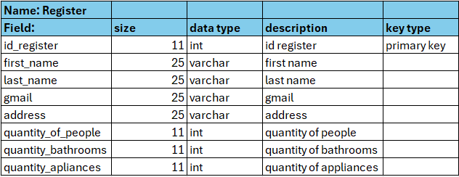

***Entity relations***

**Web display design:**

***Code:***

https://github.com/ZairaReyes13/HidroNova