1.Solution.
The graph shown in Figure(a) has Hamiltonian circuit given by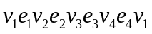
Note that all vertices appear in this a circuit but not all edges.
The edge 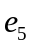 is not used in the circuit.
The graph shown in Figure (b) does not contan cireut since every cureut contaunng every vertex must contain the 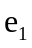 twice.
But the graph does have a Hamiltonian path 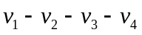
2.Solution：
