1.Solution. Let S = (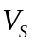,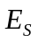) be the spanning tree to be found from G.
Initialize, there are eight nodes so the spanning tree will have seven arcs.
The iterations of Algonquin applied on the graph are given below and it runs at the most seven arcs.
The number indicates iteration number.
1.Since ares AC. ED. and DH have minimum weight 2. Since they do not form a cycle, we select all of them and= {(A, C), (E, D), (D, H)} and E=E-{(A, C), (E, D), (D, H)}.
2.Next ares with mummy weights 3 are AB. BC, and EG. We can select only one of the AB and BC. Also we can select EG.
Therefore, = {(A, C), (E, D), (D, H), (A, B), (E, G)} and E=E-{(A, B), (E, G)}
3. Next ares with minimum weights 4 are EF and FG. We can select only one of them.
Therefore, = {(A, C), (E, D), (D, H), (A, B), (E, G), (F, G)} and E =E-{(F, G)}.
4. Next ares with minimum weights 5 are CE and CF. We can select only one of them. i Therefore, E,= (A, C), (E, D), (D, H), (A, B), (E, G), (F, G), (C, E)} and E=E-{(C, E)}. Since number of edges in is seven process terminates here. The spanning tree so obtained is shown in the Fig.

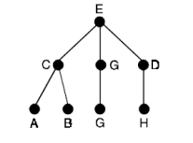

2.Solution：
Assuming that simple graph g exists。
Then deg（）=1
deg（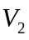）=3
deg（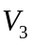）=3
deg（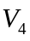）=4
deg（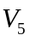）=5
deg（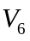）=6
deg（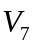）=6
Because deg（）=deg（）=6.
So and are adjacent to the other six vertices respectively。
Then 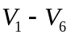 ,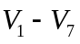
Then deg() 2 1

Therefore, there doesn’t exist a simple graph with seven vertices having degree (1,3,3,4,5,6,6).

