∑∑专业: 计算机[1191-1192]班,计算机[1193-1194]班  Major: 计算机[1191-1192]班,计算机[1193-1194]班 | 课程名称：Graph Theory and Modern Linear Algebra  Course Title: Graph Theory and Modern Linear Algebra | 学分：  Credits： 2.5 | 试卷编号 （A）  Paper Number (A)
课程编号： 1310700  Course Code :1310700 | 考试方式： 报告  Test Method: Final Report(Open-Book) | 考试时间：4  Exam Time 4 |  | 天  Days
拟卷人(签字)：  Designer Dr. Ammarah | 拟卷日期：  Design Date : 05/06/2020 | 审核人(签字)：  Reviewer
题号  Item Number | I | II | III | IV | V | VI | VII | 总 分  Total
得分
Score

得分统计表：
Question I:
Part (a)
Let IP, be the set of residue classes modulo p.
IP has p distinct elements.
IP={[0],[1],[2],…,[p-1]}.
Let[a],[b]∈Ip
[a] +[b]=[a+ b](Addition)
[a] [b]= [ab](Multiplication)
Since [a + b] and [ab] are both residue classes modulo p,Ip is closed with respect to addition and multiplication.
let [a],[b],[c] be any elements of Ip
Commutativity of Addition:[a]+[b]=[a+b]=[b+a]=[b]+[a].
Associativity of Addition:([a]+[b])+[c]=[a+b]+[c]=[(a+b)+c]=[a+(b+c)]=[a]+[b+c]=[a]+([b]+[c]).
[0]∈Ip .If[a]∈Ip ,[0]+[a]=[0+a]=[a].
Therefore [0] is the additive identity.
Let [a]∈Ip,then[-a]∈Ip.
[-a]+[a]=[-a+a]=[0].
[-a] is the additive inverse of [a].
Associativity of Multiplication:
([a][b])[c]=[ab][c]=[(ab)c]=[a(bc)]=[a][bc]=[a]([b][c]).
Commutativity of Multiplication:
[a][b]=[ab]=[ba]=[b][a].
Distributive Laws:
[a]([b]+[c])=[a][b+c]=[a(b+c)]=[ab+ac]=[ab]+[ac]=[a][b]+[a][c].
([b]+[c])[a]=[b][a]+[c][a].
Ip is a commutative ring.
it is a finite ring because it has p elements.
p is a prime number.
Let[a],[b]∈Ip, [a][b]=[0]=>[ab]=[0]=> p is a divisor of ab i.e.,p|ab
=>P|a or p|b
=>[a]=[0]or [b]= [0].
Ip is without zero divisors. Ip is an integral domain.Every finite integral domain is a field. Hence Ip is a field.
suppose that Ip is afield. Then Ip is an integral domain.Ip is without zero divisors.
Suppose p is not prime, but p is composite.
Let p= mn, where l<m<p,l<n<p.
[mn]=[p] =>[m][n] =[0]
[m] ≠[0],l<m<p [n] ≠0.
[m][n]=[0] while neither [m]=[0] nor [n]=[0], .
Ip possesses zero divisors and it is a contradiction.
Hence p is prime.
Part(b)
Let f :G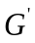be any function defined between two graphs degrees of the graphs G
and G＇ are as follows :
deg (G) deg ()
deg (a) = 3 deg (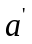) = 3
deg (b) = 2 deg () = 2
deg (c) = 3 deg () = 3
deg (d) = 5 deg (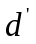) = 5
deg (e) = 1 deg () = 1
Each has 5-vertices, 6-edges and 1-circuit.
deg(a) = deg() = 3
deg(b) = deg() = 2
deg(c) = deg() = 3
deg(d) = deg() = 5
deg(e) = deg() = 1
Hence the correspondence is a – a＇, b – b＇, ....., e – e＇.
Therefore, the given two graphs G and G＇ are isomorphic.

Question II:
Part(a)
1: 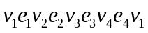
2: 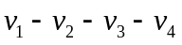
Part (b)
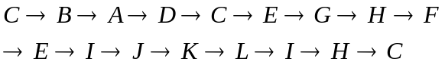
Question III:
Part (a)
Let S = (V_{S}, E_{S}) , there are eight nodes so the spanning tree will have seven arcs.
1. Since arcs AC, ED, and DH have minimum weight 2. so they don’t form a cycle, we select
all of them and E_{S}= {(A, C), (E, D), (D, H)} and E=E-{(A, C), (E, D), (D, H)}.
2. Next arcs with minimum weights 3 are AB, BC, and EG. So, we select EG.
Therefore, E_{S}={(A, C), (E, D), (D, H), (A, B), (E, G)}and E=E- {(A, B), (E, G)}
3. Next arcs with minimum weights 4 are EF and FG.
Therefore, E_{S}= {(A, C), (E, D), (D, H), (A, B),(E, G), (F, G)} and E=E- {(F, G)}.
4. Next arcs with minimum weights 5 are CE and CF.
Therefore, E_{S} ={(A, C), (E, D), (D, H),(A, B), (E, G), (F, G),(C, E)}and E=E- {(C, E)}.

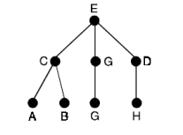
Part (b)
If it is right,
deg() 21
If two of the nodes have degree 6,6, then every other node has degree 22 or more.
So there is no.
Question IV:
Part(a)
H2=f(H1) is the image of H1underf;this is a subset of G2.
Letx,y∈H2.
Then x=f(a), y=f(b) for some a,b∈H1
Since, H1is a subgroup of G1, we have a * b-1 ∈ H1. Consequently,
x ⊕ y-1 = f(a) ⊕ [f(b)]-1 = f(a) ⊕ f(b-1) = f(a*b-1)∈f(H1)=H2
Hence, H2 is a subgroup of G2.
Since f : G1 → G2 is an isomorphism, f is a bijection.
∴ f–1:G2 →G1 exists and is a bijection.
Let x,y∈ G2. Then x⊕y∈G2
and there exists a,b∈G1 such that x=f(a) and y=f(b).
∴ f–1(x⊕y)=f–1(f(a)⊕f(b)) =f–1(f (a*b)) =a*b= f–1(x)*f–1(y)
This shows that f –1 : G2 → G1 is an homomorphism as well.
∴ f –1 is an isomorphism.

Part (b)
Let A = set of all positive rational numbers.
Let a,b,c be any three elements of A.
1. Closure property: We know that, Product of two positive rational numbers is again a rational number.
i.e., a *b ∈ A for all a,b ∈ A .
2. Associativity: (a*b)*c = (ab/2) * c = (abc) / 4
a*(b*c) = a * (bc/2) = (abc) / 4 3. Identity : Let e be the identity element.
We have a*e = (a e)/2 ...(1) , By the definition of *
again, a*e = a .....(2) , Since e is the identity. From(1)and(2), (ae)/2=a ⇒e=2 and2∈A.
∴ Identity element exists, and ‘2’ is the identity element in A.

Question V:
Part (a)
If x is any real number, positive,then 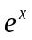is always a positive real number.
and is unique.
And if 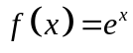，then 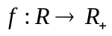.
f is one-to-one. Let 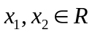. Then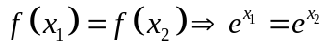
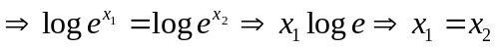
When they are equal,two elements in R have the same f-image in R₊
distinct elements in R have distinct f-images in R₊ . Therefore f is one-to-one.
f is onto. Suppose y is any element of R₊ i.e.,y is any positive real number.
Then logy is a real number i.e.,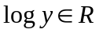.
Now 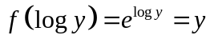. Thus 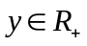that 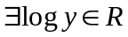such that 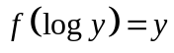.
Therefore each element of R₊ . is the f-image of some element of R. Thus f is onto.
f preserves compositions in R and R₊ .
Suppose X₁ and X₂ are any two elements of R.
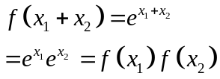
Here the composition in R is additionand the composition in R₊ is multiplication.
So,f is an isomorphism of R onto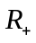.
Hence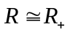.

Part(b)
Let 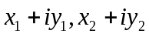be any two elements of C.
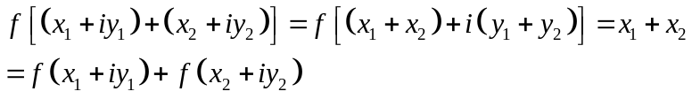
if x is any real number, ther is a complex number x+i0
f is a homomorphism of C onto R.
The identity of R is the real number zero. Therefore, the core of f is composed of all complex numbers, and the actual part is zero.

Question VI:
Part (a)
we see that C is closed with the two compositions since a+c,b+d,ac-bd,bc+ad are all real numbers.Now let (a,b),(c,d),(e,f) be any elements of C.
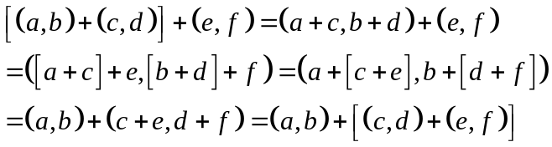
Commvfalivity of addition:we have
Existence of additive identity:we have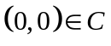
Also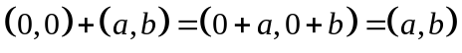
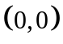 is the additive identity.
Existence of additive inverse:If 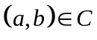,then 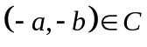,we have
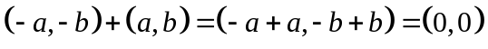
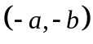is the additive inverse of 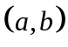.
Associalivity of mulliplication: we have
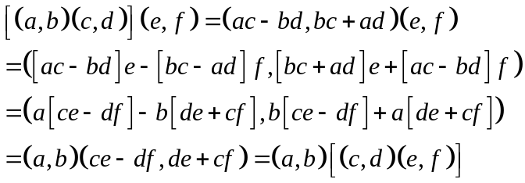
Distributive laws:
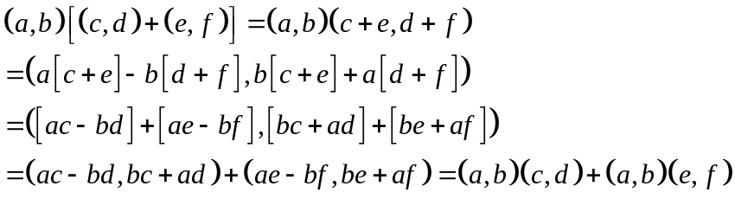
the other distributive law also nolds good.
C is a ring with respect to the two compoitions.
The ordered pairis the zero element of the ring.
Commufativity of mulliplication:
Existence of mulliplicative identity: we have 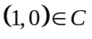.If
Therefore,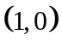 is the unity element of the ring.
Existence of mulliplicative inverse of each non-zero element of C:let (a,b) beany non-zero element of C.Then a and b are not both simutoneously zero.If (c,d) is the mulliplicalive inverse of (a,b),then we should have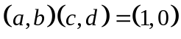 or 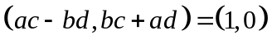
By the definilion of the equality of two ordered pairs,
we have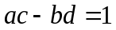and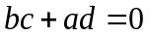.
Solving these equalions for c,d,
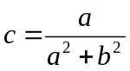,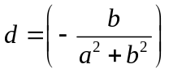.
Now,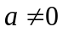or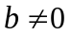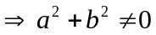
Therefore,either c or d or both are non-zero real numbers.
Then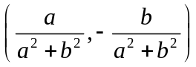is the mulliplicalive inverse of (a,b).
Hece C is a field.
Part (b)
X₇ 1 2 3 4 5 6
- 1 2 3 4 5 6
- 2 4 6 1 3 5
- 3 6 2 5 1 4
- 4 1 5 2 6 3
- 5 3 1 6 4 2
- 6 5 4 3 2 1
The composition 'X7' is associative. If a,b,c are any three elements of G, then
a X7 (b X7 c)=a X7 (bc)
= least non-negative remainder when a (bc) is divided by 7
= least non-negative remainder when (ab)c is divided by 7
= (ab) X7 c=(a X7 b) c
Existence of Identity:
1∈G. If d is any element of G, 1 X7 a=a=a X7 l.
1 is the identity element.
Existence of Inverse:
the inverses of l,2,3,4,5, 6 are l,4,5, 2, 3, 6
The composition is commutative as the corresponding rows and columns in the
composition table are identical.
The set G has 6 elements.
Hence (G, X7)is a finite
abelian group of order 6.

Question VII:

Part(a)
No
the distributive laws do not hold.

Part (b)
If it is a skew field but not a field, It must meet 2 requirements.
- It is a unitary ring and all elements except 0 are units
- Not satisfied with mulitplicative commutativity
The matrix that fits these two points is what we want to find。

Part (c)
Suppose the graph with 6 vertices has e number of edges.
Therefore by Handshaking lemma
∑deg(vi)= 2e (i=1,2,3,4,5,6)=>d(V1)+d(V2) + d(V3) +d(V4) + d(V5) +d(V6)= 2e
let 2 vertices are of degree 4 and 4 vertices are of degree 2.
Hence the above equation,
(4+4)+(2+2+2+2)= 2e
16= 2e
e= 8.
Hence the number of edges in a graph with 6 vertices is 8.
