- solution:
- 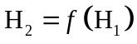 is the image of 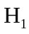 under f,this is a subset of 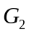.Let 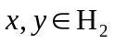,then x=f(a),y=f(b) for some 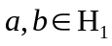
Since is a sub group of 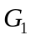,we have 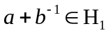
Consequently
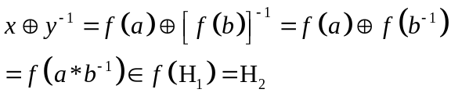
Hence 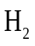 is a sub group of
- Since f: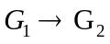 is an isomorphism,f is a bijection.
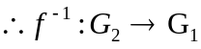,exists and is a bijection
Let 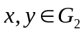,then 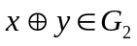
and there exists 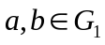 such that x=f(a) and y=f(b)
This shows that 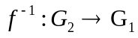 is an homomorphism as well
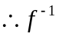 is an isomorphism.
2.Solution: Let A = set of all positive rational numbers.
Let a,b,c be any three elements of A.
1. Closure property: We know that, Product of two positive rational
numbers is again a rational number.
i.e., a *b ∈ A for all a,b ∈ A .
2. Associativity: (a*b)*c = (ab/2) * c = (abc) / 4
a*(b*c) = a * (bc/2) = (abc) / 4
3. Identity : Let e be the identity element.
We have a*e = (a e)/2 …(1) , By the definition of *
again, a*e = a …..(2) , Since e is the identity.
From (1)and (2), (a e)/2 = a ⇒ e = 2 and 2 ∈ A .
∴ Identity element exists, and ‘2’ is the identity element in A.
4. Inverse: Let a ∈ A
let us suppose b is inverse of a.
Now, a * b = (a b)/2 ….(1) (By definition of inverse.)
Again, a * b = e = 2 …..(2) (By definition of inverse)
From (1) and (2), it follows that
(a b)/2 = 2
⇒ b = (4 / a) ∈ A
∴ (A ,*) is a group.
Commutativity: a * b = (ab/2) = (ba/2) = b * a
Hence, (A,*) is an abelian group

