1.Solution:
first, let us show that f is a homomorphism.
Let a , b  R .
Now, f(a+b) = 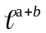
=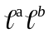
=f(a) f(b)
f is an homomorphism.
Next, let us prove that f is a Bijection.
For any a , b R, Let, f(a) = f(b)
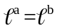
a=b
f is one.to-one.
Next, take any cR+.
Then ln c R and f (ln c) = 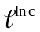 =c
 Every element in R+ has a pre image in R.i.e., f is onto.
f is a bijection.
Hence, f is an isomorphism.
- Solution. Let 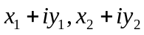be any two elements of C. Then
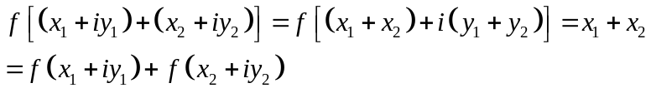
Also if x is any real number, then there exists a complex number 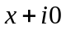 such that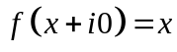
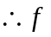is a homomorphism of C onto R.
The identity of R is the real number zero. Therefore the kernel of f consists of all complex numbers whose real part is zero.
If x is any real number, positive, zero or negative, then 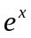is always a positive real number. Also is unique. Therefore if 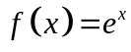，then 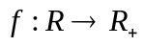.
f is one-to-one. Let 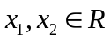. Then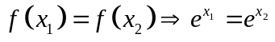
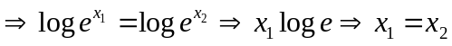
Thus two elements in R have the same f-image in 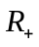 only if they are equal.
Consequently distinct elements in R have distinct f-images in. Therefore f is one-to-one.
f is onto. Suppose y is any element of i.e.,y is any positive real number.
Then logy is a real number i.e.,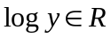.
Now 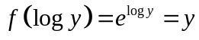. Thus 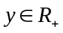that such that 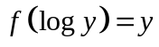.
Therefore each element of . is the f-image of some element of R. Thus f is onto.
f preserves compositions in R and . Suppose  and  are any two elements
of R. Then
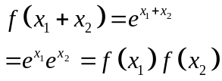
Thus f preserves compositions in R and Here the composition in R is addition
and the composition in is multiplication. Therefore f is an isomorphism of R onto. Hence

