1.Solution:we see that C is closed with the two compositions since a+c,b+d,ac-bd,bc+ad are all real numbers.Now let (a,b),(c,d),(e,f) be any elements of C.Then we make the following observations:
Associalivity of addition:we have
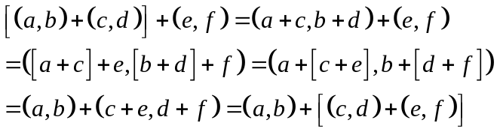
Commvfalivity of addition:we have
Existence of additive identity:we have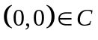
Also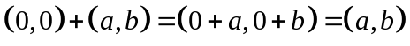
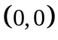 is the additive identity.
Existence of additive inverse:If 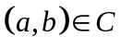,then 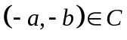,we have
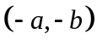is the additive inverse of 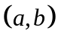.
Associalivity of mulliplication: we have
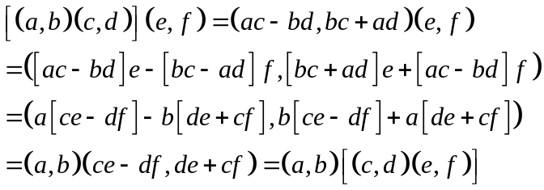
Distributive laws:we have
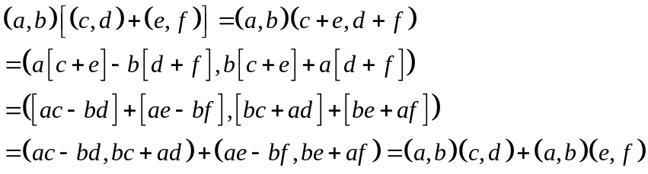
Similenly,we can show that the other distributive law also nolds good.
Therefore,C is a ring with respect to the two compoitions.The ordered pairis the zero element of the ring.
Commufativity of mulliplication: we have
Existence of mulliplicative identity: we have 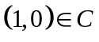.If，then
Therefore,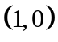 is the unity element of the ring.
Existence of mulliplicative inverse of each non-zero element of C:let (a,b) beany non-zero element of C.Then a and b are not both simutoneously zero.If (c,d) is the mulliplicalive inverse of (a,b),then we should have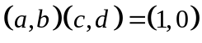 or 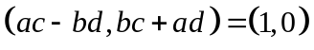
By the definilion of the equality of two ordered pairs,we have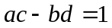and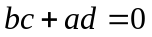.
Solving these equalions for c,d,we get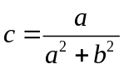,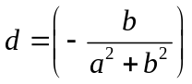.
Now,or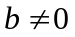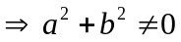.Therefore,either c or d or both are non-zero real numbers.Then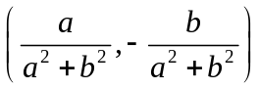is the mulliplicalive inverse of (a,b).Hece C is a field.
2.Solution: The composition table of G is
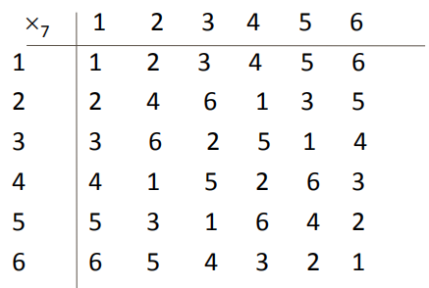
1. Closure property: Since all the entries of the composition table
are the elements of the given set, the set G is closed under 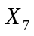 .
2. Associativity: The binary operation is associative in G.
for ex. (2 3) 4 = 6 4 = 3 and
2 ⋅7 ( 3 4 ) = 2 5 = 3
3. Identity : Here, The first row of the table coincides with the top
row. The element heading that row , i.e., 1 is the identity element.
4. . Inverse: From the composition table, we see that the inverse
elements of 1, 2, 3, 4, 5 ,6 are 1, 4, 5, 2, 5, 6 respectively.
5. Commutativity: The corresponding rows and columns of the table
are identical. Therefore the binary operation is commutative.
Hence, (G, ) is an abelian group.

