Using Trigonometry and p5.js to Make a Simple Game

1. Setup the canvas
   1. angleMode()
   2. rectMode()
2. Create variables for use later
   1. var soldierX
   2. var soldierY
   3. var soldierDir
   4. var goalX
   5. var goalY
   6. var triangleAngle
3. makeSoldier() function
   1. translate()
   2. rect()
   3. ellipse()
   4. *How much to talk about “rotate”?*
   5. Call in the draw() function
4. pointSoldier() function
   1. var xDist = soldierX - goalX;

var yDist = soldierY - goalY;

triangleAngle = Math.abs(atan(yDist / xDist));

* 1. 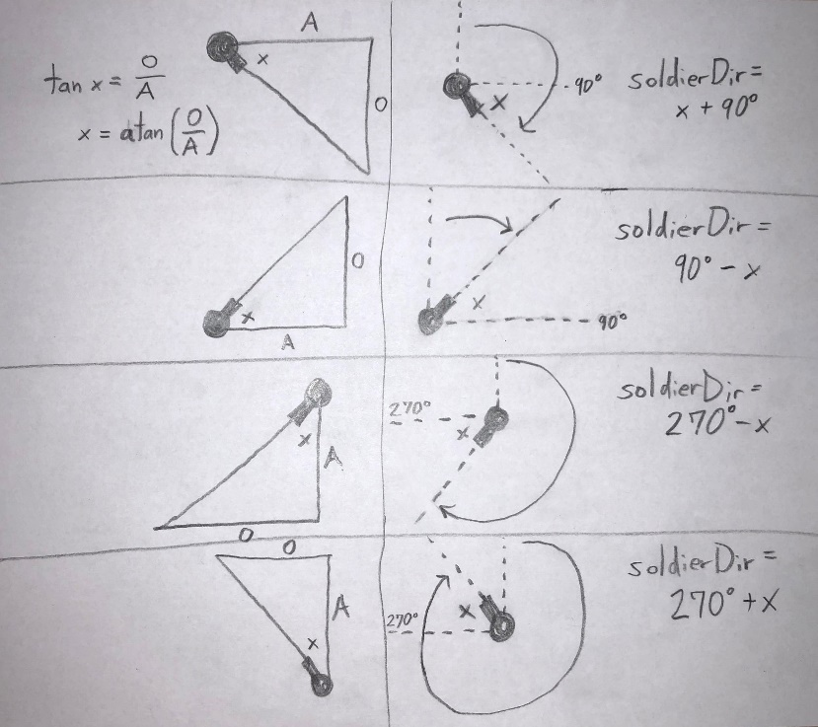
  2. Call in the draw() function
  3. mousePressed()

goalX = mouseX;

goalY = mouseY;

1. moveSoldier() function
   1. var singleYMovement = sin(triangleAngle);

var singleXMovement = cos(triangleAngle);

* 1. **NEED VISUAL**
  2. Call in the draw() function

1. Alien class
   1. constructor()
   2. showAlien()
   3. calcDistanceFromSoldier()
   4. Add “new Alien” loop to setup() function
      1. Use to populate alien array: alienList.push(anAlien);
   5. Call in the draw() function by looping through alienList array