PROJECT MANAGEMENT SAAS PLATFORM
Design & Brainstorming Document
Vision · Personas · Modules · ER Diagram · BRD · User Flows

Version 1.0 · Pre-development design phase · Confidential
Generated: 9 May 2026

1. Platform Vision
One unified workspace — for every team, every role. A project management platform where engineering, product, business, sales, and support teams collaborate without leaving the app. AI-native from day one: it plans your projects, creates tasks, takes meeting notes, and keeps your roadmap in sync with reality.

1.1 Core Principles
Principle | Description
AI-first | AI plans, creates, and adapts. Not a chatbot bolted on — it is the core engine driving planning, estimation, and continuous project adaptation.
Context-aware | Meetings feed tasks. Tickets link to commits. Everything stays connected automatically without manual sync between tools.
Role-adaptive | Same platform, different views — devs see Kanban and GitHub, sales see pipelines, managers see roadmaps.

1.2 Target Personas
Persona | Primary needs and vocabulary
Developer | Code-linked tickets, CI/CD visibility, sprint planning, GitHub/GitLab integration, branch-to-task linking, PR status on task cards.
Product Manager | Roadmaps, epics, AI feature planning, stakeholder views, sprint velocity, milestone tracking, cross-team coordination.
Business / Operations | Team capacity, project health dashboards, org-level reporting, cross-project resource management, scheduled report delivery.
Support / Sales | Customer-linked tickets, pipeline tasks, escalation flows, CRM integration, SLA tracking, onboarding project automation.

1.3 Key Differentiators vs Existing Tools
Differentiator | Why it matters
AI that acts, not just suggests | Creates the full project structure from a plain-language description and keeps it updated as work evolves. Unlike Jira AI or Monday automations.
Meetings → tasks automatically | No more Zoom + Notion + Jira context switching. Meetings live inside the platform. AI closes the loop between discussion and delivery.
Environment-aware integrations | The platform understands which environment (dev/sales/support) a project belongs to and surfaces the right integrations.
Org-level, not just team-level | Cross-project roadmaps and org analytics are first-class features, not enterprise add-ons.

2. Core Modules Overview
The platform is organised into six core modules. Each module is independently deep-dived in subsequent sections.

Module | Primary persona | Core responsibility
1 — Org & team management | Org Owner, Admin | Entity hierarchy, two-tier role system, member lifecycle, SSO, audit log.
2 — Project management core | PM, Team Lead, Contributors | Task hierarchy, 8 views, sprint lifecycle, workflow statuses, custom fields.
3 — AI planning & assistance | PM, AI system | Project generation, clarification dialogue, effort estimation, 12 AI capabilities.
4 — Communications & meetings | All roles | Chat channels, built-in WebRTC video, AI transcription, task reflection review.
5 — Integrations & adapters | PM, Dev team lead | 4 environment adapters, sync engine, automation builder, public REST API.
6 — Analytics & reporting | Org Admin, PM | 12 metrics, 4 dashboard scopes, 6 report types, AI insights, forecasting.

3. Module Deep Dives

3.1 Org & Team Management

3.1.1 Entity Hierarchy & Data Scoping
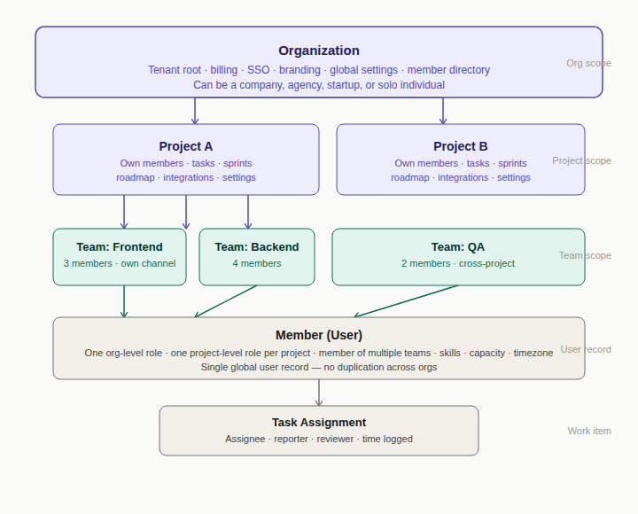
Figure 1 — Organization → Project → Team → Member hierarchy with data scoping
Entity | Description and scope
Organization | Top-level tenant. Owns billing, SSO, branding, global settings, and the member directory.
Project | Belongs to one org. Has its own members, tasks, sprints, roadmap, integrations, and environment type.
Team | Logical grouping of members inside a project. A member can belong to multiple teams. Auto-creates a team channel.
Member (User) | Has one org-level role and one project-level role per project. Single global user record — no duplication across orgs.

3.1.2 Two-Tier Role System

Org-level permissions
Permission | Owner | Admin | Member | Guest
Manage billing & plan | Yes | No | No | No
Delete organization | Yes | No | No | No
Configure SSO / SAML | Yes | Yes | No | No
Create / archive projects | Yes | Yes | No | No
Invite org members | Yes | Yes | No | No
View org member directory | Yes | Yes | Yes | No
View all projects in org | Yes | Yes | If added | No
Set org branding & defaults | Yes | Yes | No | No
View audit log | Yes | Yes | No | No

Project-level permissions
Permission | PM | Team Lead | Contributor | Viewer
Edit project settings | Yes | No | No | No
Manage integrations | Yes | No | No | No
Invite members to project | Yes | Own team | No | No
Create / close sprints | Yes | Yes | No | No
Create / edit epics | Yes | Yes | No | No
Create tasks | Yes | Yes | Yes | No
Edit any task | Yes | Team tasks | Assigned only | No
Approve AI suggestions | Yes | Yes | No | No
View all project data | Yes | Yes | Yes | Yes
Export reports | Yes | Yes | No | No

3.1.3 Member Lifecycle
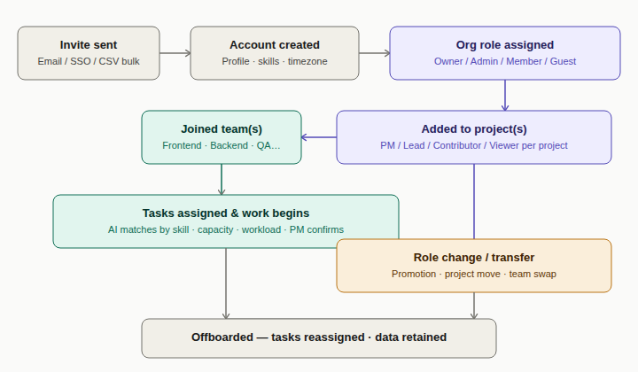
Figure 2 — Member lifecycle from invite to offboarding

3.2 Project Management Core

3.2.1 Task Hierarchy
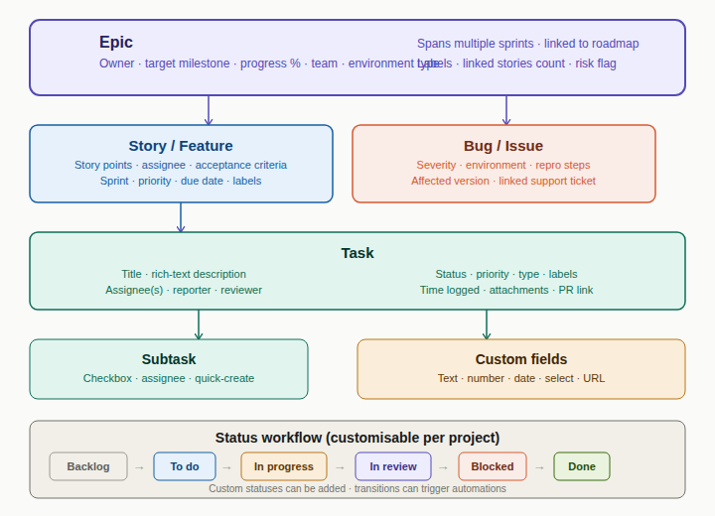
Figure 3 — Epic → Story → Task → Subtask hierarchy with status workflow
Type | Key fields and description
Epic | Owner · target milestone · progress % · team · environment type · risk flag. Spans multiple sprints. Linked to roadmap.
Story / Feature | Story points · assignee · acceptance criteria · sprint · priority · due date · labels · epic link.
Task | Title · rich-text description · assignee(s) · reporter · reviewer · status · priority · time logged · attachments · PR link · custom fields.
Subtask | Checkbox · assignee · quick-create. Contributes to parent task completion %.
Bug / Issue | Extra fields: severity · environment · repro steps · affected version · linked support ticket.

3.2.2 Sprint Lifecycle
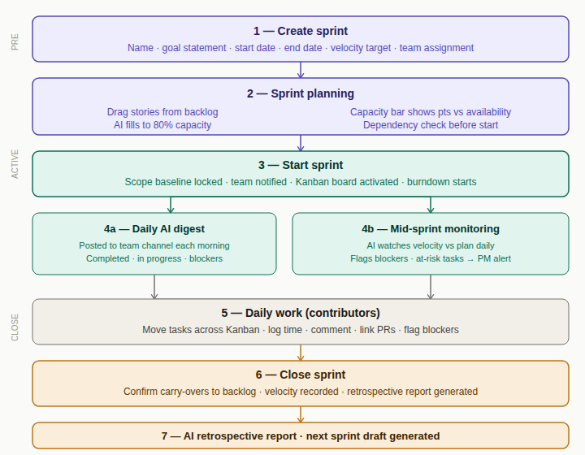
Figure 4 — Full sprint lifecycle from creation through retrospective
Stage | Detail
1 — Create sprint | Name, goal statement, start date, end date, team assignment, velocity target.
2 — Sprint planning | Drag stories from backlog. Capacity bar updates live. AI fills to 80% capacity on request. Dependency check.
3 — Start sprint | Scope baseline locked. Kanban board activated. Burndown starts. All team members notified.
4a — Daily AI digest | Posted to team channel each morning: completed yesterday, in progress today, current blockers.
4b — Mid-sprint monitoring | Velocity vs plan tracked daily. Risk alert surfaces if milestone becomes at risk.
5 — Daily work | Contributors move tasks, log time, comment, link PRs, flag blockers.
6 — Close sprint | Incomplete items confirmed and moved to backlog. Velocity recorded. Sprint report generated.
7 — AI retrospective | Delivered vs planned, blocker log, velocity trend, improvement suggestions, next sprint draft.

3.2.3 The 8 Project Views
View | Purpose and key features
Kanban board | Drag-drop cards across status columns. Swimlanes by assignee, epic, or priority. WIP limits per column.
Sprint board | Active sprint tasks only. Sprint goal banner. Inline burndown chart. Days remaining countdown.
Roadmap / timeline | Gantt-style. Epics on time axis. Milestones as diamonds. Dependency arrows. Shareable read-only link.
Backlog | Prioritised flat list. Drag to sprint. AI prioritisation suggestions. Estimation (planning poker) mode.
List view | Spreadsheet-style. All fields sortable/filterable. Inline editing. Bulk edit. CSV export.
Calendar | Tasks on due date. Sprint bands as background. Milestone markers. Drag to reschedule. iCal export.
My work | Personal task hub across all projects. Due today / this week / overdue. AI daily priority suggestion.
Dashboard | Configurable widget canvas. Sprint burndown, velocity, epic progress, workload heatmap, AI health score.

3.3 AI Planning & Assistance

3.3.1 AI Planning Flow — 5 Stages
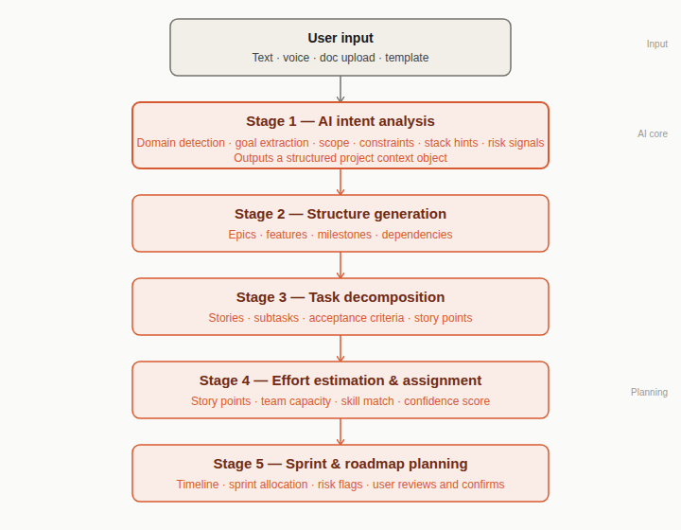
Figure 5 — AI planning master flow: input → intent analysis → structure → decomposition → sprint plan
Stage | What the AI does
1 — Intent analysis | Detects domain, extracts goals and features, infers tech stack hints, identifies risk signals. Outputs a structured project context object.
2 — Structure generation | Produces epics, features, milestones, and dependency relationships from the structured context.
3 — Task decomposition | Breaks epics into stories and tasks with acceptance criteria, priority, and story point suggestions.
4 — Effort estimation & assignment | Story points with confidence scores. Team capacity matching. Skill-based assignment suggestions.
5 — Sprint & roadmap planning | Allocates tasks to sprints, builds timeline, flags risks. User reviews and confirms before any write.

3.3.2 Continuous Adaptation Loop
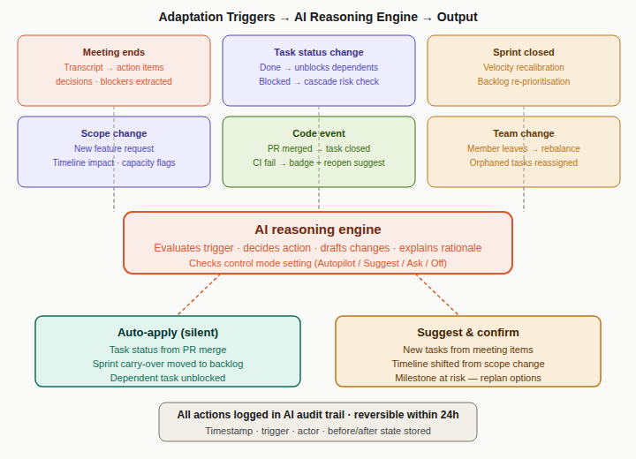
Figure 6 — AI adaptation: 6 triggers → reasoning engine → auto-apply or suggest-and-confirm
Trigger | AI action and default control mode
Meeting ends (Suggest) | Extracts action items with owners and due dates. Maps each to existing or new task. User reviews suggestion cards.
Task → Done (Auto) | Unblocks dependents, updates epic progress, checks if sprint goal is now met.
Task → Blocked (Auto) | Flags in sprint view, notifies PM and Team Lead, checks cascade risk on dependents.
Sprint closed (Suggest) | Records velocity, moves carry-overs, generates retrospective report, drafts next sprint.
New feature request (Ask) | Generates epic + story breakdown, shows timeline impact, flags capacity conflicts.
PR merged (Auto) | Auto-closes linked task(s), stores commit SHA, triggers deploy status watch.
Velocity drops 20%+ (Ask) | Reforecasts milestone dates, suggests 3 replan options with impact of each.
Member leaves / OOO (Ask) | Detects unassigned tasks, suggests reassignment candidates ranked by skill + capacity.

3.3.3 Effort Estimation Engine
Signal | Weight and description
Task description complexity | High — NLP analysis of description length, technical terms, and acceptance criteria count.
Similar past tasks | High — Semantically similar completed tasks in the org used as a calibration baseline.
Epic / feature context | Medium — Parent epic tasks used as consistency anchors for the estimate.
Team velocity history | Medium — Calibrates the scale based on this team's throughput per sprint.
Risk signals detected | Medium — Third-party dependencies or "research needed" language add a complexity buffer.
Assignee performance history | Low — Used only for assignment suggestions, never shown publicly.

3.3.4 Human-AI Control Modes
Mode | Behaviour
Autopilot | AI applies low-impact changes silently. Full audit log maintained.
Suggest mode (default) | AI drafts changes and shows a review card. User accepts, edits, or dismisses.
Ask me first | AI shows a suggestion and waits for explicit approval before any write action.
AI off | Full manual mode. No suggestions or automations. Re-enabled per project at any time.

3.4 Communications & Meetings

3.4.1 Chat Architecture
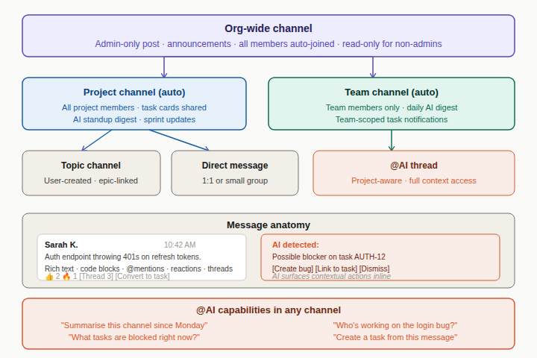
Figure 7 — Channel hierarchy: org-wide → project → team → topic/DM, with AI integration points
Channel type | Description
Org-wide | Admin-only post. All members auto-joined. Read-only for non-admins.
Project channel (auto-created) | All project members auto-joined. Task cards shareable. AI standup digest posted here.
Team channel (auto-created) | Scoped to team members. Daily AI digest each morning. Team-scoped notifications.
Topic channel | User-created for specific discussions. Linked to an epic. Auto-archived after 30 days inactivity.
Direct message | 1:1 or small group (up to 8). Cross-project. File sharing, task card sharing, reactions, threads.

3.4.2 Meeting Lifecycle
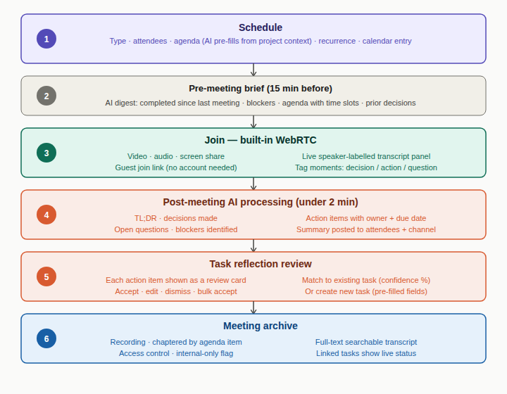
Figure 8 — Meeting lifecycle: schedule → pre-brief → WebRTC → AI summary → task reflection → archive
Stage | Detail
1 — Schedule | Type, attendees, agenda (AI pre-fills from project context), recurrence, calendar entry.
2 — Pre-meeting brief (15 min before) | AI digest: completed since last meeting, blockers, agenda with time slots, prior decisions.
3 — Join (built-in WebRTC) | Video, audio, screen share. Live speaker-labelled transcript in side panel. Guest join link (no account needed).
4 — Post-meeting AI processing | TL;DR, decisions, action items with owner and due date, open questions, blockers. Generated within 2 min.
5 — Task reflection review | Each action item shown as a card: match to existing task or create new. Accept / edit / dismiss / bulk accept.
6 — Meeting archive | Recording stored and chaptered. Full-text searchable transcript. Access control per meeting.

3.5 Integrations & Environment Adapters

3.5.1 Adapter Architecture
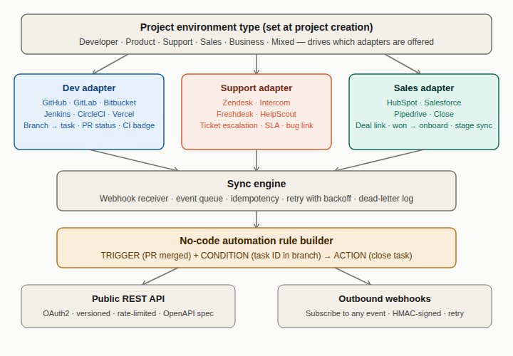
Figure 9 — Environment adapter architecture: project type → adapters → sync engine → automation → API
Environment | Adapters and behaviour
Developer | GitHub, GitLab, Bitbucket, Jenkins, CircleCI, Vercel. Branch → task link. PR status on card. CI badge. Merge auto-closes task.
Support | Zendesk, Intercom, Freshdesk, HelpScout. Ticket escalation → bug task. SLA timer on card. Resolving task optionally closes ticket.
Sales | HubSpot, Salesforce, Pipedrive, Close. Deal → project link. Won deal → onboarding template. Stage change → project status.
Business | Slack, Google Drive, MS Teams, Notion, Looker. Task status → Slack post. Doc links on tasks. Reports → Sheets / BI tools.

3.5.2 Sync Event Map
External event → internal action | Notifies
Branch created: task ID parsed, task linked, "In development" badge added. | Assignee, Team Lead
PR opened: task → In review. PR stats on card. Reviewer notified via task comment. | Assignee, reviewer
PR merged: linked task auto-closed. Commit SHA stored. Deploy watch triggered. | PM, Team Lead
CI build fails: badge on task. Failure log as task comment. Optionally reopens task. | Assignee, Team Lead
Support ticket escalated: bug task created pre-filled (title, severity, repro, customer ID). | Dev Team Lead, PM
CRM deal won: onboarding project template instantiated. Client added as Guest. | PM, account owner
Task → Done (outbound): posts to Slack, updates CRM stage, closes support ticket if rules configured. | Configured targets

3.6 Analytics & Reporting

3.6.1 Metrics Taxonomy
Metric | Scope | How computed | Update freq
Sprint velocity | Team, Project | Story points completed at sprint close. Rolling 5-sprint average. | Sprint close
Burndown | Sprint | Remaining points per day vs ideal linear burn. | Real-time
Cycle time | Task, Project | First In progress to close date. Average across tasks. | On close
Lead time | Task | Creation date to close. Includes backlog wait. | On close
On-time delivery | Project, Org | % tasks closed on or before due date. | Daily
Team capacity used | Team, Sprint | Story points assigned ÷ declared capacity × 100. | Real-time
Bug escape rate | Project, Release | Production bugs ÷ bugs fixed in release × 100. | Per release
Estimation accuracy | Team, Member | |Estimated − Actual| ÷ Estimated × 100. | Sprint close
Epic progress | Epic | Closed story points ÷ total story points × 100. | Real-time
Project health score | Project | AI-computed composite: 0–100. Red/amber/green. | Daily
Blocked time | Task, Team | Hours in Blocked status per task. Aggregated per team. | Daily
Meeting ROI | Project | Action items per meeting ÷ duration. Tasks completed from meetings. | Per meeting

3.6.2 Dashboard Scopes
Dashboard | Audience and widgets
Org portfolio | Org Owner and Admin. Health score per project, cross-project resource map, org velocity trend, milestone risk matrix, top org-wide blockers.
Project dashboard | PM and Team Lead. Sprint burndown, velocity chart (6 sprints), epic progress bars, open bugs, team workload heatmap, milestone countdown.
Team dashboard | Team Lead. Capacity utilisation, individual workload cards, cycle time per member, blocked task list, throughput trend, estimation accuracy.
Personal dashboard | All contributors. My tasks by project, due today/this week/overdue, time logged, tasks I am blocking, AI priority suggestion.

3.6.3 AI Insight Engine — Examples
Trigger | Example plain-English AI insight
Velocity drop | Sprint 7 velocity dropped to 28 pts from a 5-sprint average of 41. The auth refactor was re-estimated mid-sprint from 5 to 13 pts — consider splitting stories above 8 pts before sprint start.
Milestone at risk | At current velocity, the Client Portal epic will complete around April 3 — 11 days after the March 23 milestone. 3 options: cut CSV export story (saves 8 pts), add one developer, or shift the date.
Estimation drift | James L.'s tasks have run 40% over estimate for the last 3 sprints on integration tasks — consider bumping those tasks by 1 size next sprint.
Capacity imbalance | Reem A. is at 140% capacity this sprint while Tariq M. is at 55%. Suggest moving the Password reset flow story (5 pts) from Reem to Tariq — similar task type, Tariq has done it before.

4. Entity Relationship Diagram
The data model is organised into four schema clusters. Total: 35 entities across 4 clusters.

4.1 Cluster 1 — Org & Access (7 entities)
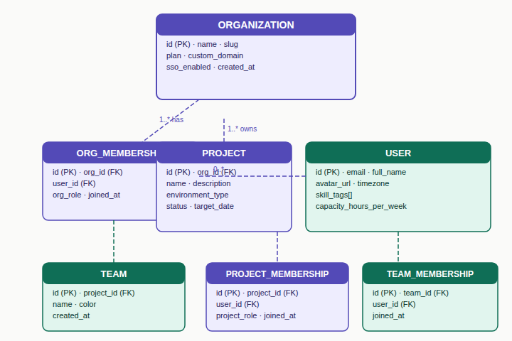
Figure 10 — ER Cluster 1: Organization, User, Memberships, Project, Team
Entity | Key fields | Notes
ORGANIZATION | id · name · slug · plan · sso_enabled | Top-level tenant. All data scoped within org.
USER | id · email · full_name · timezone · skill_tags[] · capacity_hours_per_week | One global user record. Multiple org memberships.
ORG_MEMBERSHIP | id · org_id (FK) · user_id (FK) · org_role · joined_at | org_role: owner / admin / member / guest.
PROJECT | id · org_id (FK) · name · environment_type · status · target_date | environment_type drives integration adapter offering.
PROJECT_MEMBERSHIP | id · project_id (FK) · user_id (FK) · project_role | Project role independent of org role.
TEAM | id · project_id (FK) · name · color · created_at | Auto-creates team channel on creation.
TEAM_MEMBERSHIP | id · team_id (FK) · user_id (FK) · joined_at | Members can belong to multiple teams.

4.2 Cluster 2 — Work Items (11 entities)
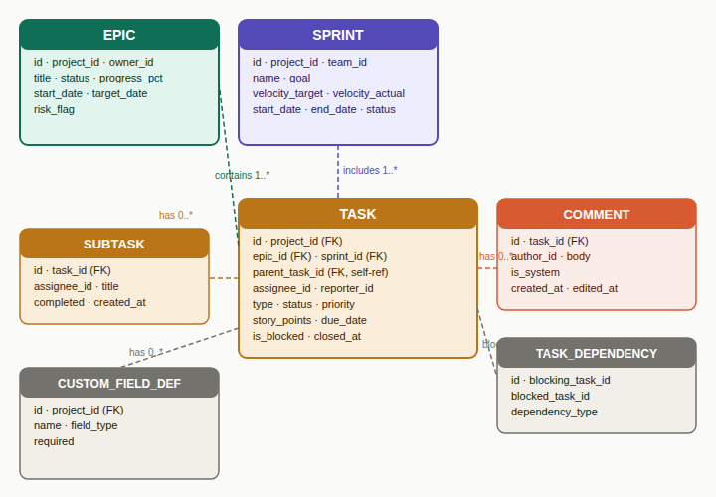
Figure 11 — ER Cluster 2: Epic, Sprint, Task, Subtask, Dependencies, Comments, Custom Fields
Entity | Key fields | Notes
EPIC | id · project_id · owner_id · progress_pct · risk_flag · target_date | progress_pct computed from child task story points.
SPRINT | id · project_id · team_id · goal · velocity_target · velocity_actual · status | velocity_actual recorded at sprint close.
TASK | id · project_id · epic_id · sprint_id · parent_task_id (self-ref) · type · status · story_points · is_blocked | Self-referencing parent_task_id handles the full hierarchy.
SUBTASK | id · task_id · assignee_id · title · completed | Lightweight checkbox item.
LABEL | id · project_id · name · color_hex | Project-scoped labels.
TASK_LABEL | task_id (FK) · label_id (FK) | Many-to-many join.
TASK_DEPENDENCY | id · blocking_task_id · blocked_task_id · dependency_type | dependency_type: blocks / relates-to / duplicates.
COMMENT | id · task_id · author_id · body · is_system · created_at | is_system = true for AI and integration comments.
ATTACHMENT | id · task_id · uploaded_by · filename · storage_url · size_bytes | Files in managed object storage (S3-compatible).
CUSTOM_FIELD_DEF | id · project_id · name · field_type · required | field_type: text / number / date / select / URL.
CUSTOM_FIELD_VALUE | id · field_def_id (FK) · task_id (FK) · value | Flexible per-project task fields without schema migrations.

4.3 Cluster 3 — Communications & Meetings (10 entities)
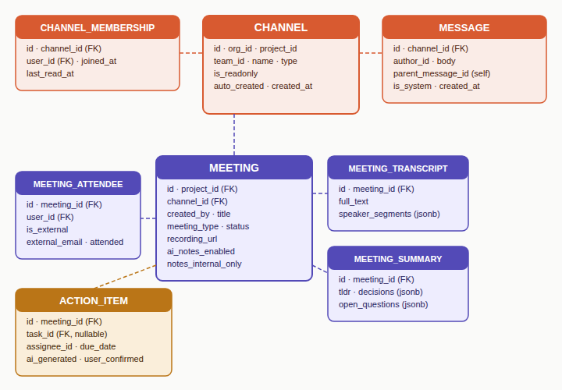
Figure 12 — ER Cluster 3: Channel, Message, Meeting, Transcript, Summary, Action Item
Entity | Key fields | Notes
CHANNEL | id · org_id · project_id · team_id · name · type · is_readonly · auto_created | type: org / project / team / topic / dm.
CHANNEL_MEMBERSHIP | id · channel_id · user_id · joined_at · last_read_at | last_read_at drives unread badge.
MESSAGE | id · channel_id · author_id · parent_message_id (self) · body · is_system | Self-referencing parent_message_id for threads.
MESSAGE_REACTION | id · message_id · user_id · emoji · created_at | Standard emoji reactions.
MESSAGE_TASK_LINK | message_id (FK) · task_id (FK) · linked_at | Created when user converts message to task.
MEETING | id · project_id · channel_id · created_by · meeting_type · status · recording_url · ai_notes_enabled · notes_internal_only | notes_internal_only hides transcript from external guests.
MEETING_ATTENDEE | id · meeting_id · user_id · is_external · external_email · attended | is_external tracks guests without platform accounts.
MEETING_TRANSCRIPT | id · meeting_id · full_text · speaker_segments (jsonb) | speaker_segments: [{speaker, start_ms, end_ms, text}].
MEETING_SUMMARY | id · meeting_id · tldr · decisions (jsonb) · open_questions (jsonb) · blockers_mentioned (jsonb) | Generated within 2 min of meeting end.
ACTION_ITEM | id · meeting_id · task_id (nullable FK) · assignee_id · due_date · ai_generated · user_confirmed | task_id nullable — confirmed when user accepts the card.

4.4 Cluster 4 — AI, Integrations & Analytics (9 entities)
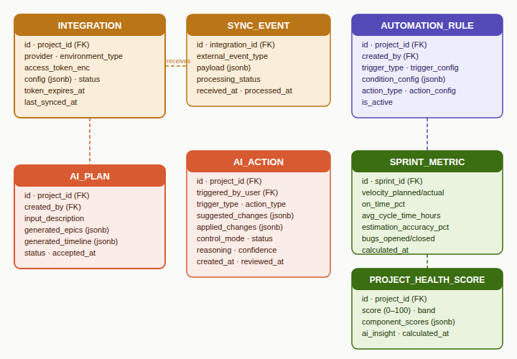
Figure 13 — ER Cluster 4: Integration, Sync Event, AI Plan, AI Action, Automation, Metrics
Entity | Key fields | Notes
INTEGRATION | id · project_id · provider · access_token_enc · refresh_token_enc · config (jsonb) · status · last_synced_at | Tokens encrypted. status: active / degraded / disconnected.
SYNC_EVENT | id · integration_id · external_event_type · payload (jsonb) · processing_status · received_at | Dead-letter log for failed events.
TASK_INTEGRATION_LINK | id · task_id · integration_id · external_id · external_url · link_type | link_type: pr / branch / commit / ticket / deal.
AUTOMATION_RULE | id · project_id · trigger_type · trigger_config (jsonb) · condition_config (jsonb) · action_type · action_config (jsonb) · is_active | Trigger + Condition + Action no-code rule builder.
AUTOMATION_LOG | id · rule_id · triggered_by_event · outcome · changes_applied (jsonb) | Full log of every automation execution.
AI_ACTION | id · project_id · trigger_type · action_type · suggested_changes (jsonb) · applied_changes (jsonb) · control_mode · reasoning · confidence_score | Stores both suggested and applied changes for auditability.
AI_PLAN | id · project_id · created_by · input_description · clarification_qa (jsonb) · generated_epics (jsonb) · generated_timeline (jsonb) · status · accepted_at | status: draft / accepted / rejected.
SPRINT_METRIC | id · sprint_id · velocity_planned · velocity_actual · on_time_pct · avg_cycle_time_hours · estimation_accuracy_pct · bugs_opened · bugs_closed | Snapshot recorded at sprint close.
PROJECT_HEALTH_SCORE | id · project_id · score (0-100) · band · component_scores (jsonb) · ai_insight · calculated_at | Recalculated daily. ai_insight is plain-English observation.

4.5 Cross-Cluster Foreign Key References
From entity → FK field | References — relationship meaning
EPIC → project_id, owner_id | PROJECT, USER (C1) — epic belongs to a project, has a user owner.
SPRINT → project_id, team_id | PROJECT, TEAM (C1) — sprint scoped to project and team.
TASK → project_id, assignee_id, reporter_id | PROJECT, USER (C1) — task lives in project, assigned to and reported by users.
CHANNEL → org_id, project_id, team_id | ORGANIZATION, PROJECT, TEAM (C1) — channel scoped to org, project, or team.
MESSAGE_TASK_LINK → task_id | TASK (C2) — message linked to a work item.
MEETING → project_id, created_by | PROJECT, USER (C1) — meeting belongs to project, created by user.
ACTION_ITEM → task_id, assignee_id | TASK (C2), USER (C1) — action item maps to a task, assigned to a user.
INTEGRATION → project_id | PROJECT (C1) — integration configured per project.
TASK_INTEGRATION_LINK → task_id | TASK (C2) — links a task to an external resource (PR, ticket, deal).
AI_ACTION → project_id, triggered_by_user | PROJECT, USER (C1) — AI action logged against project and approving user.
AI_PLAN → project_id, created_by | PROJECT, USER (C1) — AI plan belongs to a project.
SPRINT_METRIC → sprint_id | SPRINT (C2) — metrics snapshot for a closed sprint.
PROJECT_HEALTH_SCORE → project_id | PROJECT (C1) — daily AI-computed health score per project.

5. Business Requirements Document (BRD)

5.1 Document Scope & Success Criteria
v1.0 — MVP for a closed beta with 3–5 design partner orgs. Target: developer-led product teams of 5–30 people. Excludes enterprise SSO, white-labelling, and public marketplace.
Success criteria: A PM can create a project via AI description, run a full sprint, hold a meeting with AI notes, and have action items reflected as tasks — without leaving the platform.

5.2 MoSCoW Priority Legend
Priority | Definition
Must have | Required for v1 launch. Without this the product cannot ship.
Should have | High value. Ship if capacity allows. Absence is painful but not fatal.
Could have | Nice to have. Goes to post-launch backlog if time is short.
Won't v1 | Explicitly deferred. Out of scope for v1. Named to remove ambiguity.

5.3 v1 Scope Summary
Priority bucket | Count
Must have | 37
Should have | 25
Could have | 13
Won't v1 | 6
Total requirements | 81

5.4 Module 1 — Org & Team Management
ID | Requirement | Priority | Acceptance criteria
ORG-01 | Create and configure an organization | Must | Org owner can set name, slug, and upload logo. Slug is unique and URL-safe.
ORG-02 | Invite members by email | Must | Invitation email sent with accept link. Expires after 7 days. Resendable.
ORG-03 | Assign and change org-level roles | Must | Owner, Admin, Member roles enforced. Only Owner can change another Owner's role.
ORG-04 | Create projects within org | Must | Admin+ can create projects with name, description, environment type, and start date.
ORG-05 | Assign project-level roles | Must | PM, Team Lead, Contributor, Viewer enforced per project independently of org role.
ORG-06 | Create teams within a project | Must | PM+ can create named teams. Members assignable to multiple teams. Auto-creates team channel.
ORG-07 | Member profile — skills and capacity | Should | Member can set skill tags and weekly capacity hours. Used by AI assignment engine.
ORG-08 | Bulk member import via CSV | Could | Admin uploads CSV with email, name, role. Invalid rows reported. Valid rows invited.
ORG-09 | SSO / SAML integration | Won't v1 | Out of scope. Planned for v1.5 enterprise tier.
ORG-10 | Custom org branding | Won't v1 | Out of scope. Logo upload only in v1.
ORG-11 | Offboard member — task reassignment | Should | When member removed, AI suggests reassignment for open tasks. PM confirms before applying.
ORG-12 | Org-level audit log | Should | All permission changes, member adds/removes, project creates logged with timestamp and actor.

5.5 Module 2 — Project Management Core
ID | Requirement | Priority | Acceptance criteria
PM-01 | Create and manage epics | Must | PM+ can create epics with title, owner, target date. Progress % auto-computed from child tasks.
PM-02 | Create tasks with full field set | Must | All core fields editable inline: title, description, assignee, status, priority, story points, due date, epic link.
PM-03 | Task hierarchy — subtasks | Must | Tasks can have unlimited subtasks. Subtask completion contributes to parent task %.
PM-04 | Task types — Story, Task, Bug | Must | Three distinct types with type-specific fields. Bug has severity, repro steps, affected version.
PM-05 | Kanban board view | Must | Drag-drop cards across columns. Columns map to workflow statuses. Quick-create from column.
PM-06 | Backlog view with drag-to-sprint | Must | Prioritised list. Filter by epic, label, type, assignee. Drag into active sprint panel.
PM-07 | Sprint creation and lifecycle | Must | Create sprint with goal, dates. Start locks scope. Close moves incomplete items to backlog.
PM-08 | Task dependency linking | Must | Tasks can be marked as blocking / blocked-by. Dependency shown on task and on roadmap.
PM-09 | Labels and custom tags | Must | PM can create project-level labels with colour. Multiple labels per task. Filterable in all views.
PM-10 | Custom workflow statuses | Should | PM can add custom statuses between defaults. Status transitions can trigger automation rules.
PM-11 | Roadmap / timeline view | Must | Epics on Gantt-style axis. Drag to reschedule. Dependency arrows. Month/quarter zoom.
PM-12 | List view with inline editing | Should | Spreadsheet-style. All fields as sortable columns. Bulk edit on multi-row select. CSV export.
PM-13 | Calendar view | Could | Tasks on due date. Sprint bands as background. Drag to reschedule due dates. iCal export.
PM-14 | My work personal dashboard | Must | Cross-project task list grouped by project and due status. Quick status updates inline.
PM-15 | Time logging on tasks | Should | Log time in hours/minutes against a task. Aggregate shown on task and in reports.
PM-16 | Custom fields per project | Could | PM can add text, number, date, or select custom fields. Stored per project schema.
PM-17 | Sprint board with burndown | Must | Active sprint view with inline burndown chart. Sprint goal banner. Days remaining counter.
PM-18 | File attachments on tasks | Should | Upload files up to 25 MB. Preview images inline. Stored in managed object storage.

5.6 Module 3 — AI Planning & Assistance
ID | Requirement | Priority | Acceptance criteria
AI-01 | Project generation from plain-language description | Must | User inputs a paragraph. AI generates epics, stories, sprint plan. User reviews before write.
AI-02 | Clarification dialogue before generation | Must | AI asks max 3 targeted questions. Skip option with "generate with assumptions".
AI-03 | Effort estimation on tasks | Must | AI suggests story points with confidence level. Shows brief reasoning. User can override.
AI-04 | Smart assignment suggestions | Should | Top 2 candidates per task ranked by skill match and capacity. Never auto-assigns.
AI-05 | Dependency detection | Should | AI detects implicit dependencies from task descriptions. Proposes links for confirmation.
AI-06 | Sprint filling suggestion | Should | Selects backlog items to fill sprint to ~80% capacity. Respects dependencies.
AI-07 | Risk detection and milestone alerts | Must | AI monitors velocity vs plan. Flags milestones at risk with 3 replan options.
AI-08 | Meeting transcript → action items | Must | After meeting, AI extracts action items. User reviews suggestion cards before tasks created.
AI-09 | Daily standup digest | Should | Each morning AI posts a digest: completed yesterday, in progress today, current blockers.
AI-10 | Sprint retrospective report | Should | At sprint close: velocity vs plan, blockers summary, improvement suggestions, next sprint draft.
AI-11 | Task description and acceptance criteria writer | Could | Given task title, AI drafts structured description and acceptance criteria. Fully editable.
AI-12 | Backlog health check | Could | Weekly digest surfacing duplicate stories, items too large, stale items 30d+ untouched.
AI-13 | Human-AI control mode settings | Must | Autopilot / Suggest / Ask me first / Off per project. Default: Suggest. Changeable by PM.
AI-14 | Full AI audit trail with reversal | Must | Every AI write action logged. Any AI action reversible within 24h from audit log.
AI-15 | Predictive completion forecasting | Could | AI forecasts epic/project completion date from velocity trend and remaining backlog.

5.7 Module 4 — Communications & Meetings
ID | Requirement | Priority | Acceptance criteria
CM-01 | Project and team channels (auto-created) | Must | New project auto-creates a general channel. New team auto-creates a team channel.
CM-02 | Rich text messaging with threading | Must | Messages support markdown, code blocks, file attach. Thread replies scoped to parent.
CM-03 | @mentions — members, tasks, channels | Must | @mention sends notification. Task mention renders as a live card showing current status.
CM-04 | Convert message to task | Must | One-click action creates a task pre-filled with message content.
CM-05 | Direct messages (1:1 and group) | Must | DMs between any org members. Group DMs up to 8 people. Cross-project.
CM-06 | User-created topic channels | Should | Any member can create a topic channel within a project. Auto-archived after 30d inactivity.
CM-07 | @AI in channels — project-aware queries | Should | @AI responds with full project context. Can answer questions, summarise, draft replies.
CM-08 | Built-in video meetings (WebRTC) | Must | Video, audio, screen share. Works in-browser. No plugin required. Up to 25 participants.
CM-09 | Guest join link (no account required) | Must | PM generates shareable meeting link. Guest joins via browser. Lobby / waiting room.
CM-10 | AI live transcription during meeting | Must | Real-time speaker-labelled transcript in side panel. Participants can tag moments.
CM-11 | AI post-meeting summary | Must | Summary within 2 min of meeting end: TL;DR, decisions, action items, open questions.
CM-12 | Task reflection — review UI | Must | Action items as cards: match existing task or create new. Accept/edit/dismiss/bulk accept.
CM-13 | Meeting recording and archive | Should | Recording stored and chaptered. Full-text searchable transcript. Access control per meeting.
CM-14 | Recurring meeting templates | Should | Templates for standup, sprint planning, retro, 1:1. AI pre-fills agenda from project context.
CM-15 | Breakout rooms | Won't v1 | Out of scope for v1. Planned for v1.5.
CM-16 | Notification preferences per user | Should | Notification rules per channel type. Do-not-disturb schedule. Digest mode.

5.8 Module 5 — Integrations
ID | Requirement | Priority | Acceptance criteria
INT-01 | GitHub integration — PR and commit linking | Must | OAuth connect. Branch parsed for task ID. PR status on card. Merge auto-closes task.
INT-02 | CI/CD build status on task | Should | CI badge on task. Build fail triggers notification. Works with GitHub Actions, CircleCI.
INT-03 | GitLab integration | Should | Same feature set as GitHub. OAuth connect. MR linked to task, status synced.
INT-04 | Zendesk integration — ticket escalation | Should | Support ticket escalatable to bug task. Pre-filled from ticket. Resolving bug optionally closes ticket.
INT-05 | HubSpot CRM integration | Could | Deal linked to project. Deal won triggers onboarding template. Stage change in project status.
INT-06 | Slack outbound notifications | Should | Task status changes and sprint updates posted to Slack channel. Configurable per project.
INT-07 | No-code automation rule builder | Should | Trigger + condition + action model. At least 10 built-in trigger types.
INT-08 | Public REST API | Must | All core resources exposed. OAuth2. Versioned. Rate-limited. OpenAPI spec published.
INT-09 | Outbound webhooks | Should | Subscribe to platform events. Filter by project and type. HMAC-signed. Retry with backoff.
INT-10 | Zapier / Make connector | Could | Official Zapier app with triggers and actions for tasks, projects, sprints.
INT-11 | Google Drive document linking | Could | Link Google Doc to task. Live preview. Changes notify task watchers.
INT-12 | Integration health monitoring | Must | Dashboard: status, last synced, error log per integration. PM alerted on token expiry.

5.9 Module 6 — Analytics & Reporting
ID | Requirement | Priority | Acceptance criteria
AN-01 | Sprint burndown chart | Must | Ideal vs actual remaining points per day. Real-time updates. Embedded in sprint board.
AN-02 | Velocity tracking across sprints | Must | Bar chart of completed story points per sprint. Rolling average line. Project dashboard.
AN-03 | Epic progress bars | Must | Progress % on every epic. From closed vs total story points. Visible on roadmap and dashboard.
AN-04 | Team workload heatmap | Should | Grid: members vs story points. Red = over capacity. Green = healthy. Amber = near limit.
AN-05 | Sprint report (auto-generated at close) | Must | Delivered vs planned, velocity, carry-overs, blockers log, AI retrospective summary.
AN-06 | Project health score | Should | AI-computed 0–100. Red/amber/green. Component breakdown on hover. Updated daily.
AN-07 | Cycle time and lead time metrics | Should | Average cycle time per task type and team. Trend over last 5 sprints.
AN-08 | AI natural-language insights | Should | Weekly AI insight card: plain-English observation with an actionable suggestion.
AN-09 | Org portfolio dashboard | Should | Org admin: health score per project, cross-project resource conflicts, org-wide velocity.
AN-10 | Custom report builder | Could | Drag-and-drop metric and dimension selector. Saved templates. Scheduled delivery.
AN-11 | Export reports (PDF and CSV) | Should | Any dashboard exportable. Export includes filter state and date range applied.
AN-12 | Predictive milestone forecasting | Could | AI forecasts milestone date from velocity. Updates weekly. Roadmap confidence band.
AN-13 | Meeting ROI metric | Won't v1 | Out of scope. Requires sufficient meeting history data to be meaningful.

5.10 Key Risks & Mitigations
Risk (severity) | Mitigation
HIGH — Built-in video is major infrastructure risk | Evaluate embedding Daily.co or LiveKit vs building raw WebRTC. Decision needed before any CM work starts. This gates the entire meetings module timeline.
HIGH — AI transcript quality determines meeting module value | Use a proven ASR provider (Deepgram, AssemblyAI, Whisper) via API. Speaker diarisation must handle 5+ speakers. Do not attempt to build ASR from scratch.
MEDIUM — AI planning quality on first run may disappoint | Ship with 3–5 domain-specific generation templates (SaaS product, mobile app, API service) that guide output quality before org history data builds up.
MEDIUM — 37 must-haves is a large v1 surface area | Phase: Alpha = ORG + PM core + AI-01/02/03/13/14. Beta = Comms + Meetings + integrations. GA = full set. Do not open beta until AI planning and meeting reflection work end-to-end.
LOW — Integration reliability depends on third-party APIs | Build all integrations behind the sync engine with retry, dead-letter queue, and health monitoring (INT-12). Surface integration status clearly to PMs.

6. User Flows
Nine end-to-end user journeys are documented below, covering every critical path through the platform.

6.1 Flow 1 — Onboarding & AI Project Creation
Actor: Org Owner / PM. First-time setup — from sign-up to a fully AI-generated project ready for work.

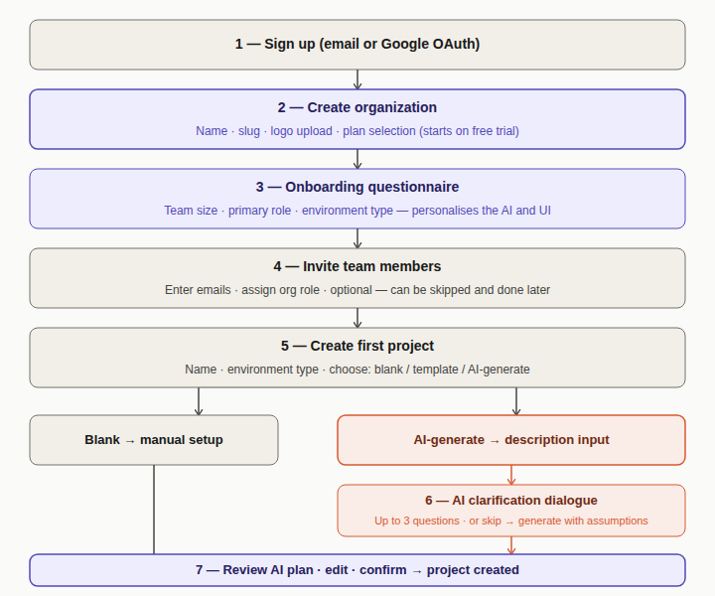
Figure 14 — Flow 1: Sign up → org creation → invite members → AI project generation → plan review
Step | Detail
1 — Sign up | Email or Google OAuth. Account creation.
2 — Create organization | Name, slug, logo upload, plan selection (starts on free trial).
3 — Onboarding questionnaire | Team size, primary role, environment type. Personalises the AI and UI defaults.
4 — Invite team members | Enter emails, assign org role. Optional — can be skipped and done later.
5 — Create first project | Name, environment type, then choose: blank / template / AI-generate.
6 — AI clarification dialogue | AI asks up to 3 targeted questions. Skip option with "generate with assumptions".
7 — AI generates plan | Epics, stories, timeline, sprint draft, and assignment suggestions produced.
8 — Review and confirm plan | Edit epics, re-order stories, adjust dates. Confirm → project created.

6.2 Flow 2 — Full Sprint Lifecycle
Actor: PM, Team Lead, Contributors. From sprint creation through to retrospective and next sprint draft.

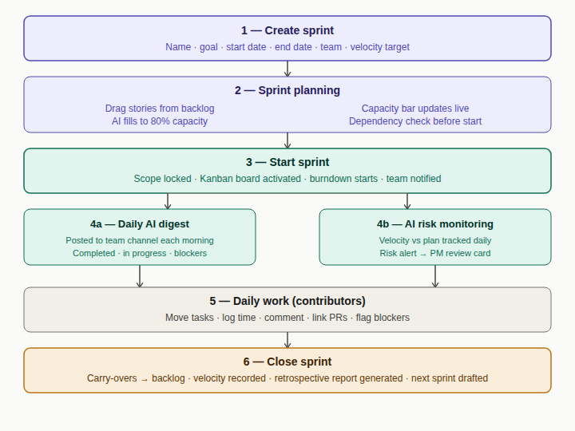
Figure 15 — Flow 2: Sprint creation → planning → active sprint → close → retrospective
Step | Detail
1 — Create sprint | Name, goal statement, start date, end date, velocity target, team assignment.
2 — Sprint planning | Drag stories from backlog. Capacity bar updates live. AI fills to 80% on request. Dependency check.
3 — Start sprint | Scope locked. Kanban board activated. Burndown starts. Team notified.
4a — Daily AI digest | Posted to team channel each morning: completed, in progress, blockers.
4b — AI risk monitoring | Velocity vs plan tracked daily. Risk alert → PM review card if milestone at risk.
5 — Daily work | Contributors move tasks, log time, comment, link PRs, flag blockers.
6 — Close sprint | Carry-overs confirmed to backlog. Velocity recorded. Retrospective report generated. Next sprint drafted.

6.3 Flow 3 — Meeting to Task Reflection
Actor: All roles. Any meeting type. The end-to-end loop from scheduling a meeting to tasks updated in the board.

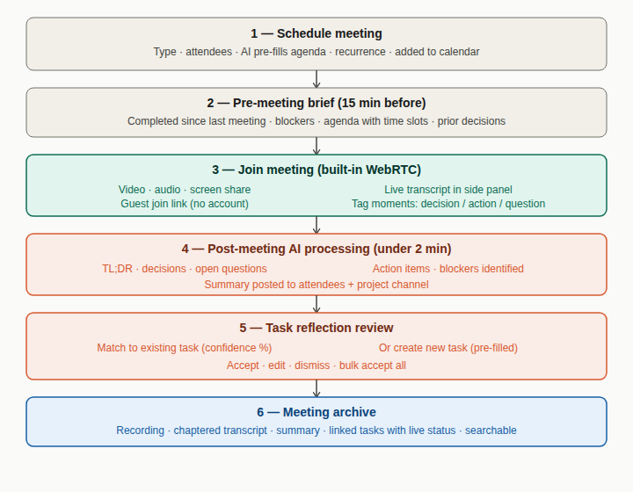
Figure 16 — Flow 3: Schedule → pre-brief → WebRTC → AI summary → task reflection → archive
Step | Detail
1 — Schedule meeting | Type, attendees, AI pre-fills agenda, recurrence, added to calendar.
2 — Pre-meeting brief (15 min before) | Completed since last meeting, blockers, agenda with time slots, prior decisions.
3 — Join (built-in WebRTC) | Video, audio, screen share. Live transcript in side panel. Guest join link (no account needed).
4 — Post-meeting AI processing | TL;DR, decisions, action items, open questions, blockers. Posted within 2 min.
5 — Task reflection review | Each action item as a card: match existing or create new. Accept / edit / dismiss / bulk accept.
6 — Meeting archive | Recording, chaptered transcript, summary, linked tasks with live status. Full-text searchable.

6.4 Flow 4 — Support Ticket Escalation
Actor: Support agent, Dev team lead, Developer. Customer issue → dev bug task → resolution → ticket closed.

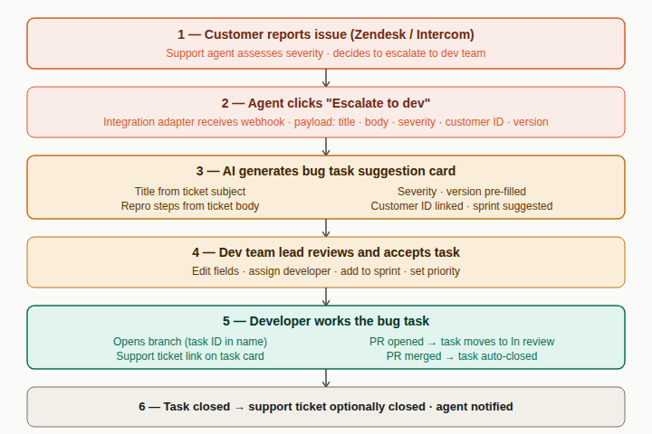
Figure 17 — Flow 4: Customer ticket → escalation → AI bug task → dev fix → ticket closure
Step | Detail
1 — Customer reports issue | Support agent receives ticket in Zendesk / Intercom. Assesses severity. Decides to escalate.
2 — Agent clicks "Escalate to dev" | Integration adapter receives webhook: title, body, severity, customer ID, affected version.
3 — AI generates bug task card | Title from ticket subject, repro steps from body, severity pre-filled, customer ID linked.
4 — Dev team lead reviews | Edits fields, assigns developer, adds to sprint backlog, sets priority.
5 — Developer works the bug | Opens branch (task ID in name). PR opened → In review. PR merged → task auto-closed.
6 — Task closed → ticket optionally closed | Automation rule fires. Support agent notified. Ticket status updated.

6.5 Flow 5 — Contributor Daily Workflow
Actor: Developer / Designer. The day-in-the-life flow for an individual contributor across projects.

Step | Detail
1 — Start of day: My Work | Due today, overdue, recently updated. AI daily priority suggestion. Standup digest in team channel.
2 — Open and claim a task | Read description and acceptance criteria. Check subtask list. Move to In progress. Create branch.
3a — Work in progress | Complete subtasks, log time, comment with questions.
3b — Hit a blocker | Mark task as blocked (reason required). Team Lead and PM notified. AI flags in digest.
4 — Communicate in channel | Post message, @mention teammate, share task card, ask @AI about the project.
5 — Submit work | Open PR → task moves to In review. PR merged → task auto-closed.
6 — End of day | Review My Work, update in-progress statuses, log time. AI prepares tomorrow's digest overnight.

6.6 Flow 6 — AI Risk Detection & Replan
Actor: AI system + PM. How a milestone risk is detected, surfaced, and replanned with minimal disruption.

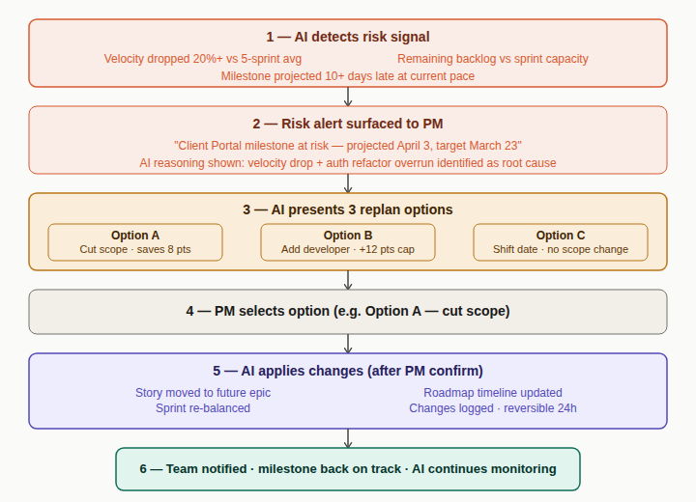
Figure 18 — Flow 6: Risk signal detected → PM alert → 3 replan options → PM selects → AI applies changes
Step | Detail
1 — AI detects risk signal | Velocity dropped 20%+ vs 5-sprint avg. Milestone projected 10+ days late at current pace.
2 — Risk alert surfaced to PM | Alert card on dashboard with AI reasoning: root cause identified.
3 — AI presents 3 replan options | Option A: cut scope. Option B: add resource. Option C: shift milestone. Each shows impact.
4 — PM selects an option | PM chooses preferred replan path from the three presented.
5 — AI applies changes (after confirm) | Scope moved, sprint re-balanced, roadmap updated, health score recalculated, changes logged.
6 — Team notified | PM posts explanation to project channel. Affected assignees notified.

6.7 Flow 7 — New Member Joins Existing Org
Step | Detail
1 — Receive invitation email | Sent by PM or Org Admin. Contains org name, role, and accept link. Expires in 7 days.
2 — Create account and set up profile | Full name, avatar, timezone, skill tags, weekly capacity hours, notification preferences.
3 — Land on org home | Org-wide welcome channel visible. Org directory accessible. Assigned projects visible; others locked.
4 — Enter assigned project | AI project brief: what this project is, sprint goal, team members. Auto-joined to channels.
5a — Introduce in channel | Post intro message. Team notified of new member join.
5b — Explore backlog | Browse open tasks, filter by label, ask @AI "what should I work on first?"
6 — PM assigns first task | AI suggests by skill tags and sprint capacity. PM confirms. Member notified.
7 — My Work dashboard populated | First task visible. Sprint context shown. Enters daily work cycle (Flow 5).

6.8 Flow 8 — Roadmap & Stakeholder Sharing
Step | Detail
1 — Open roadmap view | Epics auto-placed from target dates. Milestones as diamonds. Dependency arrows visible.
2 — Edit and refine roadmap | Drag epic bars to adjust dates. Cascade option shifts dependent epics. Add / reposition milestones.
3 — AI validates during edit | Flags capacity overlaps. Warns if milestone date unreachable. Suggests buffer periods.
4 — Configure stakeholder view | Choose which epics to show. Toggle story-level detail. Hide internal labels and assignee names.
5 — Generate shareable link | Read-only URL. No login required. Updates live. Optional password and expiry date.
6 — Stakeholder accesses roadmap | External: read-only link in browser. Guest account: added as Viewer, can comment.
7 — Roadmap updates live | Stakeholders always see the current state when they revisit the link.

6.9 Flow 9 — Org Admin Cross-Project Oversight
Step | Detail
1 — Open org portfolio dashboard | Health score per project, velocity trend, cross-project resource conflicts, top blockers.
2a — Project healthy | Green score. No action needed. Continues monitoring.
2b — Project at risk | Admin drills into project. Reads AI health insight card.
3 — Read AI health insight | Plain-English diagnosis: root cause identified, contributing factors named.
4a — Rebalance resources | Move member from healthy to at-risk project. Both PMs notified.
4b — Message PM | DM or project channel. Share insight card directly.
4c — Escalate | Export project health report for leadership review.
5 — Resolve cross-project resource conflict | AI suggests which project to deprioritise. Admin adjusts allocation. Both PMs notified.
6 — Schedule org health report | Weekly PDF digest to leadership: health scores, velocity, milestones, AI narrative summary.

7. Task State Machine
Every valid task status transition, what triggers it, and what side effects it produces.

7.1 Task States
State | Meaning
Backlog | Not yet assigned to a sprint. Visible in backlog view only.
To do | Added to an active sprint. Ready to be picked up.
In progress | Being actively worked on by the assignee.
In review | Submitted for review — PR opened or card manually moved.
Blocked | Cannot progress due to an external dependency or blocker.
Done | Work complete and accepted.
Won't do | Deprioritised or descoped. Excluded from all metrics.

7.2 Transition Table
From | To | Trigger | Actor | Side effects
Backlog | To do | Added to sprint (manual) | PM or Team Lead | Appears on sprint board. Sprint capacity bar updates.
To do | In progress | Contributor starts work (manual) | Assignee | Burndown updates. Branch creation prompt shown if GitHub linked.
To do | In progress | Branch created with task ID (auto) | GitHub integration | Branch parsed. PR link placeholder added. Assignee notified.
In progress | In review | PR opened (auto) | GitHub / GitLab | PR link added. Reviewer notified via task comment. CI badge added.
In progress | In review | Contributor moves to review (manual) | Assignee | Reviewer notified if reviewer field set.
In progress | Blocked | Contributor flags blocker (manual) | Assignee | PM and Team Lead notified. AI flags in next digest. Blocked time tracking begins.
Blocked | In progress | Blocker resolved (manual) | Assignee or PM | Blocked time logged. Badge removed. AI notes resolution in digest.
Blocked | In progress | Blocking task closed (AI flag) | AI detects dependency resolved | AI suggest-card shown: "Blocking task X is done — unblock task Y?" User confirms.
In review | Done | PR merged (auto) | GitHub / GitLab | Task closed. Commit SHA stored. Epic progress updated. Burndown drops. Dependents unblocked.
In review | Done | Reviewer approves (manual) | Reviewer or PM | Same side effects as PR merge. Time logging stops.
In review | In progress | PR changes requested (auto) | GitHub / GitLab review event | Task returns to in progress. Assignee notified with reviewer comment link.
Done | In progress | Regression / reopen (manual) | PM or Team Lead | Reopened reason required. Epic progress decremented. Sprint burndown adjusted.
Done | In progress | CI build fails post-merge (AI flag) | CI integration + AI | AI suggest-card: "Build failed after merge — reopen task X?" User confirms or dismisses.
Any state | Won't do | Deprioritised (manual) | PM | Removed from sprint. Epic excludes it. Logged in audit. Reversible.
Done | — | Support ticket auto-closed (auto) | Support integration rule | Ticket closed in Zendesk / Intercom if rule configured. Agent notified.

7.3 Trigger Legend
Trigger type | Description
Auto | Triggered by integration event or system condition. No user action needed.
Manual | User explicitly moves the task or takes an action.
AI flag | AI detects a condition and shows a suggestion card. User confirms before any write action.

8. Notification & Event Routing Map
Every major platform event, who it notifies, via which channels, what AI action fires, and whether it is audit-logged.

Event | Notified | Channels | AI action | Audit
Task assigned | Assignee | In-app, Email | AI updates capacity model | Yes
Task → Blocked | Assignee, PM, Team Lead | In-app, Team channel | Flagged in digest. Cascade risk checked. | Yes
Task → Done | Reporter, PM | In-app | Epic progress recalculated. Dependents unblocked. | Yes
Task comment posted | @mentioned, watchers | In-app, Email digest | AI scans for blocker signals | No
Due date passed | Assignee, PM | In-app, Email | AI adds to risk monitoring. | No
Sprint started | All sprint members | In-app, Team channel | Burndown baseline set. Daily digest scheduled. | Yes
Sprint 80% elapsed, <50% done | PM, Team Lead | Risk alert, In-app | AI generates replan options (Flow 6). | Yes
Sprint closed | All sprint members | In-app, Project channel | Retro generated. Next sprint drafted. Velocity recorded. | Yes
Meeting scheduled | All attendees | In-app, Email invite | AI queues pre-meeting brief. | No
Meeting ended | All attendees | In-app, Project channel, Email | Transcript processed. Summary generated. Task reflection queued. | Yes
PR opened (GitHub) | Assignee, reviewer | In-app, Task comment | Task → In review. PR badge added. | Yes
PR merged (GitHub) | PM, Team Lead | In-app | Task auto-closed. Epic progress updated. | Yes
CI build failed | Assignee, Team Lead | In-app alert, Task comment | Build failing badge added to task. | Yes
Support ticket escalated | Dev Team Lead, PM | In-app alert, Email | Bug task suggestion card generated. | Yes
Member removed from org | PM of all projects | In-app | AI generates task reassignment suggestions. | Yes
AI action applied (autopilot) | PM | In-app, Digest | Stored in AI audit trail. Reversible within 24h. | Yes — always
Integration token expired | PM, Org Admin | In-app alert, Email | Integration marked degraded. Sync paused. | Yes

9. Appendix

9.1 Glossary
Term | Definition
Epic | A large feature body grouping related stories under one strategic goal. Spans multiple sprints. Links to roadmap.
Story / Feature | A user-facing feature slice. The primary deliverable unit carried through a sprint.
Task | A concrete technical work item that completes a story. Linked to code via PR and branch.
Subtask | An atomic checklist item within a task. Contributes to parent task completion percentage.
Sprint | A fixed time-box (typically 1–2 weeks) in which a set of stories is delivered.
Backlog | The prioritised pool of all stories and tasks not yet assigned to a sprint.
Velocity | Story points completed per sprint. Rolling average used for planning and forecasting.
Cycle time | Time from first move to In progress to task close.
Lead time | Time from task creation to close. Includes backlog wait time.
Burndown | Chart of remaining story points per day vs the ideal linear burn rate through a sprint.
WIP limit | Maximum number of tasks allowed in a Kanban column at one time.
Health score | AI-computed 0–100 composite project health score, updated daily.
Control mode | Per-project AI behaviour setting: Autopilot / Suggest / Ask me first / Off.
Environment type | Project attribute (Developer / Support / Sales / Business) driving integration adapter selection.
Adapter | Project-environment-specific integration layer that surfaces context-appropriate tools on task cards.
Action item | A task or commitment extracted by AI from a meeting transcript.
Task reflection | Post-meeting UI where users review and confirm AI-generated action items before tasks are written.
Sync event | An inbound event from a third-party integration processed by the sync engine.
AI audit trail | Tamper-proof log of every AI write action including before/after state, trigger, and approving user.

9.2 Open Design Decisions
Decision | Options and recommendation
Custom roles — fixed vs user-definable | Fixed permission tiers (simpler) vs user-defined permission sets (flexible). Recommendation: fixed for v1, revisit in v1.5.
WebRTC implementation strategy | Build raw WebRTC vs embed Daily.co / LiveKit. Recommendation: managed provider for v1 to reduce risk and time-to-market.
AI provider selection | Single LLM for all AI capabilities vs specialised models per task. ASR provider (Deepgram / Whisper) is a separate decision from the LLM.
Project visibility defaults | Visible org-wide by default (better discovery) vs private until explicitly shared (more secure). Affects onboarding UX.
AI control mode default | Autopilot feels bold for new users. Recommendation: default to Suggest, allow org admin to change the org-level default.
Multi-sprint epics on roadmap | Single bar across sprints vs phase bars split per sprint. Affects roadmap readability for large orgs.

9.3 Recommended Development Phases
Phase | Scope and goal
Alpha (internal team only) | Org setup + project core (PM-01 to PM-09, PM-14, PM-17) + AI planning basics (AI-01, AI-02, AI-03, AI-13, AI-14). Goal: validate the AI generation loop end-to-end.
Private beta (3–5 design partner orgs) | Add: Comms and meetings (CM-01 to CM-12), GitHub integration (INT-01), sprint burndown (AN-01–03). Goal: validate the meeting → task reflection loop.
Public beta | Add: Remaining Should requirements across all modules. Analytics dashboards. Additional integrations. Goal: validate org-level multi-project usage.
GA (v1.0) | All Must and Should requirements shipped and stable. Could requirements triaged for v1.1 backlog. Full regression test suite passing.
v1.5 | Enterprise: SSO/SAML (ORG-09), custom roles, white-labelling, SOC 2 compliance, breakout rooms (CM-15), advanced automation builder.

