Online Sports Goods Marketing project

Overview:

I previously implemented an online sports goods marketing project. Within the project, users have the ability to order various items, such as clothing and equipment, and also avail additional services like cleaning, repair, and washing. To facilitate the project's functionality, I utilized SQL for database management and order processing. Please feel free to ask if you have specific questions regarding the implementation of SQL in the project.

Step 1: Setup

All tables:

1.CATEGORY(category_id,name)
2.DELIVERY(customer_id,address,delivery_id,order_id,dprice,date)
3.SUPPLIER(supplier_id,name)
4.ORDERS(order_id,price,customer_id,order_type,date)
5.CUSTOMERS(full_name,customer_id,age,address)
6.SERVICES(service_id,name,price)
7.GOODS(supplier_id,category_id,goods_id)
8.CLOTHES(Goods_id ,Pname,CSice,Price,Discount)
9.ACCESORIES(Goods_id ,Pname,ASice,Price,Discount)
10.EXERCISERS(Goods_id ,Pname,ESice,Price,Discount)
11.EQUIPMENTS(Goods_id ,Pname,ESice,Price,Discount)
12.SPORT SHOES(Goods_id ,Pname,SSice,Price,Discount)
13.SPORT NUTRITION(Goods_id, Pname,SSice,Price,Discount)

Step 2: ERD
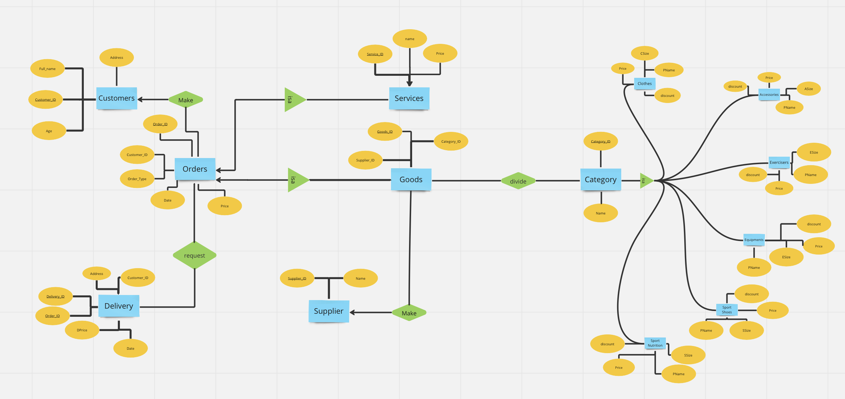
https://miro.com/welcomeonboard/VDQwTUFGenV6MnphR1ltRlRheXZUZVlqdmtENkEyVWxUcjhzdDRyQXJPNGlXN3N4ZVFHNXJibDA2MHVHN2VZTHwzNDU4NzY0NTQyNDQ5NTc1NTA0fDI=?share_link_id=278335144818

Step 3: Normalizations
Category - 3nf
Supplier - 3nf
Goods - 3nf
Delivery - 2nf
Orders - 3nf
Customers - 3nf
Services - 3nf
Step 4: Queries
1)Procedure which does group by information

CREATE OR REPLACE PROCEDURE group_customers_by_age
IS
-- Declare variables to store the grouped data
v_age Customers.age%TYPE;
v_customer_count NUMBER;
-- Define a cursor to select the data from the table
CURSOR c_customers IS
SELECT age, COUNT(*) AS customer_count
FROM Customers
GROUP BY age;
BEGIN
-- Open the cursor
OPEN c_customers;
-- Loop through the cursor and print out the grouped data
LOOP
FETCH c_customers INTO v_age, v_customer_count;
EXIT WHEN c_customers%NOTFOUND;
-- Print out the grouped data
DBMS_OUTPUT.PUT_LINE('Age: ‘ || v_age ||', Customer Count: ' || v_customer_count);
END LOOP;
-- Close the cursor
CLOSE c_customers;
END;

BEGIN
group_customers_by_age;
END;

2)Function which counts the number of records

CREATE OR REPLACE FUNCTION count_goods RETURN NUMBER
IS
-- Declare a variable to store the count
v_count NUMBER;
BEGIN
-- Use the COUNT function to count the number of records in the table
SELECT COUNT(*) INTO v_count
FROM Goods;
-- Return the count
RETURN v_count;
END;

SELECT count_goods() as num_goods
FROM dual;

3)Procedure which uses SQL%ROWCOUNT to determine the number of rows affected

CREATE OR REPLACE PROCEDURE update_delivery_price
(
p_order_id Delivery.Order_id%TYPE,
p_new_price Delivery.Price%TYPE
)
IS
BEGIN
-- Update the price for the specified order
UPDATE Orders
SET Price = p_new_price
WHERE Order_id = p_order_id;

-- Print the number of rows affected
DBMS_OUTPUT.PUT_LINE('Number of rows updated: ' || SQL%ROWCOUNT);
END;

BEGIN
update_delivery_price(1, 2323);
END;

4)Add user-defined exception which disallows to enter title of item (e.g. book) to be less than 5 characters

DECLARE
ageT customers.age%TYPE := :Enter_Age;
age_exception EXCEPTION;
BEGIN
IF ageT < 18 THEN
RAISE age_exception;
ELSE
INSERT INTO customers (CUSTOMER_ID, age, fullname, address) VALUES (46, ageT, 'Sanya milo', 'Qaskelen');
END IF;
EXCEPTION
WHEN age_exception THEN
DBMS_OUTPUT.PUT_LINE('Error: Customer has to be older than 18.');
END;

select * from customers

5)Create a trigger before insert on any entity which will show the current number of rows in the table

CREATE OR REPLACE TRIGGER trg_show_num_rows
BEFORE INSERT ON goods
FOR EACH ROW
DECLARE
num_rows NUMBER;
BEGIN
SELECT COUNT(*) INTO num_rows FROM goods;
DBMS_OUTPUT.PUT_LINE('Current number of rows in the table: ' || num_rows);
END;

insert into goods(GOODS_ID, SUPPLIER_ID, CATEGORY_ID) values(31, 7, 2)

select * from goods

