INF 305: Midterm Project

Overview:

Our team provides an Online Sports Goods Marketing project. In it, in addition to the fact that you can order some things (clothes, equipment, etc.), you can also purchase a service (cleaning, repair, washing).

Step 1: Setup

All tables:

1.CATEGORY(category_id,name)
2.DELIVERY(customer_id,address,delivery_id,order_id,dprice,date)
3.SUPPLIER(supplier_id,name)
4.ORDERS(order_id,price,customer_id,order_type,date)
5.CUSTOMERS(full_name,customer_id,age,address)
6.SERVICES(service_id,name,price)
7.GOODS(supplier_id,category_id,goods_id)
8.CLOTHES(Goods_id ,Pname,CSice,Price,Discount)
9.ACCESORIES(Goods_id ,Pname,ASice,Price,Discount)
10.EXERCISERS(Goods_id ,Pname,ESice,Price,Discount)
11.EQUIPMENTS(Goods_id ,Pname,ESice,Price,Discount)
12.SPORT SHOES(Goods_id ,Pname,SSice,Price,Discount)
13.SPORT NUTRITION(Goods_id, Pname,SSice,Price,Discount)

Step 2: ERD
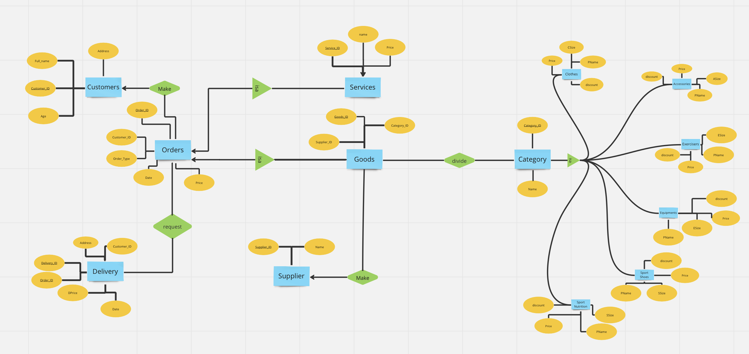
https://miro.com/welcomeonboard/VDQwTUFGenV6MnphR1ltRlRheXZUZVlqdmtENkEyVWxUcjhzdDRyQXJPNGlXN3N4ZVFHNXJibDA2MHVHN2VZTHwzNDU4NzY0NTQyNDQ5NTc1NTA0fDI=?share_link_id=278335144818

Step 3: Normalizations
Category - 3nf
Supplier - 3nf
Goods - 3nf
Delivery - 2nf
Orders - 3nf
Customers - 3nf
Services - 3nf
Step 4: Queries
1)Procedure which does group by information

CREATE OR REPLACE PROCEDURE group_customers_by_age
IS
-- Declare variables to store the grouped data
v_age Customers.age%TYPE;
v_customer_count NUMBER;
-- Define a cursor to select the data from the table
CURSOR c_customers IS
SELECT age, COUNT(*) AS customer_count
FROM Customers
GROUP BY age;
BEGIN
-- Open the cursor
OPEN c_customers;
-- Loop through the cursor and print out the grouped data
LOOP
FETCH c_customers INTO v_age, v_customer_count;
EXIT WHEN c_customers%NOTFOUND;
-- Print out the grouped data
DBMS_OUTPUT.PUT_LINE('Age: ‘ || v_age ||', Customer Count: ' || v_customer_count);
END LOOP;
-- Close the cursor
CLOSE c_customers;
END;

BEGIN
group_customers_by_age;
END;

2)Function which counts the number of records

CREATE OR REPLACE FUNCTION count_goods RETURN NUMBER
IS
-- Declare a variable to store the count
v_count NUMBER;
BEGIN
-- Use the COUNT function to count the number of records in the table
SELECT COUNT(*) INTO v_count
FROM Goods;
-- Return the count
RETURN v_count;
END;

SELECT count_goods() as num_goods
FROM dual;

3)Procedure which uses SQL%ROWCOUNT to determine the number of rows affected

CREATE OR REPLACE PROCEDURE update_delivery_price
(
p_order_id Delivery.Order_id%TYPE,
p_new_price Delivery.Price%TYPE
)
IS
BEGIN
-- Update the price for the specified order
UPDATE Orders
SET Price = p_new_price
WHERE Order_id = p_order_id;

-- Print the number of rows affected
DBMS_OUTPUT.PUT_LINE('Number of rows updated: ' || SQL%ROWCOUNT);
END;

BEGIN
update_delivery_price(1, 2323);
END;

4)Add user-defined exception which disallows to enter title of item (e.g. book) to be less than 5 characters

DECLARE
ageT customers.age%TYPE := :Enter_Age;
age_exception EXCEPTION;
BEGIN
IF ageT < 18 THEN
RAISE age_exception;
ELSE
INSERT INTO customers (CUSTOMER_ID, age, fullname, address) VALUES (46, ageT, 'Sanya milo', 'Qaskelen');
END IF;
EXCEPTION
WHEN age_exception THEN
DBMS_OUTPUT.PUT_LINE('Error: Customer has to be older than 18.');
END;

select * from customers

5)Create a trigger before insert on any entity which will show the current number of rows in the table

CREATE OR REPLACE TRIGGER trg_show_num_rows
BEFORE INSERT ON goods
FOR EACH ROW
DECLARE
num_rows NUMBER;
BEGIN
SELECT COUNT(*) INTO num_rows FROM goods;
DBMS_OUTPUT.PUT_LINE('Current number of rows in the table: ' || num_rows);
END;

insert into goods(GOODS_ID, SUPPLIER_ID, CATEGORY_ID) values(31, 7, 2)

select * from goods

