🧠 How to Collect a Dataset from Roboflow for Object Detection
- Go to Roboflow
Visit 👉 https://app.roboflow.com/
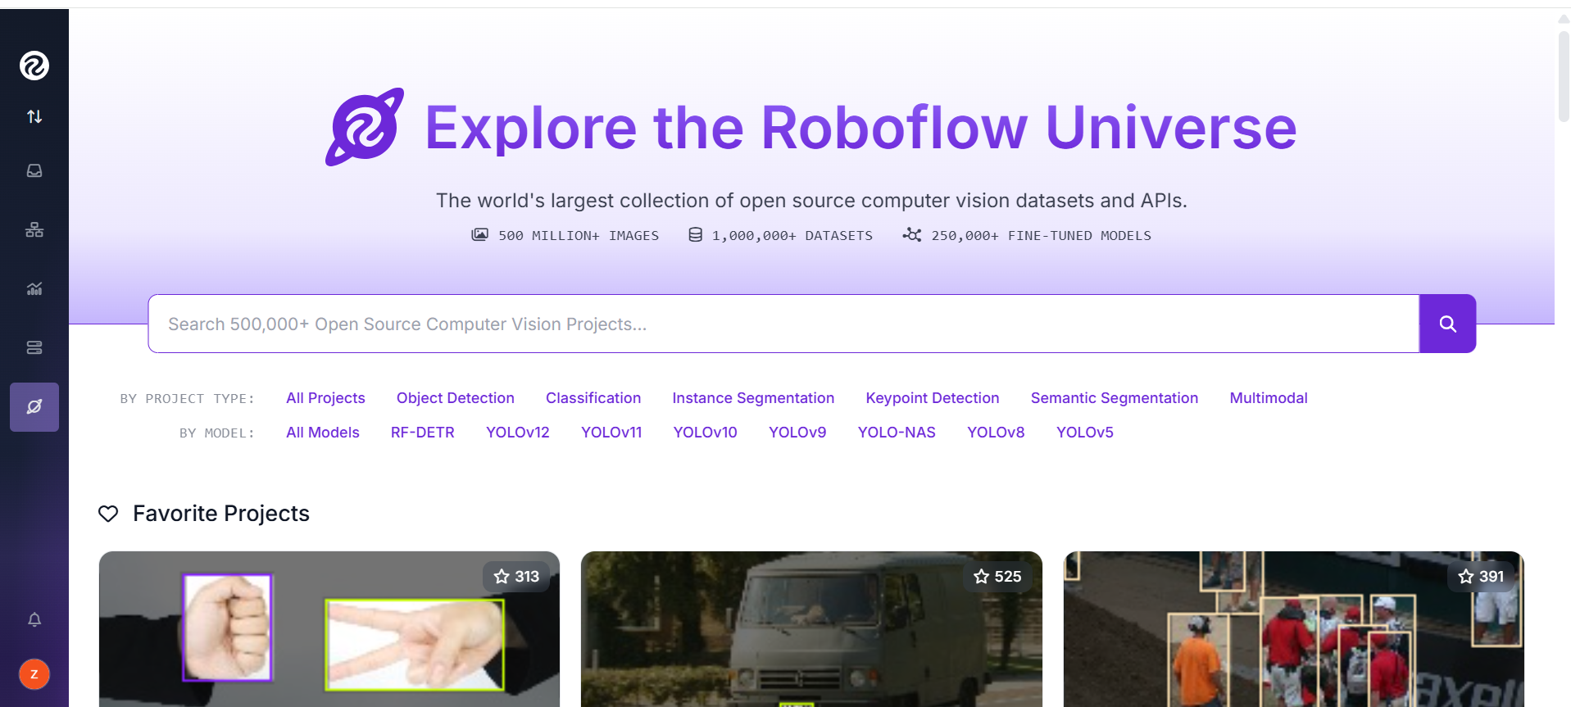
- Sign In or Create an Account
Log in or sign up for a free account.
- Select or Create a Project
  - Choose a public dataset (e.g., car detection, helmet detection, etc.)
  - Or upload your own images to create a custom project.
- Open the Dataset Version
  - On the left side, click “Versions”.
  - Select Version 12 (v12) from the list.
💡 Each version may contain improvements or updates in labeling and preprocessing.
- Export the Dataset
  - Click on the “Export” button.
  - Choose your preferred format (for example: YOLOv8, TensorFlow, or COCO JSON).
- Copy the Python Code
Roboflow will give you a code snippet.
Example (for v12):
- !pip install roboflow
- from roboflow import Roboflow
- rf = Roboflow(api_key="YOUR_API_KEY")
- project = rf.workspace("workspace-name").project("project-name")
- dataset = project.version(12).download("yolov8")
🔹 Make sure the version number is 12.
🔹 Replace "YOUR_API_KEY", "workspace-name", and "project-name" with your own.
- Paste and Run the Code
Paste the code into the program or notebook I provided.
When you run it, it will automatically download Version 12 (v12) of your dataset and save it in your working directory.

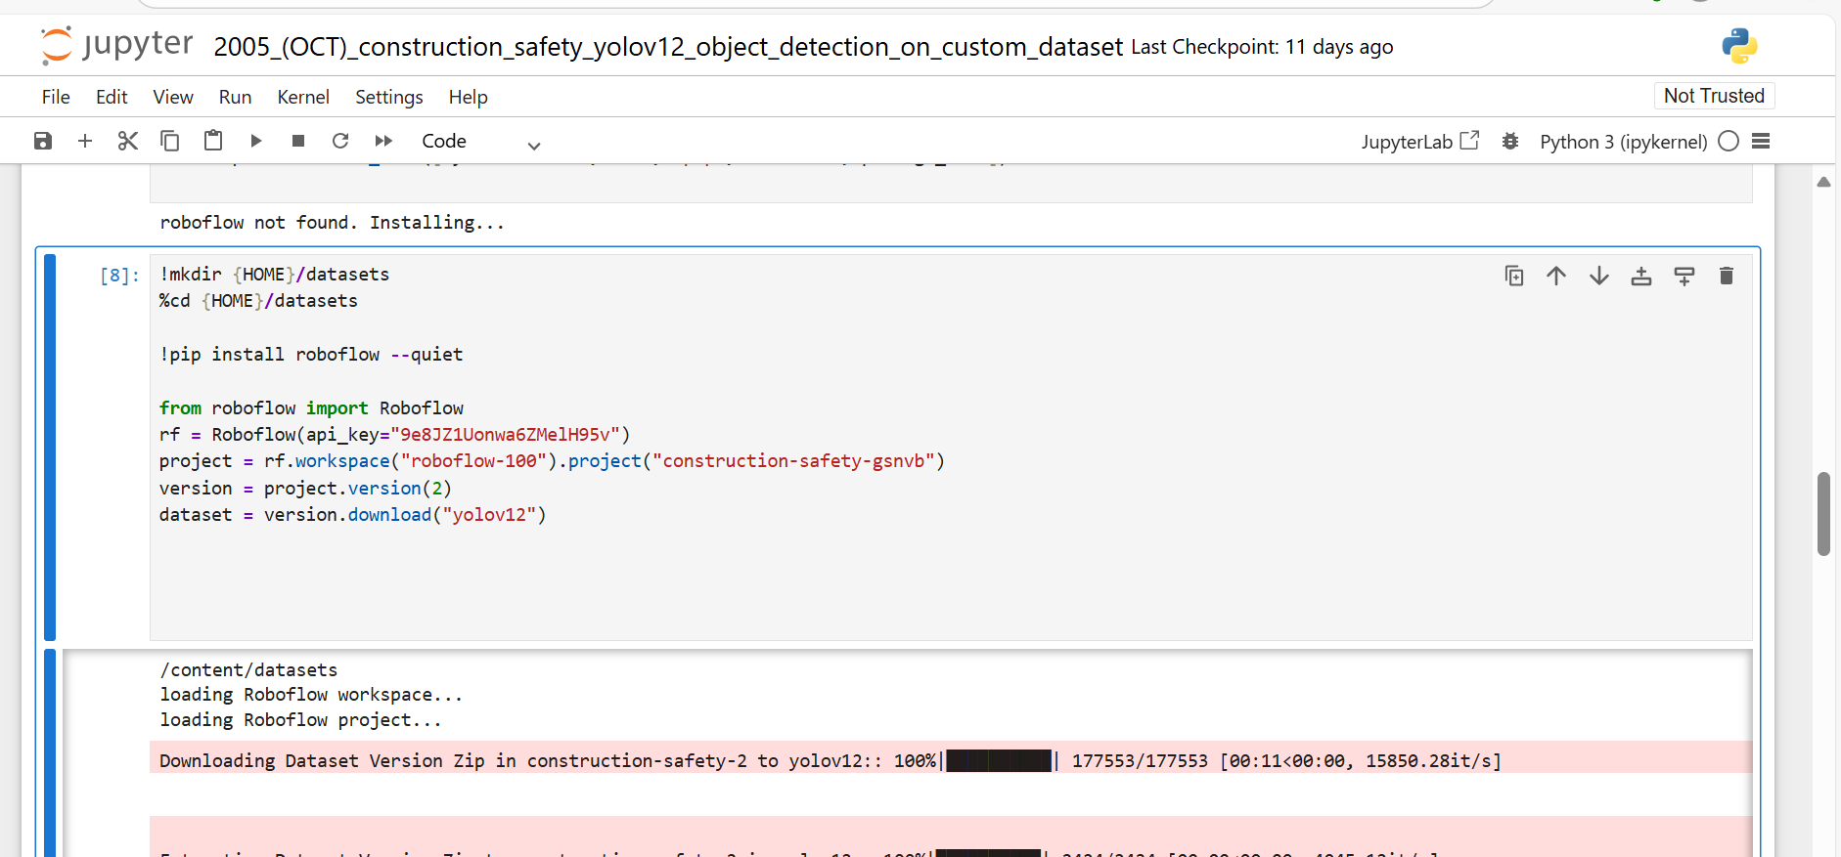

After training your model, you will find the files as shown in the provided image.
- Save the best.pt file for use in real-time testing.
- Save the remaining files and matrices, such as auc, confusion_matrix, and results.csv, to analyze and explain your results in detail.
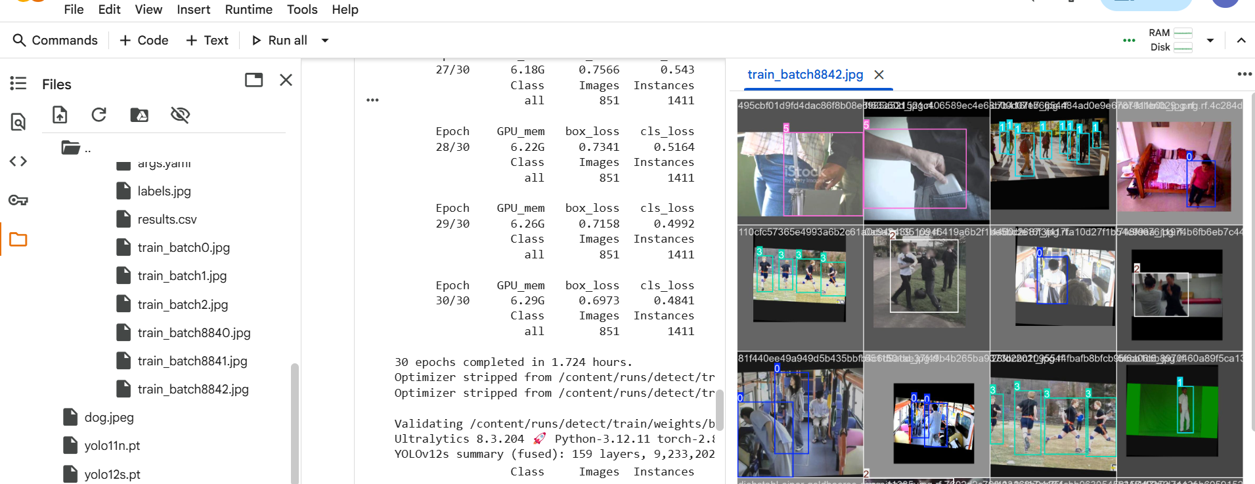

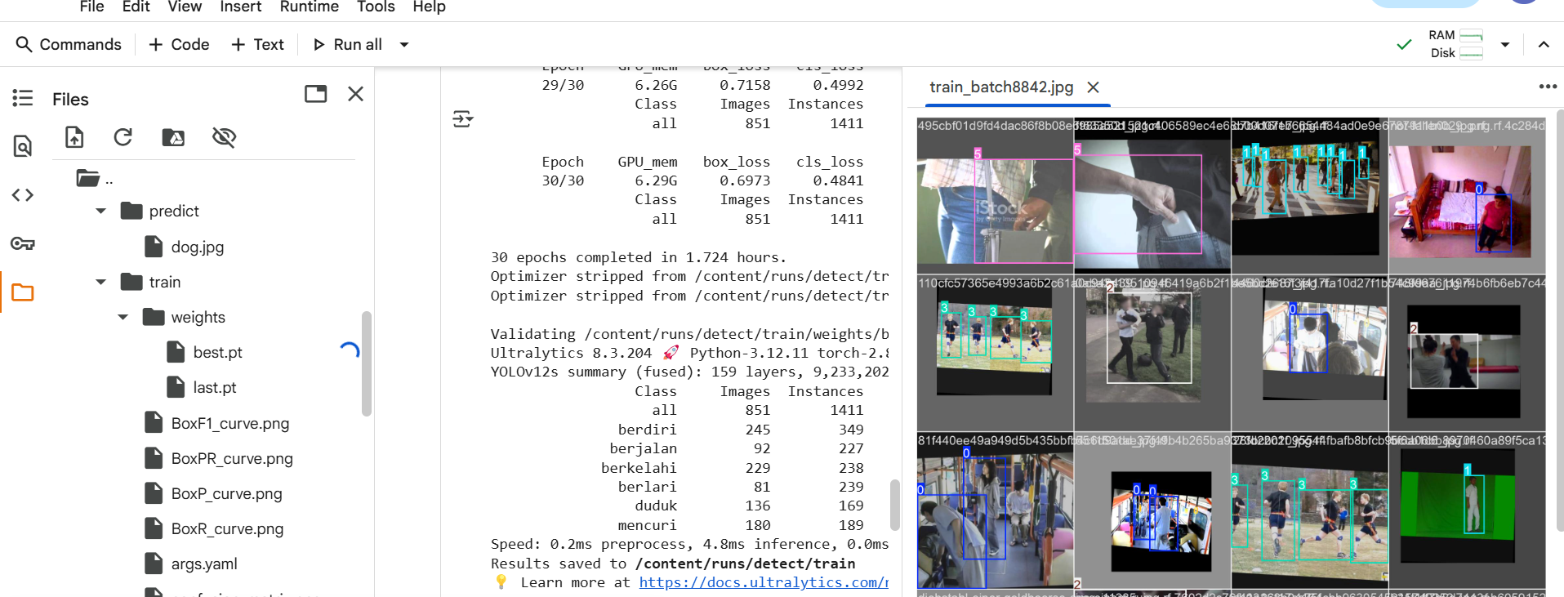

Detect anything you want! 🤖 Create your own custom OBJECT DETECTOR with YOLO - YouTube
https://youtu.be/qyIIXxy8JmA?si=N8f65bWVK6nFfwOs

If you want to integrate Telegram to receive alerts on your Telegram account, follow these steps:
- You will need an API key.
- Obtain your chat ID.

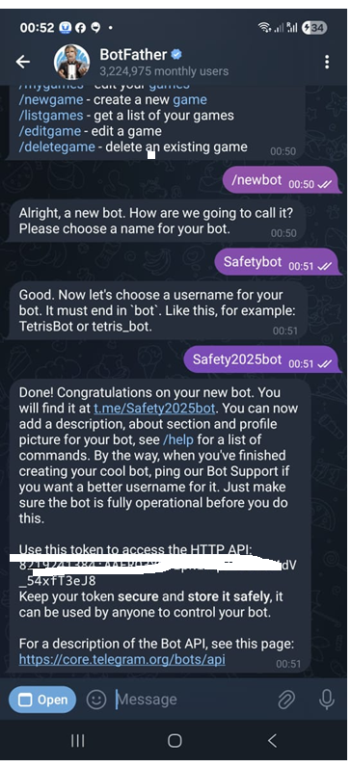
- Obtain your chat ID.

To proceed, copy the following link with your API key into your browser. Ensure you start your bot on Telegram by sending a message like "hi" or any other command.
(Note: Please replace "your_API_key" with your actual API key in the link provided to you.)

https://api.telegram.org/bot(API.....)/getUpdates

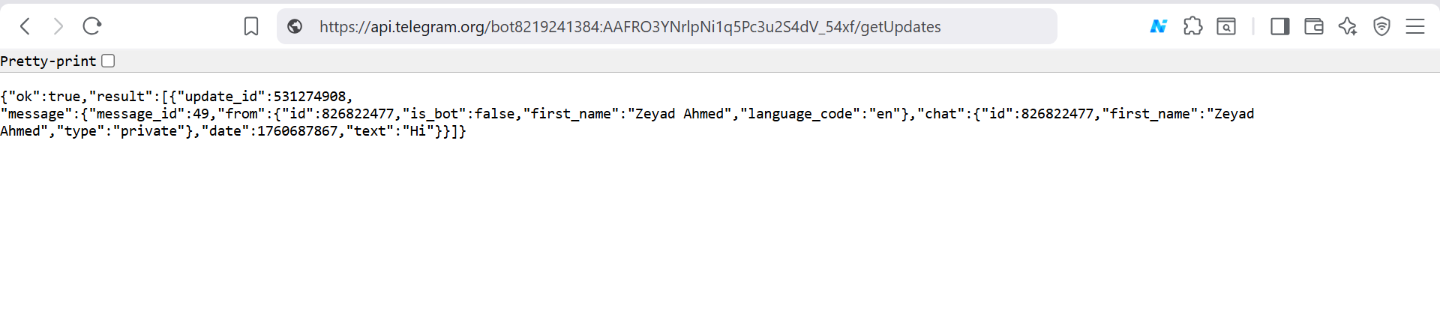
You may need to use some libraries for this task.
pip install ultralytics opencv-python pillow python-telegram-bot

