

**KHULNA UNIVERSITY OF ENGINEERING & TECHNOLOGY**

**Department of Computer Science and Engineering**

CSE 4128

Image Processing and Computer Vision Laboratory

Assignment-04

**Date of Submission:** 8 May, 2024

|  |  |
| --- | --- |
| **Submitted By** | **Submitted To** |
| Md. Zakaria Hossain  Roll: 1907056  Year: 4th Semester: 1st  Department of Computer Science and Engineering (CSE)  Khulna University of Engineering and Technology (KUET), Khulna-9203 | **Dr. Sk. Md. Masudul Ahsan**  Professor  **Dipannita Biswas**  Lecturer  Department of Computer Science and Engineering (CSE)  Khulna University of Engineering and Technology (KUET), Khulna-9203 |

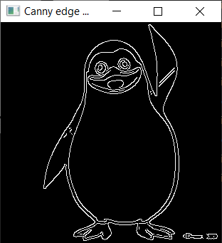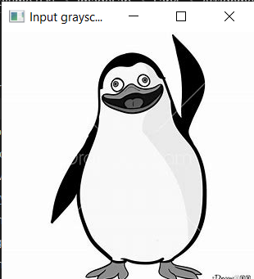

Fig-1 : Input grayscaled image. Fig-2 : Canny edge detection.

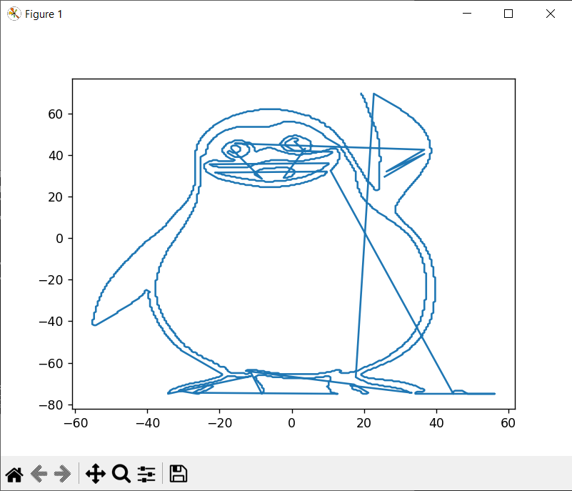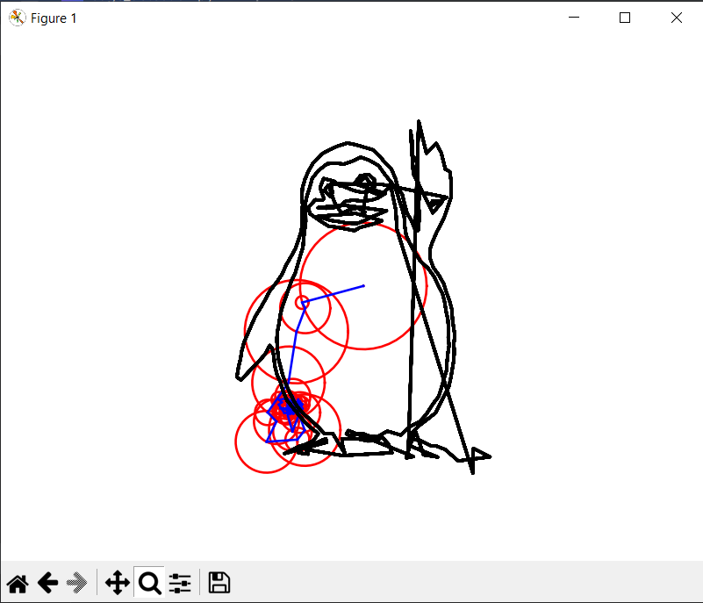

Fig-3 : Plot after applying contour. Fig-4 : Final animation plot.